**ELEC 4700**

**Assignment - 4**

**Circuit Modeling**

**Written by:**

**Matthew Janok**

**101036060**

**Activity 1**

1. Using a fixed bottled neck value and the simulation code from assignment 3, a voltage sweep of the device from 0.1 to 10V was simulated. R3 was found to be 2.3204 Ohms and was used for the rest of the assignment.

Figure : C and G matrices used for simulation

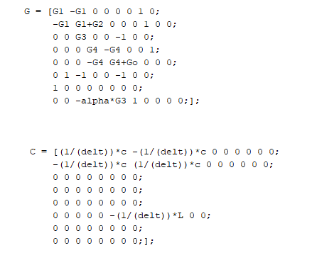

1. A DC sweep from -10V to 10 was performed and results for Vo and V3 can be seen in Figure 2 below.

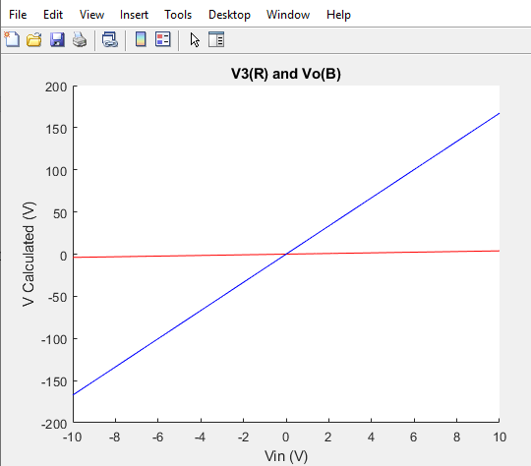

Figure : Plot of Vo and V3 for a DC simulation

1. An AC sweep over frequency was performed and gain was plotted in Figure 3 below.

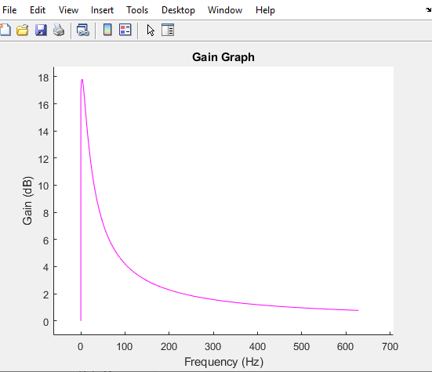

Figure : Plot of Gain vs Frequency of an AC sweep

A histogram of the gain after running an AC simulation with random perturbations on C can be seen in Figure 4 below.

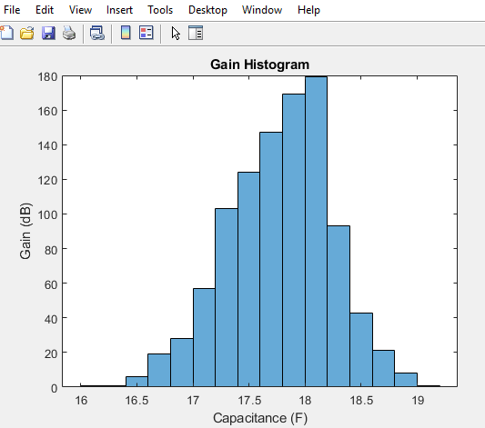

Figure : Histogram of AC simulation with perturbations on C

1. Plotting Vin and Vout from numerical solutions in the time domain with three different input signals can be seen in Figures 5, 6, and 7 below. For the sinusoidal input, when we increase the frequency, we can see two things happen. First the output shrinks since the capacitive effects don’t let the output rise fast enough before the input changes again. Secondly, the frequency response has two peaks spread far apart which are thin because we take many time samples.

When the time step was changed from 1000 steps to 100 steps to make deltaT larger. This had an effect where the graphs provided would be under sampled and the output waveform would be majorly distorted. This also changed the frequency response since we simulate over a shorter time, the peaks of the graphs became very wide and their magnitude shrunk do to the large unknown spots of data in time.

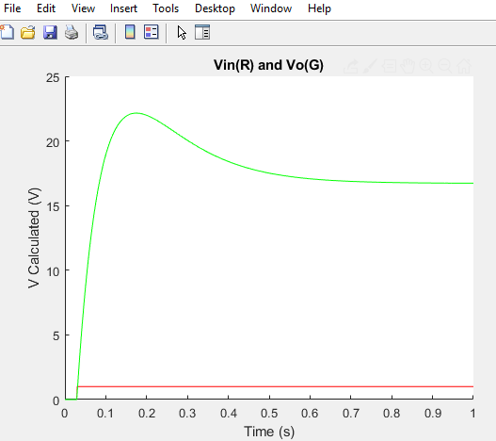

Figure : Step input from 0 to 1 at 0.03s

Figure : Frequency response of step input

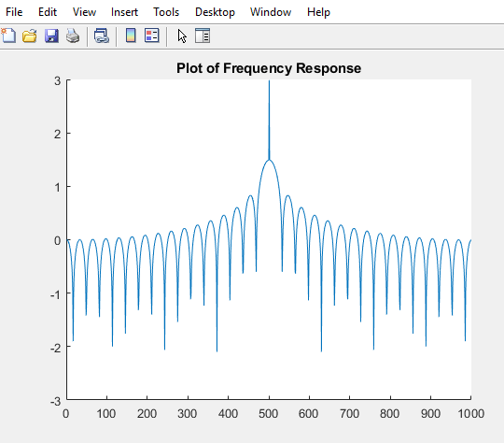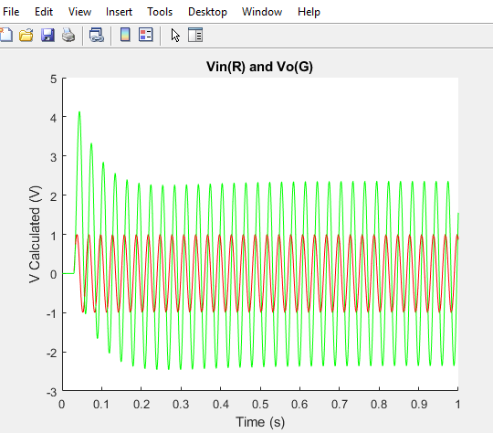

Figure : Sinusoidal input starting at 0.03s with f=1/0.03

Figure : Frequency response of sinusoidal input plotted on logarithmic scale

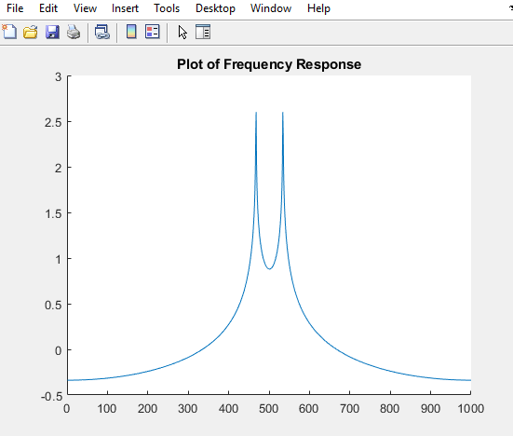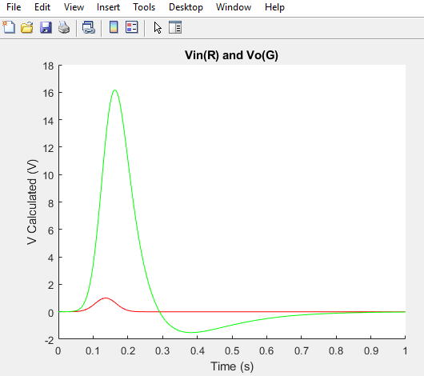

Figure : Gaussian input pulse

Figure : Frequency response of gaussian input

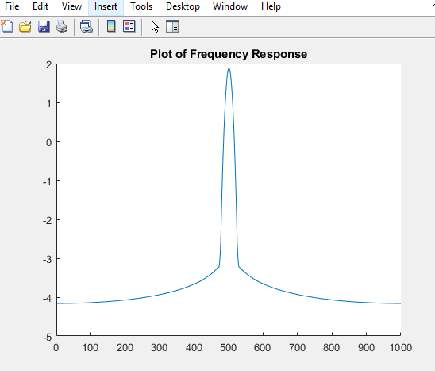

**Activity 2**

1. By inspection, this is an LRC circuit which looks like it has a gain stage. We can expect a band pass type of frequency response with extra gain. The formulation for using finite difference for the numerical solution of this equation in the time domain can be found in the matlab code provided. The C and G matrices used can be seen in Figure 5 below. The updated C and G matrices can be found in Figure 11 below.

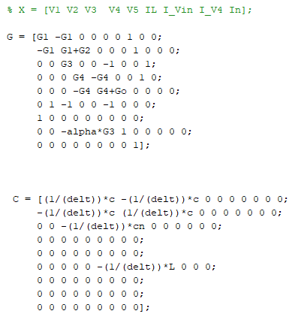

Figure : Updated C and G matrices

1. Using a gaussian excitation, the noisy plot of Vout can be found in Figure 12 below.

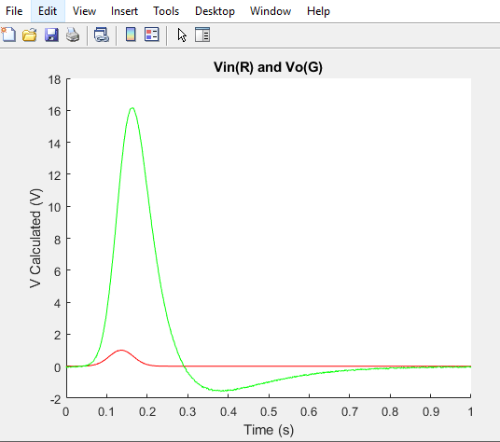

Figure : Plot of Vout using a Gaussian excitation with noise source

1. The Fourier Transform plot for the gaussian excitation can be found in Figure 13 below.

Figure : Fourier Transform of Gaussian excitation

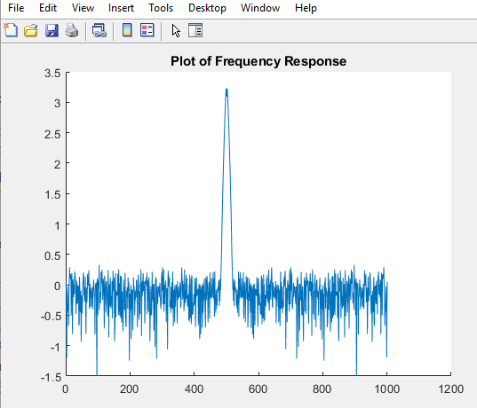

1. 3 plots of Vout with different values of Cn at 0.000001, 0.00007, and 0.0002 can be seen in Figures 14, 15, and 16 respectively. We can see that with more noise (increased Cn) that the frequency response gets more distorted at the edges of the graph. This is due to the capacitive effect which we can see well in Figure 15, starts high and has a time constant where it tries to find equilibrium back at 0.

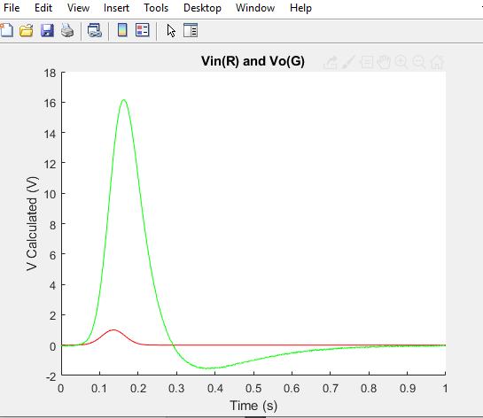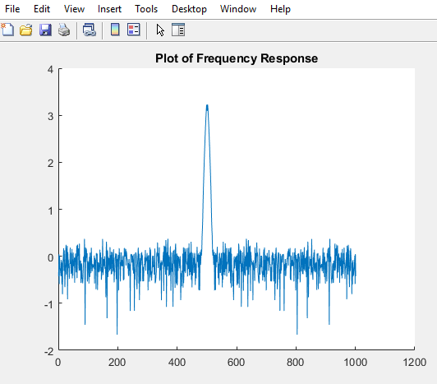

Figure : Plot of Vo and frequency response at Cn=0.000001

Figure : Plot of Vo and frequency response at Cn=0.0002

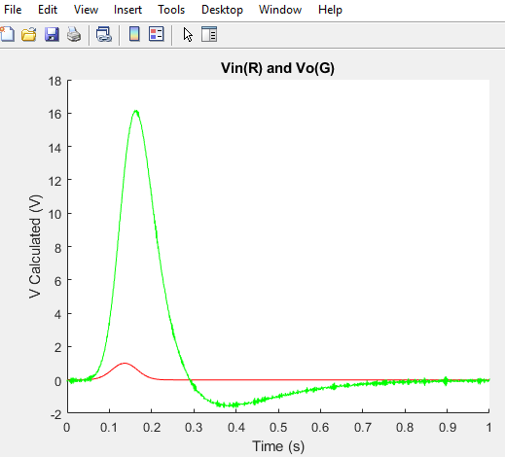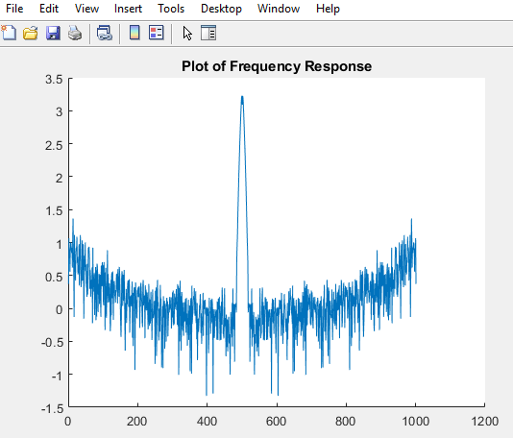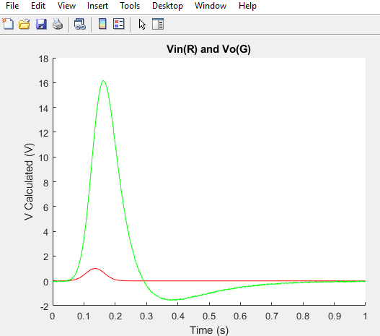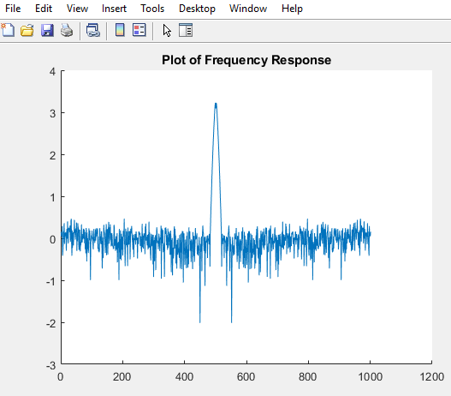

Figure : Plot of Vo and frequency response at Cn=0.00007

1. 2 plots of Vout with the time steps being 0.002 and 0.005 can be seen below in Figures 17 and 18 respectively. We can observe that as the time step gets larger, we start to notice distortions in Vo such as having the peak of Figure 17 be slightly above 16V while the peak of Figure 18 is slightly below 16V. The more under sampled the graphs get, the more the shape and peaks will distort and try to blend together. We notice in the frequency plots that the peak frequency not only gets lowered but the range also becomes more uncertain and the peak gets wider.

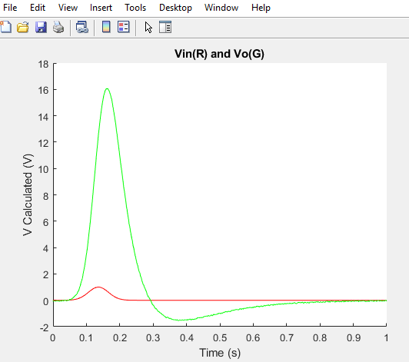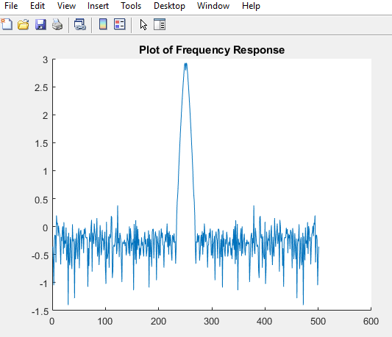

Figure : Vo and frequency response with delt=0.002, 500 steps

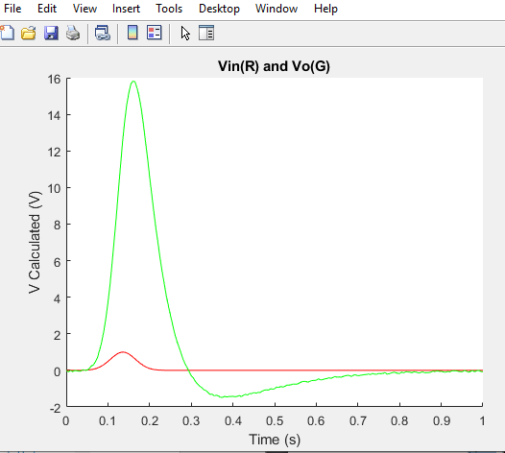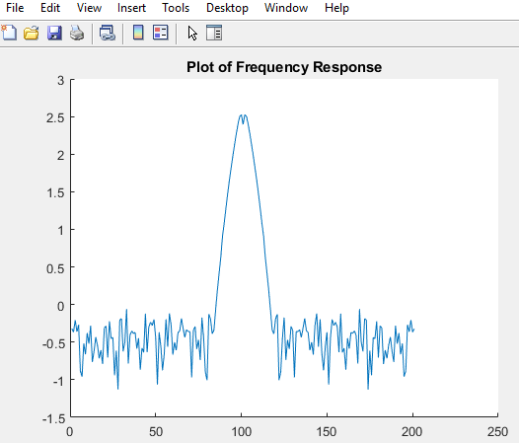

Figure : Vo and frequency response with delt=0.005, 200 steps

**Activity 3**

1. If the voltage source on the output stage described by the transconductance equation V = αI3 was instead modeled by V = αI3 + βI2 3 + γI3 3 we would need to employ the B matrix since it would no longer be a linear device.
2. We would need to make changes in the G matrix to compensate for the newly non-linear component and instead add it to a B matrix. For finding solutions to the B matrix we could use a newton-Raphson approach where we use a matrix of derivatives. We can rearrange and expand the base expression about f(V) =0 so that we can construct the Jacobean to have solutions of 0 where we would only need to iterate over dV to substitute back into the base equation and then be able to solve for Vn (the node of interest).
3. No bonus material