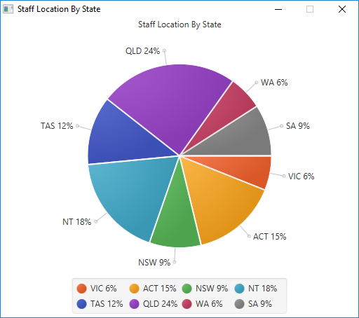
No other output, should look something like this depending on how many staff members of each state have been added using program from Task 1.

