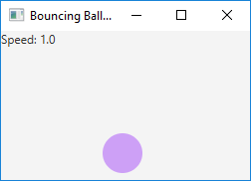
Hold left mouse click to pause, up arrow key to increase ball speed, down to decrease.

