When the program starts it displays the message to click the buttons to view of insert a new record.
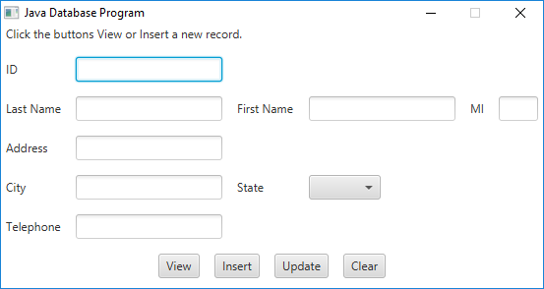

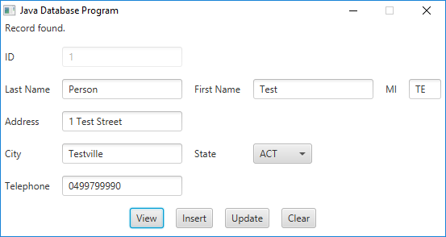
If an id is chosen that doesn't exist it displays Record not found.
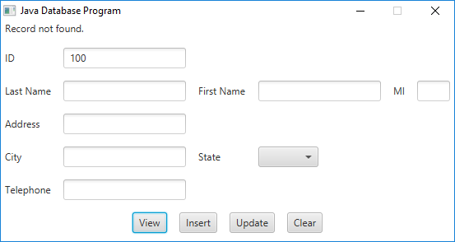
Or if details are entered and Insert clicked, will create that person and show their returned ID from db:
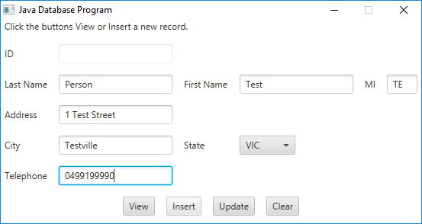
Update will update record:
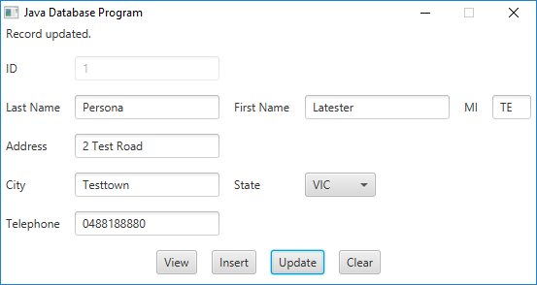
And clear will return it to the initial state, allow view again.

