**RESOURCE MANAGER**



**USER GUIDE**

Table of Contents

1. Introduction 3

Terminology 3

Reporting 3

1.1 Login 4

1.2 Home Page 4

1.3 Menu 5

1.3.1 Access 5

2. Features 6

2.1 My Profile 6

2.2 Notifications 7

2.3 Projects (User) 8

2.3 Projects (Admin) 10

2.3.1 Adding a Project 11

2.3.2 Editing a Project 12

2.3.3 Deleting a Project 12

2.4 Resources 13

2.4.1 Adding a Resource 14

2.4.2 Editing a Resource 15

2.4.3 Deleting a Resource 15

2.5 Skills 16

2.5.1 Adding a Skill 17

2.5.2 Editing a Skill 17

2.5.3 Deleting a Skill 18

2.6 Users 19

2.6.1 Adding a User 20

2.6.2 Editing a User 20

2.6.3 Deleting a User 21

2.7 Organisational Requirements 22

2.8 Reports 24

2.8.1 Hours per skill report 24

2.8.2 Hours per project report 25

# Introduction

Resource Manager is a *web-based* tool that allows consultants to add their skills and capabilities to be recognised by the broader organisation. Using this system, project managers will be able to manage resource utilisation in projects.

The objective of resource manager is to enable a more structured resource planning for an organisation, by ensuring all staff members have a resource profile, project requirements are properly mapped out, resource manager gives your organisation the capability to have the skills ready for tasks prior to needing them.

## Terminology

Resource Manager has several objects which are managed through the system:

**User:** A User is a person who logs into the system. Usually these will be Project Managers but there are times where other users will need to log in. There are 2 types of Users Administrator and Standard, which can both be linked to a Resource.

**Skill:** A Skill is a reference to a particular capability in which may be employed during a project. Some examples of skills include: Project Management, Programming (C#, Java and Python) or Systems Administration (Windows or Linux admin). While this system was originally developed for an IT company, skills can be mapped to any capability which could be required.

**Resource:** A Resource is an employee’s skill profile; this is a collection of skills to which a person is capable of. For example, a Database Administrator (DBA) may have skills in Oracle, SQL Server and/or MySQL. A Resource contains time frames designed to be measured per week and can also be linked to a User account to allow people to self-manage if required.

**Project:** A Project is usually measured by a collection of Resource requirements (a collection of skills within a time frame). When a body of work has been decided upon within the organisation, these projects are used to allow the organisation to assign the expected workload to a team of people.

**Resource Allocation:** A Resource Allocation is a Skill which is needed for a specific time period on a Project. The allocations can be added by Project Managers to demonstrate what type of Resource they will need and how long they will need it for.

## Reporting

Reporting within Resource Manager allows the organisation to view their skill usage profile which in turn allows them to define whether they need to up-skill resources or find resources with appropriate skills.

## Login

Once an administrator has organised your user account access, simply enter the URL for Resource Manager into a web browser and the following screen will appear.

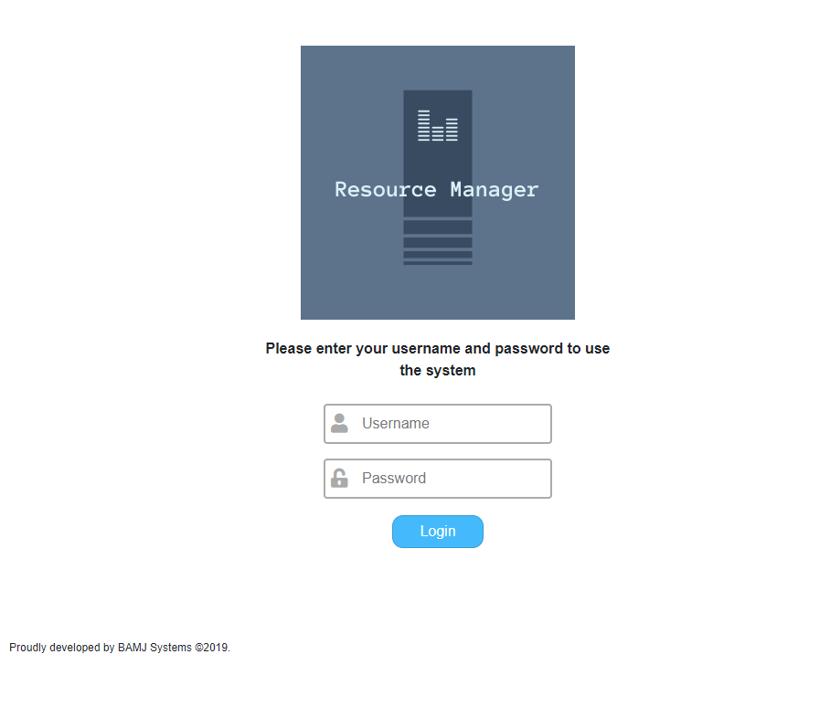

Your **Username** and **Password** will be organised by your administrator.

*Note: Once you are logged in, you can exit Resource Manager at any time by selecting the Menu and pressing the “Logout” button.*

## Home Page

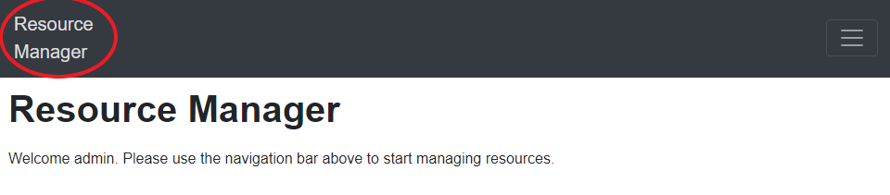

To access the home page from any page, press Resource Manager on the left side of the menu bar.

## Menu

The menu can be accessed via the top right of the menu bar.



### Access

Depending on the level of access required for your position, some parts of Resource Manager may not be available to you, therefore they may not appear for your log-on. Your level of availability will be set by your administrator.

Standard Users have limited access to Resource Manager features and can only use the following:

* My Profile
* Notifications
* Projects

Administrators have full access to the following features:

* My Profile
* Notifications
* Projects
* Resources
* Skills
* Users
* Organisational Requirements
* Reports

# Features

## 2.1 My Profile

**Overview**

This instruction covers the process used to maintain the current user’s profile. A User Profile contains details about the current user such as the User’s name, email address, resource that has been allocated to and the type of User.

**Step 1**

Select *My Profile* from the menu bar.

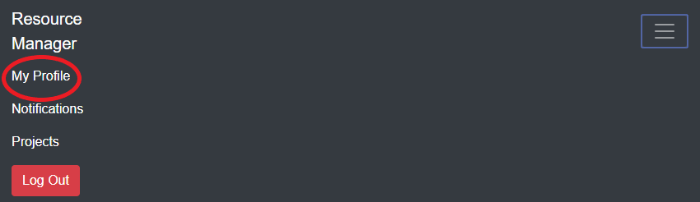

**Step 2**

From here you can edit the details of the User account, such as change the Password, Resource and/or Authority type.

*Note: Resource and Authority can only be changed by an administrator account.*

**User**

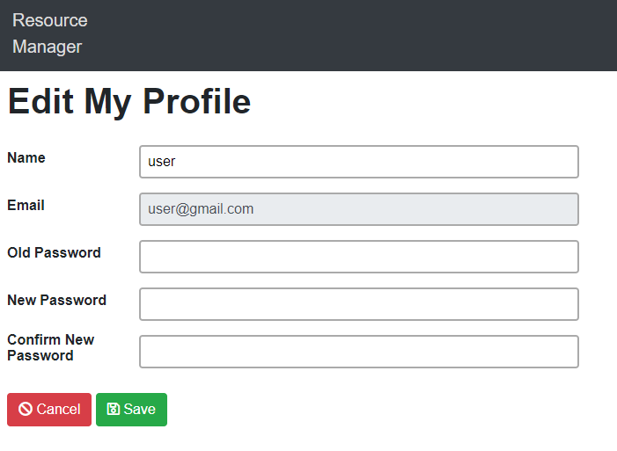

**Admin**

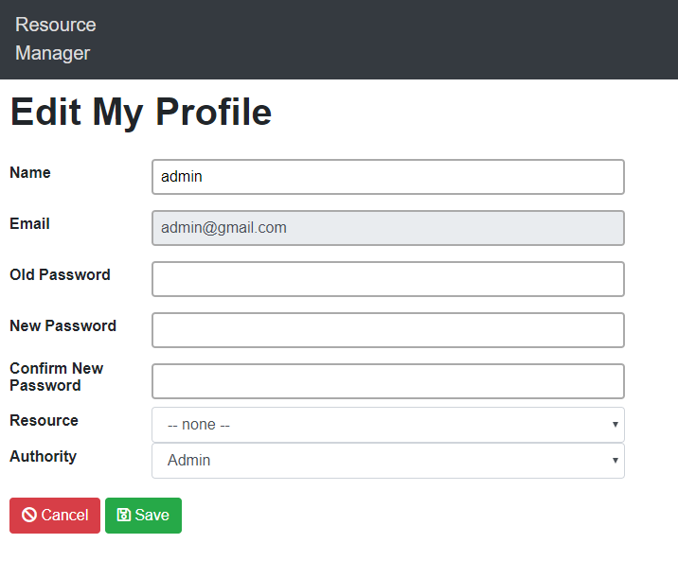

## 2.2 Notifications

**Overview**

This instruction covers the process used to view and delete notifications. Notifications inform the user of any activity that involves their account such as the account being created and being added to a new or existing Project.

**Step 1**

Select *Notifications* from the menu bar.

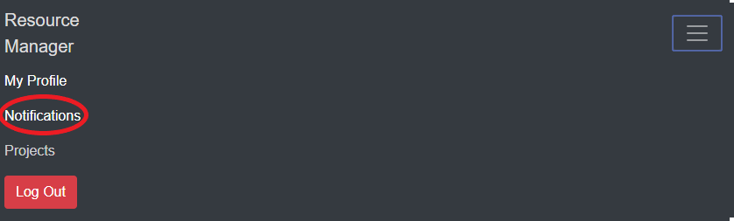

**Step 2**

From here you can mark notifications as “read” and/or delete them.

To mark a notification as read, press the green ‘eye’ button in the *Read* column as shown in the image below.

To delete a notification simply press the delete icon for that notification.

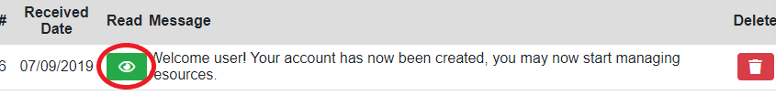

## 2.3 Projects (User)

**Overview**

This instruction covers the process used to view and request to join projects as a standard User.

Standard Users can request to join a specific project if they have skills that the project requires all other projects will not be available to join.

**Step 1**

Select *Projects* from the menu bar.

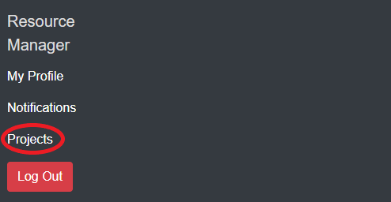

**Step 2**

From here you can view and request to join projects.

To join a project, press the blue button in the *Join* column for the desired project.

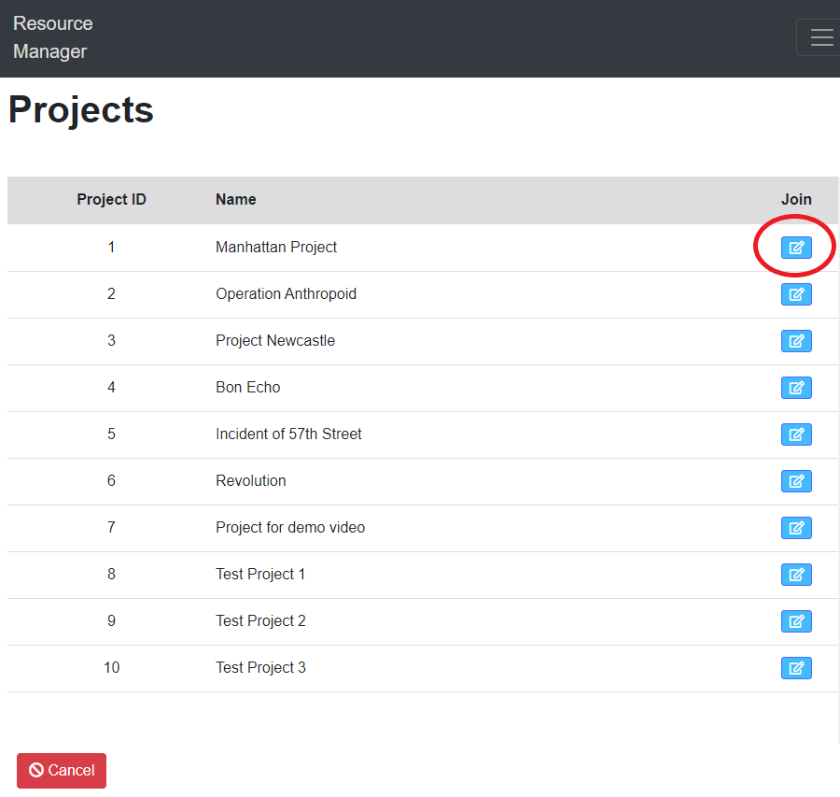

**Step 3**

Now you can see the requirements that the selected project needs. Press the blue button in the *Join* column to join the project.

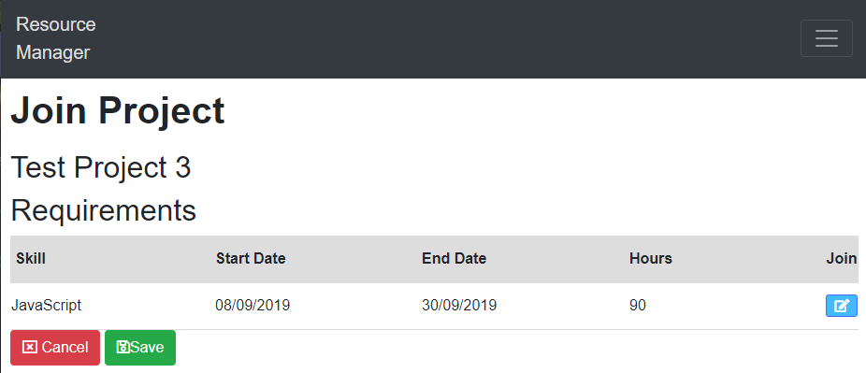

## 2.3 Projects (Admin)

**Overview**

This instruction covers the process used to add/edit/delete Projects as an Administrator.

Maintaining projects is enabled only as an admin and admin accounts cannot join a project.

**Step 1**

Select *Projects* from the menu bar.

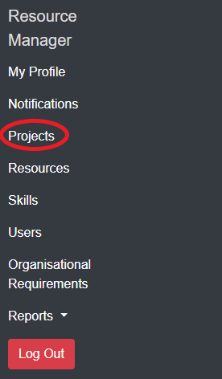

**Step 2**

From here you can view all existing projects. You can add, edit and/or delete projects from the system.

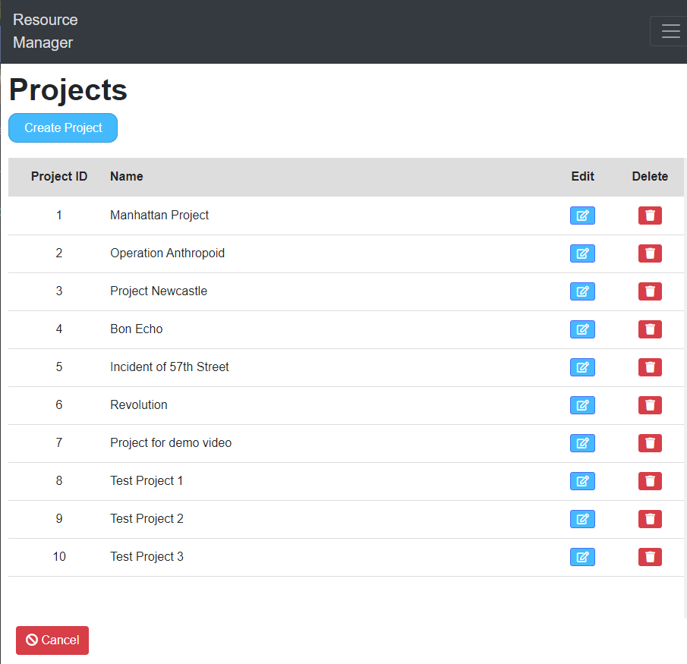

### 2.3.1 Adding a Project

**Step 1**

To add a new project, click the blue *Create Project* button at the top of the page.

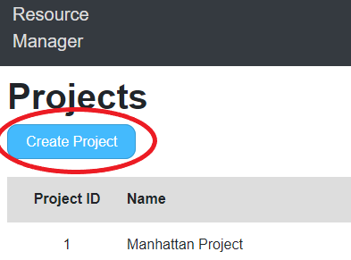

**Step 2**

Enter the Project Name and press the *Save* button.

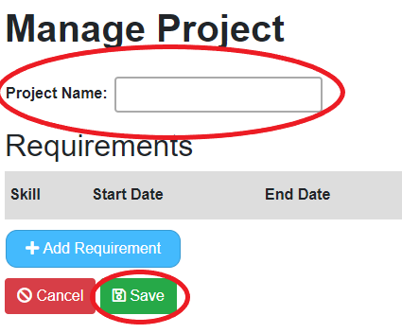

**Step 3**

Press the *Add Requirement* button, fill in the fields and press *Save.*

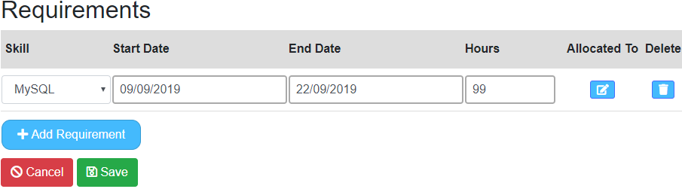

### 2.3.2 Editing a Project

**Step 1**

To edit an existing project, press the blue button in the *Edit* column.

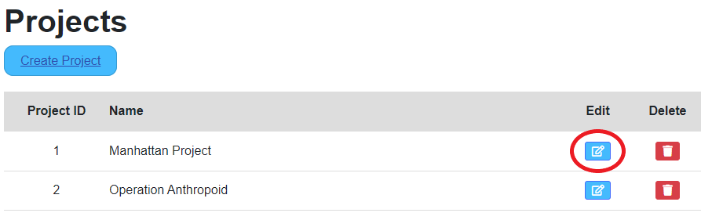

**Step 2**

From here you can change details of requirements, add/delete requirements and see who the project has been allocated to.

**Step 3**

Press the *Save* button to save any changes made.

### 2.3.3 Deleting a Project

**Step 1**

To delete a project, press the red button in the *Delete* column.

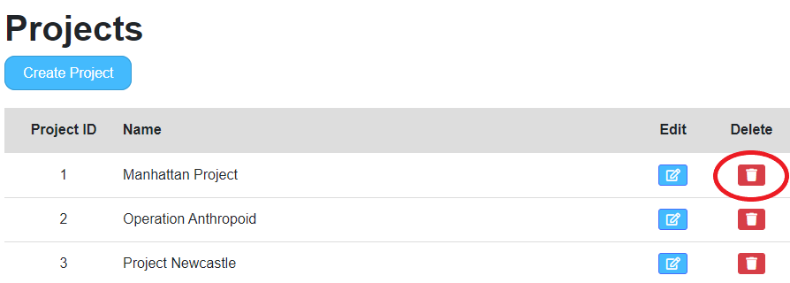

**Step 2**

A warning message will appear after clicking the delete button. Press *Delete* to remove the project from the system.

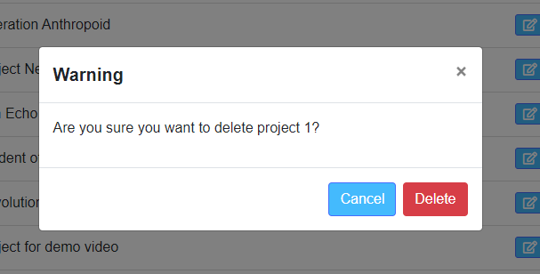

## 2.4 Resources

**Overview**

This instruction covers the process used to add/edit/delete Resources as an Administrator.

A Resource is an employee’s skill profile and can only be maintained by an admin user.

**Step 1**

Select *Resources* from the menu bar.

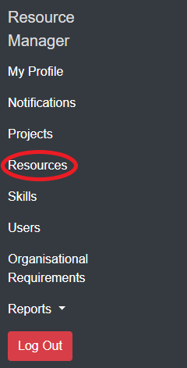

**Step 2**

From here you can view all existing resources. You can add, edit and/or delete resources from the system.

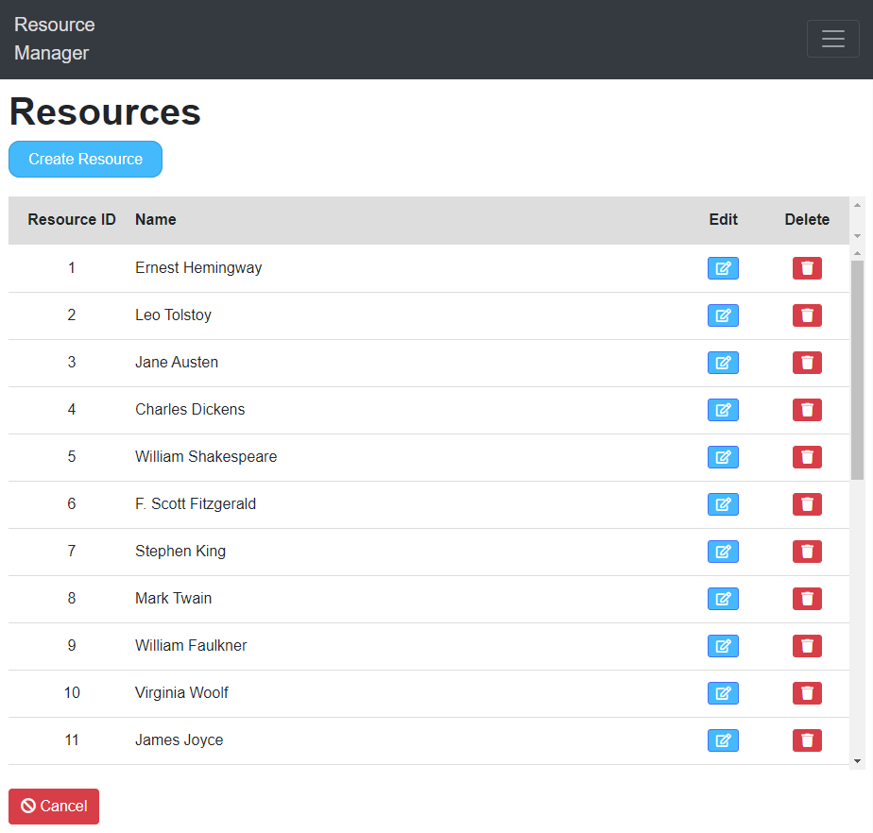

### 2.4.1 Adding a Resource

**Step 1**

To add a resource, click the blue *Create Resource* button at the top of the page.

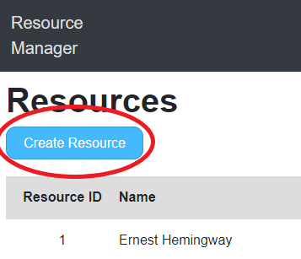

**Step 2**

Enter the Resource Name, Hours and select a Skill(s). Press the *Save* button to save the resource.

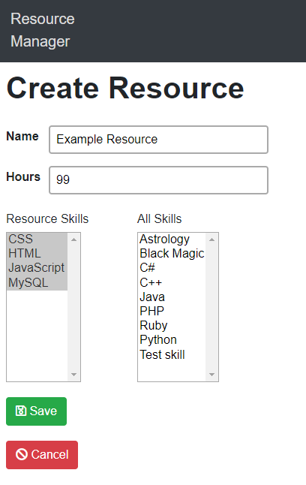

### 2.4.2 Editing a Resource

**Step 1**

To edit an existing resource, press the blue button in the *Edit* column for the desired resource.

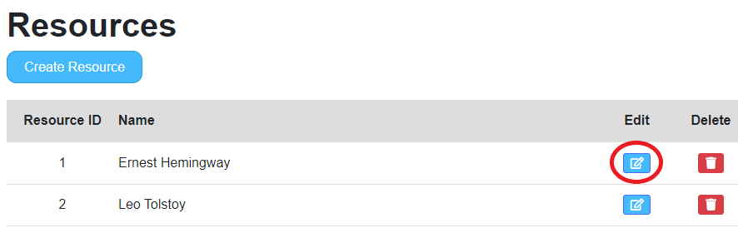

**Step 2**

From here you can change the details of the selected resource and press *Save* to save any changes made.

### 2.4.3 Deleting a Resource

**Step 1**

To delete a resource, press the red button in the *Delete* column.

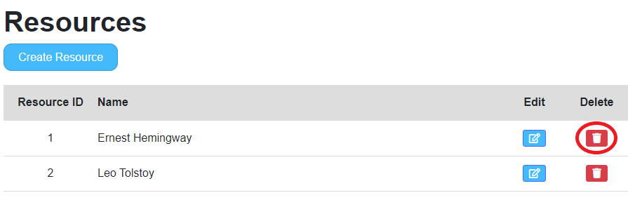

**Step 2**

A warning message will appear after clicking the delete button. Press *Delete* to remove the resource from the system.

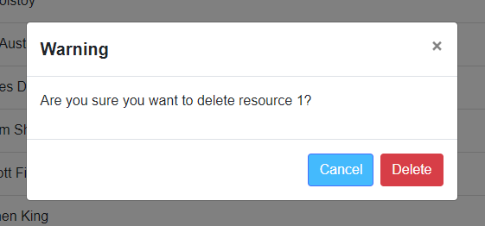

## 2.5 Skills

**Overview**

This instruction covers the process used to add/edit/delete Skills as an Administrator. A Skill can be defined as a User’s ability to do something, such as programming in a specific language.

Skills can only be maintained by an admin user.

**Step 1**

Select *Skills* from the menu bar.

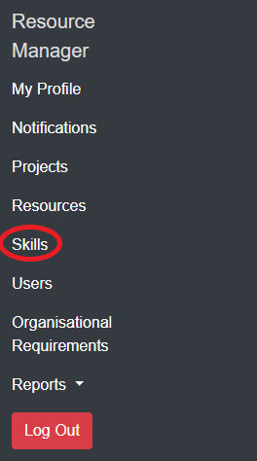

**Step 2**

From here you can view all existing skills. You can add, edit and/or delete skills from the system.

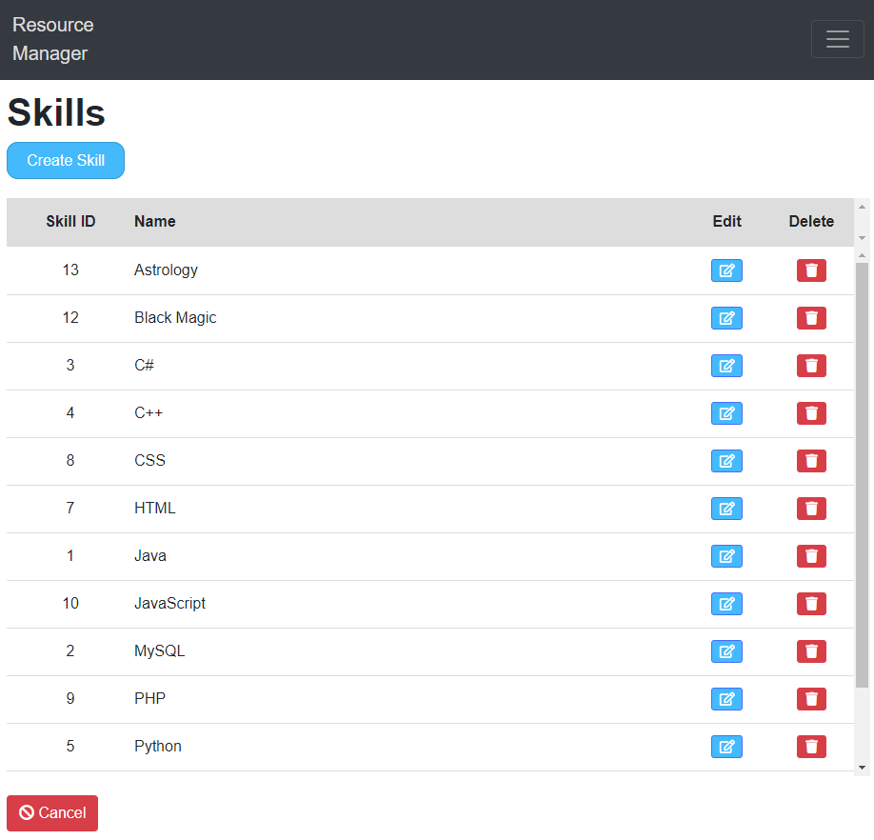

### 2.5.1 Adding a Skill

**Step 1**

To add a skill, click the blue *Create Skill* button at the top of the page.

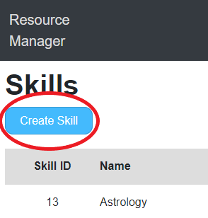

**Step 2**

Enter a Skill Name then press the *Save* button to save the skill.

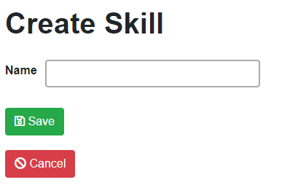

### 2.5.2 Editing a Skill

**Step 1**

To edit an existing skill, press the blue button in the *Edit* column for the desired skill.

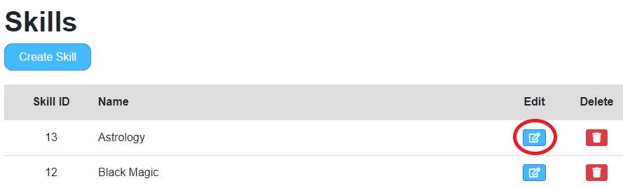

**Step 2**

From here you can change the name of the selected skill and save the change.

### 2.5.3 Deleting a Skill

**Step 1**

To delete a skill, press the red button in the *Delete* column.

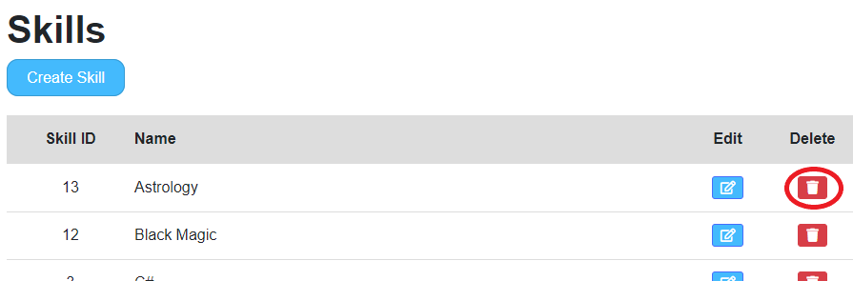

**Step 2**

A warning message will appear after clicking the delete button. Press *Delete* to remove the skill from the system.

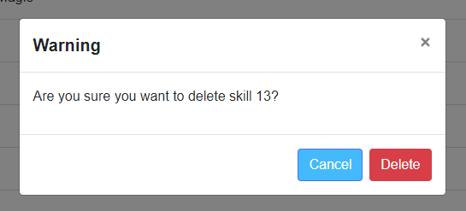

## 2.6 Users

**Overview**

This instruction covers the process used to add/edit/delete Users as an Administrator. Standard User accounts can only be maintained by an admin user.

**Step 1**

Select *Users* from the menu bar.

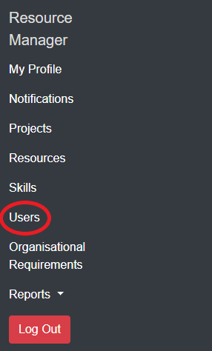

**Step 2**

From here you can view all existing users. You can add, edit and/or delete users from the system.

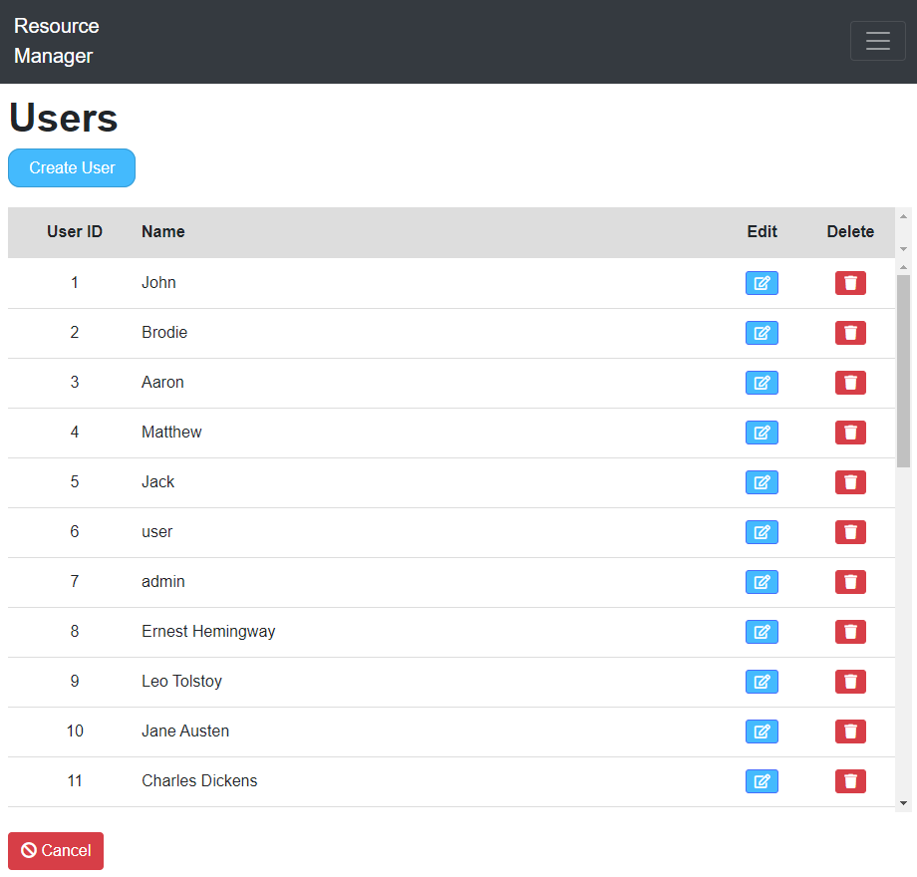

### 2.6.1 Adding a User

**Step 1**

To add a user, click the blue *Create User* button at the top of the page.

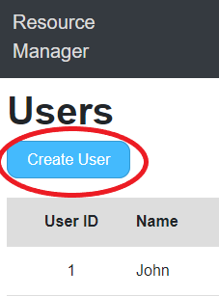

**Step 2**

Enter the details and press the *Save* button to save the new user to the system.

*Note: Setting Authority to “User” will limit the access to the system. Set to Administrator for full access to Resource Manager.*

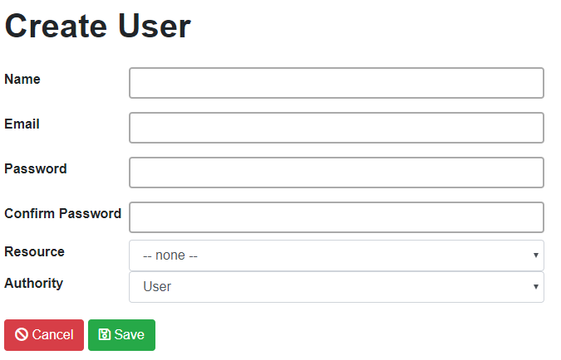

### 2.6.2 Editing a User

**Step 1**

To edit an existing user, press the blue button in the *Edit* column for the desired user.

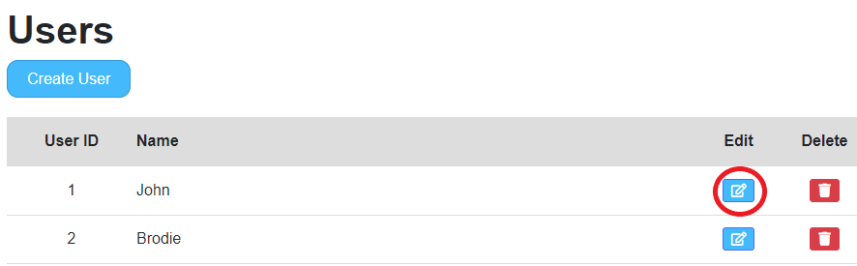

**Step 2**

From here you can change the password, resource and authority of the selected user and save any changes made.

### 2.6.3 Deleting a User

**Step 1**

To delete a user, press the red button in the *Delete* column.

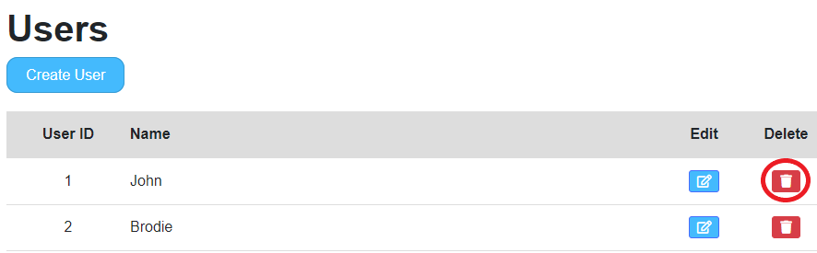

**Step 2**

A warning message will appear after clicking the delete button. Press *Delete* to remove the user from the system.

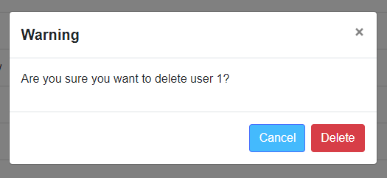

## 

## 2.7 Organisational Requirements

**Overview**

This instruction covers the process used to view Organisational Requirements as an Administrator.

An Organisational Requirement can be defined as one or many skills or attributes that is required to complete a specific project. For example, an admin user can see what programming skills are needed from an employee for a specific project between certain dates. From January 1st to February 1st a project may have an organisational requirement of c#. Admins can then allocate one or many Users to a project(s).

**Step 1**

Select *Organisational Requirements* from the menu bar.

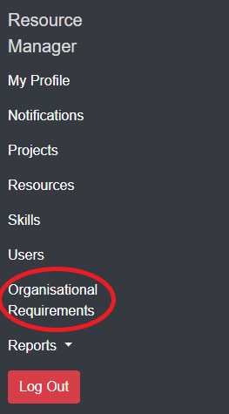

**Step 2**

From here you can view all projects that have requirements outstanding. You can manage these projects from this process.

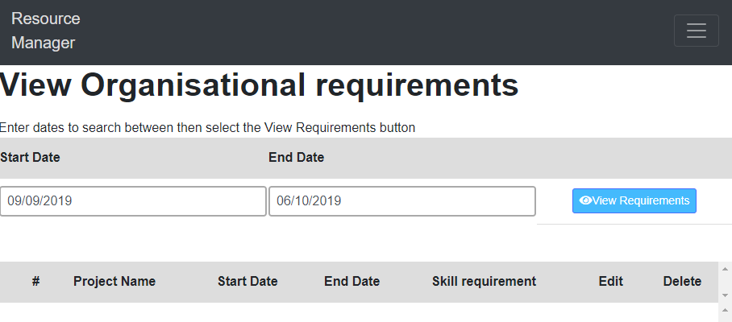

**Step 3**

To search between specific dates for projects, enter a *Start Date* and *End Date* and press the *View Requirements* button.

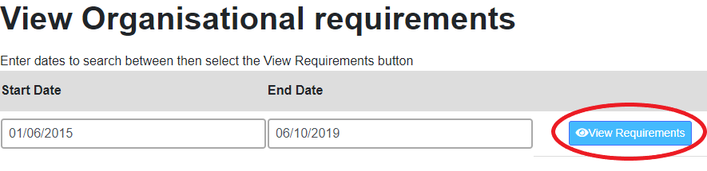

**Step 4**

A list of projects that have outstanding requirements will be listed below (if any).

See example below:

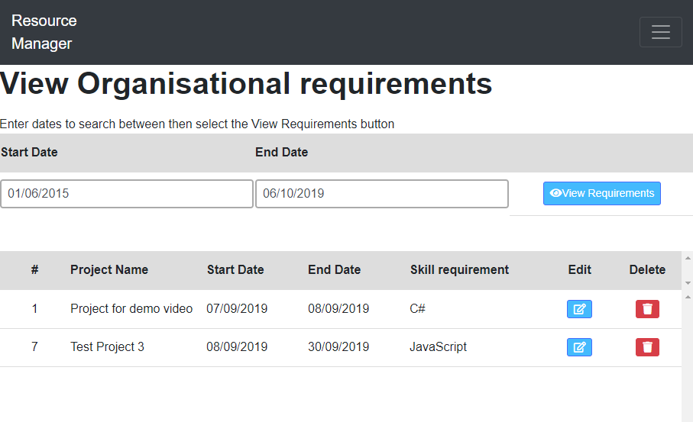

**Step 5**

From here you can manage the projects by pressing the edit/delete buttons of the desired project.

## 2.8 Reports

**Overview**

This instruction covers the process used to view Reports as an Administrator.

There are currently 2 existing reports within Resource Manager, Hours Per Skill and Hours Per Project.

Reports enable admin users to view the statistics of the Resource Manager system in a graph.

**Step 1**

Select *Reports* from the menu bar.

### 2.8.1 Hours per skill report

**Step 2**

Select the *Hours per skill* sub menu under *Reports*.

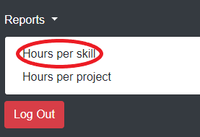

**Step 3**

From here you can view the report statistics by hovering over each column in the graph.

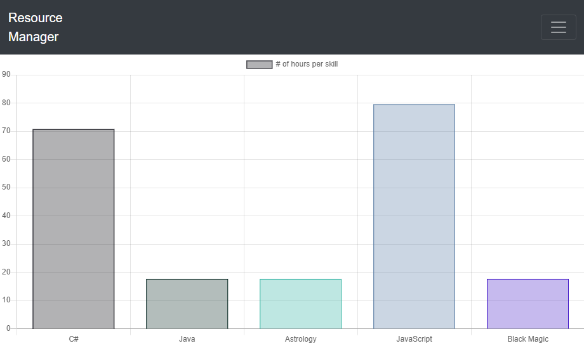

### 2.8.2 Hours per project report

**Step 2**

Select the *Hours per project* sub menu under *Reports*.

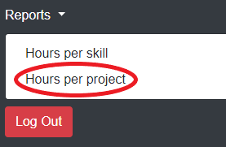

**Step 3**

From here you can view the report statistics by hovering over each column in the graph.

