Babel in React



Name: Matthew Kamal Saad
Submitted to: Eng. Ahmed Saber
Date: 24/1/2026

Simple idea
Babel converts modern JavaScript and JSX into plain JavaScript that browsers understand. Browsers don’t understand JSX or some new JS features directly—Babel fixes that.

Why React needs Babel

When you write React, you usually write things like this:
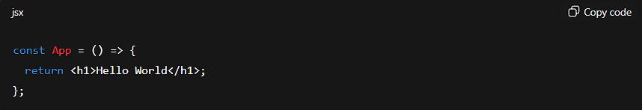

Browsers cannot understand <h1> inside JavaScript
So Babel converts it into something like this:
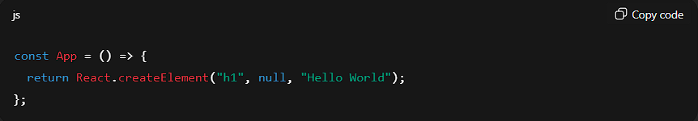

What Babel does in React
Babel mainly:
- Converts JSX → JavaScript
- Converts modern JS (ES6+) → older JS (ES5)

Conclusion
Babel is an essential JavaScript compiler (transpiler) used in React to convert modern JavaScript code (like ES6+) and the special JSX syntax into a backwards-compatible version of JavaScript that all browsers and environments can understand.

