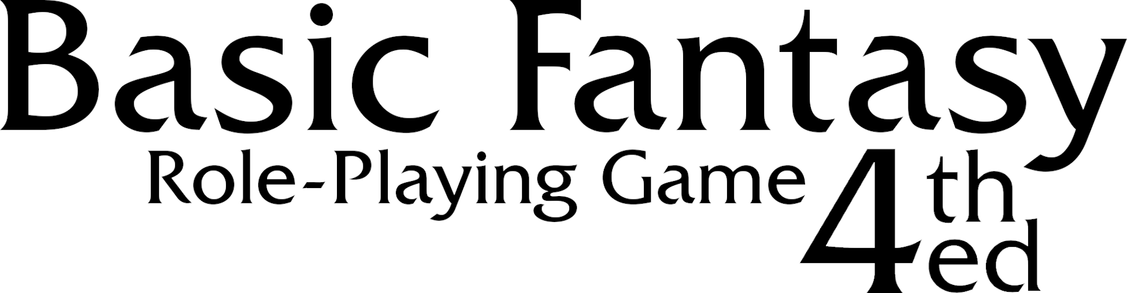
Beginner's Essentials

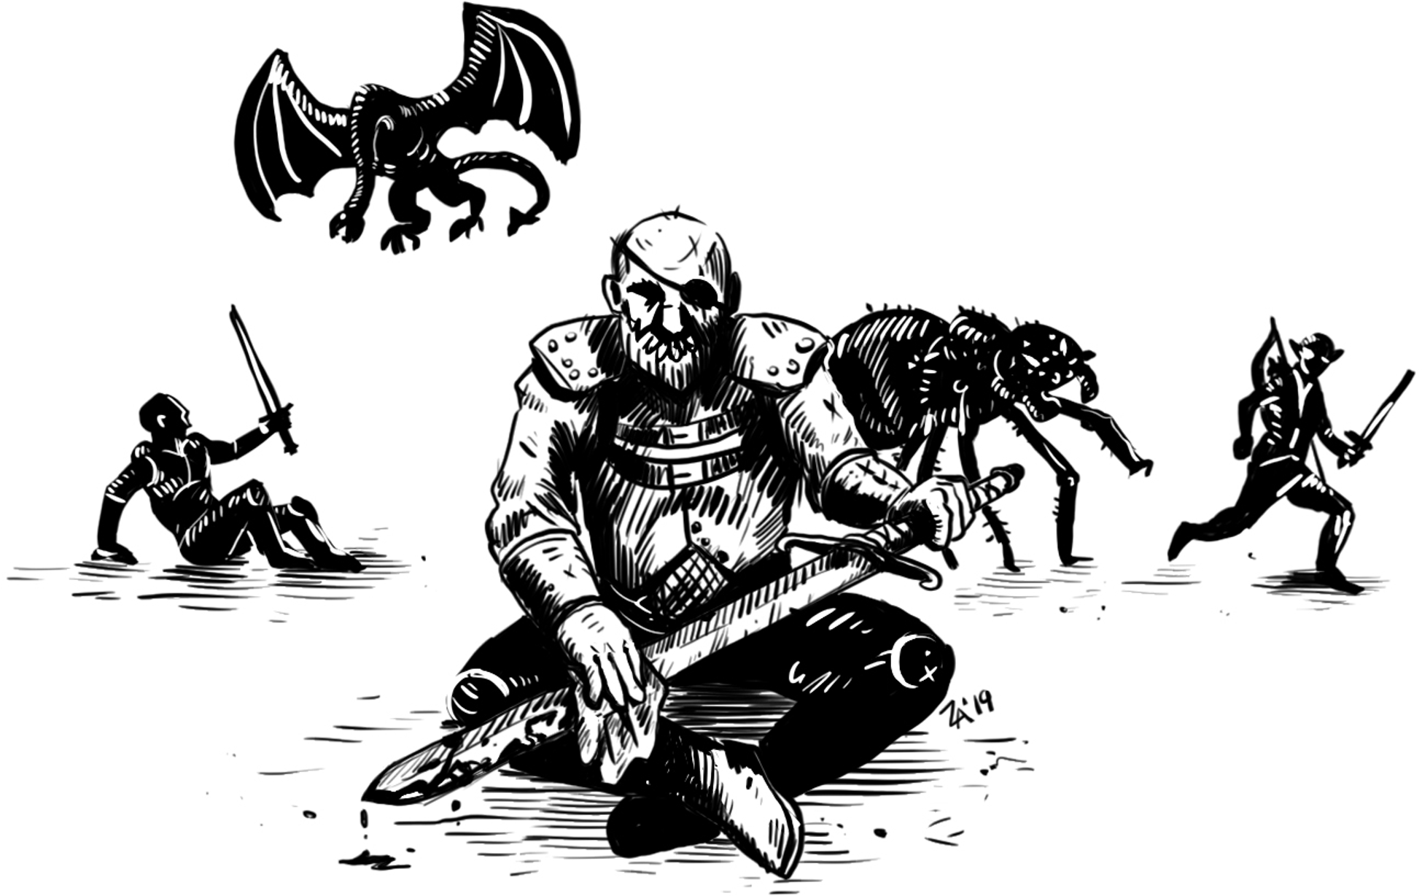

Copyright © 2011-2014, 2017, 2019, 2023-2025 Tom Hoyt
All Rights Reserved. See next page for license information.
www.basicfantasy.org

Basic Fantasy Role-Playing Game Beginner's Essentials
4th Edition, Release 18
Copyright © 2011-2014, 2017, 2019, 2023-2025 Tom Hoyt – All Rights Reserved


All textual materials in this document, as well as all maps, floorplans, diagrams, charts, and forms included herein, are distributed under the terms of the Creative Commons Attribution-ShareAlike 4.0 International License. Most other artwork presented is property of the original artist and is used with permission. Note that you may not publish or otherwise distribute this work as is without permission of the original artists; you must remove all non-licensed artwork before doing so.
The full license text can be viewed at:
https://creativecommons.org/licenses/by-sa/4.0/
Proofing: Barry Gergel, GreatTheAlfred, James Lemon, Matthew Ozor, Pytheas, Matt Sluis, Daniel Collins, and Chris Gonnerman
Artwork: Zaozabob
INTRODUCTION
Beginner's Essentials provides the essential information beginning players need to quickly create and start playing first-level characters in a Basic Fantasy role-playing game. This booklet does not provide all of the information necessary to run a Basic Fantasy adventure or campaign. The Game Master should have a copy of the Basic Fantasy Role-Playing Game Core Rules, which contains the complete rules. The rulebook can be downloaded for free from basicfantasy.org. Once characters reach second level, players will also need to use a copy of the Core Rules. Additionally, Simone Felli's Basic Fantasy RPG Charts and Tables supplement is quite useful and also available for free on the Basic Fantasy website.
CONTENTS
Creating a Character 1
Gear 4
Combat 6
Spells 9
CREATING A CHARACTER
First, you will need a pencil, some game dice, and somewhere to record your character's information. You can write up your character simply using a blank sheet of paper or use a Character Record Sheet created for Basic Fantasy RPG. A number of different character sheets can be downloaded and printed from the Basic Fantasy RPG website. For the first-time player, Chris Gonnerman's Basic Fantasy RPG Standard Character Record Sheet is a good place to start.
Character Creation Steps
- Roll 3d6 for each ability score.
- Write down the bonus / penalty for each score.
- Choose a race & write in its special abilities.
- Choose a class & write in its special abilities.
- Write down the experience points needed to advance to second level.
- For hit points, roll the hit die for your class and add your Constitution bonus / penalty.
- Write down your attack bonus of +1. (All characters have +1 at first level.)
- Write down your saving throw numbers (adjust the figures by your race bonuses / penalties).
- Roll for your starting money (3d6 x 10 gold pieces).
- Purchase equipment for your character (check the weapon and armor restrictions for your class and race).
- Write down your Armor Class, adding your Dexterity bonus / penalty.
- Fill out your character with a name and background.
Character Abilities (3d6)
Ability | Bonuses
Strength (STR) | - Adds to the attack roll when using melee weapons.  - Adds to the Damage roll for melee weapons or thrown weapons (including slings).
Dexterity (DEX) | - Adds to the attack roll when using ranged weapons (bows, crossbows, throwing axes)  - Armor Class (AC)  - Initiative die roll
Constitution (CON) | - Add to each Hit Die  - Save vs. Poison
Intelligence (INT) | - Number of languages the character knows  - Save vs. Illusion  - May be useful for remembering spells & research
Wisdom  (WIS) | - Some saving throws vs. magical attacks
Charisma (CHA) | - Reaction rolls  - Number of retainers a character may hire
Ability Bonus/Penalty
Ability Score | Bonus / Penalty
3 | -3
4-5 | -2
6-8 | -1
9-12 | 0
13-15 | +1
16-17 | +2
18 | +3
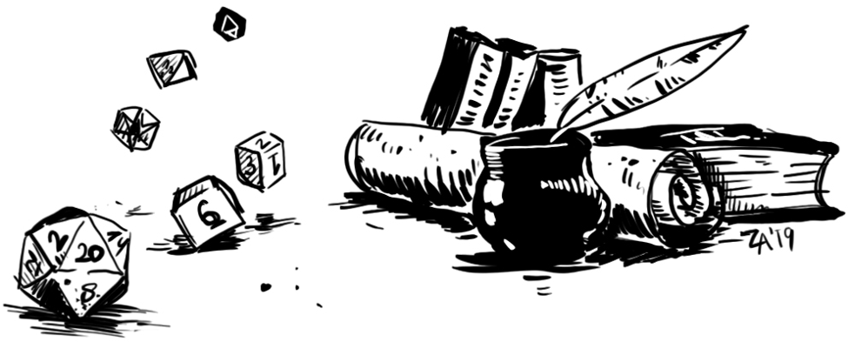
Character Races
Dwarves
Ability Requirements | CON 9 or higher, CHA 17 or lower
Classes | Cleric, Fighter, Thief
Hit Die | Any
Weapons | Large weapons require two hands.  No 2-handed swords, pole-arms, or longbows.
Special | - Darkvision 60'  - Detect new construction, shifting walls, slanting passages, traps w/ 1-2 on d6
Save Bonuses | - +4 vs. Death Ray or Poison  - +4 vs. Magic Wands  - +4 vs. Paralysis or Petrify  - +3 vs. Dragon Breath  - +4 vs. Spells
Languages | - Common, Dwarvish  - +1 / point of INT bonus
Description | Typically about 4' tall, stocky, lifespan of 300-400 years. Thick hair and beards.
Elves
Ability Requirements | INT 9 or higher, CON 17 or lower
Classes | Any single class as well as Fighter/Magic-User and Magic-User/Thief
Hit Die | d6 maximum
Weapons | Large weapons require two hands.
Special | - Darkvision (60' range)  - Detect secret doors (1-2 on 1d6; 1 on 1d6 with a cursory look)  - Immune to the paralyzing attack of ghouls  - Range reduction by one for surprise checks (see Check for Surprise below)
Save Bonuses | - +2 vs. Magic Wands  - +1 vs. Paralysis or Petrify  - +2 vs. Spells
Languages | - Common, Elvish  - +1 / point of INT bonus
Description | Typically about 5' tall, slender, 130 lbs. Lifespan of 1,200 years or more. Pale with dark hair, pointed ears, little or no facial hair.
Halflings
Ability Requirements | DEX 9 or higher, STR 17 or lower
Classes | Cleric, Fighter, Thief
Hit Die | d6 maximum
Weapons | Must use medium weapons in two hands.  Cannot use large weapons.
Special | - +1 attack bonus on ranged weapons  - +2 bonus to AC when attacked in melee by creatures larger than man-sized  - +1 to initiative die rolls  - Hide (10% chance to be detected outdoors, 30% chance to be detected indoors)
Save Bonuses | - +4 vs. Death Ray or Poison  - +4 vs. Magic Wands  - +4 vs. Paralysis or Petrify  - +3 vs. Dragon Breath  - +4 vs. Spells
Languages | - Common, Halfling  - +1 / point of INT bonus
Description | Typically 3' tall, 60 lbs., with curly hair, no facial hair, lifespan of about 100 years.
Humans
Ability Requirements | No ability score requirements
Classes | Any
Hit Die | Any
Weapons | Large weapons require two hands.
Special | +10% to all earned experience
Save Bonuses | None
Languages | - Common  - +1 / point of INT bonus
Description | Average male is typically 6' tall, 175 lbs., and lives about 75 years.
Bonus Languages
The Game Master will have a list of the languages available in their campaign. Players are not required to choose bonus languages when the character is created. They can choose them at some point in the future.
Character Classes
Cleric
Prime Requisite | WIS (Must be 9+)
Hit Dice | D6
Weapons | Blunt weapons only (club, mace, maul, quarterstaff, sling, warhammer)
Armor | Any, shields allowed
XP for 2nd Level | 1,500
Spells | None at first level
Special | Turn the Undead (see below)
Saving Throws at 1st Level | - Death Ray or Poison: 11  - Magic Wands: 12  - Paralysis or Petrify: 14  - Dragon Breath: 16  - Spells: 15
Turn the Undead
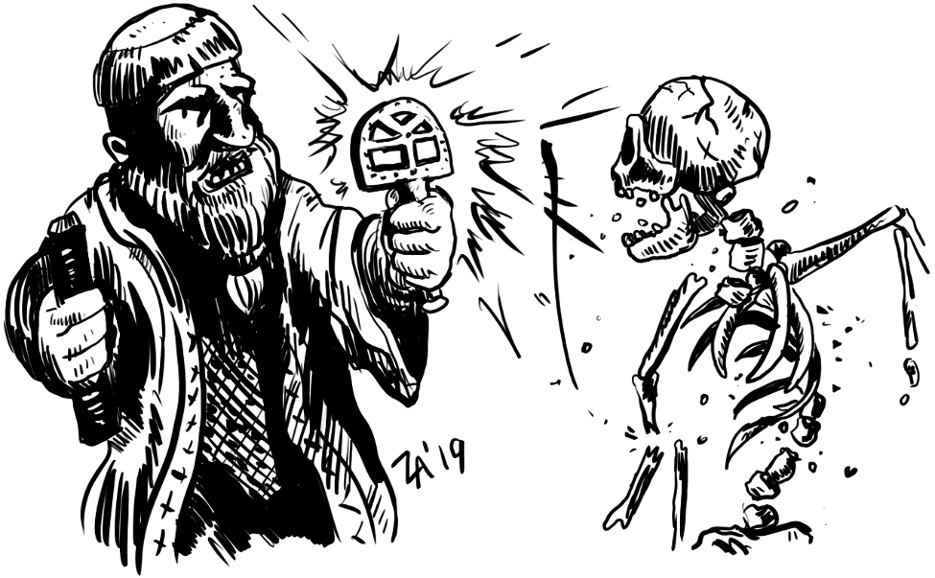
Clerics may be able to Turn the undead or drive away undead monsters by means of faith alone. The Cleric brandishes their holy symbol and calls upon the power of their divine patron. The player rolls 1d20 and tells the GM the result.
Fighter
Prime Requisite | STR (Must be 9+)
Hit Dice | d8
Weapons | Any
Armor | Any, shields allowed
XP for 2nd Level | 2,000
Spells | None
Special | None
Saving Throws at 1st Level | - Death Ray or Poison: 12  - Magic Wands: 13  - Paralysis or Petrify: 14  - Dragon Breath: 15  - Spells: 17
Magic-User
Prime Requisite | INT (Must be 9+)
Hit Dice | d4
Weapons | Cudgel, dagger, walking staff
Armor | None
XP for 2nd Level | 2,500
Spells | 1 first-level spell (see Spells below)
Special | None
Saving Throws at 1st Level | - Death Ray or Poison: 13  - Magic Wands: 14  - Paralysis or Petrify: 13  - Dragon Breath: 16  - Spells: 15
Thief
Prime Requisite | DEX (Must be 9+)
Hit Dice | d4
Weapons | Any
Armor | Leather, no shield
XP for 2nd Level | 1,250
Spells | None
Special | - Sneak attack (see below)  - See the Thief Abilities chart below
Saving Throws at 1st Level | - Death Ray or Poison: 13  - Magic Wands: 14  - Paralysis or Petrify: 13  - Dragon Breath: 16  - Spells: 15
Sneak Attack
- +4 attack bonus and does double damage if it is successful. The attack must be from behind (may require a Move Silently and/or Hide roll).
- Can't be performed on the same opponent more than once in any given combat.
- Can also be performed bare-handed and with the "flat of the blade" (+0 attack bonus and does normal damage). In both cases subduing damage is done.
Thief Abilities at First Level
Open Locks | 25% | Climb Walls | 80%
Remove Traps | 20% | Hide* | 10%
Pick Pockets | 30% | Listen | 30%
Move Silently | 25%
*Halflings should use the special Halfling ability to hide instead, which gives them only a 10% chance of being detected in forested terrain and 30% anywhere else.
GEAR
Monetary values
1 platinum piece (pp) | = | 5 gold pieces (gp)
1 gold piece (gp) | = | 10 silver pieces (sp)
1 electrum piece (ep) | = | 5 silver pieces (sp)
1 silver piece (sp) | = | 10 copper pieces (cp)
For game purposes, assume that one gold piece weighs 1/20th of a pound.
General Equipment
Item | Cost | Weight
Backpack | 4 gp | *
Belt Pouch | 1 gp | *
Bit and bridle | 15 sp | 3
Candles, 12 | 1 gp | *
Chalk, small bag of pieces | 2 gp | *
Cloak | 2 gp | 1
Clothing, common outfit | 4 gp | 1
Glass bottle or vial | 1 gp | *
Grappling Hook | 2 gp | 4
Holy Symbol | 25 gp | *
Holy Water, per vial | 10 gp | *
Ink (per jar) | 8 gp | ½
Iron Spikes, 12 | 1 gp | 1
Ladder, 10 ft. | 1 gp | 20
Lantern | 5 gp | 2
Lantern, Bullseye | 14 gp | 3
Lantern, Hooded | 8 gp | 2
Manacles (without padlock) | 6 gp | 4
Map or scroll case | 1 gp | ½
Mirror, small metal | 7 gp | *
Oil (per flask) | 1 gp | 1
Padlock (with 2 keys) | 12 gp | 1
Paper (per sheet) | 1 gp | **
Pole, 10' wooden | 1 gp | 10
Quill | 1 sp | **
Quill Knife | 1 gp | *
Quiver or Bolt case (specify type) | 1 gp | 1
Rations, Dry, one week | 10 gp | 14
Rope, Hemp (per 50 ft.) | 1 gp | 5
Rope, Silk (per 50 ft.) | 10 gp | 2
Sack, Large | 1 gp | *
Sack, Small | 5 sp | *
Saddle, Pack | 5 gp | 15
Saddle, Riding | 10 gp | 35
Saddlebags, pair | 4 gp | 7
Spellbook (128 pages) | 25 gp | 1
Tent, Large (ten men) | 25 gp | 20
Tent, Small (one man) | 5 gp | 10
Thieves' picks and tools | 25 gp | 1
Tinderbox, flint and steel | 3 gp | 1
Torches, 6 | 1 gp | 1
Whetstone | 1 gp | 1
Whistle | 1 gp | **
Wineskin/Waterskin | 1 gp | 2
Winter blanket | 1 gp | 3
* Ten of these items weigh one pound.
** These items should not be considered for encumbrance unless hundreds are carried.
Note: A Magic-User's first spellbook is provided by their master.
Armor and Shields
Armor Type | Cost | Weight | AC
No Armor | 0 gp | 0 | 11
Leather Armor | 20 gp | 15 | 13
Chain Mail | 60 gp | 40 | 15
Plate Mail | 300 gp | 50 | 17
Shield | 7 gp | 5 | +1
Tack and Harness
Item | Cost | Weight
Bit and bridle | 15 sp | 3
Horseshoes & shoeing | 1 gp | 10
Saddle, Pack | 5 gp | 15
Saddle, Riding | 10 gp | 35
Saddlebags, pair | 4 gp | 7
Beasts of Burden
Animal | Mv | HD | AC | Save as | Attacks | Load (Lt/Hvy) | Cost
Camel | 50’ | 2 | 13 | F2 | 1 bite, 1 hoof, 1, 1d4 | 400/800 | 75 gp
Donkey | 40’ | 2 | 13 | F2 | 1 bite, 1d2 | 70/140 | 40 gp
Horse, Draft | 60' | 3 | 13 | F3 | 2 hooves, 1d4 each | 350/700 | 120 gp
Horse, War | 60' | 3 | 13 | F3 | 2 hooves, 1d6 each | 350/700 | 200 gp
Horse, Riding | 80' | 2 | 13 | F2 | 2 hooves, 1d4 each | 250/500 | 75 gp
Mule | 40’ | 2 | 13 | F2 | 1 kick or 1 bite, 1d4 or 1d2 | 300/600 | 40 gp
Pony* | 40' | 1 | 13 | F1 | 1 bite, 1d4 | 275/550 | 40 gp
Pony, War* | 40' | 1 | 13 | F1 | 1 bite, 1d4 | 275/550 | 80 gp
* Due to their small stature, Dwarves and Halflings generally ride ponies rather than horses.

Load
 | Dwarf, Elf, Human |  | Halfling
Strength | Light Load | Heavy Load | Light Load | Heavy Load
3 | 25 | 60 | 20 | 40
4-5 | 35 | 90 | 30 | 60
6-8 | 50 | 120 | 40 | 80
9-12 | 60 | 150 | 50 | 100
13-15 | 65 | 165 | 55 | 110
16-17 | 70 | 180 | 60 | 120
18 | 80 | 195 | 65 | 130
Movement and Encumbrance
Armor Type | Lightly Loaded | Heavily Loaded
No Armor or Magic Leather | 40' | 30'
Leather Armor or Magic Metal | 30' | 20'
Metal Armor | 20' | 10'
Weapons
Weapon | Cost | Size | Weight | Dmg.
Axes
Hand Axe | 4 gp | S | 5 | 1d6
Battle Axe | 7 gp | M | 7 | 1d8
Great Axe | 14 gp | L | 15 | 1d10
Bows
Shortbow | 25 gp | M | 2
Shortbow Arrow | 1 sp |  | 0.1 | 1d6
Silver* Shortbow Arrow | 2 gp |  | 0.1 | 1d6
Longbow | 60 gp | L | 3
Longbow Arrow | 2 sp |  | 0.1 | 1d8
Silver* Longbow Arrow | 4 gp |  | 0.1 | 1d8
Light Crossbow | 30 gp | M | 7
Light Quarrel | 2 sp |  | 0.1 | 1d6
Silver* Light Quarrel | 5 gp |  | 0.1 | 1d6
Heavy Crossbow | 50 gp | L | 14
Heavy Quarrel | 4 sp |  | 0.1 | 1d8
Silver* Heavy Quarrel | 10 gp |  | 0.1 | 1d8
Daggers
Dagger | 2 gp | S | 1 | 1d4
Silver* Dagger | 25 gp | S | 1 | 1d4
Swords
Shortsword | 6 gp | S | 3 | 1d6
Longsword/Scimitar | 10 gp | M | 4 | 1d8
Two-Handed Sword | 18 gp | L | 10 | 1d10
Hammers and Maces
Warhammer | 4 gp | S | 6 | 1d6
Mace | 6 gp | M | 10 | 1d8
Maul | 10 gp | L | 16 | 1d10

Weapon | Cost | Size | Weight | Dmg.
Other Weapons
Club/Cudgel/Walking Staff | 2 sp | M | 1 | 1d4
Quarterstaff | 2 gp | L | 4 | 1d6
Pole Arm | 9 gp | L | 15 | 1d10
Sling | 1 gp | S | 0.1
Bullet | 1 sp |  | 0.1 | 1d4
Stone | n/a |  | 0.1 | 1d3
Spear | 5 gp | M | 5
Thrown (one handed) |  |  |  | 1d6
Melee (one handed) |  |  |  | 1d6
Melee (two handed) |  |  |  | 1d8
* Silver tip or blade, for use against lycanthropes.
Missile Weapon Ranges
Weapon | Short (+1) | Medium (0) | Long (-2)
Longbow | 70 | 140 | 210
Shortbow | 50 | 100 | 150
Heavy Crossbow | 80 | 160 | 240
Light Crossbow | 60 | 120 | 180
Dagger | 10 | 20 | 30
Warhammer | 10 | 20 | 30
Hand Axe | 10 | 20 | 30
Oil or Holy Water | 10 | 30 | 50
Sling | 30 | 60 | 90
Spear | 10 | 20 | 30
* These ranges are in feet (indoors) or yards (outdoors).
Wilderness Movement Rates
Movement rates in the wilderness are related directly to encounter movement rates. See the table below:
Encounter Movement  (Feet per Round) | Wilderness Movement  (Miles per Day)
10' | 6
20' | 12
30' | 18
40' | 24
50' | 30
60' | 36
70' | 42
80' | 48
Naturally, any group traveling together moves at the rate of the slowest member.
The terrain type will alter the rate somewhat, as shown on this table:
Terrain | Adjustment
Jungle, Mountains, Swamp | x1/3
Desert, Forest, Hills | x2/3
Clear, Plains, Trail | x1
Road (Paved) | x1 1/3
These rates are for 8 hours of travel. Characters may choose to perform a forced march, traveling 12 hours per day. If this is done, add an additional 50% to the distance traveled. Each day of forced march performed after the first inflicts 1d6 points of damage on the characters (and their animals, if any). A save vs. Death Ray with Constitution bonus applied is allowed to avoid this damage, but after this save is failed once, it is not rolled again for that character or creature. A day spent resting “restarts” the progression.
Day to Day Survival
Normal characters must consume one day's worth of rations (or equivalent food) and a minimum of one quart of water per day. Failure to consume enough food does not significantly affect a character for the first two days, but after that they lose 1 hit point per day. Furthermore, at that point the character loses the ability to heal wounds normally, though magic will still work. Eating enough food for a day (over the course of about a day, not all at once) restores the ability to heal, and the character will recover lost hit points at the normal rate.
Inadequate water affects characters more swiftly; after a single day without water, the character loses 1d4 hit points, and will lose an additional 1d4 hit points per day thereafter. Healing ability is lost when the first die of damage is rolled.
Normal characters require 6 hours sleep out of every 24. Subtract from this the character's Constitution bonus; so a character with 18 Constitution needs only 3 hours sleep per night (and a character with 3 Constitution needs 9 hours). These figures are minimums; most characters would prefer to sleep two or more hours longer.
Characters who get less than the required amount of sleep suffer a -1 penalty on all attack rolls and saving throws (as well as not healing any hit points). For each additional night where sufficient sleep is not received, the penalty becomes one point worse. Regardless of how long the character has gone without adequate sleep, the normal amount of sleep will remove these penalties.
COMBAT
When the party encounters potential enemies, the time scale shifts from 10-minute-long turns to 10-second-long combat rounds. The phases of combat are:
- Check for surprise (GM option)
- Check monster reaction (GM option)
- Combat cycle
Check for Surprise (GM option)
If applicable, roll 1d6. Characters are usually surprised on a 1-2, or in the case of a well-prepared ambush on a 1-4. Deafened characters are surprised on a 1-3 and blinded characters on a 1-4. Elves are surprised on a 1 normally, 1-2 if deafened, and 1-3 when blinded or in ambushes. Characters who are surprised cannot act in the first combat round, though they can defend themselves and so have normal AC.
(At this point, the GM may also roll for the monster's reaction to the party. See the Basic Fantasy RPG Core Rules for details.)
Combat Cycle
1. Roll Initiative. Roll 1d6 and add any bonuses or penalties, including DEX bonus, -1 if deafened, and -2 if blinded.
2. Act in initiative order. Characters who have the same initiative number act simultaneously. A character can delay their action until another character acts, acting simultaneously with them.
On their turn, individuals may move and then attack (in that order), just move, or just attack. An attack ends the character's turn. In combat, casting a spell usually takes the same time as making an attack. If a spellcaster is attacked on the Initiative number on which they are casting a spell, the spell is spoiled and lost.
Continue this cycle until the combat is resolved.
A character using a weapon with a long reach (spears, for instance) may choose to attack a closing opponent on the closing opponent's number and thus attack simultaneously with the opponent, even if the attacker rolled lower for Initiative.
Combat Movement
(Also see the sections on Running, Charging, and Set Weapons Against Charge below.)
Opponents more than 5' apart may move freely, but once two opposing figures are within 5' of each other, they are “engaged” and must abide by the rules under Defensive Movement, below. In some circumstances two opponents who are within 5' of each other may not realize it, such as when one character successfully sneaks up behind the other. In such a case, the characters are not engaged.
If one side wishes to evade the other, play the evasion and pursuit out as combat actions. Mapping, of course, is impossible while fleeing or pursuing. Any time a character must pass through a doorway, make a hard turn, etc., the GM may require a saving throw vs. Death Ray (with Dexterity bonus added); if the save is failed, the character has fallen at that point and moves no further that round; they may stand up and make a full move on their Initiative number in the next round.
If at any point the pursuers are within 5' (melee range) at the start of a round, they may begin melee combat; the fleeing characters will be subject to “parting shots” if they continue to flee after the pursuers close to melee range.
If the fleeing characters or creatures are ever able to get beyond the pursuer's sight for a full round, they have evaded pursuit… the pursuers have lost them.
Any time a character turns their back on an adjacent opponent (who has a ready weapon) and begins movement, that opponent is allowed a “parting shot” with a +2 bonus to attack, even if that opponent has already made all attacks for the round. Opponents with attack routines must choose one attack mode; for instance, a tiger with a claw/claw/bite routine could only claw once or bite once.
Alternately, the character may begin backing away (at up to half normal walking movement) while continuing to fight (if the opponent remains within reach, that is, follows the retreating character). This is termed a fighting withdrawal. The character must still move first, however.
Running
A running character is not normally allowed to attack (but see Charging below). Running characters can move at double their normal encounter movement rate for a maximum number of rounds equal to 2 times the character's Constitution, after which they are exhausted and may only walk (at the normal encounter rate). For monsters without a given Constitution, allow the monster to run for 24 rounds. Exhausted characters or creatures must rest for at least a turn before running again.
Charging
Under some circumstances, characters or creatures may be allowed to attack after a running move. This is called a charge, and some specific limitations apply. First, the charging character or creature must move at least 10 feet, and may move up to double their normal movement rate, as given above. The movement must be in a more or less straight line toward the intended target, and the path to the target must be reasonably clear. Finally, the attacker must be using a weapon such as a spear, lance, or pole arm which is suitable for use while charging. Certain monsters, especially including those with horns, are able to use natural attacks when charging. If the attacker does not have line of sight to the opponent at the start of the charge, that opponent can’t be charged.
The attack made after the charge is made at +2 on the attack roll. The charging character or creature takes a -2 penalty to Armor Class for the remainder of the round. If the attack hits, it does double damage.
Set Weapon Against Charge: Spears, pole arms, and certain other piercing weapons deal double damage when “set” (braced against the ground or floor) and used against a charging creature. For this to be done, the character or creature being charged must have equal or better Initiative; this counts as holding an action: both attacker and defender act on the attacker's Initiative number and are therefore simultaneous.
Typical Actions
Standard  attack | Move (encounter movement distance) + melee or ranged attack
Run | Move (2 x encounter movement distance)
Charge* | Move (2 x encounter movement distance) + attack (+2 bonus)
Parting shot | Free attack (+2 bonus) vs. opponents turning from the fight
Fighting withdrawal | Move back (half normal walking movement) + melee attack
* -2 penalty to Armor Class for the round
Attack and Defense
The attacker rolls a d20 “to hit” and adds any modifiers, including the +1 Attack Bonus. If the score is equal to or greater than the target's armor class (AC) the attack hits and the attacker rolls damage. A natural “1” on the die roll is always a failure. A natural “20” is always a hit, if the opponent can be hit at all (e.g., monsters that can only be hit by silver or magic weapons cannot be hit by normal weapons, so a natural “20” with a normal weapon will miss).
Attack Bonus / Penalty
Attacking From Behind | +2 (do not combine with the Sneak Attack ability)
Flat of the blade attack | -4 (do half subduing damage)
Punch | +0 (1d3 points subduing damage)
Kick | -2 (1d4 points subduing damage)
Attacker/Defender is invisible | +4 / -4
Attacker/Defender is blinded | -4 / +4
Defender is pinned | +4
Missile Fire
Target distance | Attack bonus / penalty
5' or less | -5*
Up to short range | +1
Up to medium range | +0
Up to long range | -2
Beyond long range | Cannot be attacked
* If the attacker is behind the target creature and undetected, or that creature is distracted apply +1 bonus (+3 total bonus if attacking from behind)
Cover and Concealment Penalty
Target is | Covered | Concealed
25% | -2 | -1
50% | -4 | -2
75% | -6 | -3
90% | -8 | -4

Grenade-Like Missiles Miss Table
(behind) |  |  | Roll 1d10, and consult the diagram to determine where the missile hit. Each number represents a 10' square area.
 | 0
7 | 8 | 9
5 | Target | 6
2 | 3 | 4
 | 1
(in front)
Oil Grenade-Like Missiles
- Direct hit: 1d8 points of fire damage, plus in the next round an additional 1d8 points of damage, unless the character spends the round extinguishing the flames.
- Splash Hit: 1d6 points of fire damage within 5 feet of the point of impact. A save vs. Death Ray is allowed to avoid this damage.
- A burning puddle of oil is effective for 10 rounds. Those attempting to cross the burning oil will receive 1d6 points of fire damage each round they are in it.
Holy Water vs. Undead
- Can be thrown at corporeal undead; must be poured out onto incorporeal undead.
- Direct hit: 1d8 points of damage.
- Splash Hit: 1d6 points of damage within 5 feet of the point of impact.
- Effective for 1 round
Missiles That Miss
With the exception of grenade-like missiles, missile weapons which miss the intended target are normally considered lost. However, if the weapon is fired into a melee where allies of the shooter are involved, and the attack misses, it may hit one of the allied creatures. The GM should decide which allies may be hit, and roll attacks against each until a hit is made or all possible targets are exhausted. These attack rolls are made with the shooter's normal attack bonus, just as if they intended to attack the allied creature. However, the GM must make these rolls, not the player.
Damage
If an attack hits, the attacker rolls damage as given for the weapon. Melee attacks apply the Strength bonus or penalty to the damage dice, as do thrown missile weapons such as daggers or spears. Usually, attacks with bows or crossbows do not gain the Strength bonus, but sling bullets or stones do.
Also, magic weapons will add their bonuses to damage (and cursed weapons will apply their penalty). Note that, regardless of any penalties to damage, any successful hit will do at least one point of damage. As explained elsewhere, a creature or character reduced to 0 hit points is dead.
Subduing Damage
Attacks made with the “flat of the blade” for non-lethal damage are made at a -4 attack penalty and do half damage. Most weapons can be used this way; only those with penetration or slashing features on all sides cannot.
Wounds & Healing, Death & Dying
Anyone reduced to zero hit points is (probably) dead. At the GM's discretion, it is possible that a high-level Cleric could raise the character from the dead, if the character's friends are willing to haul the body to one, and if the Cleric is willing. Often a hefty fee or some form of service will be required.
If a character who has taken at least some subduing damage is reduced to zero hit points, the character becomes unconscious rather than dying. (Any further subduing damage is then considered killing damage, allowing the possibility that someone might be beaten to death.) A character knocked out in this way, but not subsequently killed, will wake up with 1 hit point in 1d4 turns, or can be awakened (with 1 hit point) by someone else after 2d10 rounds.
Wounded characters recover 1 hit point of damage every day, provided that normal sleep (6 hours per day, plus / minus Constitution bonus) is possible. Characters who choose full bed rest regain an additional hit point each evening.
Brawling
Sometimes a character will attack without a weapon, striking with a fist or foot. This is called brawling. Normal characters do 1d3 points of subduing damage with a punch, 1d4 with a kick; kicks are rolled at a -2 attack penalty. A character in no armor or leather armor cannot successfully punch or kick a character in metal armor, and in fact, if this is attempted the damage is applied to the attacker instead of the defender. The GM must decide which monsters can be successfully attacked this way. All character classes may engage in brawling; there is no “weapon” restriction in this case.
SPELLS
Clerics
Clerics have no spells at first level.
Magic-Users
Magic-Users cast spells through the exercise of knowledge and will. They prepare spells by study of their spellbooks; each Magic-User has their own spellbook, containing the magical formulae for each spell the Magic-User has learned, written in a magical script that can only be read by the Magic-User who wrote it, or through the use of a special first-level spell: read magic. All Magic-Users begin play with read magic as their first spell, and it is so ingrained that a Magic-User can prepare it without a spellbook. Read magic has a range of “touch” and is permanent with respect to any given magical work (spellbook or scroll).
Magic-Users may learn spells by being taught directly by another Magic-User, or by studying another Magic-User's spellbook. If being taught, a spell can be learned in a single day; researching another Magic-User's spellbook takes one day per spell level. Either way, the spell learned must be transcribed into the Magic-User's own spellbook, at a cost of 500 gp per spell level transcribed. A beginning Magic-User starts with a spellbook containing read magic and at least one other first-level spell, as determined by the GM, at no cost.
Each day, usually in the morning, Magic-Users must study their spellbooks to prepare spells to replace those they have used. Spells prepared but not used persist from day to day; only those actually cast must be replaced. A spellcaster may always choose to dismiss a prepared spell (without casting it) in order to prepare a different spell of that level.
Spellcasters must have at least one hand free, and be able to speak, in order to cast spells; thus, binding and gagging a spellcaster is an effective means of preventing them from casting spells. In combat, casting a spell usually takes the same time as making an attack. If a spell caster is attacked (even if not hit) or must make a saving throw (whether successful or not) on the Initiative number on which they are casting a spell, the spell is spoiled and lost. As a specific exception, two spell casters releasing their spells at each other on the same Initiative number will both succeed in their casting; one caster may disrupt another with a spell only if they have a better Initiative, and chooses to delay casting the spell until right before the other caster.
Some spells are reversible; such spells are shown with an asterisk (*) after the name.
First Level Magic-User Spells
1 | Charm Person
2 | Detect Magic
3 | Floating Disc
4 | Hold Portal
5 | Light*
6 | Magic Missile
7 | Magic Mouth
8 | Protection from Evil*
9 | Read Languages
10 | Shield
11 | Sleep
12 | Ventriloquism
Spell Descriptions
Charm Person Range: 30'
Magic-User 1 Duration: special
This spell causes a humanoid (including all character races as well as creatures such as orcs, goblins, gnolls, and so on) of 4 hit dice or less to perceive the caster as a close friend, love interest, or at the very least as its trusted ally. Normal characters (PC or NPC) may be affected regardless of level of ability.
A save vs. Spells will negate the effect. If hostilities have already commenced or the target otherwise feels threatened by the caster, they receive a bonus of +5 on their saving throw.
The caster does not directly control the target; rather, orders must be given verbally, in writing, or by means of gestures. Obviously, verbal orders will only work if the target and caster share a spoken language, and the same limitation applies to written orders. Also note that the exact perception of the caster by the affected individual is not under the control of the caster; the GM should decide how the subject of this spell perceives their relationship to the caster.
Commands that go against the target's basic nature or ask them to attack their own allies or friends grant them a fresh saving throw with a bonus of +5 on the roll. Even if the target fails this save they may still choose to do something else when commanded to perform an unwanted action. Of course, if the caster is attacked, the charmed creature will act to protect their "friend" (though that could mean attacking their own allies, which might cause the target to instead attempt to carry off the caster to a "safe" place).
The target receives a new saving throw each day if they have an Intelligence of 13 or greater, every week if their Intelligence is 9-12, or every month if its Intelligence is 8 or less; the GM must rule on the equivalent intelligence of humanoid monsters.
Detect Magic Range: 60'
Cleric 1, Magic-User 1 Duration: 2 turns
The caster of this spell is able to detect enchanted or enspelled objects or creatures within the given range by sight, seeing them surrounded by a pale glowing light. Only the caster sees the glow. Invisible creatures or objects are not detected by this spell, but the emanations of the invisibility magic will be seen as an amorphous glowing fog, possibly allowing the caster (only) to attack the invisible creature at an attack penalty of only -2.
Floating Disc Range: 0
Magic-User 1 Duration: 5 turns +1/level
The casting of this spell causes an invisible platform of magical force to appear. It is about the size of a shield, about 3 feet in diameter and an inch deep at its center. It can support a maximum of 500 pounds of weight. (Note that water weighs about 8 pounds per gallon.)
The disc floats level to the ground, at about the height of the caster's waist. It remains still when within 10' of the caster, and follows at the caster's movement rate if they move away from it. The floating disc can be pushed as needed to position it but will be dispelled if somehow moved more than 10 feet from the caster. When the spell duration expires, the disc disappears from existence and drops whatever was supported to the surface beneath.
The disc must be loaded so that the items placed upon it are properly supported, or they will (of course) fall off. For example, the disc can support just over 62 gallons of water, but the water must be in a barrel or other reasonable container that can be placed upon the disc. Similarly, a pile of loose coins will tend to slip and slide about, and some will fall off with every step the caster takes; but a large sack full of coins, properly tied, will remain stable.
Hold Portal Range: 100'+10'/level
Magic-User 1 Duration: 1 round/level
This spell secures a portal such as a door, gate, window, or shutter made of normal non-magical building materials; the portal behaves as if securely locked for the duration of the spell. The door may be opened early only by means of knock or a successful casting of dispel magic, or by literally destroying the door (which may well require more time than the duration of this spell allows).
Light* Range: 120'
Cleric 1, Magic-User 1 Duration: 6 turns + 1/level
This spell creates a light equal to torchlight which illuminates a 30' radius area well (with dim light extending for an additional 20') around the target location or object. This effect is stationary when cast in an area, but it can be cast on a movable object or even onto a character or creature.
Reversed, light becomes darkness, creating an area of darkness just as described above. This darkness blocks out Darkvision and negates mundane light sources. Wherever both spells overlap they cancel out, leaving only normal illumination in the overlapping area.
A light spell may be cast to dispel the darkness spell of an equal or lower level caster (and vice versa), leaving neither spell active; likewise, a darkness spell can cancel the light spell of an equal or lower level caster.
Either version of this spell may be used to blind an opponent by means of casting it on the target's ocular organs. The target is allowed a saving throw vs. Death Ray to avoid the effect, and if the save is made the spell does not take effect at all. A light or darkness spell cast to blind does not have the given area of effect (that is, no light or darkness is shed around the victim).
Magic Missile Range: 100'+10'/level
Magic-User 1 Duration: instantaneous
This spell causes a magical arrow of energy to fly from the caster's finger and unerringly hit its target, inflicting 1d6+1 points of damage. The target must be at least partially visible to the caster, and no saving throw is normally allowed. It's not possible to target a specific part of the target. Inanimate objects are not affected by this spell.
For every three caster levels beyond 1st, an additional missile is fired: two at 4th level, three at 7th, four at 10th, and the maximum of five missiles at 13th level or higher. When multiple missiles are fired in this way, the caster can target one or several creatures as desired, as long as all are visible to the caster at the same time. All such targets must be designated before any damage is rolled.
Magic Mouth Range: 30'
Magic-User 1 Duration: special
This spell places a simple form of programmed illusion on a non-living object within range. When triggered, the spell causes the illusion of a mouth to appear on the object and a message to be said aloud. The enchantment can remain in place indefinitely, but is expended when triggered (i.e. the message is normally delivered only once).
The message recounted may be up to three words per caster level in length. The caster may insert pauses in the message, but the entire message must be delivered in a time period of no more than a turn. The voice of the spell can be made to speak at any volume attainable by a normal Human. It will sound enough like the caster's own voice to be recognized by a close associate of the caster, but not identical.
The illusionary mouth moves as if actually speaking the message being delivered, and remains visible during pauses. If placed on an artistic depiction of a creature with a mouth (such as a painting or statue), the spell can be made to appear to animate the mouth of the object.
This spell cannot be used to activate magic items which have command words, nor to activate any other magical effects.
The caster must choose the conditions under which this spell is triggered. The conditions may be as complicated or simple as desired, but must depend only on sight and hearing; the spell has no other sensory capabilities. The spell also has no particular intelligence, and can be fooled by disguises or illusions. The spell does have the capability to effectively see in normal darkness, but not in any sort of magical darkness, and it cannot detect invisible creatures nor see through doors, walls, or even opaque curtains. Likewise, stealth or magical silence are effective in preventing audible triggers. Finally, the spell cannot detect a character's class, level, ability scores, or any other item not obvious to a normal NPC.
Triggers have an effective sensory range of 10 feet per caster level; sounds, sights, or actions outside that range will never trigger the spell.
Protection from Evil*
Cleric 1, Magic-User 1 Range: touch
Duration: 1 turn/level
This spell protects the caster or a creature touched by the caster (the "subject") from evil; specifically, the spell wards against summoned creatures, creatures with significantly evil intentions, and extraplanar creatures of evil nature. A magical barrier with a radius of just 1 foot is created around the subject. The barrier moves with the subject, and provides three specific forms of magical protection against attacks or other effects attempted by the affected creatures against the subject.
First, the subject receives a bonus of +2 to their Armor Class, and a similar bonus of +2 on all saving throws.
Second, the barrier blocks all attempts to charm or otherwise control the subject, or to possess the subject (such as with magic jar). Such attempts simply fail during the duration of this spell. Note however that a creature who receives this protection after being possessed is not cured of the possession.
Third, any and all summoned creatures and extraplanar creatures of evil nature are unable to physically touch the subject. Attacks by such creatures using their natural weapons simply fail. This effect is canceled if the subject performs any form of physical attack (even with a ranged weapon) on any affected creature, but the other features of the spell continue in force.
Reversed, this spell becomes protection from good. It functions in all ways as described above, save that "good" creatures are kept away, rather than "evil" creatures.
Read Languages Range: 0
Magic-User 1 Duration: special
This spell grants the caster the ability to read almost any written language. It may be cast in one of three modes:
In the first mode, the spell allows the caster to read any number of written works in a variety of languages. This mode lasts for 1 turn per caster level.
In the second mode, the spell allows the caster to read any one book or tome; this mode lasts 3 hours per caster level.
In the third mode, the spell allows the caster to read any one non-magical scroll or other single-sheet document; this mode is permanent.
This spell does not work on any sort of magical text, such as spell scrolls or spellbooks; see read magic, below, for the correct spell to use in such cases.
The spell grants the ability to read the texts, but does not in any way hasten the reading nor grant understanding of concepts the caster doesn't otherwise have the ability to understand. Also, for this spell to function, there must be at least one living creature that can read the given language somewhere on the same plane. The knowledge is not copied from that creature's mind; rather, it is the existence of the knowledge that enables the spell to function.
Read Magic Range: 0
Magic-User 1 Duration: permanent
When cast upon any magical text, such as a spellbook or magic-user spell scroll, this spell enables the caster to read that text. Casting this spell on a cursed text will generally trigger the curse. All Magic-Users begin play knowing this spell, and it can be prepared even if the Magic-User loses access to their spellbook.
Shield Range: self
Magic-User 1 Duration: 5 rounds+1/level
This spell creates an invisible shield made of magical force which floats in front of the caster, protecting them from various attacks. The spell totally blocks magic missile attacks directed at the caster, and improves the caster's Armor Class by +3 vs. melee attacks and +6 vs. missile weapons. The Armor Class benefits do not apply to attacks originating from behind the caster, but magic missile are warded off from all directions.
Sleep Range: 90'
Magic-User 1 Duration: 5 rounds/level
This spell puts several creatures of 3 or fewer hit dice, or a single 4 hit die creature, into a magical slumber. Creatures of 5 or more hit dice are not affected. The caster chooses a point of origin for the spell (within the given range, of course), and those creatures within 30' of the chosen point may be affected. Each creature in the area of effect is allowed a save vs. Spells to resist.
Victims of this spell can always be hit if attacked. Injuring such a creature will cause it to awaken, and it may begin fighting back or defending itself on the very next round. Slapping or shaking such a creature will awaken it in 1d4 rounds, but normal noises will not.
Sleep does not affect unconscious creatures, constructs, or undead creatures.
When the duration elapses, the sleeping creatures normally wake up immediately; however, if they are made very comfortable and the surroundings are quiet, the affected creatures may continue sleeping normally at the GM's option.
Ventriloquism Range: 60'
Magic-User 1 Duration: 1 turn/level
This spell causes the caster's voice to appear to come from another location within range, for example, from a dark alcove or statue. The caster may choose a new location each round if desired, and can cause the spell to temporarily abate without ending it and then resume it again at any time within the given duration.

