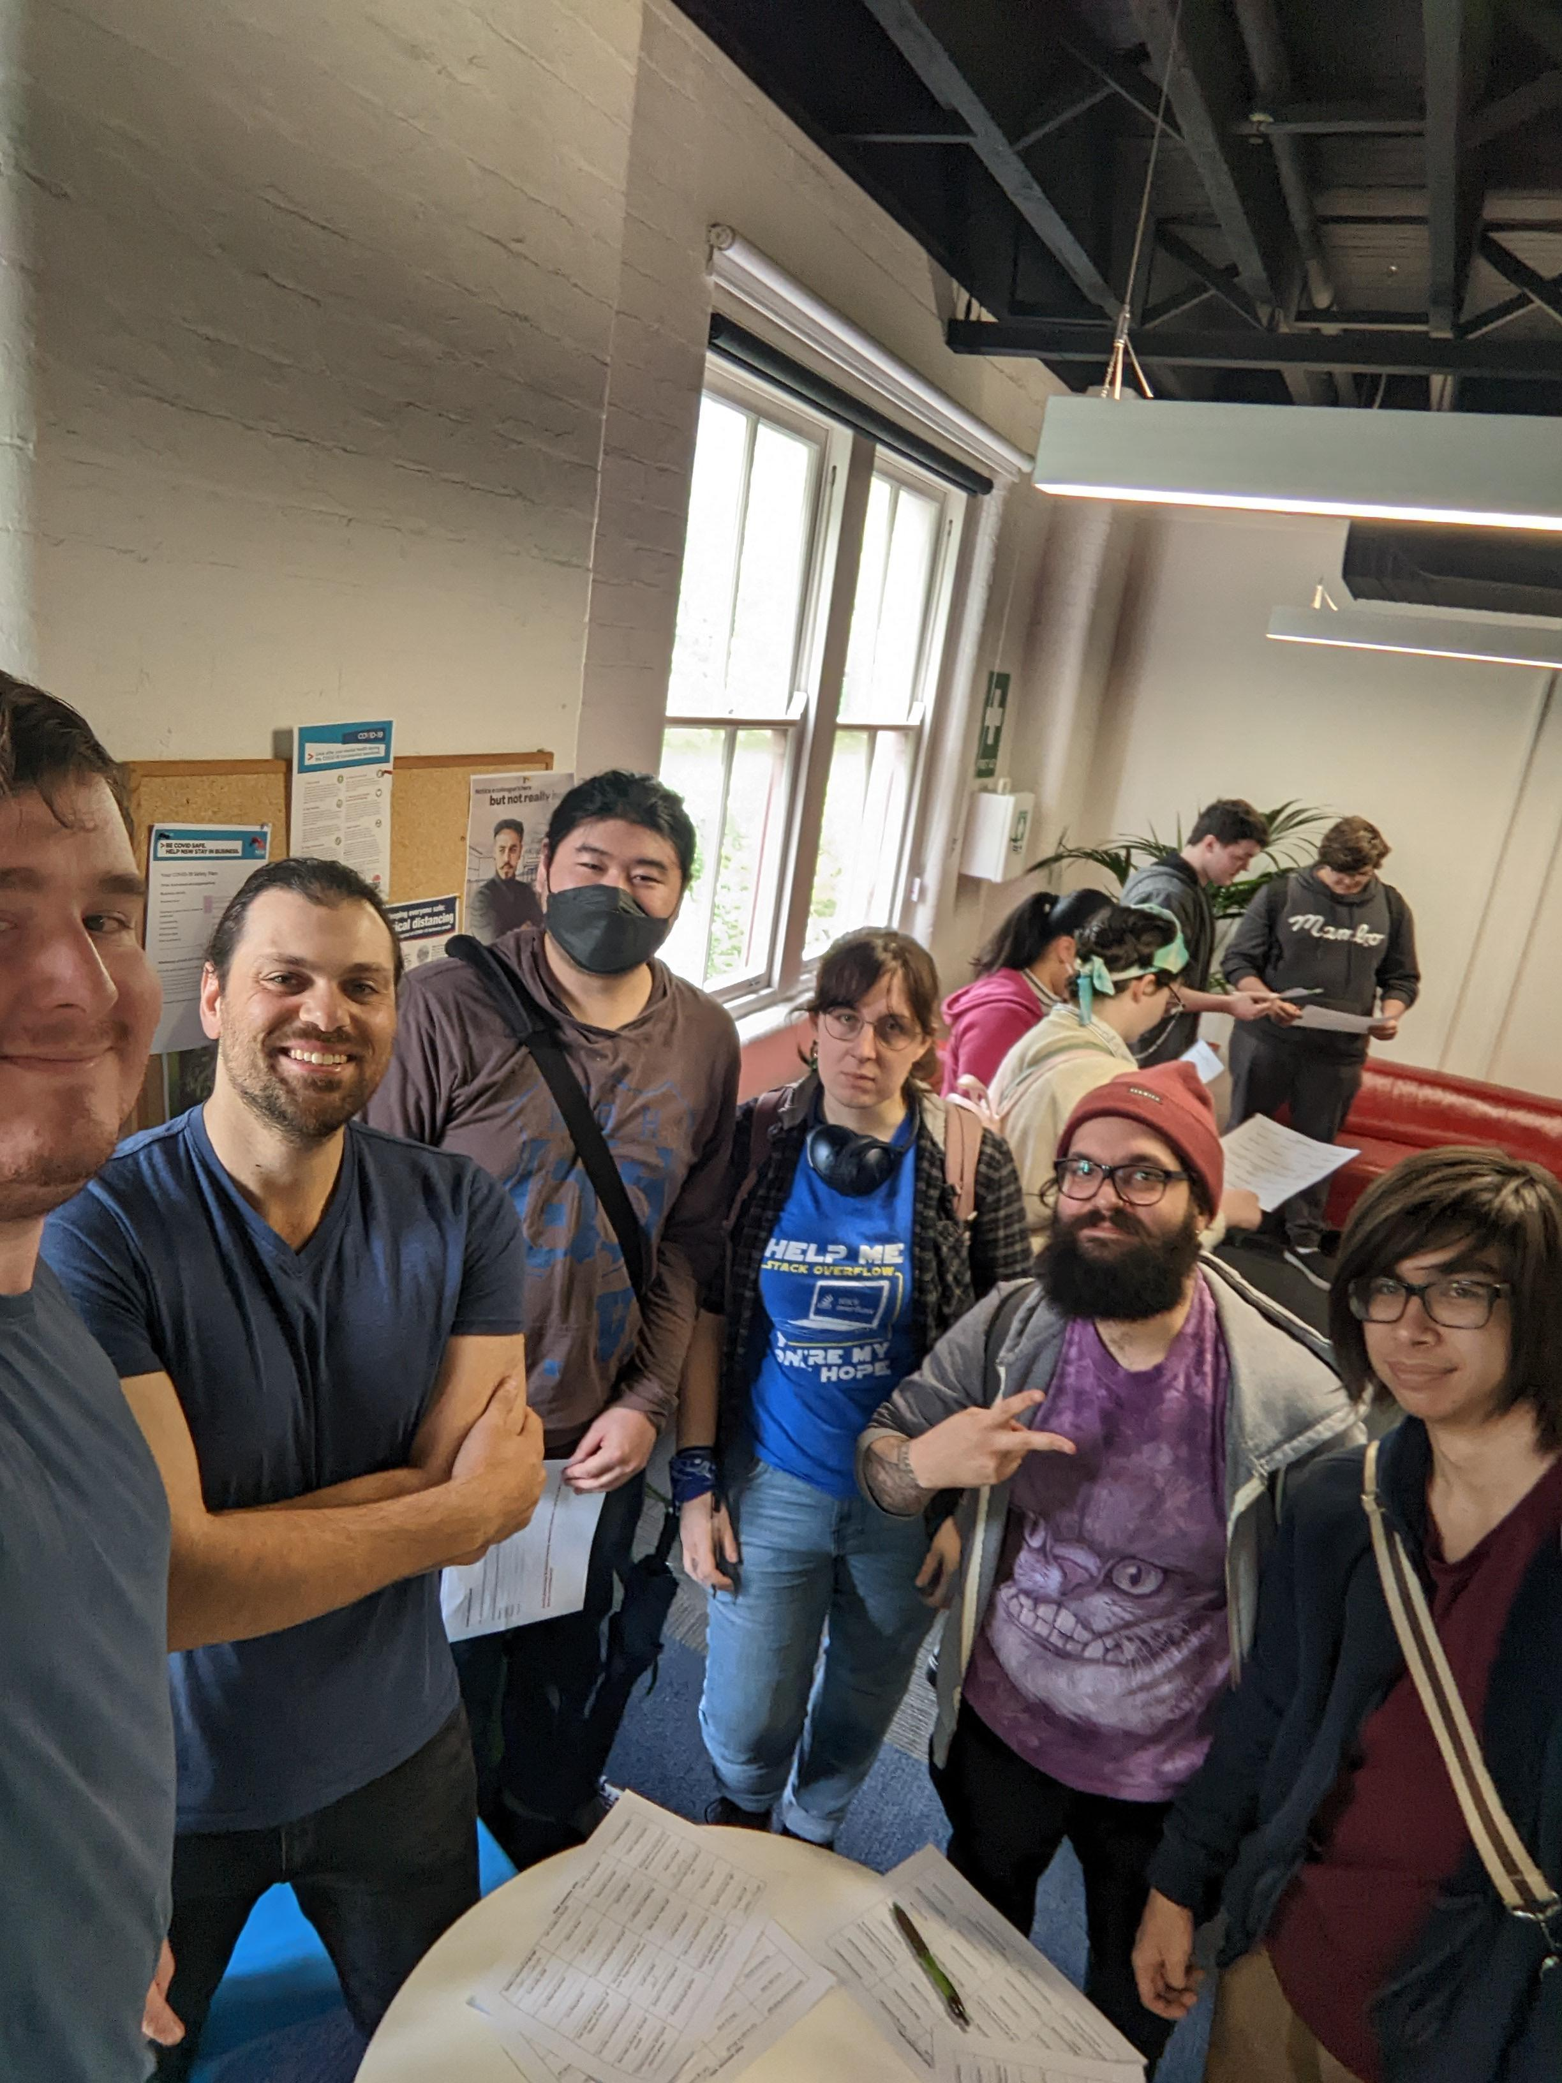Matthew Carver

Professional Network

