Retail Report

Date range: 2000/01 to 2025/06

Report generated on: 09/06/2025

# Table of Contents

Table of Contents 2

1. Comparative Z-Score Matrix 3

2. Earnings vs Dividend Plots 4

2.1 Z-score P/E vs D/Y 4

2.2 Abs P/E vs Abs D/Y 5

# 1. Comparative Z-Score Matrix

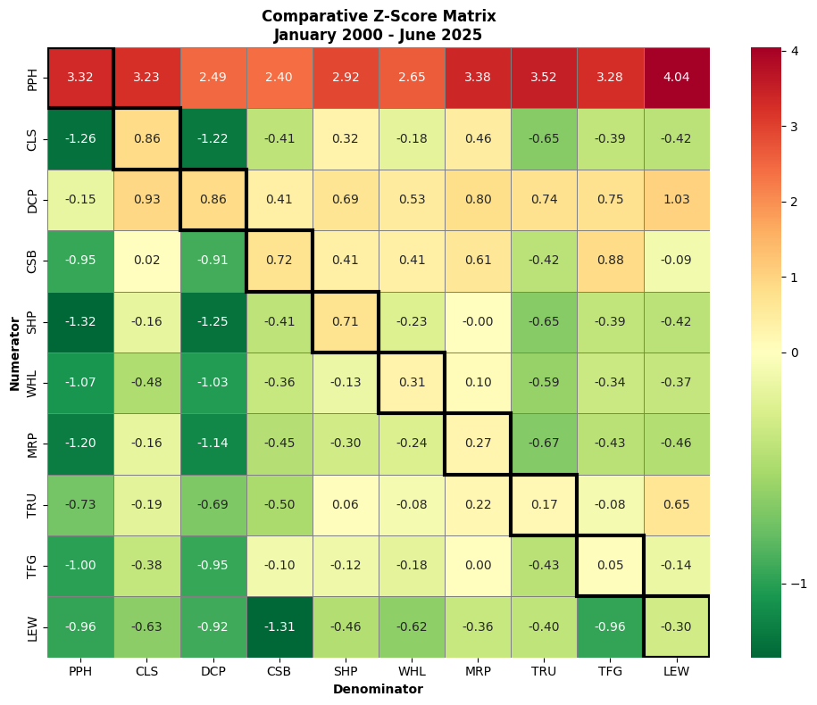

Date range: 2000/01 to 2025/06

# 2. Earnings vs Dividend Plots

## 2.1 Z-score P/E vs D/Y

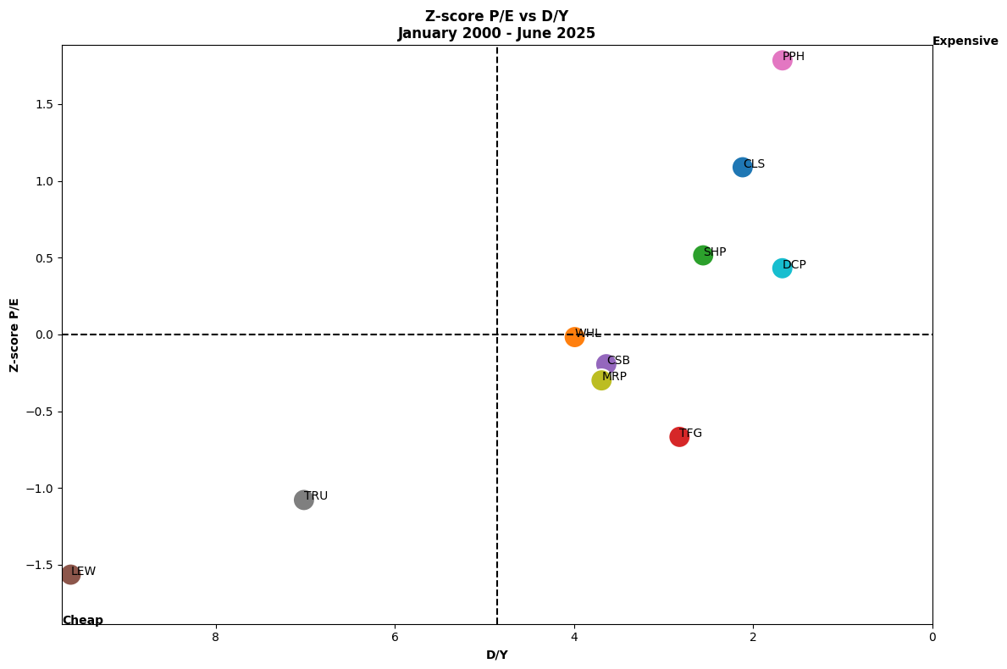

## 2.2 Abs P/E vs Abs D/Y

