1.

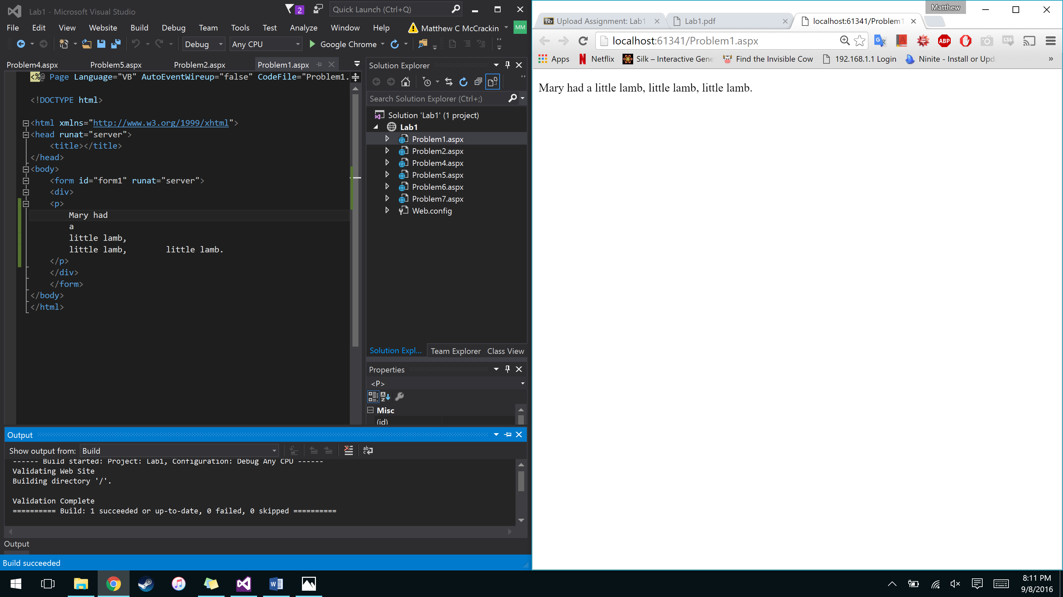

The webpage looks different from the code because HTML only reads one blank space. All other blank spaces between characters are ignored. The code on different lines does not appear to be on different lines on the webpage because the <br /> tag must be used to create a new line in HTML while in a paragraph.

2.

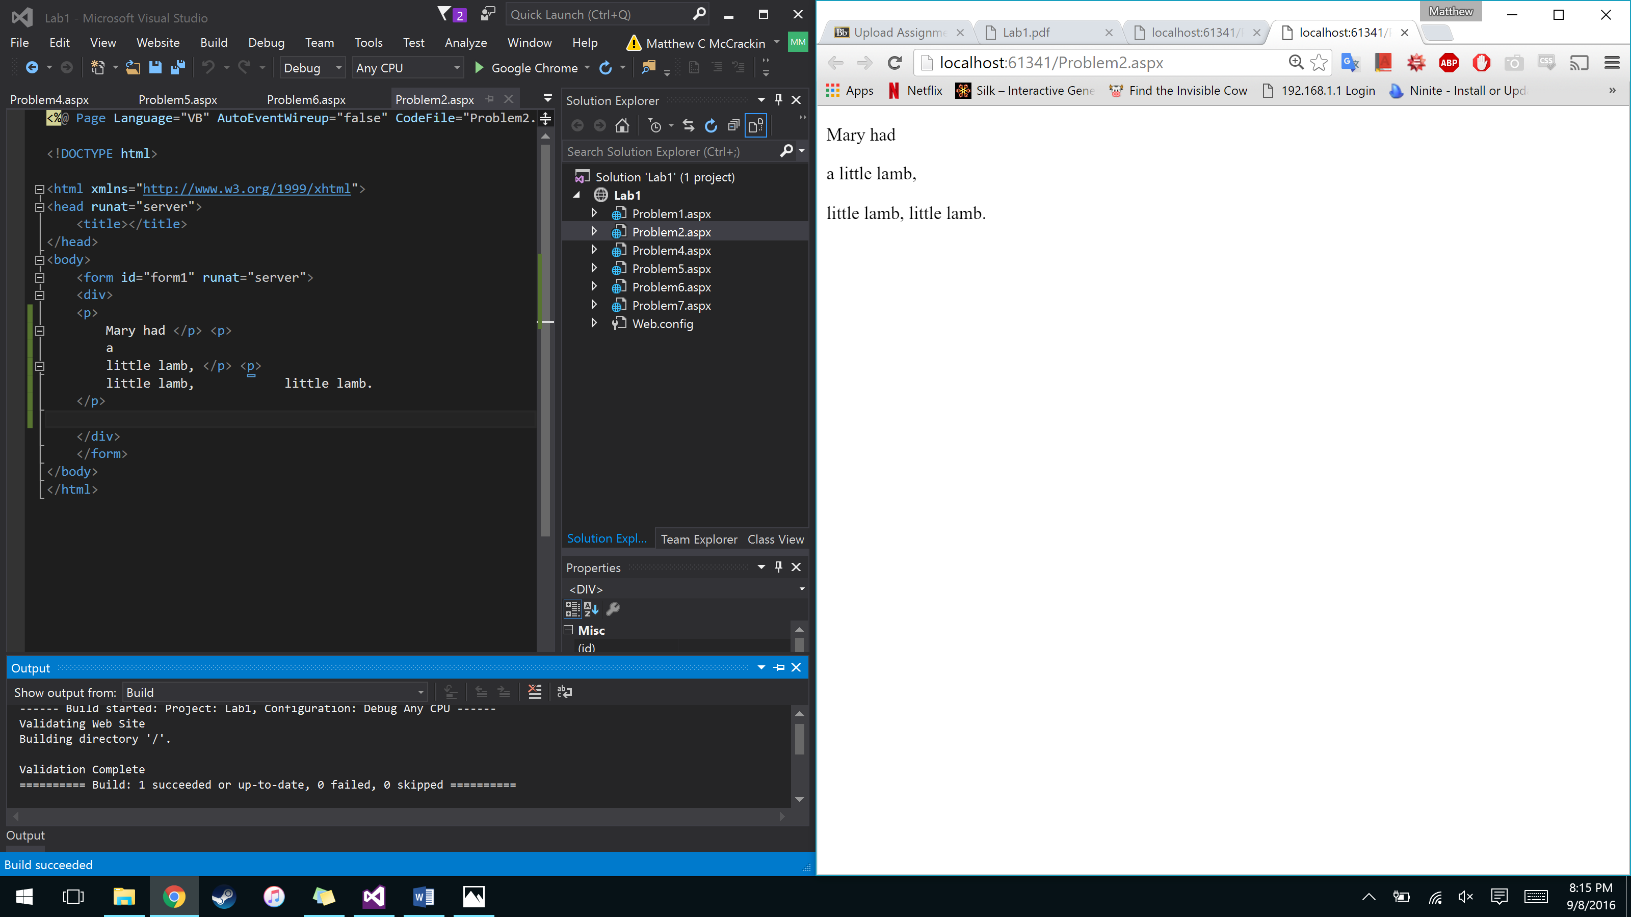

The webpage looks different than the code. In the code, “Mary had” is a paragraph. “a little lamb,” and “little lamb, little lamb” are also enclosed in their own paragraph tags. So, each phrase will be displayed on its own line.

3.

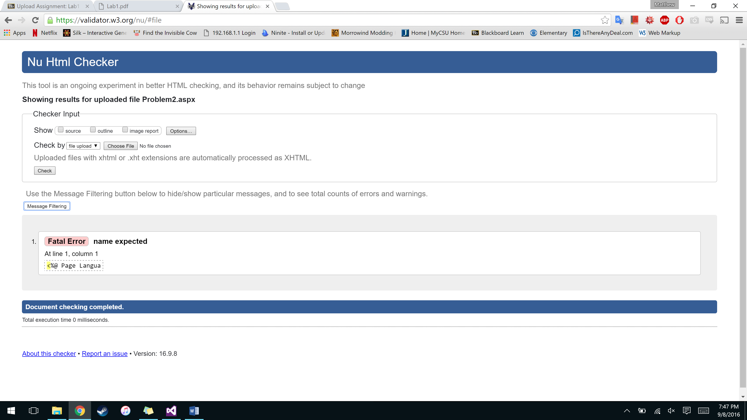

4.

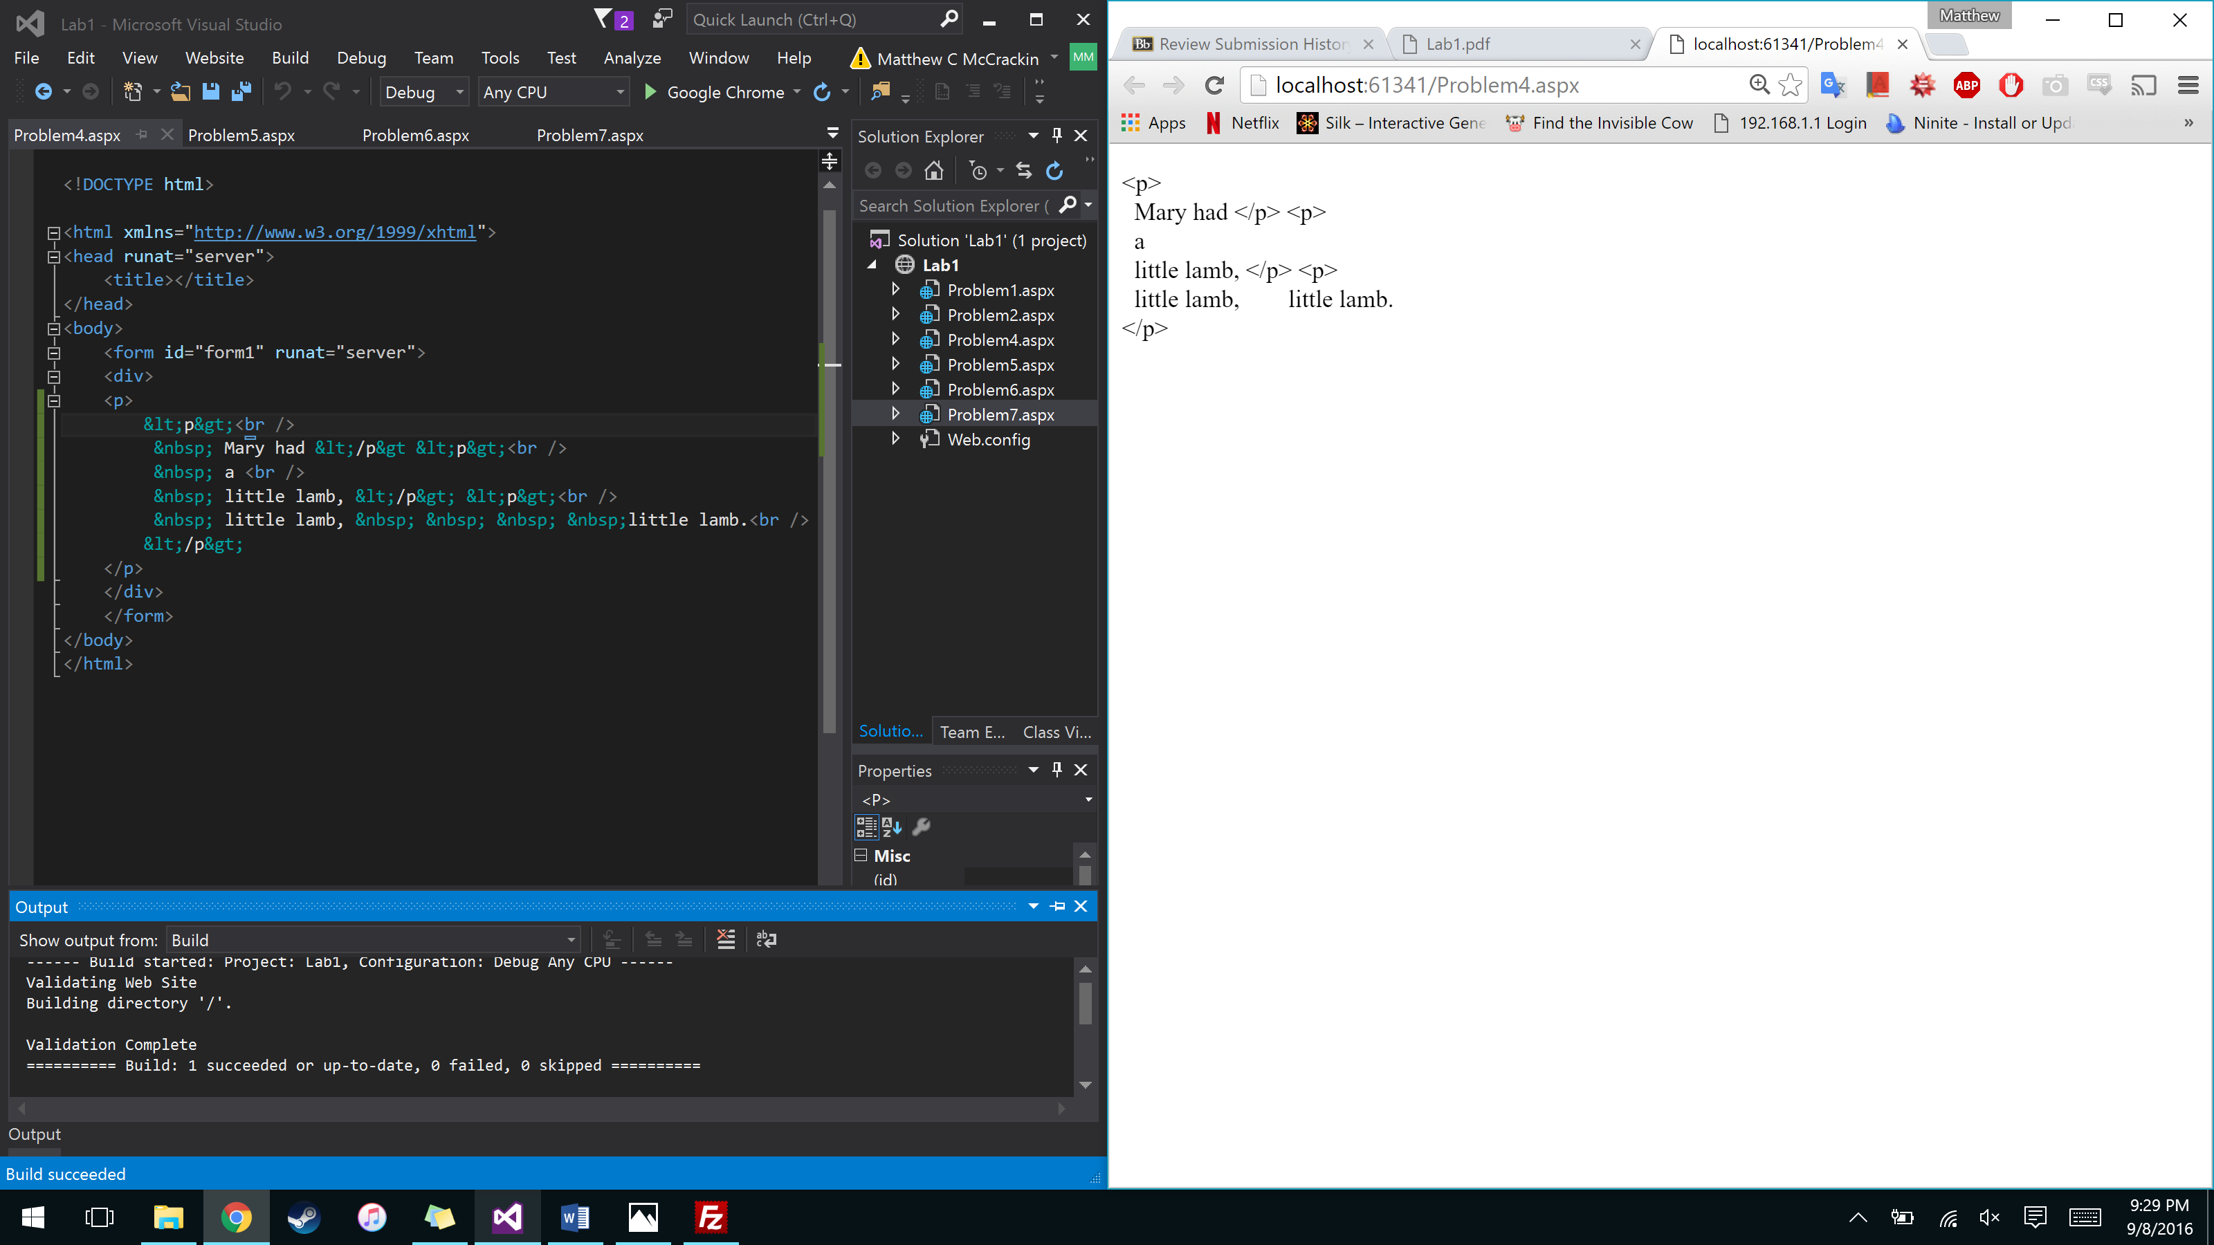

You can modify Problem 2 to show the p tags by using the &lt; and &gt; tags to display the less than and greater than symbols respectively.

5.

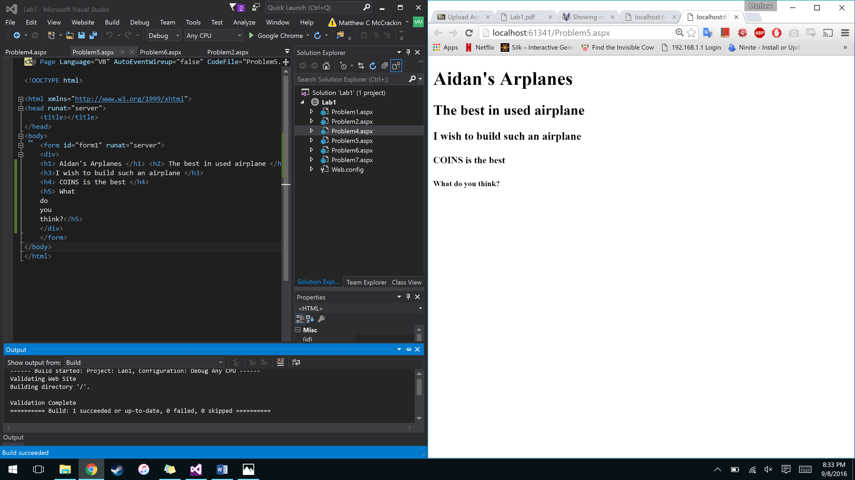

6.

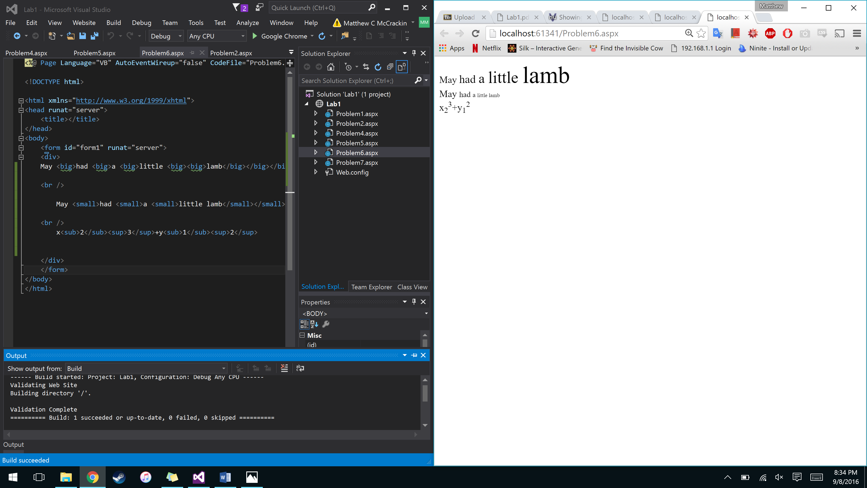

7.

