Fight the Landlord
Controller Journal
  - Video game control project October 27 2026
I made a physical controller for a browser version of Fight the Landlord using an Arduino Uno, a joystick, a push button, and three LEDs. I used ChatGPT to write the code and help me understand it. The physical controller worked, and I think the results are quite good.

My goal
My goal was to connect physical controls to the card game so I could move between cards, select a combination, and play or pass. The player competes against two programmed opponents. The browser manages the cards, rules, and turns, while the Arduino reads the controls. The LEDs provide a physical indication of whose turn it is.

How I used ChatGPT
ChatGPT helped me produce the code and understand how the parts fit together. This was useful because the project combines Arduino inputs with a browser game. I needed to understand what the board sends, how the game responds, and how the game sends information back to the LEDs. The explanations helped me connect the code to the behavior of the controller.

The physical controls
Joystick left and right: VRx connects to A4. Tilting moves the blue focus outline to the previous or next card. Return to center before moving again. Tilting does not select a card.
Joystick click: SW connects to D2 and is pressed to GND. Clicking selects or deselects the focused card during my playing turn. Selected cards rise and have a gold border.
Separate mini button: D9 connects to GND when pressed. During play, it submits selected cards, or passes with no cards selected when passing is allowed. During bidding, it chooses the next higher legal bid.
Turn LEDs: D4 shows my turn as player 0, D5 shows Bot 1 on the left as player 1, and D6 shows Bot 2 on the right as player 2. Each LED uses a 220–330 ohm series resistor.
The joystick connects to 5 V and GND; its up/down axis is unused. Its click switch and the mini button are separate inputs. Both use INPUT_PULLUP, so pressing connects the input to ground. All grounds connect to Arduino GND.

The screen controls
The blue outline means “this is the card I am browsing.” A raised card with a gold border means “this card is selected to play.” I can select several cards before pressing the mini button. A leading player cannot pass, and controller gameplay actions are ignored during the bots’ turns or while the rules window is open.
Connect Arduino and Disconnect Arduino open the port chooser to connect the controller, or close an existing connection.
Hint selects a suggested legal play. I still press Play to submit it.
Play validates and submits selected cards. With no selection, it passes only when passing is legal.
Pass during play passes when responding to another player’s trick. It cannot pass while leading.
Deselect All clears the selected cards.
Bid 1, Bid 2, and Bid 3 choose an available bid higher than the current highest bid.
Pass during bidding declines to bid. The physical mini button raises the bid; it does not choose this option.
New Game starts a fresh round.
Rules and its close buttons open or close the rules window.
The speaker button turns game audio on or off.

Reading the code walkthrough
The walkthrough after the photos explains 20 sections of the Arduino sketch, browser game, and USB connection. Each section places the original code excerpt above its explanation. The code keeps its original indentation and punctuation, including the confirmed pin 9 correction. The source links identify the full files and exact lines used.

How the Arduino and computer connect
There are two programs. The Arduino sketch runs on the board and reads electrical inputs. The HTML file runs in the computer’s browser and handles cards, rules, turns, and the screen. A USB data cable provides a serial connection between them. In this project, that connection carries short text commands rather than keyboard key presses.
1. I upload the sketch to the Arduino and connect the board to the computer by USB.
2. I open the game in a browser that supports Web Serial, click Connect Arduino, and choose the board’s port. The browser asks for permission to access that port.
3. The browser opens the port at 9600 baud, matching the sketch. Baud rate is the configured serial communication speed; both ends must agree.
4. The Arduino sends input messages such as NAV_LEFT, NAV_RIGHT, TOGGLE_SELECT, and BTN_PLAY. Each message ends with a newline so the receiver knows where it finishes.
5. The browser interprets the message using the current game state. It also sends TURN:0, TURN:1, TURN:2, or TURN:OFF back to the board to control the LEDs.
For example, clicking the joystick connects D2 to ground. After the press is stable for 50 milliseconds, the Arduino sends TOGGLE_SELECT. The browser collects the complete line, checks that it is my playing turn, changes the focused card’s selection, and redraws my hand. Pressing the D9 mini button then sends BTN_PLAY. If the selected cards are legal and the round continues, the browser plays them and advances the turn to Bot 2. The reply TURN:2 makes the Arduino light Bot 2’s LED on D6.
The board does not send commands to ChatGPT; ChatGPT helped write and explain the code before it runs. The actual messages and button behavior described here come from this project’s source code.
The port chooser, permission step, byte streams, and matching baud rate follow the browser’s Web Serial API documentation.

Execution and troubleshooting
The physical controller worked, so the project reached the main goal of connecting the hardware to the game. The setup described in the project README is to upload the sketch to the Arduino Uno, close Serial Monitor and Serial Plotter, open the game in desktop Chrome or Edge, and use Connect Arduino to choose the USB serial port.
I confirmed that the separate play button is connected to pin 9. The earlier supplied code listed pin 3; the current sketch and documentation now use D9 to match that confirmation. The joystick click remains on D2. This is a pin documentation correction, with a physical retest still to be recorded.
For future troubleshooting, I would follow the same path as the signal: input, Arduino command, serial connection, and browser action. That would help me narrow down a problem before changing code. These are useful checks to carry forward from the existing implementation.

Checks I would use if a problem appeared
For repeated or missing joystick movements, I would tilt and hold, return to center, and tilt again. The expected behavior is one movement per tilt. I would check the center reading and orientation setting before changing the thresholds. For a button that does not respond, I would check its pin and ground connection. On a four-leg tactile switch, the selected contacts must connect only when pressed.
For a rejected play, I would first check whose turn it is and whether the selected combination is legal. For a connection problem, I would check that both programs use 9600 baud and that another program is not holding the serial port. For an LED problem, I would compare the active player with the D4–D6 wiring and check the behavior when disconnecting and reconnecting.

My reflection
I am satisfied with the result because the physical controller worked and the results are quite good. Using ChatGPT helped me get the code written and understand what it does. The most useful way for me to explain the project is to connect each code section to a physical action or visible response, such as a tilt moving the card focus or a turn message changing an LED.
This project showed me why understanding the code matters even when AI helps write it. A controller depends on several parts agreeing: the wiring must match the pin definitions, the messages must match the browser handlers, and the action must be valid for the game state. I can use those connections to guide future changes and decide what to check when something behaves unexpectedly.

Next steps
The photos and demo link on the next page now document the setup. My next step would be to record a physical retest with the D9 sketch and keep a simple log of each action, expected behavior, actual behavior, and any change. Holding the controls, reconnecting the board, and checking the LEDs across turns would be useful tests to document.

Project files
Game: gemini-code-1793038528517.html. Controller sketch: LandlordController/LandlordController.ino. Wiring, setup, and controls: README.txt.

Project photos and demonstration
These photos show the assembled controller and the browser game beside the connected hardware. The video link provides the accompanying demonstration.
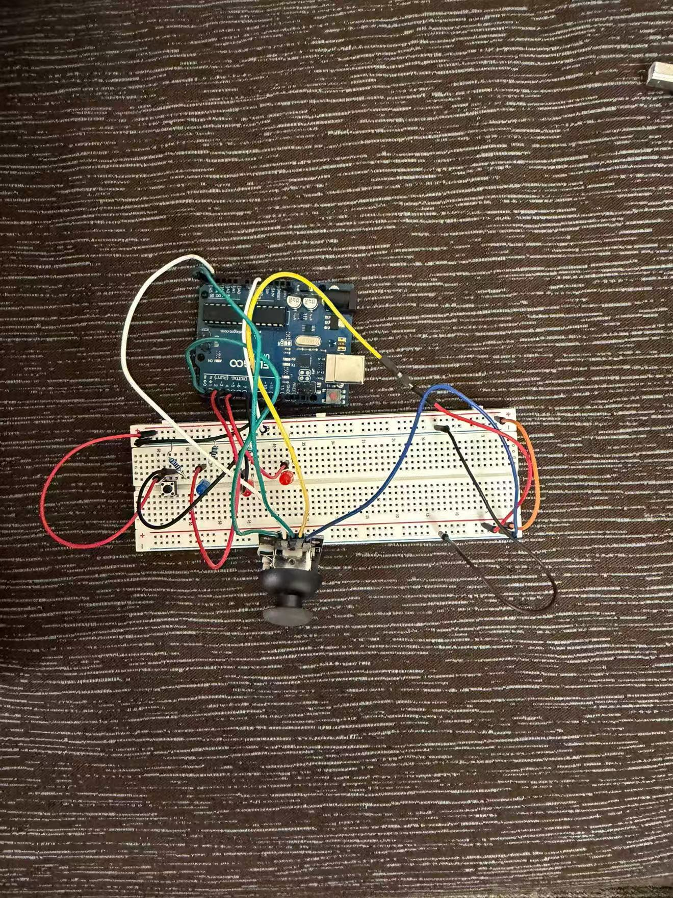
Figure 1. Arduino Uno, breadboard, joystick, separate push button, and LEDs.
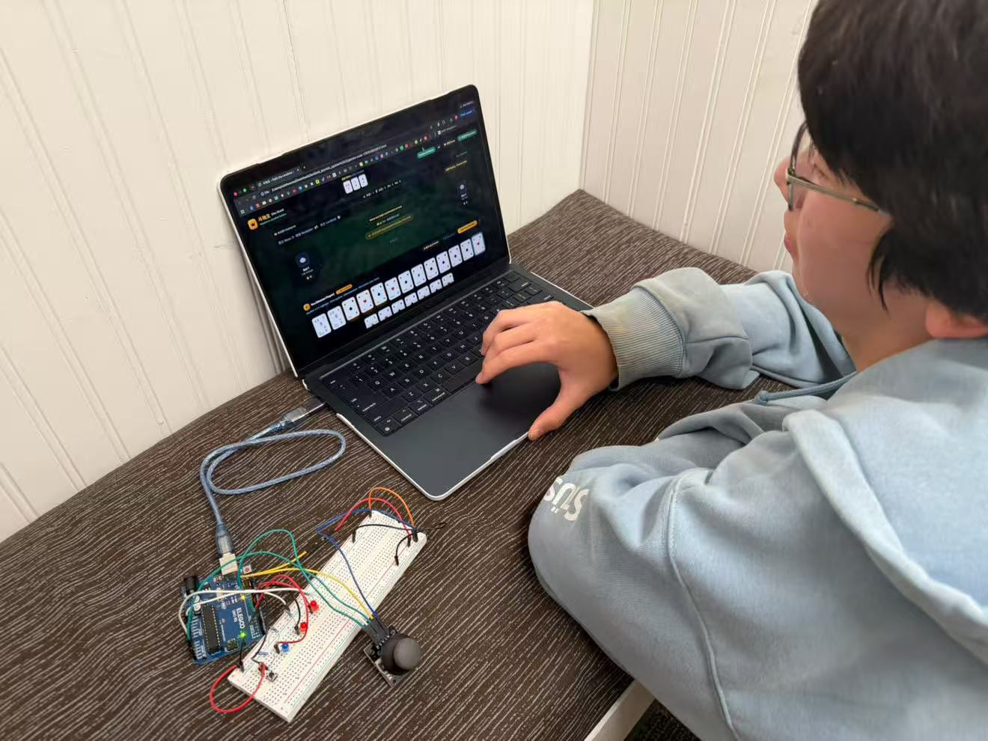
Figure 2. The browser game on the laptop beside the USB connected controller.
Watch the controller demonstration video

Understanding my code section by section
Each section puts the original code excerpt first, followed by its explanation. These excerpts come directly from the shared project files. The Arduino sketch includes the confirmed pin 9 correction. Long functions are identified as excerpts when only part is shown. The linked source files contain the complete code.

Arduino sketch

1 Arduino libraries pins and sensitivity
Original LandlordController.ino lines 14 to 32
#include <Arduino.h>
#include <string.h>
const byte PIN_JOY_X = A4;
const byte PIN_JOY_SW = 2;
const byte PIN_PLAY_BTN = 9;
const byte LED_P0 = 4;
const byte LED_P1 = 5;
const byte LED_P2 = 6;
// Reversed to match the orientation of your joystick.
// Set false if you later rotate or replace the joystick.
const bool REVERSE_X = true;
const int CENTER_MIN = 400;
const int CENTER_MAX = 620;
const int THRESHOLD_LOW = 250;
const int THRESHOLD_HIGH = 770;
const unsigned long DEBOUNCE_DELAY = 50;
bool movedX = false;
Arduino.h supplies the Arduino functions, and string.h supplies strcmp for comparing incoming messages. The pin constants name each connection: the joystick horizontal signal uses A4, its click switch uses D2, the separate mini button uses D9, and the three turn LEDs use D4, D5, and D6. This is the current shared sketch, including my confirmed pin 9 correction.
The remaining constants tune the controls. A reading from 400 to 620 counts as centered. A reading below 250 or above 770 counts as a strong tilt. REVERSE_X reverses the direction for this joystick orientation. DEBOUNCE_DELAY sets a 50-millisecond wait for a stable button change. movedX starts false, meaning a new tilt is allowed.

2 Arduino remembering button and message state
Original LandlordController.ino lines 34 to 46
struct ButtonState {
byte pin;
bool lastReading;
bool stableState;
unsigned long changedAt;
};
ButtonState selectButton = {PIN_JOY_SW, HIGH, HIGH, 0};
ButtonState playButton = {PIN_PLAY_BTN, HIGH, HIGH, 0};
char incoming[24];
byte incomingLength = 0;
bool discardLine = false;
unsigned long lastTurnUpdate = 0;
ButtonState groups the information needed for one button: its pin, the most recent reading, the last accepted stable reading, and the time the reading changed. selectButton and playButton each have their own copy, so one button does not overwrite the other button’s timing. HIGH is the initial released state.
incoming holds a message from the computer. Its 24-character array can store up to 23 message characters plus the ending zero character used by C strings. incomingLength tracks the next position, discardLine marks an oversized message, and lastTurnUpdate remembers when the last recognized LED command arrived.

3 Arduino setup runs once at startup
Original LandlordController.ino lines 109 to 122
void setup() {
Serial.begin(9600);
pinMode(PIN_JOY_SW, INPUT_PULLUP);
pinMode(PIN_PLAY_BTN, INPUT_PULLUP);
pinMode(LED_P0, OUTPUT);
pinMode(LED_P1, OUTPUT);
pinMode(LED_P2, OUTPUT);
digitalWrite(LED_P0, HIGH);
digitalWrite(LED_P1, HIGH);
digitalWrite(LED_P2, HIGH);
delay(500);
setTurnLEDs(-1);
Serial.println("READY");
}
setup opens serial communication at 9600 baud and configures the two button pins as INPUT_PULLUP. With this setting, an unpressed button reads HIGH; pressing it connects the input to GND and makes it read LOW. The joystick click and the separate D9 button are separate switches, even though the program reads them in the same way.
The three LED pins become outputs. All three lights turn on for half a second as a startup check, then turn off. Finally, the board sends READY to the computer. When the connected browser receives READY, it calls syncTurnLED to restore the current turn indication. The startup flash is not a game turn: during normal play, the browser tells the board which single turn LED to light.

4 Arduino converting a tilt into one navigation message
Original LandlordController.ino lines 67 to 77
void readJoystickInputs() {
int x = analogRead(PIN_JOY_X);
if (x >= CENTER_MIN && x <= CENTER_MAX) movedX = false;
if (!movedX && (x < THRESHOLD_LOW || x > THRESHOLD_HIGH)) {
bool left = (x < THRESHOLD_LOW);
if (REVERSE_X) left = !left;
Serial.println(left ? "NAV_LEFT" : "NAV_RIGHT");
movedX = true;
}
// VRy is intentionally unused. Selection comes ONLY from the SW click.
}
analogRead reads the joystick’s horizontal position from A4. Returning to the center range resets movedX to false. A strong tilt is accepted only while movedX is false. The code determines left or right, applies the orientation reversal, sends NAV_LEFT or NAV_RIGHT, and sets movedX to true.
Holding the joystick to one side therefore sends one navigation command rather than continuously scrolling. To move another card, I return it to center and tilt again. The vertical axis is intentionally unused. Tilting browses cards; pressing the joystick straight down is what selects or deselects a card.

5 Arduino accepting one stable button press
Original LandlordController.ino lines 54 to 65
void readButton(ButtonState &button, const char *command) {
bool reading = digitalRead(button.pin);
if (reading != button.lastReading) {
button.changedAt = millis();
button.lastReading = reading;
}
if (millis() - button.changedAt >= DEBOUNCE_DELAY &&
reading != button.stableState) {
button.stableState = reading;
if (reading == LOW) Serial.println(command);
}
}
readButton works for either physical button. Whenever the raw reading changes, it records the time. Only after that reading has stayed unchanged for at least 50 milliseconds does it accept a new stable state. This filters the brief on/off flicker that a mechanical switch can produce when pressed or released.
The command is sent only when the newly accepted state is LOW, meaning pressed. Holding the button does not send more commands, and releasing it does not send a command. The command parameter lets the same function send TOGGLE_SELECT for the joystick click and BTN_PLAY for the separate mini button.

6 Arduino choosing the correct turn LED
Original LandlordController.ino lines 48 to 52
void setTurnLEDs(int player) {
digitalWrite(LED_P0, player == 0 ? HIGH : LOW);
digitalWrite(LED_P1, player == 1 ? HIGH : LOW);
digitalWrite(LED_P2, player == 2 ? HIGH : LOW);
}
Original LandlordController.ino lines 79 to 88
void handleIncomingLine() {
int player;
if (strcmp(incoming, "TURN:0") == 0) player = 0;
else if (strcmp(incoming, "TURN:1") == 0) player = 1;
else if (strcmp(incoming, "TURN:2") == 0) player = 2;
else if (strcmp(incoming, "TURN:OFF") == 0) player = -1;
else return;
setTurnLEDs(player);
lastTurnUpdate = millis();
}
setTurnLEDs compares the requested player with 0, 1, and 2, setting the matching LED HIGH and the others LOW. Player 0 is me on D4, player 1 is Bot 1 on D5, and player 2 is Bot 2 on D6. Passing -1 makes all three comparisons false, so all lights turn off.
handleIncomingLine accepts TURN:0, TURN:1, TURN:2, and TURN:OFF from the browser. strcmp returns zero when two strings match exactly. An unknown message is ignored. A recognized message changes the lights and updates lastTurnUpdate. These LEDs indicate whose turn it is, not whether my cards are valid or whether I won.

7 Arduino collecting a complete message from the computer
Original LandlordController.ino lines 90 to 107
void readIncomingSerial() {
// Consume complete lines without blocking joystick/button polling.
while (Serial.available() > 0) {
char c = Serial.read();
if (c == '\r') continue;
if (c == '\n') {
if (!discardLine) {
incoming[incomingLength] = '\0';
handleIncomingLine();
}
incomingLength = 0;
discardLine = false;
} else if (!discardLine) {
if (incomingLength < sizeof(incoming) - 1) incoming[incomingLength++] = c;
else discardLine = true;
}
}
}
readIncomingSerial reads only bytes already available, so it can return to checking the controls without waiting for a whole message. It ignores the carriage return character, shown as \r, and treats a newline, shown as \n, as the end of a command. It then adds the string-ending zero character and calls handleIncomingLine.
A command may arrive over several passes through loop; incoming preserves the unfinished text. If the line is too long for the buffer, the code discards it until the next newline. This prevents a partial or oversized message from being treated as a valid turn command.

8 Arduino repeating input checks and clearing stale lights
Original LandlordController.ino lines 124 to 131
void loop() {
readJoystickInputs();
readButton(selectButton, "TOGGLE_SELECT");
readButton(playButton, "BTN_PLAY");
readIncomingSerial();
// Turn lights off if the game stops sending its one-second heartbeat.
if (millis() - lastTurnUpdate > 3500) setTurnLEDs(-1);
}
After setup, loop repeats continuously. It checks joystick movement, reads the joystick click as TOGGLE_SELECT, reads the D9 mini button as BTN_PLAY, and collects messages coming back from the computer. The Arduino reports physical actions; it leaves card rules and turn decisions to the browser.
The final condition turns all LEDs off if more than 3.5 seconds have passed since a recognized turn message. The browser normally repeats the current turn every second. If communication stops, an old turn light therefore does not stay on indefinitely. This timeout does not end or restart the card game.

Browser game

9 Browser controls and the hand area HTML excerpts
Original game.html lines 300 to 309
<button id="btn-hint" class="bg-slate-800 hover:bg-slate-700 text-amber-300 border border-slate-600 px-3 py-1.5 rounded-xl text-xs font-bold transition flex items-center gap-1 shadow">
<i class="fa-solid fa-lightbulb"></i>
<span>提示 Hint (Tíshì)</span>
</button>
<button id="btn-pass" class="bg-slate-800 hover:bg-slate-700 text-slate-300 border border-slate-600 px-3.5 py-1.5 rounded-xl text-xs font-bold transition shadow">
不要 Pass (Guò)
</button>
<button id="btn-play" class="bg-gradient-to-r from-amber-400 to-amber-500 hover:from-amber-300 hover:to-amber-400 text-slate-950 px-5 py-1.5 rounded-xl text-xs font-extrabold shadow-lg transition transform active:scale-95">
出牌 Play (Chū Pái)
</button>
Original game.html lines 317 to 318
<p class="text-xs text-sky-300 mb-2">Joystick ←/→: highlight · Click joystick: select/deselect · Mini button: play / pass</p>
<div id="human-hand-container" class="min-h-[150px]"></div>
The HTML creates the visible Hint, Pass, and Play buttons. Each id gives JavaScript a specific element to find, while the class names control its appearance. These tags define the buttons; the click handlers later in the file give them their behavior. Hint selects a legal suggestion, Pass skips a response when passing is allowed, and Play submits the selected cards.
The instruction above human-hand-container explains the physical controls. JavaScript fills this initially empty container with the player's cards. Moving the joystick browses those cards, pressing the joystick changes selection, and the mini button performs the game action.

10 Showing focus and selection CSS excerpts
Original game.html lines 39 to 49
.card-item.selected {
transform: translateY(-30px) !important;
box-shadow: 0 14px 24px -4px rgba(245, 158, 11, 0.6), 0 4px 8px rgba(0, 0, 0, 0.4);
border-color: #f59e0b !important;
}
/* Joystick Cursor Focus Ring */
.card-item.focused {
outline: 3px solid #38bdf8;
outline-offset: 3px;
}
Original game.html lines 69 to 71
#human-hand-container > .card-item.selected {
transform: translateY(-10px) !important;
}
The selected class marks cards chosen for the next play with an amber border, shadow, and upward movement. The focused class draws a blue outline around the card currently reached by the joystick. A card can have both classes: focus identifies the cursor position, while selection records which cards will be submitted.
The later rule specifically targets cards inside human-hand-container. It overrides the general selected movement, so cards in the actual hand rise by 10 pixels instead of 30. This keeps the selection visible without moving cards as far out of their row.

11 Remembering the game and advancing turns class excerpts
Original game.html lines 464 to 474
this.players=[
{id:0,name:'You',isAI:false,hand:[],role:'PEASANT',bids:-1,playsCount:0},
{id:1,name:'Bot 1',isAI:true,hand:[],role:'PEASANT',bids:-1,playsCount:0},
{id:2,name:'Bot 2',isAI:true,hand:[],role:'PEASANT',bids:-1,playsCount:0}
];
this.holeCards=[];this.selectedCardIds=new Set();this.aiTimer=null;
this.focusedCardIndex=0;this.gamePhase='BIDDING';this.currentTurn=0;
this.landlordId=-1;this.highestBid=0;this.highestBidder=-1;
this.baseScore=1;this.multiplier=1;this.bombCount=0;
this.lastTrick=null;this.passCount=0;this.playedCards=[];
this.springType=null;this.roundScores=null;
Original game.html lines 548 to 555
nextPlayTurn() {
if(this.gamePhase!=='PLAYING')return;
if(this.passCount>=2){this.currentTurn=this.lastTrick.playerId;this.lastTrick=null;this.passCount=0;}
sendLedCommandToArduino(this.currentTurn);renderAllUI();
const player=this.players[this.currentTurn],lead=!this.lastTrick;
updatePlayedCardsTitle(lead?`👑 ${player.name} · 自由出牌 Lead`:`${player.name} · 跟牌 Follow`);
if(!player.isAI) {
showAIReasonTag(lead?'Select any legal combination to lead.':'Beat the same pattern and card count, play a bomb/rocket, or pass.',true);
DouDiZhuGame stores the game's changing information. Player 0 is the human, player 1 is the left bot, and player 2 is the right bot. Each player has a hand and bidding information. selectedCardIds is a Set of chosen card IDs; focusedCardIndex separately records the joystick position. gamePhase and currentTurn determine which actions are currently allowed.
nextPlayTurn handles the next stage of play. After two consecutive passes, the last successful player regains the lead and lastTrick is cleared. The function sends the current player number to the Arduino, redraws the screen, and displays whether the player is leading or following.

12 Checking combinations and choosing bot moves function excerpts
Original game.html lines 638 to 649
const pattern = (type, primaryRank, wing='none', chainLength=1) => ({type,primaryRank,length:n,wing,chainLength});
const run = ranks.every((r,i) => i===0 || r===ranks[i-1]+1) && ranks.at(-1)<=14;
if (n===2 && counts.has(16) && counts.has(17)) return pattern(PATTERNS.ROCKET,17);
if (ranks.length===1) {
const types={1:PATTERNS.SINGLE,2:PATTERNS.PAIR,3:PATTERNS.TRIO,4:PATTERNS.BOMB};
return pattern(types[n],ranks[0]);
}
const trio = ranks.find(r => counts.get(r)===3);
if (n===4 && trio) return pattern(PATTERNS.TRIO_SOLO,trio,'single');
if (n===5 && trio && ranks.length===2) return pattern(PATTERNS.TRIO_PAIR,trio,'pair');
if (n>=5 && ranks.length===n && run) return pattern(PATTERNS.STRAIGHT,ranks.at(-1),'none',ranks.length);
if (n>=6 && ranks.every(r=>counts.get(r)===2) && run) return pattern(PATTERNS.CHAIN_PAIRS,ranks.at(-1),'none',ranks.length);
Original game.html lines 685 to 690
if (target.type===PATTERNS.INVALID || target.type===PATTERNS.ROCKET) return false;
if (candidate.type===PATTERNS.ROCKET) return true;
if (candidate.type===PATTERNS.BOMB && target.type!==PATTERNS.BOMB) return true;
return candidate.type===target.type && candidate.length===target.length &&
candidate.wing===target.wing && candidate.chainLength===target.chainLength &&
candidate.primaryRank>target.primaryRank;
Original game.html lines 751 to 765
function chooseLeadPlay(hand) {
const plays=generateLegalPlays(hand);
const whole=plays.find(p=>p.length===hand.length);
if (whole) return whole;
const ordinary=plays.filter(p=>![PATTERNS.BOMB,PATTERNS.ROCKET].includes(evaluatePattern(p).type));
return (ordinary.length?ordinary:plays).sort((a,b)=>b.length-a.length || evaluatePattern(a).primaryRank-evaluatePattern(b).primaryRank)[0] || [];
}
function chooseFollowPlay(hand,targetTrick) {
const plays=generateLegalPlays(hand,targetTrick);
const weight=p=>p.type===PATTERNS.ROCKET?2:p.type===PATTERNS.BOMB?1:0;
return plays.sort((a,b)=>{
const pa=evaluatePattern(a),pb=evaluatePattern(b);
return weight(pa)-weight(pb) || pa.primaryRank-pb.primaryRank;
})[0] || null;
evaluatePattern describes a selection using its type, main rank, card count, and sequence information. This excerpt recognizes jokers, matching ranks, triples with attachments, straights, and consecutive pairs. Sequences stop at Ace, excluding 2s and jokers. canBeat compares legal combinations: a rocket wins over other patterns, a bomb beats ordinary patterns, and otherwise the shape and count must match with a higher main rank.
The game bots use local JavaScript rules, separate from generative ChatGPT. When leading, chooseLeadPlay prefers finishing the hand, then longer ordinary combinations and lower ranks. When following, chooseFollowPlay prefers an ordinary legal response before bombs or rockets, then a lower rank. The Hint button also uses these functions.

13 Turning Arduino commands into game actions handler excerpt
Original game.html lines 802 to 821
if (command === 'NAV_LEFT' || command === 'NAV_RIGHT') {
const delta = command === 'NAV_LEFT' ? -1 : 1;
game.focusedCardIndex = Math.max(0, Math.min(game.focusedCardIndex + delta, humanCards.length - 1));
renderHumanHand();
const focused = document.querySelector('#human-hand-container .focused');
if (focused && focused.scrollIntoView) focused.scrollIntoView({block:'nearest', inline:'nearest'});
} else if (command === 'TOGGLE_SELECT' && game.gamePhase === 'PLAYING') {
const card = humanCards[game.focusedCardIndex];
if (!card) return;
if (game.selectedCardIds.has(card.id)) game.selectedCardIds.delete(card.id);
else game.selectedCardIds.add(card.id);
playSound('card');
renderHumanHand();
} else if (command === 'BTN_PLAY') {
if (game.gamePhase === 'BIDDING') {
// Preserve button bidding, always using the lowest legal higher bid.
if (game.players[0].bids === -1 && game.highestBid < 3)
game.handleBid(0, game.highestBid + 1);
} else playSelectedOrPass();
}
handleHardwareInput receives command text from the serial reader. NAV_LEFT and NAV_RIGHT move focusedCardIndex within the hand's limits and redraw the cards; they do not add cards to the selection. TOGGLE_SELECT, sent by pressing the joystick, adds or removes the focused card's ID during play.
BTN_PLAY comes from the separate mini button. During bidding, it chooses the lowest legal bid above the current highest bid. During play, it calls playSelectedOrPass. Bidding Pass remains an onscreen choice. Before this excerpt, the handler blocks gameplay input when the rules window is open, the round is over, or it is another player's turn.

14 Deciding whether to play or pass complete function
Original game.html lines 773 to 793
function playSelectedOrPass() {
if (game.gamePhase !== 'PLAYING' || game.currentTurn !== 0) return;
const cards = game.players[0].hand.filter(c => game.selectedCardIds.has(c.id));
if (cards.length === 0) {
if (!game.lastTrick || game.lastTrick.playerId === 0) {
showToastNotice('You are leading: select cards to play. You cannot pass.');
} else {
game.passTurnAction(0);
}
return;
}
if (evaluatePattern(cards).type === PATTERNS.INVALID) {
showToastNotice('These cards are not a valid combination.');
return;
}
if (game.lastTrick && game.lastTrick.playerId !== 0 && !canBeat(cards, game.lastTrick)) {
showToastNotice('Select a stronger combination, or deselect all cards to pass.');
return;
}
game.playCardsAction(0, cards);
}
playSelectedOrPass is shared by the onscreen Play button and the mini button during play. It first requires the human's turn, then collects the selected cards from the actual hand. With no cards selected, it passes only when responding to another player's trick. A player who is leading must select a legal combination instead.
With cards selected, the function checks that they form a valid pattern and, when following, beat the current trick. Invalid selections produce a message without playing the cards. Only a selection that passes these checks reaches playCardsAction, which updates the game state.

15 Drawing cards and supporting mouse input rendering excerpt
Original game.html lines 1003 to 1018
hand.forEach((card, idx) => {
const isSelected = game.selectedCardIds.has(card.id);
const isFocused = (idx === game.focusedCardIndex && game.currentTurn === 0 && game.gamePhase === 'PLAYING');
const cardEl = createCardElement(card, idx + 1);
if (isSelected) cardEl.classList.add('selected');
if (isFocused) cardEl.classList.add('focused');
cardEl.onclick = () => {
if (game.gamePhase !== 'PLAYING' || game.currentTurn !== 0) return;
game.focusedCardIndex = idx;
playSound('card');
if (game.selectedCardIds.has(card.id)) game.selectedCardIds.delete(card.id);
else game.selectedCardIds.add(card.id);
renderHumanHand();
};
renderHumanHand rebuilds the displayed hand from the cards stored in game.players[0].hand. For each card, it checks whether the card ID is selected and whether its position matches the joystick cursor. It then adds the corresponding CSS classes. The blue focus ring is shown only during the human's playing turn.
Each card also receives a mouse click handler. Clicking a card moves focus to it and toggles its selection, then redraws the hand. The turn check prevents clicks from selecting cards during bidding or another player's turn. Mouse input and hardware input therefore update the same selection state.

16 Connecting screen buttons to functions event handler excerpt
Original game.html lines 1072 to 1094
document.getElementById('btn-hint').onclick = () => {
if(game.gamePhase!=='PLAYING'||game.currentTurn!==0)return;
const hand=game.players[0].hand;
const cards=game.lastTrick?chooseFollowPlay(hand,game.lastTrick):chooseLeadPlay(hand);
game.selectedCardIds=new Set((cards||[]).map(c=>c.id));
renderHumanHand();
showToastNotice(cards&&cards.length?'Legal suggestion selected. Press Play to use it.':'No legal response. Press the mini button to pass.');
};
document.getElementById('btn-play').onclick = playSelectedOrPass;
document.getElementById('btn-pass').onclick = () => {
if (game.gamePhase !== 'PLAYING' || game.currentTurn !== 0 ||
!game.lastTrick || game.lastTrick.playerId === 0) return;
game.passTurnAction(0);
};
document.getElementById('btn-deselect').onclick = () => { game.selectedCardIds.clear(); renderHumanHand(); };
document.getElementById('btn-restart').onclick = () => { game.init(); };
document.getElementById('btn-rules').onclick = () => { document.getElementById('rules-modal').classList.remove('hidden'); };
document.getElementById('btn-close-rules').onclick = () => { document.getElementById('rules-modal').classList.add('hidden'); };
document.getElementById('btn-close-rules-bottom').onclick = () => { document.getElementById('rules-modal').classList.add('hidden'); };
document.getElementById('btn-audio-toggle').onclick = () => {
audioEnabled = !audioEnabled;
document.getElementById('audio-icon').className = audioEnabled ? 'fa-solid fa-volume-high' : 'fa-solid fa-volume-xmark';
};
These onclick assignments connect the HTML buttons to JavaScript actions. Hint finds a legal lead or response, selects those cards, and redraws the hand; the player still presses Play to use the suggestion. Play calls the shared playSelectedOrPass function. The separate Pass button checks that another player's trick exists before passing.
Deselect All clears the selected card IDs, and New Game calls game.init to restart. Rules opens the rules window, while its close buttons hide it again. The audio button toggles audioEnabled and changes the speaker icon. These controls provide browser access to the game alongside the Arduino controls.

USB serial connection

17 Connection asking permission and opening the USB serial port
Original game.html lines 891 to 909
async function connectSerial() {
if(serialBusy||serialClosing)return;
if(serialPort){await disconnectSerial();return;}
if(!('serial' in navigator)){setSerialStatus('Open this downloaded HTML in desktop Chrome or Edge to connect Arduino.');return;}
serialBusy=true;$('connect-btn').disabled=true;
try {
const port=await navigator.serial.requestPort();
await port.open({baudRate:9600});
serialPort=port;serialWriter=port.writable.getWriter();
serialBuffer='';serialDropping=false;
serialReadTask=readSerialLoop(port);
$('connect-btn').textContent='Disconnect Arduino';
setSerialStatus('Connected · 9600 baud');
await syncTurnLED();
} catch(error) {
if(serialPort)await disconnectSerial();
setSerialStatus(error.name==='NotFoundError'?'No port selected.':'Connection failed: '+error.message+' Close Arduino Serial Monitor and try again.');
} finally {serialBusy=false;$('connect-btn').disabled=false;}
}
connectSerial runs when Connect Arduino is clicked. It prevents overlapping connection attempts, checks whether the browser supports Web Serial, and asks the user to choose a port. It opens that port at 9600 baud, matching Serial.begin(9600) on the Arduino. If a connection already exists, the same button disconnects it.
The browser obtains a writer for outgoing bytes and starts readSerialLoop for incoming bytes. It changes the button to Disconnect Arduino, displays the connected status, and sends the current turn to the LEDs. The catch block distinguishes canceling the port chooser from a failed connection and suggests closing Arduino Serial Monitor if the port cannot be opened.

18 Connection receiving bytes and assembling command lines
Original game.html lines 829 to 843
let serialPort=null, serialReader=null, serialWriter=null, serialReadTask=null;
let serialBusy=false, serialClosing=false, serialBuffer='', serialDropping=false;
let writeQueue=Promise.resolve();
function feedSerialText(text) {
for(const ch of text) {
if(ch==='\r')continue;
if(ch==='\n') {
if(!serialDropping)handleHardwareInput(serialBuffer.trim());
serialBuffer='';serialDropping=false;
} else if(!serialDropping) {
if(serialBuffer.length<100)serialBuffer+=ch;
else {serialBuffer='';serialDropping=true;}
}
}
}
Original game.html lines 856 to 872
async function readSerialLoop(port) {
const decoder=new TextDecoder();
try {
serialReader=port.readable.getReader();
while(!serialClosing) {
const {value,done}=await serialReader.read();
if(done)break;
feedSerialText(decoder.decode(value,{stream:true}));
}
} catch(error) {
if(!serialClosing)setSerialStatus('Arduino disconnected: '+error.message);
} finally {
if(serialReader){serialReader.releaseLock();serialReader=null;}
// Let this read task finish before disconnect waits for it.
if(!serialClosing)Promise.resolve().then(()=>disconnectSerial());
}
}
The first variables remember the connection, reader, writer, unfinished command, and whether the connection is closing. readSerialLoop waits asynchronously for incoming byte chunks. TextDecoder converts those bytes into text, and feedSerialText collects characters until a newline arrives. The browser can keep responding while it waits for serial input.
A read might contain only TOGGLE_ and the next read SELECT followed by a newline. The buffer joins them before calling handleHardwareInput once with TOGGLE_SELECT. Carriage returns are ignored, and lines longer than 100 characters are discarded. If reading ends or fails, the code releases the reader and begins disconnect cleanup.

19 Connection sending the current turn back to the board
Original game.html lines 845 to 855
function sendSerialLine(line) {
const writer=serialWriter;
if(!writer)return Promise.resolve();
writeQueue=writeQueue.then(()=>writer.write(new TextEncoder().encode(line+'\n')))
.catch(()=>{if(!serialClosing)setSerialStatus('Connection lost. Disconnect and reconnect Arduino.');});
return writeQueue;
}
function syncTurnLED() {
const turn=['OVER','REDEAL'].includes(game.gamePhase)?'OFF':game.currentTurn;
return sendSerialLine('TURN:'+turn);
}
Original game.html lines 910 to 913
function sendLedCommandToArduino(turnVal) {
return sendSerialLine('TURN:' + turnVal);
}
setInterval(() => { if (!serialClosing) syncTurnLED(); }, 1000);
sendSerialLine adds a newline, converts the text into bytes with TextEncoder, and writes it to the serial port. writeQueue chains writes in order so separate parts of the game can send messages without overlapping their writes. With no connected writer, the function simply returns.
syncTurnLED sends TURN followed by the current player number, or TURN:OFF when the phase is OVER or REDEAL. sendLedCommandToArduino is another route used when turns change. The timer repeats synchronization every 1000 milliseconds. This regular update works with the Arduino’s 3500-millisecond timeout to clear a stale light after communication stops.

20 Connection disconnecting and releasing the port
Original game.html lines 873 to 890
async function disconnectSerial() {
if(serialClosing)return;
serialClosing=true;
try {
await sendSerialLine('TURN:OFF');
if(serialReader)await serialReader.cancel().catch(()=>{});
if(serialReadTask)await serialReadTask;
await writeQueue;
if(serialWriter){serialWriter.releaseLock();serialWriter=null;}
if(serialPort)await serialPort.close().catch(()=>{});
} finally {
serialPort=null;serialReadTask=null;serialBuffer='';serialDropping=false;
serialClosing=false;serialBusy=false;
$('connect-btn').textContent='Connect Arduino';
$('connect-btn').disabled=false;
setSerialStatus('Disconnected');
}
}
disconnectSerial first marks the connection as closing and attempts to send TURN:OFF. It cancels the reader, waits for the read task and queued writes, releases the writer, and closes the port. Releasing readers and writers matters because they hold access to the streams while in use.
The finally block clears the saved connection and partial-message state, re-enables the button, and changes the display to Disconnected. If communication stops while the Arduino remains powered, its own timeout is the backup for clearing the LEDs. Disconnecting its only power source turns the LEDs off immediately. Reconnecting starts with a fresh message buffer.

