Introduction

For my website, I decided to do one on my local running club. The main reason I decided the running club, was because I was aware of some of the criticism we have received for our lack of online appearance. Some members were complaining they did not know about events and club news as they were not on Facebook. The intended audience is primarily current members and their friends/family who are interested in seeing whats happening at the club. Other interested parties would be - people new to the new town hoping to join the club, rival club members and Athletics NI.

Original Mock-up Sketch of Website Homepage

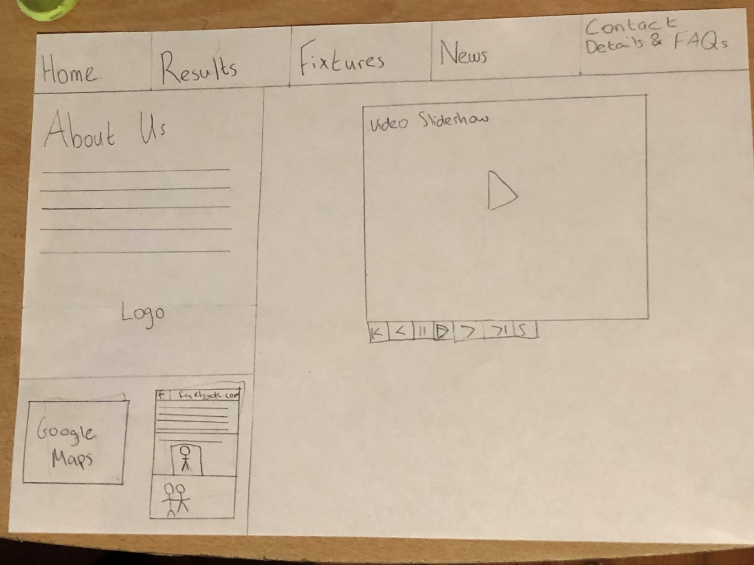

Website Description

**Page 1 (index.html)**

The purpose of this page is to allow the user to see a little bit of everything to do with the club. Through the Facebook and Google Maps iframes, viewers can see where the club has a Facebook page and where we train, respectively. All images on the page are from the Facebook page.

**Page 2(AboutScreen.html)**

The purpose of this page is to give the viewer a further depth of key information relating to the club. There are no new images on this page, but the header is again, from Facebook.

**Page 3(ResultsScreen.html)**

The purpose of this page is to give users who would not know where to find results from races they participated in (or someone they know). The pictures are again from Facebook.

**Page 4(FixturesScreen.html)**

The purpose of this page is very similar to the results page. It allows users to get links for upcoming races. As mentioned on the site there are no upcoming races due to Covid-19, so I thought I would share a video from a different sort of challenge some of us members participated in. The video is from YouTube – made by a club member.

**Page 5(NewsScreen.html)**

The purpose of this page is to provide the user with the latest non-race results news. This could be social events coming up, fundraisers and anything in between. There a no new pictures on this page.

**Page 6(ContactUsScreen.html)**

The purpose of this page is to allow the viewer to submit a query if they have one, and do not have Facebook. The background image used on this page is from Facebook.

HTML5 Validation

Page 1

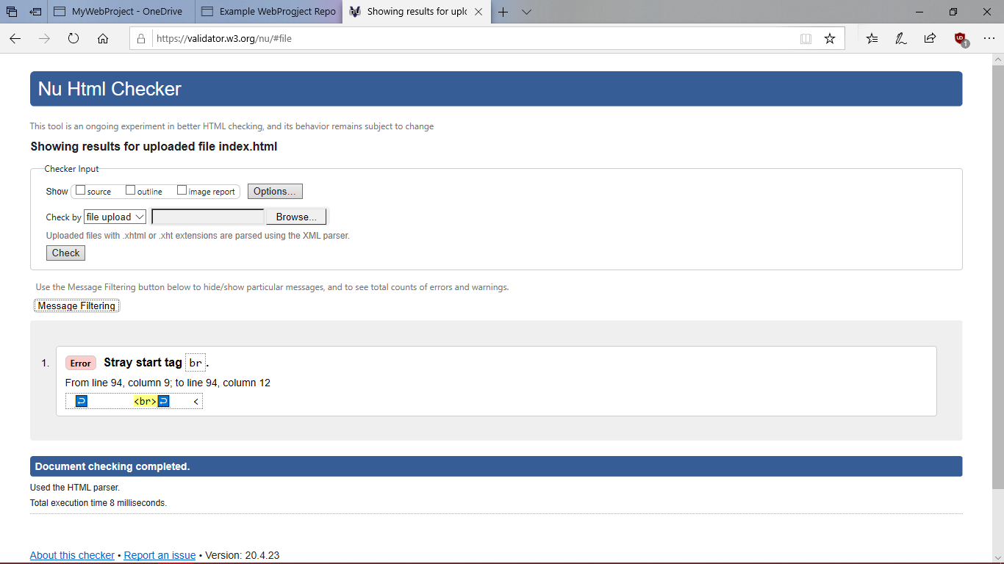

Page 2

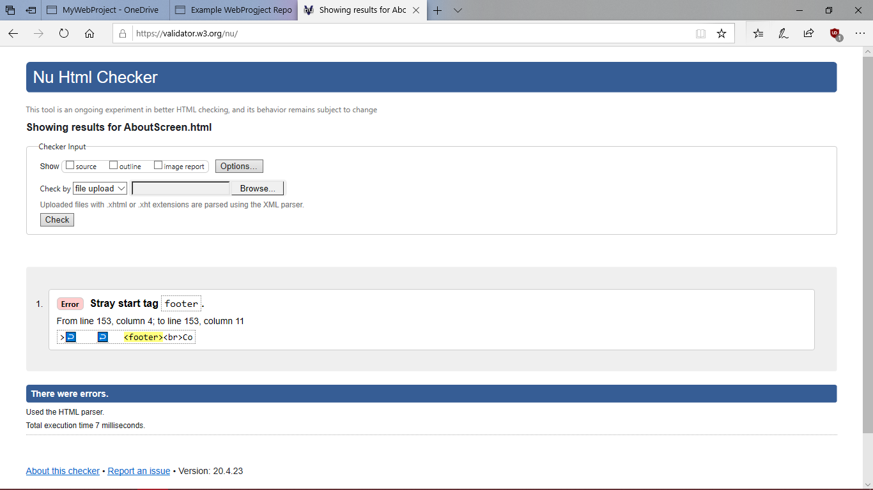

Page 3

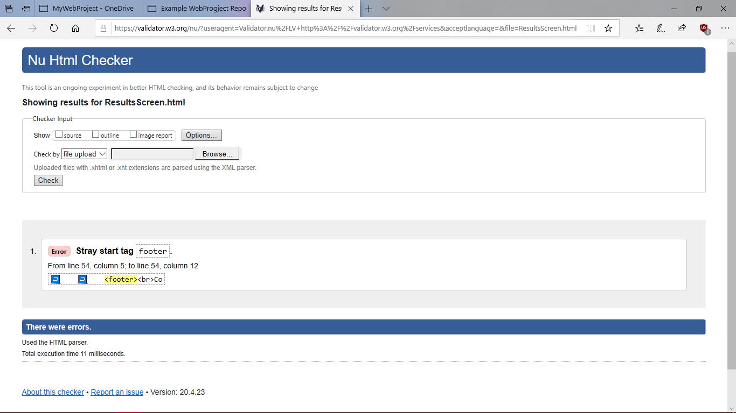

Page 4

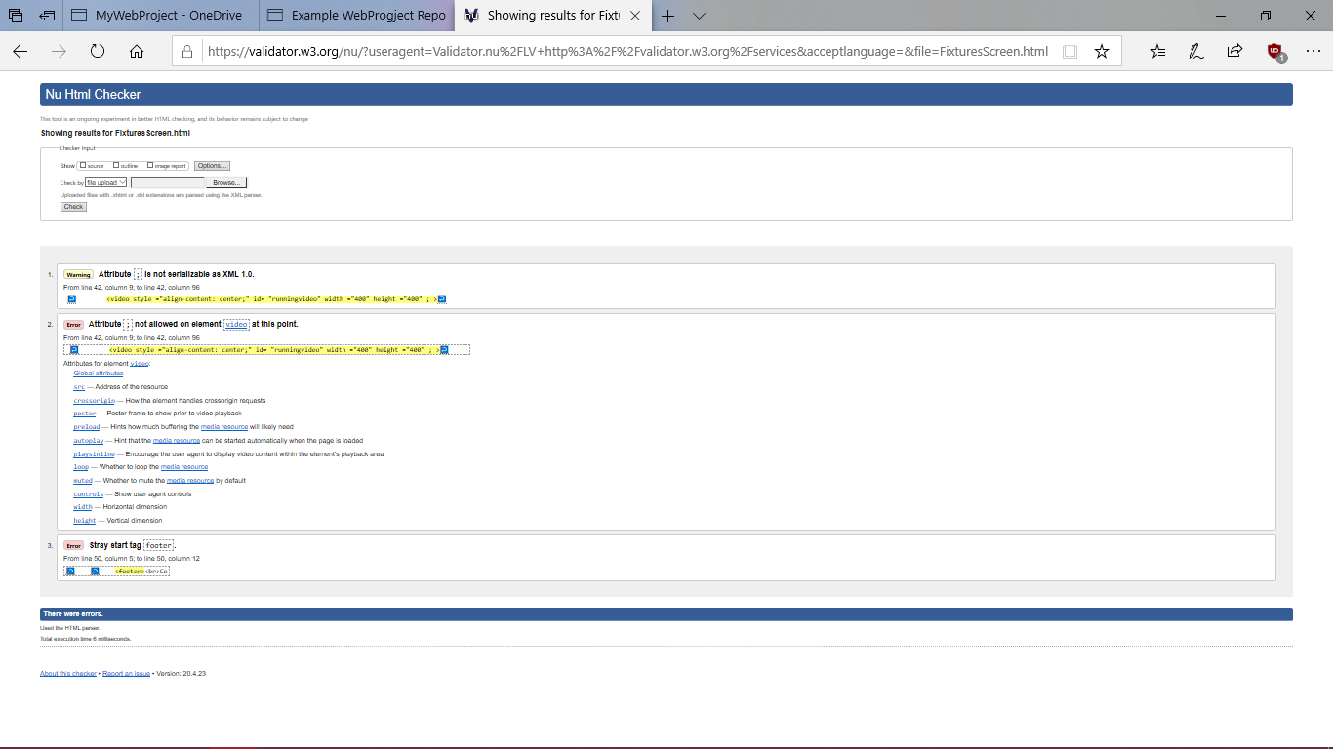

Page 5

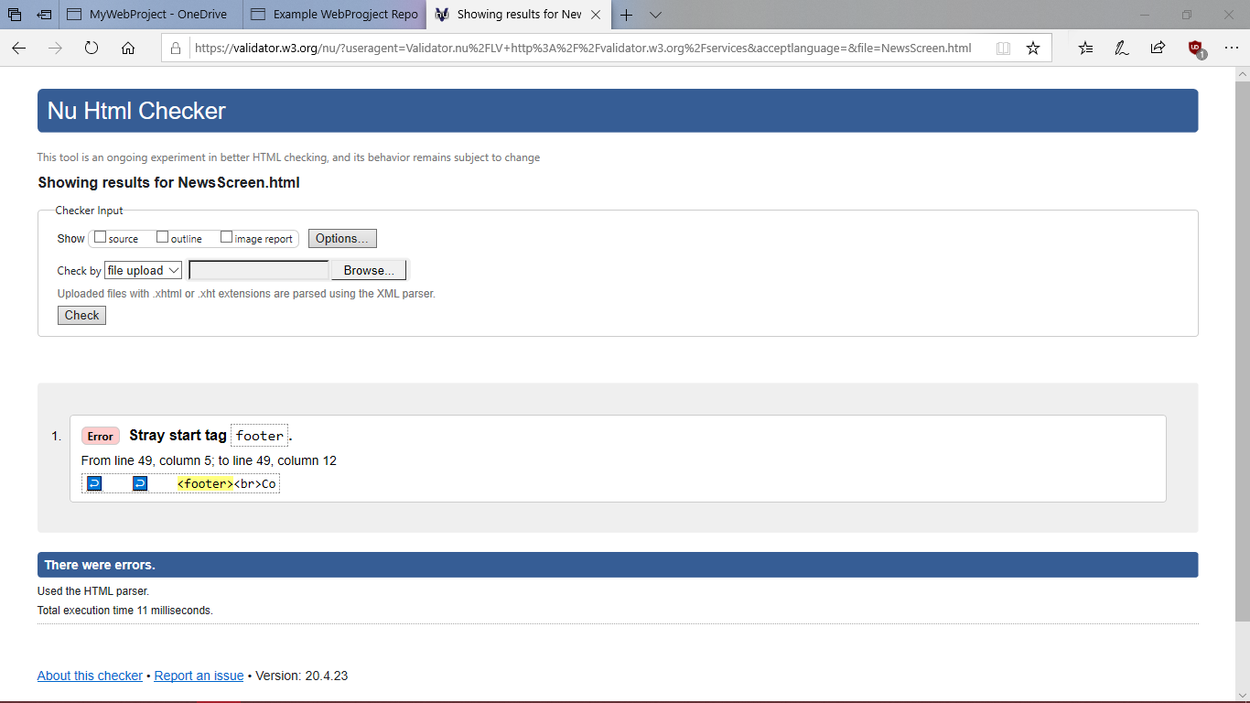

Page 6

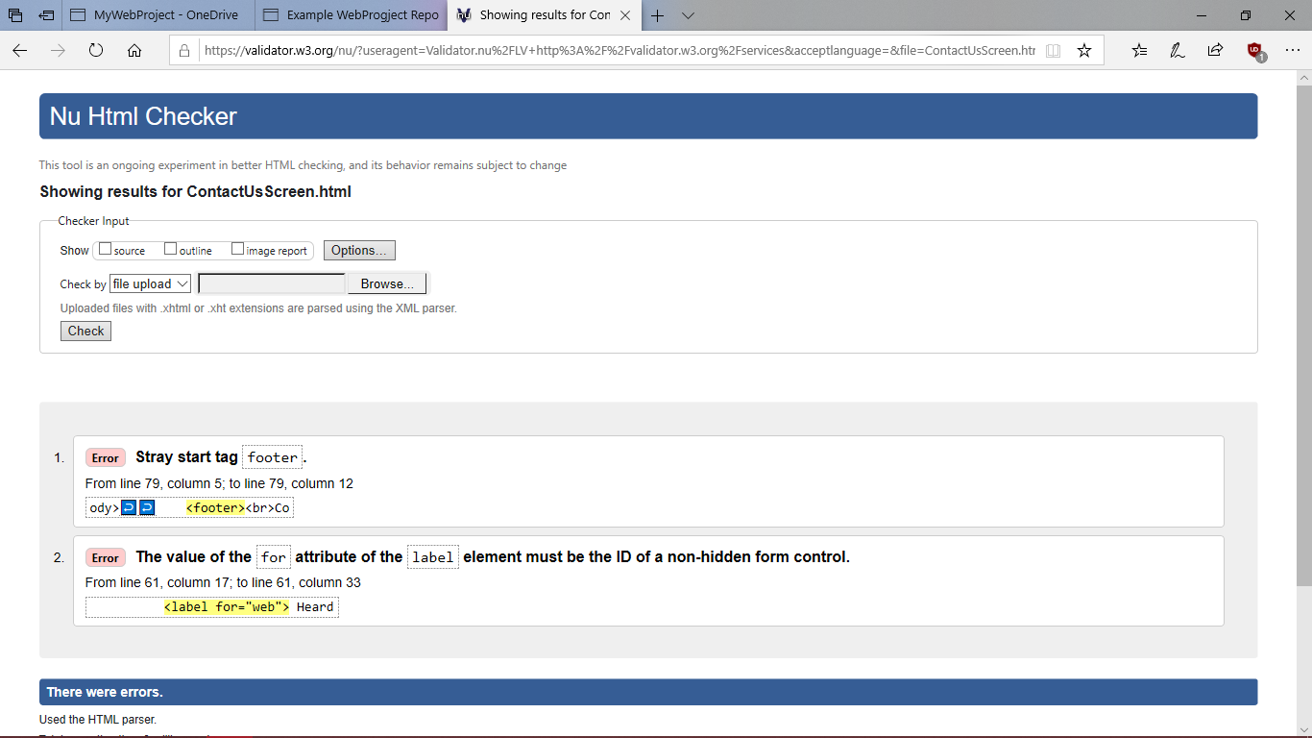

CSS Validation

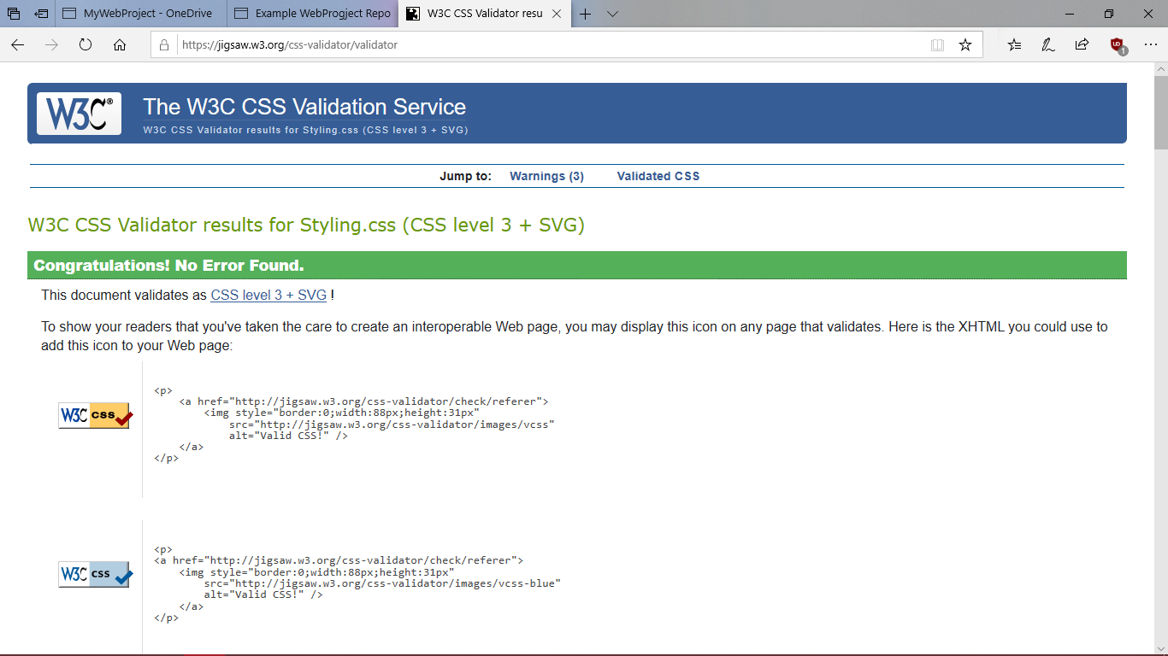

Project Checklist

**You are asked to complete an original website of your own work, the website should contain the features listed below.**

Create a website using html5/css that will include the below Project Check List elements: if features are not obvious outline where they are located on the web page below. In order to mark the project the student will present the website and explain the code, declaration of own work submitted.

|  |
| --- |
| **\*\*\*\*Must include Report including purpose and intended audience of the website and sources of images and information of each web page and HTML & CSS validation results. Upload completed project include url in report** |
| **Minimum of 4 HTML Pages with navigation menu not dummy text, use text and hyper link from appropriate website** ( outline college project on landing page, do not include any personal or college information in the content of the pages) |
| **Upload progress and completed website to your GitHub account** |
| **HTML5 standards and recommended page layout structure** (header,main,aside,article,footer,etc) |
| **Include appropriate Meta data – description & appropriate keywords etc to improve pages SEO**  Used in header section of each page |
| **Include font family for web page body**  Set in Styling.css |
| **Appropriate use of External Style Sheet – Recommended CSS (**standard for majority of your CSS) |
| **Appropriate use of Internal & Inline Styling on HTML page** (one example of each)  Internal – columns on AboutScreen.html |
| **Home page content aligned to each other and visually attractive** |
| **Include navigation above fold and bottom of web pages- Indicate on navigation the current page** |
| **Include both Class and ID as CSS Selectors** |
| **Consistency of design on all pages , use of fonts, colour etc**  Design simple with same colours and fonts |
| **Appropriate use of Headings (h1, h2, h3, h4)**  Used varying headings across all page |
| **Appropriate use of Colours (test for colour blind users)**  Colours straightforward |
| **Include an article or section with 2 or 3 columns** (by using appropriate css)  On AboutScreen.html |
| **Include logo and display in header of page**  On all pages |
| **Clear, consistent and align content on all pages** (reference all sources) |
| **Include images (with at least one image floated with text alongside)**  Used on ResultsScreen.html |
| **Use of background image**  Used on ContactUsScreen.html (assumed it was only needed on one page) |
| **Include table of data/information only for statistical data**  On AboutScreen.html |
| **Include lists ordered or unordered (different shaped bullet points)**  Used for navigation bar on all pages |
| **Include a link to a suitable video and google map –** use iframe code from YouTube or google maps from share, embed, copy iframe into your html page  Video on FixturesScreen.html  Maps on index.html |
| **Include a contact me form and include red * beside required/mandatory input fields**  Used on ContactUsScreen.html |
| **Verify data collected on contact form, using get and data attached to URL** (Use the method get to display values entered on form will be appended to url and passed to server <form action=" [http://year1.ccpdev.me/FormTest.php](http://year1.ccpdev.me/FormTest.php?fdf=fdsaf&fdsfs=hfdsahfkjhfa)" method="get">  Used on ContactUsScreen.html |
| **Footer information including Copyright© 2020 and navigation**  Used on each page |
| **Internal anchor Links on one of the webpages**  Used on in navigation bar |
| **External Link to external website**  Used on NewsScreen.html |
| **Any Additional Features included Slideshow**  Used on index.html |
| **Results included in report of HTML5 Validation (with majority of issues addressed)**  See above |
| **Results included in report of CSS Validation (with majority of issues addressed)**  See above |
| **Include Favicon on the Title tab**  Included | |
| **Guide line on Website appearance, design and Content** [**https://webdesignledger.com/10-signs-of-a-user-focused-design/**](https://webdesignledger.com/10-signs-of-a-user-focused-design/) | |
| **Guidelines on Website overall appearance & design** [**https://webdesignledger.com/20-dos-and-donts-of-effective-web-design/**](https://webdesignledger.com/20-dos-and-donts-of-effective-web-design/) | |