Here is our graphs per 0.0333… seconds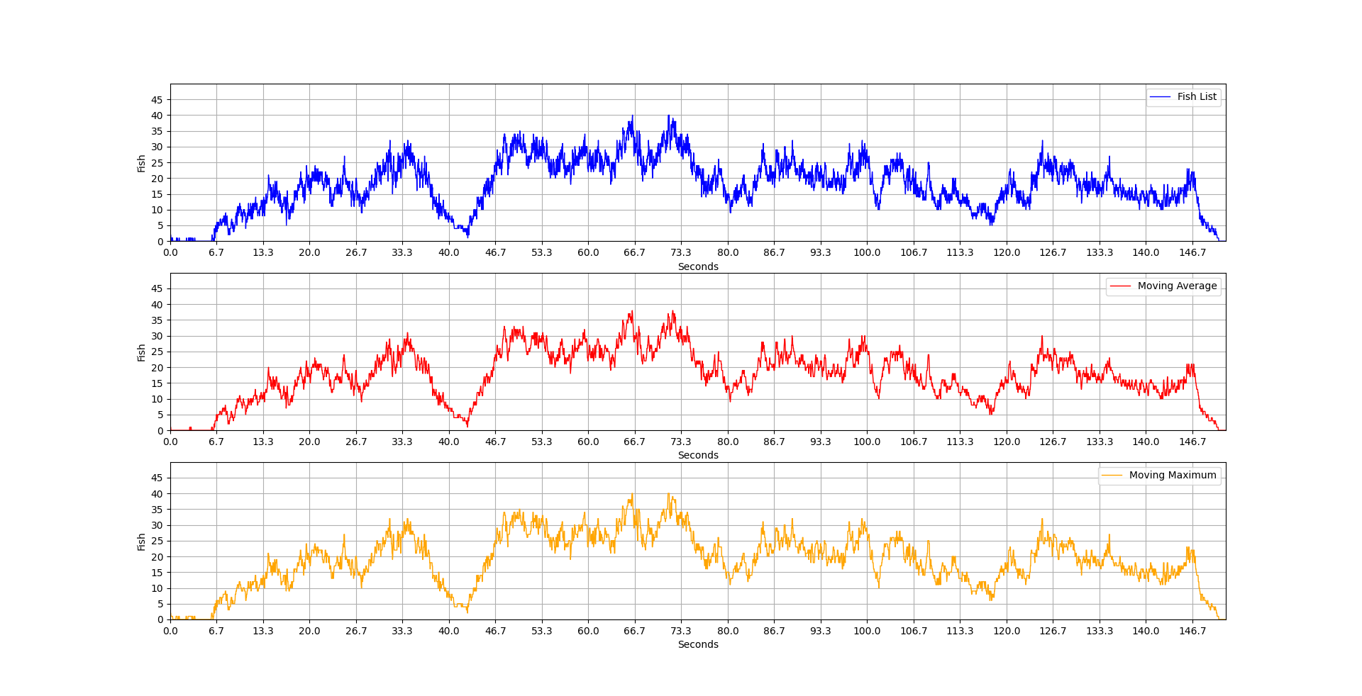

The fish list is our original list without any process

The moving average the average of the moving method that we explained in the explanation file

The moving maximum is the maximum of moving method that we explained in the explanation file

And here is a simplified version of the past graphs

These graphs are per second each

The simplified fish list is our original list but simplified to look smooth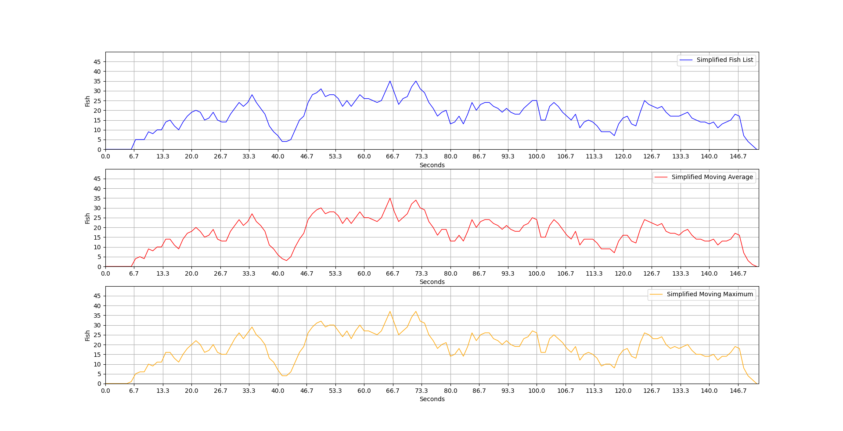

The simplified moving average the average of the moving method but simplified to look smooth

The simplified moving maximum is the maximum of moving method but simplified to look smooth