Abstract

Most computers that are available for purchase nowadays contain CPUs with multiple cores, furthermore, due to advancements in technology, graphics cards are becoming increasingly affordable and commonplace. However, when not being used to render complex graphics on the screen, the Graphics Processing Units are usually sitting idly by. This is a dreadful waste of resources. Therefore, to fill this void, General Purpose computing for Graphics Processing Units was introduced (GPGPU). This allowed programmers to offload work to the GPU (as a coprocessor) using a language extension built for general purpose computing on a graphics card (as opposed to graphics computing). Two such language extensions are OpenCL and CUDA. CUDA was introduced by Nvidia specifically for their graphics cards as opposed to OpenCL, which, as its name suggests, is designed to run on graphics cards (among other devices) from a variety of vendors. The aim of this project was to study whether OpenCL provided portability at an unreasonable cost by implementing a number of algorithms using both OpenCL and CUDA and comparing the performance. The results show that while OpenCL is indeed slower than CUDA, it is not substantially slower than CUDA and hence is a good platform independent alternative to CUDA. ^{[1][2][3][4][5][6][9]}
Motivation and Background

In 1965 Gordon Moore from Intel proposed that the number transistors on a chip would double every eighteen months (later altered to two years). Since his prediction, the number of transistors on a chip have indeed doubled every two years, however, as the size of transistors are reduced to allow more to be squeezed onto a single chip, heat dissipation and power consumption become ever increasing problems. Not to mention, cost. Experts predict that Moore's law will come to an end some time between 2017 and 2020. Already signs of that are beginning to show, as, from 2007 to 2011 clock speed rose by 33%, while, from 1994 to 1998, clock speeds rose by 300%. The graph below shows how various parameters concerning a CPU have varied over time:
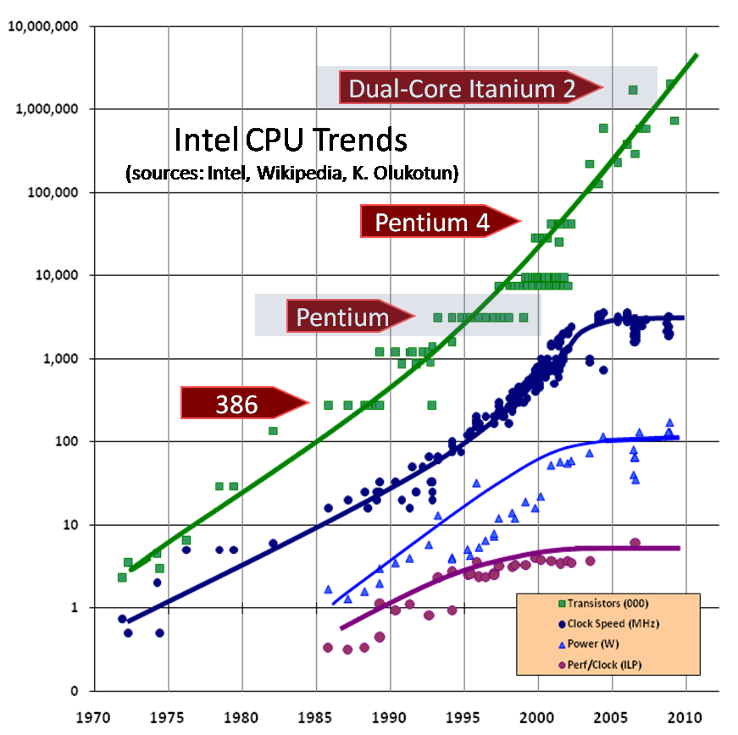
^{[32]}

As is evident in the graph shown above, the clock speed has reached a plateau for many of the reasons I mentioned earlier and while it is true that the graph shows the number of transistors increasing, this is because the number of cores on a chip are increasing, but, the speed of each core is unchanged. As a result, one might expect that given the eventual death of Moore's law (as proven by the graph above), demand for faster computers will seize. Unfortunately, this has not been the case. ^{[1][2][3][4][5][6][9]}

In order to meet this growing demand, engineers have looked for alternative methods to improve performance. One such method (which I touched on earlier) is to add more cores to a processor. Multi-core processors have proven to greatly reduce the time taken to perform a number of tasks when utilised to their full potential. In addition, to supplement multi-core CPUs, manufacturers of Graphics Processing Units (GPUs) have made it possible for programmers to offload general tasks to the GPU (Prior to this, GPUs were only really used for graphics programming). This is commonly referred to as General Purpose computing on Graphics Processing Units (GPGPU). To the untrained eye this may not seem like much to celebrate about, but GPGPU has opened the doors to a plethora of applications that can now be simulated/calculated/tested on computers due to the huge performance gains that are provided by employing the assistance of GPUs, as, unlike CPUs, GPUs contain tens to hundreds of cores and therefore they should not be neglected. Furthermore, what is worth noting is that as off November 2013, 53 of the computers in the top 500 list of the fastest computers in the world contained accelerators/coprocessors. A graph showing how the number of co-processors in the top 500 computers has varied over time is shown below:

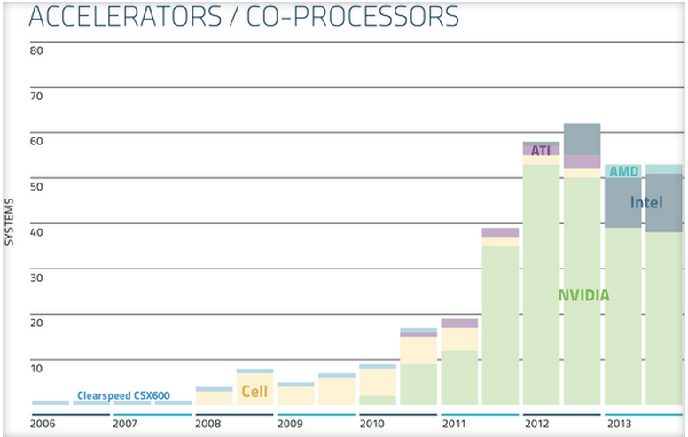
^{[25]}

The increasing trend for computers in the top 500 to contain co-processors as depicted in the graph above further highlights the importance of co-processors in improving performance. The graph also shows that while all co-processors were at one time only supplied by Nvidia to the top500, other manufacturers (such as Intel and AMD) are beginning to realise their potential and have obviously begun producing GPUs of comparable performance. Another reason why GPUs are growing in popularity with such pace is evident in the next graph shown below which compares the Floating point Operations Per Second (FLOPS) of GPUs and CPUs over time:

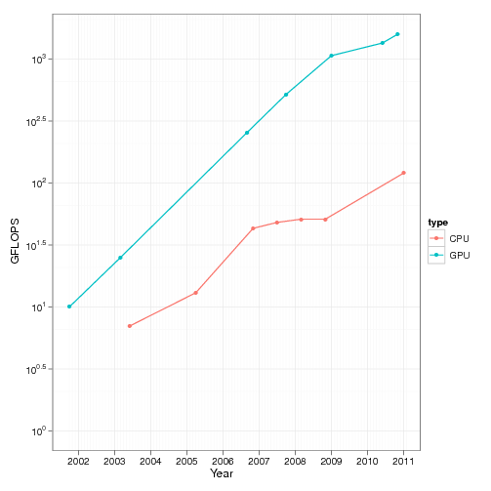
^{[33]}
In the graph above GFLOPS refers to Giga FLOPS. GFLOPS is just one measure that can be used to evaluate performance (or at the very least, provide a rough idea as to the performance one should expect). Knowing this, it is clear from the graph above that the potential for performance gain within an application that utilises the GPU is far greater than that which can be achieved by only using a CPU in an application (as is the case with sequential code).^{[4][5][9][25][26]}

Before I get lost in praise for GPUs, it is important to remember that as the well known No Free Lunch Theorem (NFLT) suggests, all this performance gain does not come without a cost. Users only stand to see performance improvements if developers exploit the multiple cores and co-processors (GPUs) in their software. Essentially this requires developers to learn a new programming model, one which can be frustratingly difficult to use and debug. While this may be feasible for new applications, however, when it comes to existing software (especially commercial software filled with legacy code), it can present quite a challenge to parallelise parts of the code to improve performance. This is especially true if the software is run on a variety of different machines with different capabilities. ^{[1][4][5][9]}

From the software models currently available, one of the more popular ones that allows programmers to employ a GPU as a coprocessor for general tasks is called Compute Unified Device Architecture (otherwise known as CUDA). CUDA was introduced by Nvidia in 2007 and runs specifically on Nvidia's line of GPUs. CUDA provides extensions to the programming language that allow the programmer to achieve parallelism through employing the GPU to perform some tasks alongside the CPU. ^{[7][8]}

Another parallel programming architecture available is Open Computing Language (OpenCL). This differs from CUDA in that it aims at standardising software development on GPUs. OpenCL was introduced by Apple in 2008 as the first cross platform language for heterogeneous systems and it is currently managed by the Khronos Group which consists of industries such as Apple, Nvidia, AMD and Intel among others. In addition to running on a GPU, it can run on a CPU, FPGA (Field Programmable Gate Array) or DSP (Digital Signal Processor). ^{[10][11][12]}

While OpenCL boasts of being able to run on GPUs from any vendor (among other devices), through this project I attempted to find out whether such interoperability came at a cost. Essentially I wanted to draw a comparison between OpenCL and CUDA not just in terms of performance, but also in relation to usability and online support. ^{[10][11][12]}

