Matthew Oliver

Professors Darcy and Wiser

Design 115

October 1, 2022

Game Analysis Paper

The introduction to Horizon: Zero Dawn(H:ZD) works hard to make sure the player’s schema will serve them for the rest of the game. This introduction has three distinct parts. The first is a cutscene which serves to introduce the game’s setting. The second is a short section of gameplay in a cave that teaches the player about the exploration and puzzle aspects of the game. And the final section, a survival and combat tutorial, shows the player how to use various resources and fight the machines. All of these parts come together to create an informative introduction full of affordances and signifiers.

H:ZD’s initial cutscene is full of signifiers which provide players with information regarding the game’s setting. The first of these is the wooden home which looks to be high in the mountains. Most people, not just gamers, would immediately connect this with thoughts of the wilderness, or of survival, giving a taste of what the game will be like. The next few signifiers are all within a few seconds of each other and serve to reinforce the same idea. At this time a character is shown and immediately players can see that he is wearing rather primitive clothes, including a boar pelt pauldron, as well as face paint. This would indicate to players that this world, or at least this character, is rather primitive. This schema is immediately shaken however, as the character is also shown to be wearing strange metal armor on the opposite shoulder of his pauldron. This makes the player unsure of their assumptions, as it is very odd to see metal mixed with these other signifiers. The next thing the cutscene shows is the character holding a spear, which serves two purposes. The first is to signify that this character is a warrior, and the second is that it affords the player that they might be fighting with a spear during gameplay as well. The final, and most important, signifier of this cutscene is the overgrown buildings shown as the character is traveling. This image, along with everything else so far, gives a clear picture of the games setting. The player is now able to determine that they are in some sort of post-apocalyptic setting with primitive technology.

The next important part of the game’s introduction is the cave gameplay. The purpose of this section is to introduce the player to the “dungeon” exploration and puzzle style of the game. It is full of signifiers and affordances which serve to either reinforce, or, if necessary, rebuild the player’s schema. The first signifier is when the player reaches a door that they know they need to get through and see a holographic red “x” on it. This serves two purposes. The first is that it acts as a signifier showing that the door is locked. The second is the red “x” affords that the player is somehow able to unlock the door. The next thing the player notices is a purple line that looks like a cable going from the door to a strange box on the other side of a wall. This signifier hints that the player should go to that box as it may be used to unlock the door. After the player makes their way to the other side of the wall and interacts with the box, they can unlock the door and progress. This reinforces veteran player’s schemas about dungeon progression and conveys the idea to new players.

The final part of the introduction is where Rost teaches Aloy how to survive and hunt. The first section of this is dedicated to consumables, more specifically the kinds of plants the player can use. All these plants have different purposes and signifiers, but I will focus specifically on the stealth plant. As it is a tutorial the game makes it very clear what this plant does by quite literally showing the player how to use it. However, veteran players can assume what it does before the game tells them for one simple reason, these clusters of plants are very tall and thick. A common signifier in games with a stealth mechanic is having plants that are much taller than the surrounding foliage. This practice is so common that the player can afford what the plant does before they hear an explanation. And when this assumption is proven correct a few seconds later, it serves to reinforce the player’s schema. The second section contains obvious signifiers which the game does not directly explain. That is because they are so specific and well-known that virtually any player should be able to interpret them. These come in the form of the machine’s eye color. Normally, a machine’s eyes glow an obvious bright blue, which by itself wouldn’t mean much. However, something the player will notice is that when a machine is somehow alerted, whether it heard or saw something, its eye will change to yellow. And finally, when a machine has become aggressive its eye will turn red. These signifiers play directly into most people’s schema as yellow and red are already associated with caution and danger respectively.

In conclusion, the introduction to Horizon: Zero Dawn is full of signifiers and affordances which teach the player what to expect throughout the rest of the game. The first cutscene contains signifiers which lead the player to understand the setting. The cave section contains both signifiers and affordances which teach the player how exploration and puzzles will work. The survival and combat section contains some signifiers that most gamers will immediately recognize, and some which anyone can understand.

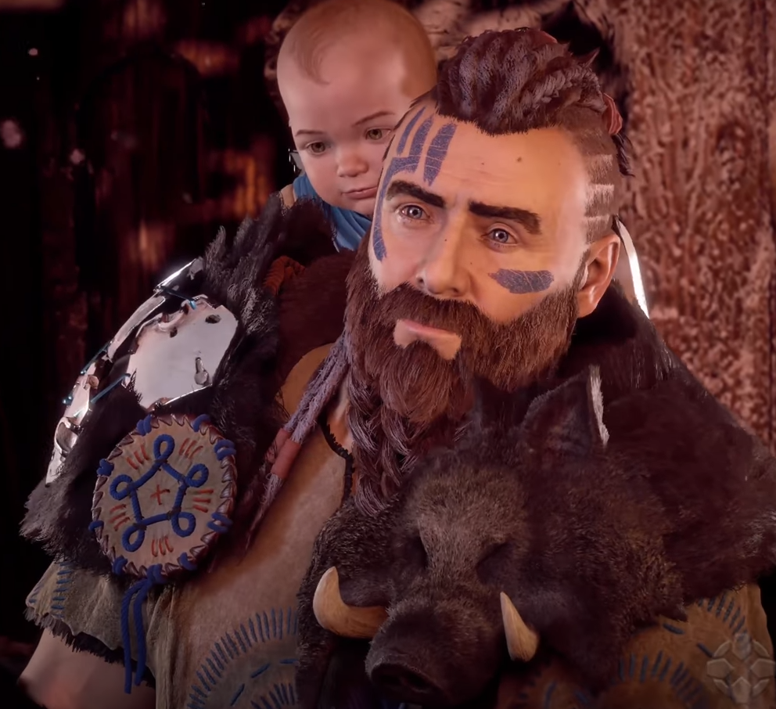

Figure : Rost wearing primitive clothes and facepaint

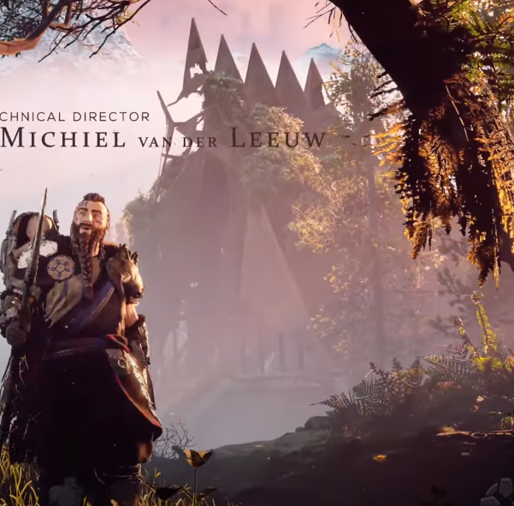

Figure : Rost walking by an overgrown building

Figure : A door with a red "x" on it

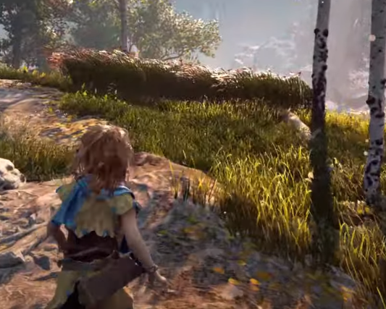

Figure : Aloy looking at tall grass

Figure : A watcher that has been alerted