1. Genre

Folklore horror

1. Setting or location

Rural areas with lots of trees

1. What does your monster look like? (Use images to back up your description.)

It looks like the typical portrayal of bigfoot, but much, much thinner, and more monkey-like. If you find it when it’s not storming, it will have a dark coat of thick fur. However, an electrical charge in the air causes its fur to stick up, revealing the bright white fur underneath.

1. Does it reflect/symbolize people’s fears? Explain how.

This monster reflects people’s fears of storms and losing power. It only appears during a storm; heavy rain and lightning are said to summon it from the old dead tree that it slumbers in. It then hangs from power lines and causes them to snap.

1. Why does it look the way it does?

It’s supposed to be a rural folk monster, which are typically man-like in appearance. It is also very monkey-like because it lives in the trees and hangs from power lines. Realistically, if the monster did exist, it would look like this because it is a cousin of the bigfoot.

1. Where did it come from?

Some people say that it has always lived in the woods, slumbering in its home until a storm rolls in. The native Americans have stories of what they call the “Storm Man,” who would only appear during storms but was relatively passive.

1. Man-made or natural?

This beast is natural, it has lived in the woods of North America for generations.

1. Is there a real-life inspiration in lore from our natural world?

Its appearance is inspired by stories of Bigfoot but otherwise, it’s just an explanation for loss of power during storms.

1. Who does your monster tend to target?

The monster hates electricity, so its priority when it wakes up is snapping power lines. Afterward, it goes up to people’s houses and stares in the window, but only if they still have active electrical devices, like anything battery-powered.

1. When does your monster appear, and why?

The monster appears during storms because it hates electricity. Normally it just slumbers in its home tree, not bothering anyone or causing any trouble. But storms and lightning cause it to go crazy

1. Can you reason with the monster, or is it more primal and reacts based on instincts/emotions?

The monster is essentially a wild animal, it doesn’t reason it acts only on instincts.

1. What’s their motivation?

To get rid of any nearby electrical sources, so that it can go back to sleep

1. What are your monster’s strengths?

It has animalistic strength, it’s essentially a stronger, faster human capable of climbing and moving rapidly through the woods.

1. What are your monster’s weaknesses?

Electricity drives the monster wild, some people say that if you’re somehow able to hit it with a large electrical burst, then you will kill it.

1. What makes your monster hard to kill?

It’s extremely fast and hardy, presenting all the difficulties people typically associate with bigfoot. It’s also hard to spot as it only comes out when it’s storming, meaning that it is dark and usually raining pretty hard.

1. Give your monster a name.

The Native Americans called it the “Storm Man,” which in Cherokee is Aniyvwia'taga, which has been shortened in modern times to “Anitaga” pronounced An-ee-taw-ga.

1. Anything else your team might need to know to help bring your creation to life. (Music, art/color palette, cultural relevance, era.)

The Anitaga only appears during storms and lives in the woods. So a dark, earthy color palette would be best. As mentioned before it usually has a black coat, but electricity makes it stand on end which reveals the white fur underneath.

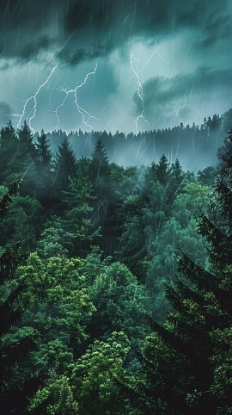

Figure 1The idea for the setting would be much darker.

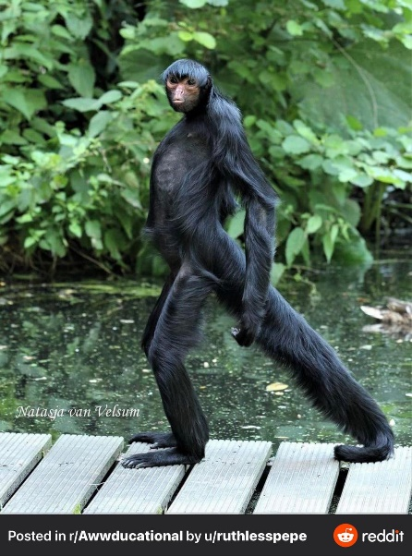

Figure 2The general build of the monster is much bigger and without a tail.



Figure 3Muted forest color palette