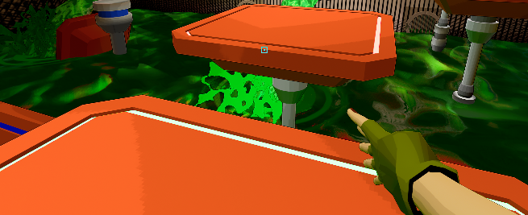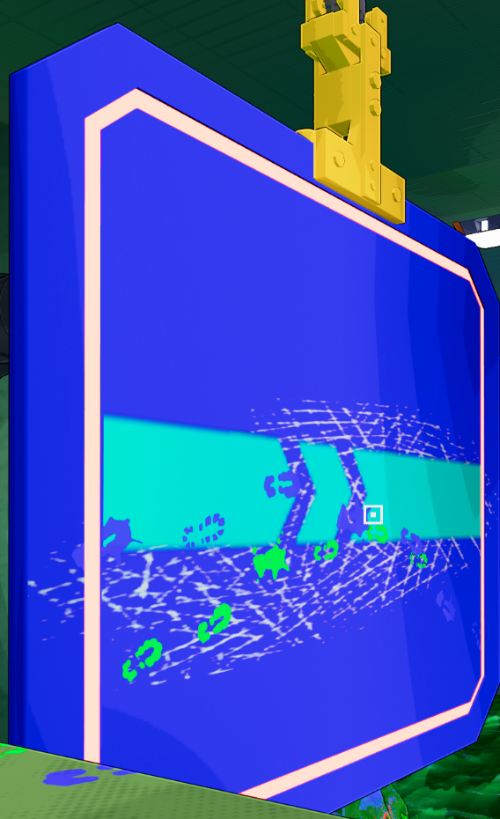

Creating Environmental Movement

# Make the environment pop-

It’s important in any game that your environment isn’t static. When you walk into a room there should be something interesting going on in there, even if there are no enemies. There are many ways to do this. Games which take place in a dungeon might use torches and sconces for fire. A game that takes place outside can use leaves or foliage that moves in the wind. In our game we have lots of examples of environmental movement. The images above are various set pieces that we used in Goosthetic. The important thing to note is that not only do these set pieces add movement to the rooms, they also exist to add to the narrative.

# Environmental Storytelling-

Each of the set pieces in the images above adds something to the narrative. The platform on the top left has two aspects. First, it is springy. This isn’t super important, more just for fun. The second feature though is the glowing lights. On these platforms there is a glowing ring, which changes color depending on whether the player is standing on it. This indicates some kind of telemetry being collected as the platforms can tell when the player jumps on them. It adds to the background of it being a testing area. The wallrunning platform on the top right does the same thing. It has a light ring which glows a different color based on whether the player is wallrunning on it. Once again indicating telemetry. The lower left is a little different. It is meant to be some sort of turbine that is purifying the liquid or attempting to. Most of these turbines spin, some are stuck. Most of them also feature flickering lights, which indicate that maybe they’re failing. It’s one way to show that the normal processes that govern this facility are falling apart, and everything is collapsing. The final piece is the fan in the bottom right. This asset is used in multiple places but is straight forward. In an industrial/lab setting like this it is important to have proper airflow to discourage contamination. All of these pieces make sense for the environment and serve to add to the narrative.