DES 335: Role-Playing Game Design

Student Intro

## Overview

I am greatly outnumbered in here so I’d appreciate a head start on getting to know everyone in the class! I’ve met and/or taught some of you before, but it’s always good to get a refresher. Please answer the following questions, ***save your form with your LAST NAME in the file name***, and submit it in the [CENSUS ASSIGNMENT] Student Introductions assignment. **Doing this intro will meet your Census requirement, so do not forget to submit this assignment!**

Thanks!

Professor Cagle

## IMPORTANT: A Note on Experience and Expectations

I want to stress the following as early as possible: this is NOT “Introduction to Roleplaying Games”. It is also not a course on how to create RPGs for video games, though you will learn skills that will help you in that regard.

This course assumes a base level of knowledge and experience on the unique manner that tabletop roleplaying games (TTRPGs) are designed, played, and run. If you have never played a tabletop roleplaying game before (video game RPGs do not count), this class will be far more challenging, though not impossible.

## IMPORTANT: On Systems vs. Narrative

Although this course is listed as a narrative elective, it focuses very heavily on your systems design skills. You will be creating a TTRPG from scratch (systems), with narrative guiding what you write.

## IMPORTANT: On Writing & Workload

This course is about analog game design and not computer programming. This means that you must write everything in your game: Your systems, adventures, and narrative elements are entirely created in written format. If you dislike, or find difficult, writing at length in the form of thousands of words, consider changing to a different course before the Withdrawal date deadline.

## IMPORTANT: First Assignment

On Moodle, please download and read through the PDF for the ***Unbelievably Simple Roleplaying (USR) Game*** before our first session on Wednesday!

|  |  |
| --- | --- |
| **The Name You Want Me to Call You (First & last)** | Matthew Oliver |
| **Personal Pronouns** | he/him |
| **Home Town/Country/Where’s Home?** | Washington |
| **Academic Year (Choose one from list)** | Senior |
| **Design Focus (Choose one from list)** | Systems |

# Questions

**What is your level of experience with tabletop roleplaying games (TTRPGs)? Choose one from the choices below.**

1. **EXPERT—I’ve been a player, a gamemaster, and written adventures for my friends. I’m perfectly comfortable with TTRPGs and have played a variety of systems.**

**Have you been a player, a gamemaster, or both? What was that first game that you played?**

**I’ve been both, started with 5E**

**If you’re an experienced tabletop roleplayer, how long have you been playing? What games have you played and/or ran as gamemaster? Are you currently playing in a campaign?**

**I’ve been playing for 7-8 years now. I’ve played 5E, PF1E, PF2E, and Star Wars 5E. I’m currently in a 5E campaign that my brother is DMing**

**This class involves a LOT of systems and overall writing. How much experience do you have creating your own TTRPG systems or homebrew rules? How much experience do you have writing fiction and dialogue? Are you comfortable describing scenes?**

**I’ve been writing homebrew for 5E for almost as long as I’ve been playing it. This is my first real attempt at my own TTRPG but I’ve been doing a lot of research and feel fairly confident. In terms of fiction and dialogue I haven’t done a ton, but I am very comfortable describing scenes.**

**Take** [**this online quiz**](https://www.tryinteract.com/quiz/what-role-playing-game-play-style-are-you/) **and let me know what results you got! Do you agree with the assessment?**

**I got fighter, which I don’t agree with since I’ve played 90% Barbarian over the years.**

**What are your three favorite games (any game, not just video) ever and why?**

1. **Star Wars Battlefront 2, because it was my first game and played a ton of it.**
2. **Legend of Zelda: Twilight Princess, I also played a ton of this, over and over**
3. **The Witcher 3**

**Name a tabletop RPG game that you’ve played where you felt immersed in the story and action. Briefly describe why.**

**I felt more immersed in PF1E than anything else because it feels like you can genuinely build your character into a unique individual.**

**Why do you want to make games?**

**Cause I love them, and it just so happens I love making them as well.**

**What are your post-DigiPen career aspirations?**

**I would love to make my own games, which is what everyone says. But realistically I’ll just take the first job I can get and see what goes from there.**

**Please attach a photo of yourself here! (It doesn’t have to be your official Digipen picture)**

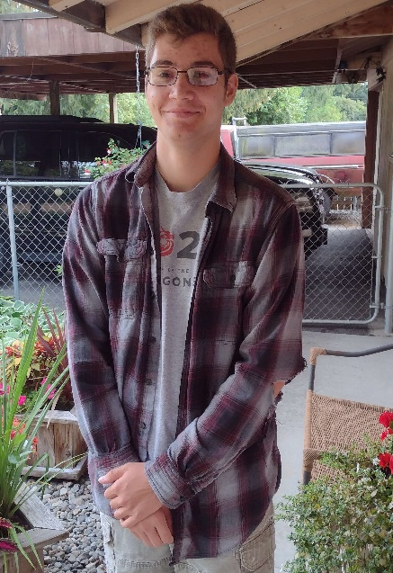

**Now, attach a photo that encapsulates your personality (It doesn’t even have to be you!)**