**Music sequencer with a Musical Instrument Digital Interface**

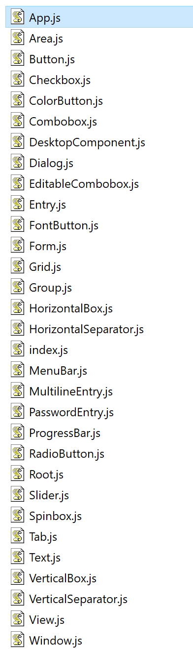

Proton Native innately come with these Components, which interfaces with the libui-node, and in turn invoke the libui library. It is a platform independent GUI Library written in C. Great for performance but lacking in features and functionality.

**Features**:

Sequencing sound bites/samples on a UI component.

Save track as a sound file.

Replay sound track, On UI component timeline based.

Predefined sound samples/bites to use.

Clickable tiles in which a sound will play when clicked or played on timeline.

Change the BPM of the track.

Edit and play back music.

**Functionality**:

Electron JS as the foundation and using React. Importing any JS libraries that improve the functionality of React. Compared to Proton Native it has and can already use existing Technologies.

Since React is the same for browser and Electron. Compare Electron build performance with the browser build equivalent and observe differences and how.

**Libraries**:

React – UI components.

Electron – JavaScript Desktop Framework.

P5-Wrapper for Electron – This will visualise the timeline UI component by extension P5-Sound.

Web-audio-api library (if necessary) – this will allow JavaScript libraries to manipulate audio data.

<http://sampulator.com/>

<https://splice.com/sounds/beatmaker>