|  |  |
| --- | --- |
| Critical Information Summary | |
| Student Name | Matthew Pindral |
| SID | 215315133 |
| Mark Aimed For (%) | 60% |

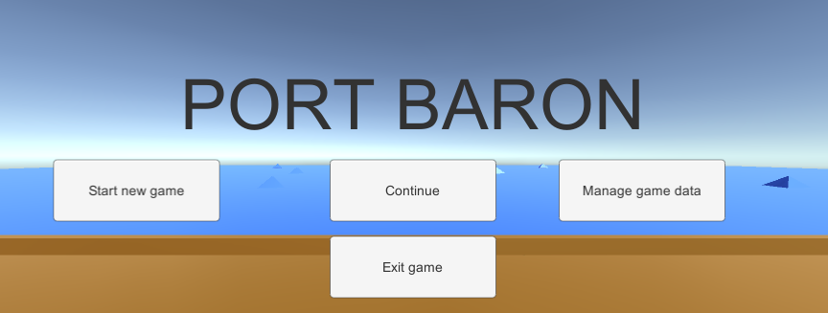

### Criteria: Code Commits [Distinction]

* I have completed 20 unique day commits.

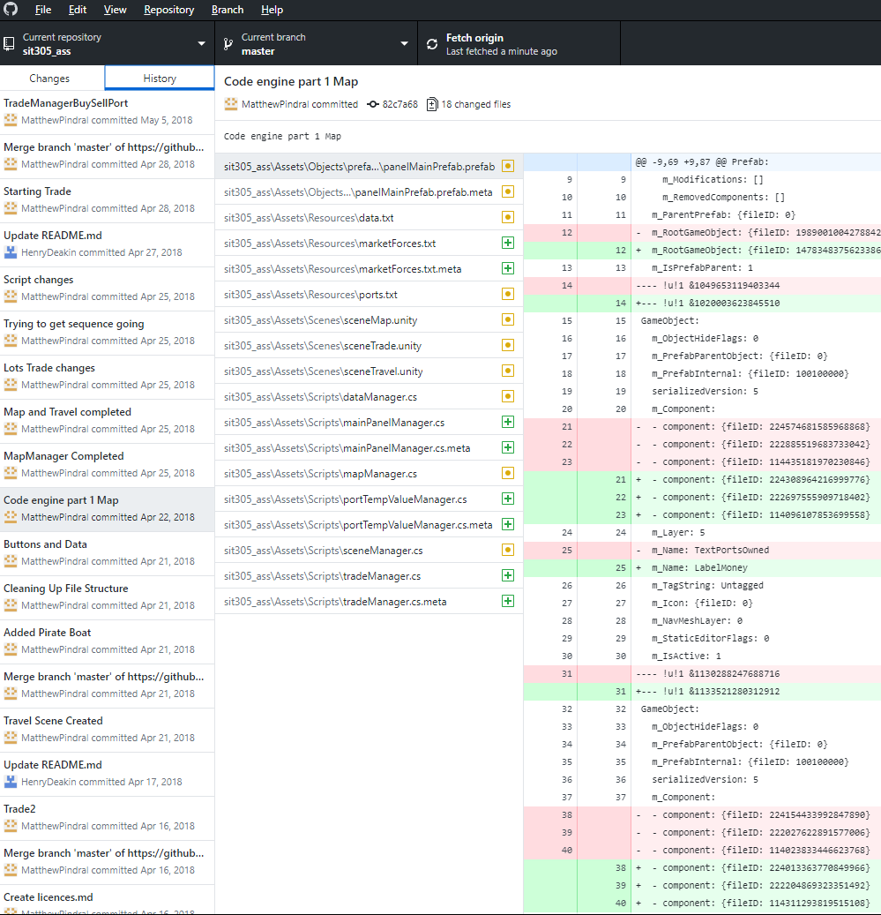

### Criteria: Weekly Progress [Pass]

* My Github Change Summary had comments against each commit.
* The changelog text file (which replicates the Github comments) was updated only a few times.

### Criteria: Code Quality [Credit]

* Every class, and each major method/function has an explanation comment, as well as method/function signature explanation.

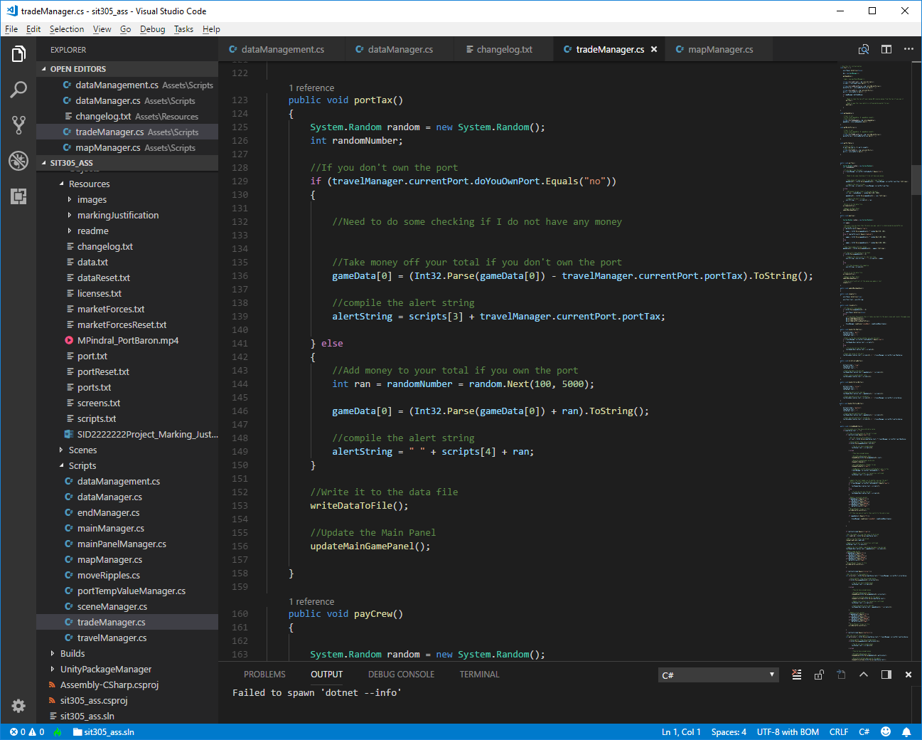

### Criteria: Legal [Credit]

* I have a licenses.txt file, and all materials I use I have legal rights to use for commercial use.
* My attributions include hyperlinks to source pages as per the authors wishes.

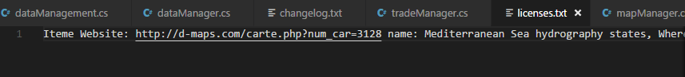

### Criteria: Playability [Credit]

* My game is engaging for atleast two hours.
* The game difficulty gets harder if the player is succeeding, thus to prevent the user from finishing the game too quickly.
* This is achieved by increasing the cost of commerce (wages, real estate, merchandise, import taxes etc)

### Criteria: Data Handling [Distinction]

* I load all game data through local text files.
* I maintain user game state within local files
* I enable the user to manually change the local text files (if they want to cheat)
* I save user settings within a local text file.

### Criteria: Layout [~Pass]

* The screen layout is not great and it is not adapting to orientation changes well.

### Criteria: Publishing [Pass]

* My App meets guidelines.
* It has appropriate permissions defined in the Android Manifest.
* It includes an Icon and Company name.

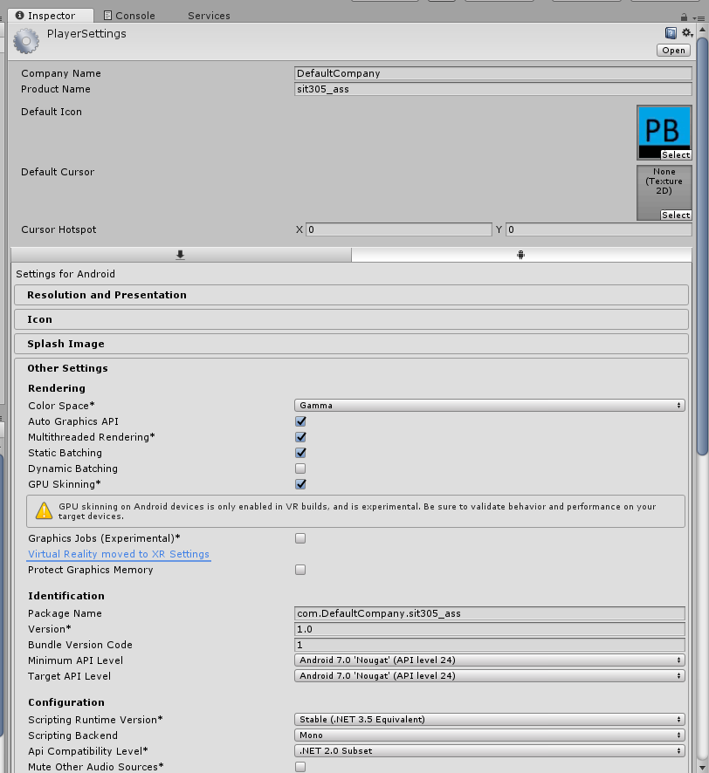

### Criteria: Demonstration video [Pass]

* I demonstrated all main features working in the app which I wish to be graded on.