**System Requirements**

This program is developed in C# using Microsoft Visual Studio 2015. The .exe should run on any windows operating system. This file can not be read by Linux or Mac devices without additional third party software. This file will run in the computer science lab computers on the second floor of the engineering building and can be tested there.

**Running The Program**

To run this program simply plug in the usb drive, locate it in your computers file explorer and double click the .exe file located on the drive. This will open a terminal window and start requesting user input. The program will ask for an integer value to use as the programs increment amount for updating the program counter(PC). Input an integer value and press enter.If a non-integer is entered the user will be prompted to input a valid value. Next the computer will ask for a list of instructions you want to make available to the machine. The available instructions are the 31 instructions from the data sheet passed out in class as well as brz as explained in class. Enter your desired instructions one at a time pressing enter after each. You can enter the * character to finish inputing instructions. If you enter an instruction that you have already selected the program will prompt you to try again. If you do not want to input any more instructions enter *. After the program reads * or reachs 32 unique values it will then validate the givin instructions for spelling and availability. If an instruction is not valid the program will ask you if you want to change or delete that instruction. Enter the correct instruction or type delete to remove the instruction. Once all validation errors are fixed the program will output:

1) the givin IPC (displayed in blue)

2) the present available control vectors(displayed in pink)

3) the complete micro program(displayed in purple)

The program will then ask if you want to restart or exit. To exit type * and to restart enter any other value(or leave the input empty and press enter).

Note regarding the IPC: only a select few instructions will print their entire syntax within the IPC. These instructions are add,lw,sw,mult,brz,bne,beq, and j.

**Test Case Example**

**Input:**

* Increment size = 1
* Available Methods = add,lw,brz

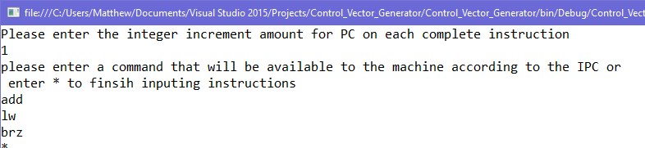

**Output:**

