Oundle Minibus Rental System

Matthew Riegels Coursework 2025

Contents

Analysis 2

Project description 2

Stakeholders 4

Research 6

Essential features 7

Limitations 8

Hardware & software requirements 9

Success criteria 10

Design 11

Tables 11

# Programming project (Component 03 or 04) marking criteria AO 2.2 Analysis (maximum 10 marks) marks The candidate Will have: • Identified some features that make the problem solvable by computational methods. • Identified suitable stakeholders for the project and described them and some of their requirements. • Identified some appropriate features to incorporate into their solution. • Identified some features of the proposed computational solution. • Identified some limitations of the proposed solution. • Identified some requirements for the solution. • Identified some success criteria for the proposed solution. 3—5 marks • Described the features that make the problem solvable by computational methods. • Identified suitable stakeholders for the project and described how they will make use of the proposed solution. • Researched the problem looking at existing solutions to similar problems identifying some appropriate features to incorporate into their solution. • Identified the essential features Of the proposed computational solution. • Identified and described some limitations of the proposed solution. • Identified most requirements for the solution. • Identified some measurable success criteria for the proposed solution. — 70 marks marks • Described the features that make the problem solvable by computational methods and why it is amenable to a computational approach. • Identified suitable stakeholders for the project and described them and how they will make use of the proposed solution and why it is appropriate to their needs. • Researched the problem in depth looking at existing solutions to similar problems identifying and describing suitable approaches based on this research. • Identified and described the essential features of the proposed computational solution. • Identified and explained any limitations of the proposed solution. • Specified the requirements for the solution including (as appropriate) any hardware and software requirements. • Identified measurable success criteria for the proposed solution. 9—10 marks • Described and justified the features that make the problem solvable by computational methods, explaining why it is amenable to a computational approach. • Identified suitable stakeholders for the project and described them explaining how they will make use of the proposed solution and why it is appropriate to their needs. • Researched the problem in depth looking at existing solutions to similar problems, identifying and justifying suitable approaches based on this research. • Identified the essential features of the proposed computational solution explaining these choices. • Identified and explained with justification any limitations of the proposed solution. • Specified and justified the requirements for the solution including (as appropriate) any hardware and software requirements. • Identified and justified measurable success criteria for the proposed solution. O marks = no response or no response worthy of credit. Analysis

## Project description

*Described and justified the features that* make *the problem solvable by computational methods, explaining why it is* amenable *to a computational approach.*

#### Current system details

When a teacher at school wants to organise transportation for a group of students, they have to email the school’s transportation office and request a minibus with a certain capacity for a certain time. The minibus also needs a driver, and sometimes the drivers are hired instead of being school staff. Staff requesting transport can either drive themselves or choose to use a hired driver. The school has a small number of hired drivers on casual contracts. Additionally, the school sometimes hires minibuses instead of using those from its own fleet.

* Required information for a request:
  + Vehicle type,
  + Date/time required,
  + Destination/use,
  + Date/time returned,
  + Whether a hired driver is required.
* Booking process:
  + Provide all above information for each vehicle.
  + If you request a driver, the job is added to a shared spreadsheet and an email is sent to the group of drivers notifying them; the drivers choose to take jobs for times when they are available.
    - The drivers are not full-time employees, and as such are not obliged to take the jobs. As a result, this part can take a few days.
  + Once a driver has accepted a job, the requestor will be informed that their request has been accepted.
  + The current system aims to respond within 4 days of a request.
  + Requestors can talk to drivers directly, but any change of plan must still be reflected in the spreadsheet so that the drivers are appropriately paid, and the office knows when they are busy.
* Additional details:
  + The school has four casual drivers currently on the books.
  + They have the same recruitment checks as permanent staff, but they have casual contracts (they can work as much or little as they want).
  + There are some drivers currently on holiday (general point being that driver time off should be accounted for).

#### Description of the problem

The problems with the current system that I am trying to solve are as follows:

* Requests come through by email to the office that manages transportation, and those emails can get lost in the inbox, or take a long time to be actioned on by the office.
  + A computerized system would be able to keep track of individual requests and remind administrators to action on them.
  + Since the requests will be kept track of in an online database, they will be easily accessible.
  + Once logged in, the website would allow easy traversal to all its features eliminating any confusion, lack of clarity, or miscommunication.
* The number of staff that can drive large minibuses is dwindling due to some recent legislation change in the UK which means that staff need special training to legally drive the minibuses on their licence.
  + The current system can’t deal with the heightened demand for drivers.
  + The new system would streamline requests, allowing reduced numbers of drivers to handle a greater number of requests.
* It is often unclear whether all drivers are aware that a job is available.
  + The new system will make jobs obviously and readily visible to drivers on the main page. This will ensure that all drivers can clearly see what jobs are available to them.
  + I should also add a means by which drivers can indicate that they have read a job so that the coordinator can confirm that all drivers are aware of their options.

## Stakeholders

Identified suitable stakeholders for the project and described them explaining how they will make use of the proposed solution and why it is appropriate to their needs.

In general, any stakeholders will be in one of the following categories:

* Coordinator.
  + The only candidate for this category is Kristian Fewster ([kfewster@oundleschool.org.uk](mailto:kfewster@oundleschool.org.uk)), the school’s transport manager.
  + A coordinator uses the system to ensure that the driver knows about any details of the job, and that the requestor knows that their job has been taken. The coordinator is also responsible for making sure that the drivers are aware of the jobs available.
  + The system will be able to send automated emails to relevant people, as well as store request information online in a centralized location to make the details of a particular job clear.
* Driver.
  + Drivers need to see the details of the jobs they can choose to take. It should also be clear which jobs are available and which have already been taken.
  + Available jobs will be posted on the online system with all relevant information provided.
* Requestor.
  + Requestors need to provide the information relevant to their request.
  + There will be a fixed online form to enter this information.

#### Stakeholder feedback

Kristian Fewster helpfully answered some of my questions:

* Could you shed some light on the recent changes in British licencing laws and how they have affected transportation at school?
  + “As far as British Driving legislation, I would suggest you go on the DVLA Website as this explains everything to do with transport licencing laws and is up to date.”
* How much do the aesthetics of the website matter to you?
  + “Aesthetically, it needs to be simple to use and have clear steps as all levels of IT competencies would have access including the more mature drivers.”
* What problem with the current system would you most like to avoid in the new system?
  + “The problem we currently have is a that we use a shared spreadsheet that I populate with details of a trip, then the casual drivers look through and put their names against them, but I need to know if all drivers have seen them. Below is part of our current sheet and details I need.”

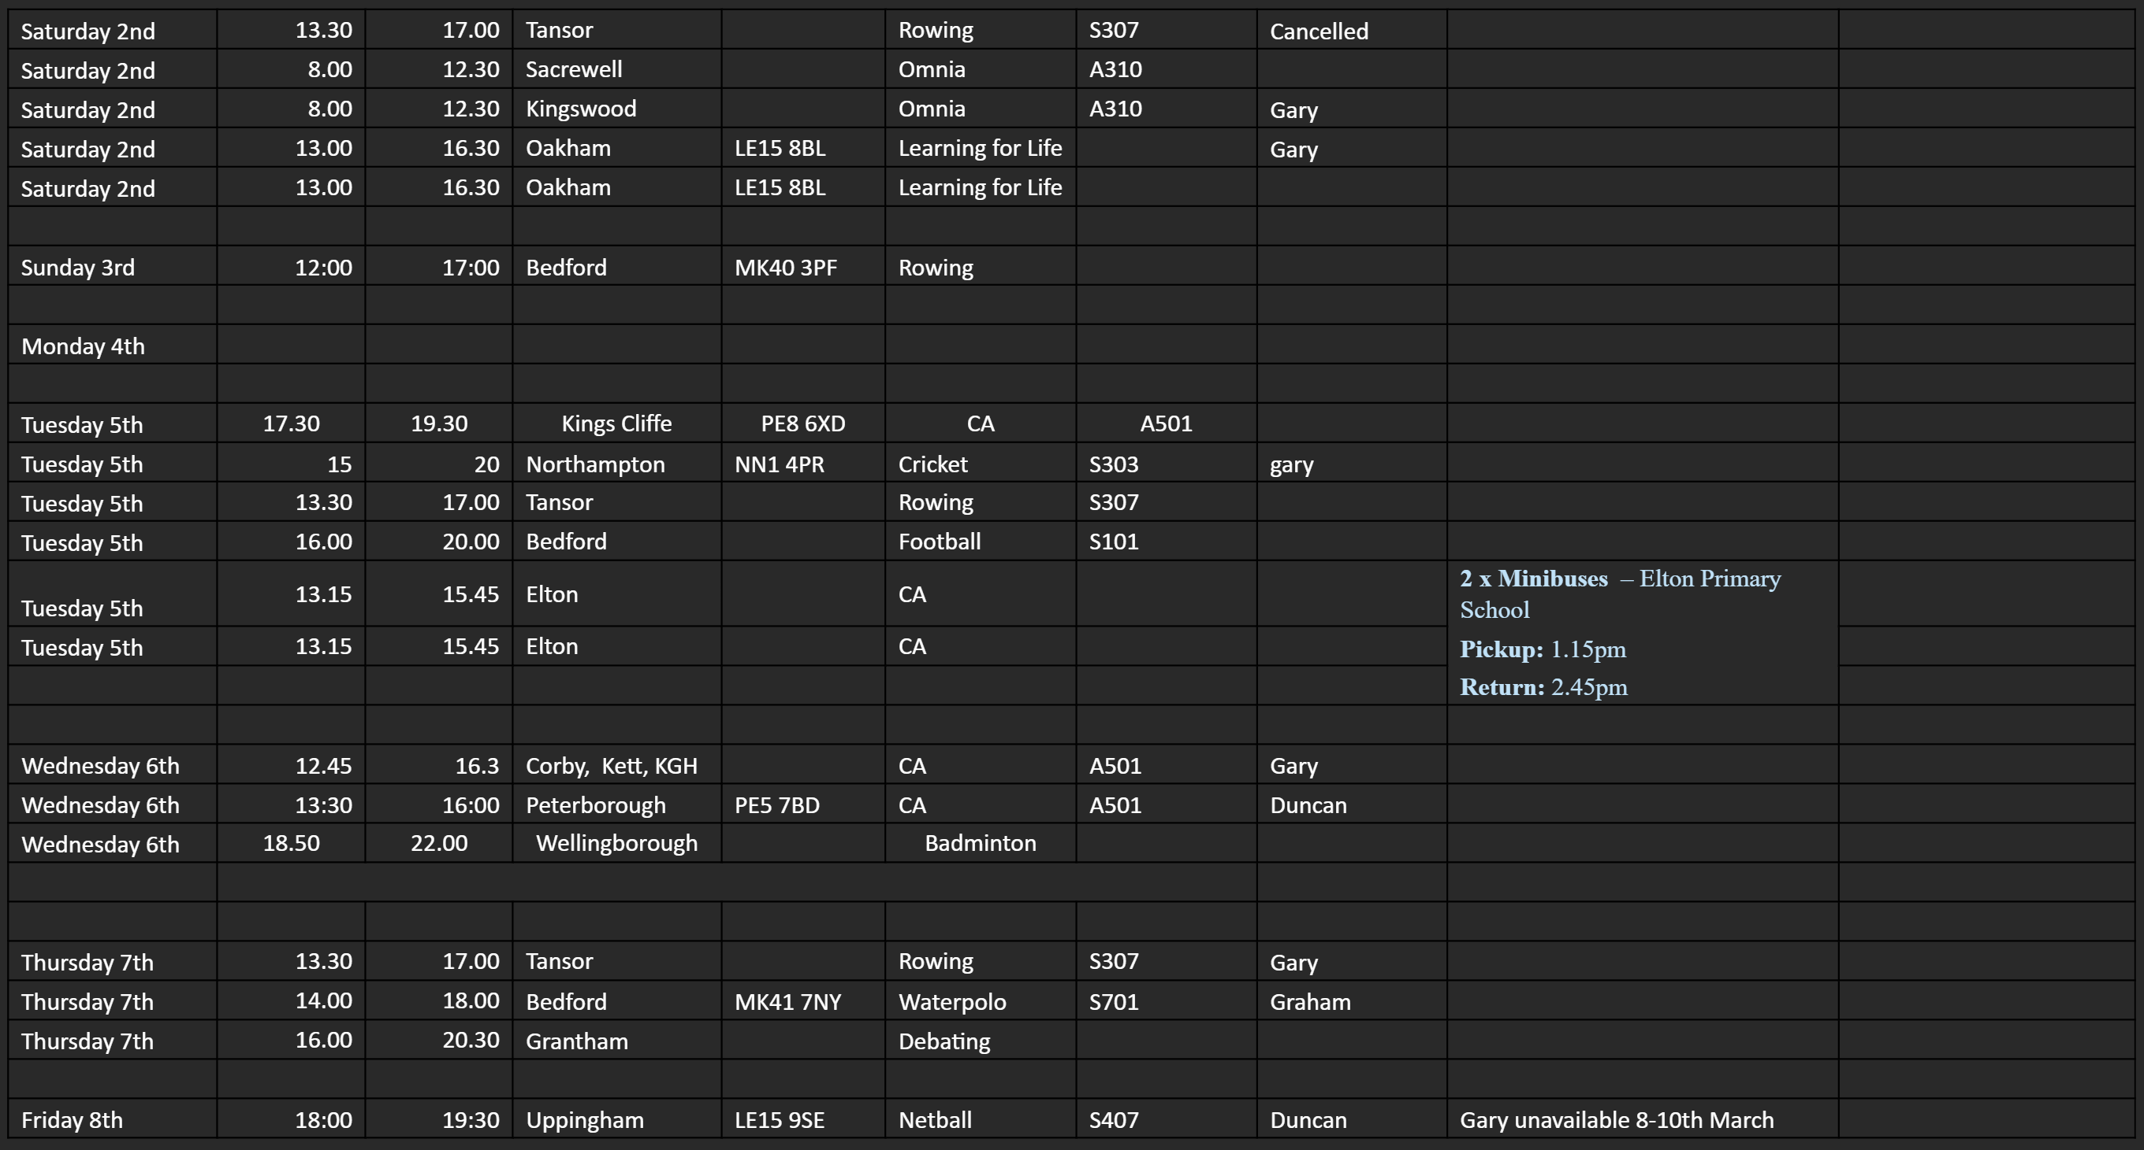

Considering this feedback and the screenshot, I will

* Ensure the design of the website is straightforward and simple, so that technologically inexperienced users will not have difficulty using the service.
* Create a feature that lets Kristian know whether drivers have seen that a job is available (and read the details of said job).
* Make it possible for requestors to provide a postcode for destinations outside of school.
* Similarly, add a field for the purpose of the trip (such as “CA”, “Cricket”, “Learning for Life”) in the screenshot above.

## Research

Researched the problem in depth looking at existing solutions to similar problems, identifying and justifying suitable approaches based on this research.

I followed Kristian’s advice and looked on the DVLA website to research the recent changes to UK licencing laws.

## Essential features

Identified the essential features of the proposed computational solution explaining these choices.

All users will have an account which they must log in to before accessing the system. Each account will have one or more roles. Roles determine the capabilities of that account.

* The school’s hired drivers:
  + Must be able to read all requests.
    - So that they can make an informed choice whether to accept them.
  + Must be able to indicate to Kristian that they have read a request.
    - So that Kristian knows whether they are unavailable or just haven’t read the request (since the drivers are on casual contracts, they may not be checking available jobs frequently).
  + Must be able to accept requests, and these requests must then be unavailable to other drivers.
    - Any request only requires one driver, so multiple drivers shouldn’t be able to accept the same job otherwise their time will be wasted.
    - Drivers should be able to accept the jobs so that the system can record when they are busy and how many hours they’ve worked.
* Staff members:
  + Must be able to add requests to the database.
    - So that drivers can see and accept them.
  + Must be able to remove their own requests from the database.
    - So that they can remove mistakes, preventing them from clogging up the system.
  + Must be able to view when drivers are available.
    - So that they can judge whether to
* Coordinator
  + Realistically, the only person to hold this role will be Kristian Fewster, the school’s transport manager.
  + The coordinator is the one who oversees the requesting and accepting of all jobs.

## Limitations

Identified and explained with justification any limitations of the proposed solution.

* The system will not manage money or automate transfers of funds.
  + This is because I do not have the experience or skills required to safely manage digital currency, and any mistakes could result in unjustified charges to people’s accounts. I do not want to be responsible for accidentally removing people’s money from their accounts for no reason.
  + This means that it will not automate payments to the hired drivers, although it can calculate how much they are owed so that higher authorities can handle the actual payment.

## Hardware & software requirements

Specified and justified the requirements for the solution including (as appropriate) any hardware and software requirements.

## Success criteria

Identified and justified measurable success criteria for the proposed solution.

# Design

## Tables

#### Entity relationship diagram

I will have three tables in the database for this system.

One will represent the school’s fleet of vehicles. This will need to store information about each vehicle such as registration number and maximum capacity. It will also need to take into account the hired vehicles, and one way to do this is to have a Boolean variable attached to each vehicle in the table that indicates whether they are currently in school or not. This means that if the same vehicle is hired more than once, its information doesn’t need to be re-entered. An alternative method could be to instead have a date/time in and out for each minibus, and I think this method is superior. This is because if a vehicle is in school now, it might be requested for a job in a week, in which time it will have been returned. As such, the end date of the renting (NotAvailableFrom) should be stored to avoid this problem. I do not think the start date is necessary.

**Requests**

**Users**

**Transport**

UserID  
Password  
Email  
Telephonenumber  
Forename  
Surname  
IsDriver

RequestID  
Date/time out  
Date/time in  
DriverID (foreign UserID)  
VehicleID (foreign)

VehicleID  
RegNum  
Capacity  
NotAvailableFrom

These are more detailed descriptions of each of the three tables the database will require.

#### Users

|  |  |  |  |  |
| --- | --- | --- | --- | --- |
| **Field name** | **Data Type** | **Validation** | **Typical data** | **Justification** |
| UserID | INT(6), auto increment, Primary key | Must be exactly 6 digits, auto generated by the system. | 840551 | Unique identifier for each user. This will be used in other tables for drivers and requestors of jobs. |
| Password | VARCHAR(60) | Will be hashed with password_hash so will have exactly 60 characters always. Plaintext passwords will not be restricted. | $2y$10$.vGA1O9wmRjrwAVXD98HNOgsNpDczlqm3Jq7KnEd1rVAGv3Fykk1a | Password is required to log in to the system, which is required to view anything on the system, or make or accept requests. |
| Email | VARCHAR(40) | Must have exactly one ‘@’, and at least one ‘.’ after. | smith.j@oundleschool.org.uk | The entire email address of the user. This will be used to send automated email reminders to drivers when jobs become available. |
| Telephonenumber | VARCHAR(11) | Must be 11 characters, all numeric. | 07305715924 |  |
| Forename | VARCHAR(20) | None | John | First name of user |
| Surname | VARCHAR(20) | None | Smith | Surname of user |
| IsDriver | TINYINT(1) | None | false | Whether the driver is a hired driver or not. False indicates ordinary member of staff. True indicates hired driver |