**Version 2 – Rework after finding that external voltage sources cannot be used**

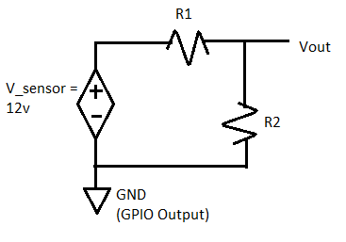

Vout = 3.3v or 5v if door open, 0v if closed (by Raspberry pi GPIO [documentation](https://www.raspberrypi.org/documentation/hardware/raspberrypi/gpio/README.md#:~:text=On%20Raspberry%20Pi%2C%20all%20GPIO,GPIO%20block%20within%20the%20SoC.)). This is a GPIO input pin.

Vs = Vsensor  = 12v if door closed, 0v if open (by manufacturer documentation).

**Program -**  checks for when Vout = 0, corresponds to open door.

**Circuit -** When door closed, need circuit to lower voltage to not destroy input pins (reduce voltage to 3.3v).

Calculations:

Vo = ->

**Relationship: $R1=\frac{12}{3.3}*R2-R2$ = 3.64*R2 – R2 = 2.64*R2 = R1**

R2 = R1 / 2.64. R1 = R2 * 2.64

Lowering R2, decreases Vout. If needed for resistor availability, approx coefficient to 3. Vout might become too low even when high. **Requires threshold testing.**

Solution set:

R1 = 2640, R2 = 1000. Approx R1 = 3000, R2 = 1000 -> drop 3/4th of the voltage before Vout, 12*3/4 = 3v max, won’t burn out input pin.

Resistors used all 1k ohms. R1 = 3 1k’s in series.

**Pins Used**:

* Vout = GPIO Pin 1 (set to in and pull up)
* GND = Any ground pin (picked pin next to pin 1)
* Gpio read 1 = 0 when close, 1 when far

**Version 1 – Does not work, sensor cannot work with external voltage source.**