**CS673S16 Software Engineering** 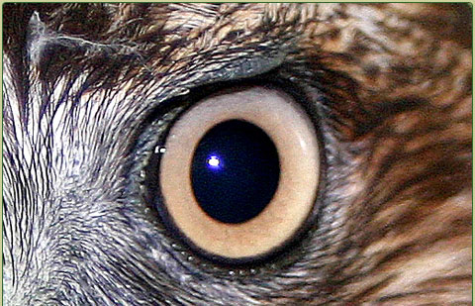

**Team 4 - Bird’s Eye Statistics**

**Tests Report**

|  |  |  |  |
| --- | --- | --- | --- |
| Team Member | Role(s) | Signature | Date |
| Matthew Scott | Project Lead | *Matthew Scott* | 2018/04/22 |
| Patrick Ryan | Assistant Lead | *Patrick Ryan* | 04/30/2018 |
|  |  |  |  |
|  |  |  |  |
|  |  |  |  |
|  |  |  |  |
|  |  |  |  |
|  |  |  |  |

**Revision history**

|  |  |  |  |
| --- | --- | --- | --- |
| **Version** | **Author** | **Date** | **Change** |
| **1** | **Matthew Scott** | **2018/04/22** | **Initial** |
|  |  |  |  |

Introduction

Test Summary

Tests Reports

Testing Metrics

References

Glossary

# Introduction

In this document we go over the test cases for the project in a general way. The details of each of the test cases are included in the Test Report.

# Test Summary

* + Unit Tests
    - ScraperTests - These tests all ensure that given a predefined text (mock of an actual html scrape), the correct data is parsed from that. In some of these tests it is the “getJobSkills” function being tested where the return is a dictionary of skills and counts, while the remainder are tests of the “getJobs” function where the return is an array of JobData (company, jobTitle, salary, location, url, and skills).
    - CollectDataTests - Two of these are tests of the getNextMonth function, which returns the next month from a date. The other three are tests of the “getCounts” function which converts the dictionary returned from a scraper function to a format easily inserted into the database.
  + System Tests - Our system tests test that various elements are present on the UI and/or that control objects work as intended through button clicks.
  + Acceptance Tests - Our test report has a column for those tests specifically tied to acceptance of a user story.

# Tests Reports

See TestCases worksheet (..\Documents\TestCases.xlsx)

# Testing Metrics

|  |  |  |  |  |  |
| --- | --- | --- | --- | --- | --- |
| **Auto (A) or Manual (M)** | **Unit / System / Acceptance** | **Module** | **Total Count** | **Passing Count** | **Failures** |
| A | Unit | CollectData | 5 | 5 | 0 |
| A | Unit | Scraper Function | 10 | 10 | 0 |
| A | Unit | UI | 17 | 16 | 1 |
| A | Acceptance | Selenium | 6 | 6 | 0 |
| M | Acceptance |  | 3 | 2 | 1 |
| Total |  |  | 41 | 39 | 2 |

# References

# Glossary