Assessment Brief

CA1 – Learning Journal

Module Name | Lecturer Name
Physical Interaction | Joachim Pietsch
Title of Brief
Learning Journal
Percentage of Overall Grade | 20%
Date handed out | 21/09/2026
Due date | 14/12/2026, 20:59
Individual or Group | I

Description
You are required to maintain a weekly learning journal for this physical computing module. This journal will serve as a personal record of your journey, documenting your progress, challenges, and insights as you engage with the course material and practical projects.
It is a crucial tool for self-reflection and a key component of your overall assessment.

The purpose of this journal is to:
- Track your progress and development throughout the module.
- Document your practical work, including code snippets, circuit diagrams, and photos/videos of your projects.
- Reflect critically on what you have learned, identifying both successes and areas for improvement.
- Develop problem-solving skills by recording challenges you encounter and how you overcome them.

Deliverables

Your journal should be maintained in a single Word document, with a new entry for each week. Each weekly entry should be approximately 300-500 words and should clearly articulate your activities and reflections for that period.

Resources
Weekly Journal Template

Week Number: [e.g., Week 1] Date: [e.g., 21/09/2026]
1. Goals for this Week:
- Briefly list what you aimed to achieve this week based on the module's schedule and your project goals. (e.g., "Understand how to use a potentiometer to control an LED," "Build and test the initial prototype for my final project.")
2. Activities Undertaken:
- Describe the tasks you completed. Be specific. Mention the tutorials you followed, the components you used (e.g., Arduino Uno, breadboard, servo motor), and the programming concepts you applied.
- Include evidence of your work. This can be in the form of code snippets (properly formatted), photographs of your circuits, screenshots of your software, or short video clips of your project in action.
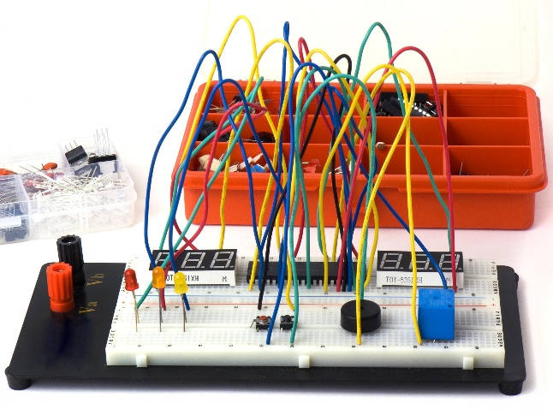
3. Challenges & Problem-Solving:
- What problems did you encounter? Was it a bug in your code, a faulty connection in your circuit, or a concept you struggled to grasp?
- Explain the steps you took to diagnose and solve the problem. Did you use a multimeter, consult online forums (e.g., Stack Overflow, Arduino Forum), or ask a classmate for help? This section demonstrates your resilience and analytical skills.
4. Key Learnings & Reflections:
- What were your main takeaways from this week? This is the most important section.
- Reflect on your successes and what you are proud of.
- Consider what you would do differently next time. How has this week's work influenced your understanding of physical computing and your plans for your final project?

Schedule
Date | Description | Deliverable
21/09/2026 | Hand out of assignment | Link to your word document
14/12/2026, 20:59 | Hand in of assignment | Final version of journal

Marking Scheme
Category | Description | Weighting %
Writing & Structure |  | 30%
Reflection |  | 30%
Evidence (Code, Images) |  | 30%
Resources Referencing |  | 10%

Rubric
Criteria | A (Excellent) | B (Good) | C (Satisfactory) | D (Adequate) | F (Unsatisfactory)
Writing & Structure | Writing is clear, concise, and professional. Entries are well-structured and easy to follow. Free from significant spelling or grammatical errors. | Writing is mostly clear and well-organized. There may be a few minor errors, but they do not impede understanding. | Writing is generally understandable, but may lack clarity or structure in places. Some recurring errors are present. | Writing is difficult to follow at times due to poor structure or significant errors. | Writing is unclear and unstructured. Numerous errors make the journal very difficult to comprehend.
Reflection | Entries are deeply insightful and critical. The student analyzes successes and failures, connecting practical activities to theoretical concepts and considering future improvements. | Entries are thoughtful and analytical. The student explains what they learned and why things happened, going beyond simple description. | Entries are more descriptive than reflective. The student states what they did and learned, but with limited analysis of the process. | Entries show minimal reflection. The journal acts as a simple log of activities with little to no analysis. | No reflection is present. Entries are purely a list of tasks with no insight into the learning process.
Evidence (Code, Images) | High-quality, relevant evidence is seamlessly integrated to support the text. Code is well-formatted and commented. Photos /screenshots are clear and purposeful. | Good quality, relevant evidence is consistently included. The evidence clearly supports the points made in the journal. | Evidence is present, but it may be of inconsistent quality, poorly integrated, or not always directly relevant. | Evidence is sparse, of poor quality (e.g., blurry photos, unformatted code), or frequently missing. | Little to no evidence of practical work is provided.
Resources & Referencing | Consistently and correctly cites a range of appropriate external resources (datasheets, tutorials, forums). Demonstrates proactive research. | Cites most external resources used, generally with correct formatting. Shows good use of provided materials and some independent research. | Mentions using external resources, but without formal citations or links. Primarily relies on class materials. | Vague mention of using external help (e.g., "I looked online") with no specific references provided. | No mention or crediting of external resources. Appears to have worked in isolation or fails to credit others' work.

