CA documentation
CA: | No XX
Title: | My 1st project
Title: | Joe Bloggs
Date submitted: | 3/2/2024

Description
A brief description of your project goes here. Explain its purpose and sensor input and desired output. Mention the tutorials or references [1] that you have used. List these in the reference section.

How to use the project

Describe how to interact with the hardware and software interfaces of the system. Describe the expected behaviour of the system for given sensor readings.

Hardware

Include a bill of materials used in the build of the project, such as:
Item | Quantity | Notes
Arduino Uno R3 | 1
4-Digit 7-Segment | 4 | Common Anode, 14 pins
220Ω Resistor | 8 | Connect to the 7-segment segment pins
PNP Transistor | 4 | Optional, recommended
4.7kΩ Resistor | 4 | If you use the PNP transistors
12mm Push button | 3
Piezo Buzzer | 1 | Used for the alarm
DS1307 RTC | 1 | Optional

Electronics
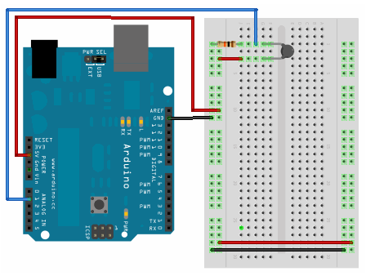 Figure 1: Fritzing diagra | 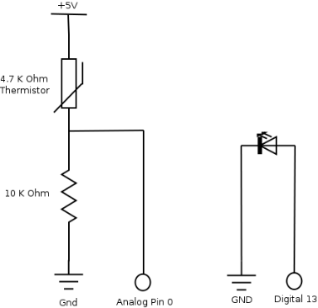  Figure 2: Schematic
Include a diagram/Schematic of your project here. Also include relevant information about type of sensors. What voltage they are producing based on which environmental input. You could refer to their respective datasheets. [2]
Describe the PIN connections for your system here

Pin Connections
Arduino Uno Pin | Device | Device Pin
2 | 7-Segment | 14 (Dig 1)
3 | 7-Segment | 11 (Dig 2)
4 | 7-Segment | 10 (Dig 3)
5 | 7-Segment | 6 (Dig 4)
6 | 7-Segment | 13 (A)
7 | 7-Segment | 9 (B)
8 | 7-Segment | 4 (C)
9 | 7-Segment | 2 (D)
10 | 7-Segment | 1 (E)
11 | 7-Segment | 12 (F)
12 | 7-Segment | 5 (G)
13 | 7-Segment | 8 (Colon)
A0 | Hour Button | -
A1 | Minute Button | -
A2 | Alarm Button | -
A3 | Buzzer / Speaker | -
A4 | DS1307 RTC | SDA
A5 | DS1307 RTC | SCL

Project Structure

The code is divided into several modules. Describe these here and any libraries that you used for example servo.
The code should be split into HW section and Interface. You do not need to copy and paste the entire codebase but it should include a walkthrough how the system functions. You can point to key functions that support the function of your system:
- Arduino code
- Processing or other platform

User Testing
Describe the user tests conducted, please see the separate file game_controller testing.

Reflection
What you have learnt during this project. Where did you encounter difficulties, how did you overcome them. How you could develop this project further.

References
[1] Available at: http://arduino.cc/en/Tutorial/Blink
Accessed 25th January 2012
[2] http://www.vishay.com/docs/29046/29046.pdf
Accessed 25th January 2012

