CA documentation
CA: | No 2.
Title: | Alternate Controller
Name: | Matthew Seymour
Date submitted: | 01/11/2026

Description
A brief description of your project goes here. Explain its purpose and sensor input and desired output. Mention the tutorials or references [1] that you have used. List these in the reference section.

How to use the project

Describe how to interact with the hardware and software interfaces of the system. Describe the expected behaviour of the system for given sensor readings.

Hardware

Include a bill of materials used in the build of the project, such as:
Item | Quantity | Notes
Arduino Leonardo | 1
HC-SR04 Ultrasonic Sensor | 1 | To measure the distance from the hand/arm to the sensor, and steer the car accordingly.
Piranha RGB LED (Common Anode) | 1 | To show if the safety is on by showing red or green. Red shows that the board is disconnected, and that the safety is on. Green shows that the board is connected, and that the safety is off.
560Ω Resistor | 2 | For the red and green pin of the piranha RGB LED. A third resistor is not needed as the only two colours I’m using are red and green, therefore there is no need from the blue pin at all.
Breadboard | 2 | The second breadboard is for extra space and user comfortability.
Button | 4 | Three of the buttons control keys on the keyboard. ‘W’ for accelerating the car forward, ‘S’ for reversing/braking, and ‘R’ for resetting the car back on the road. The fourth button is a toggle that enables/disables the rest of the controls.

Electronics
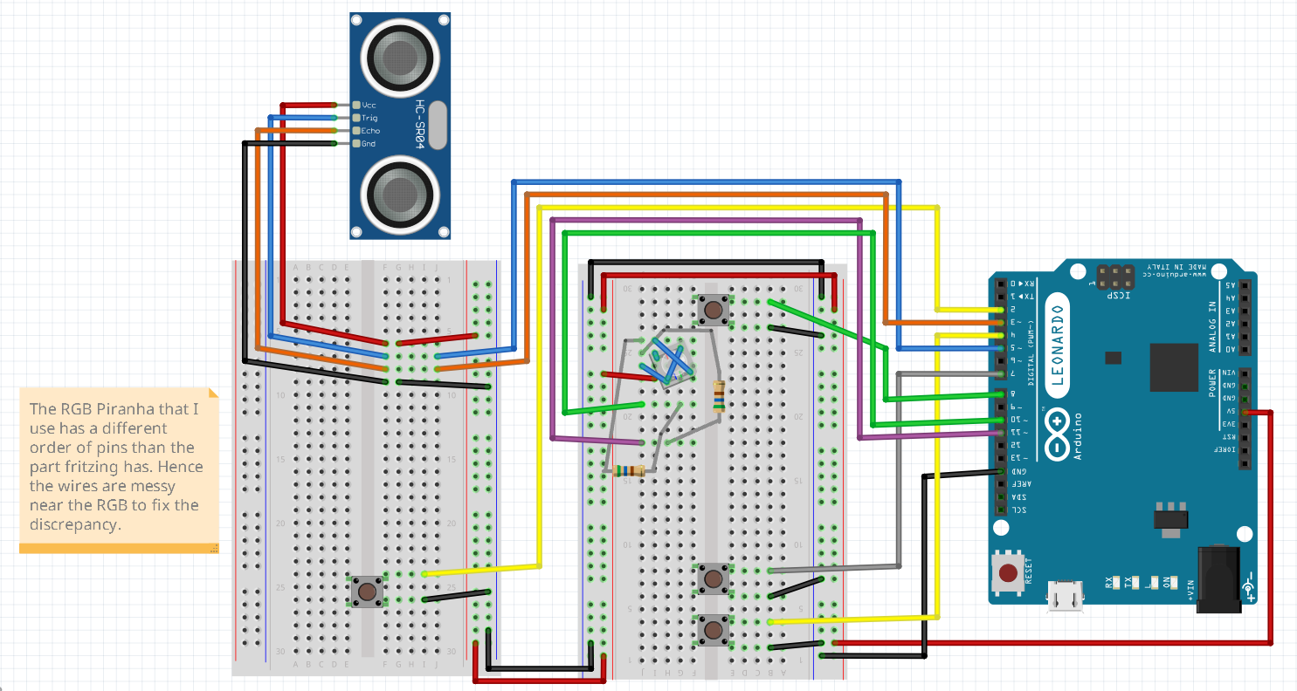 Figure 1: Fritzing diagram
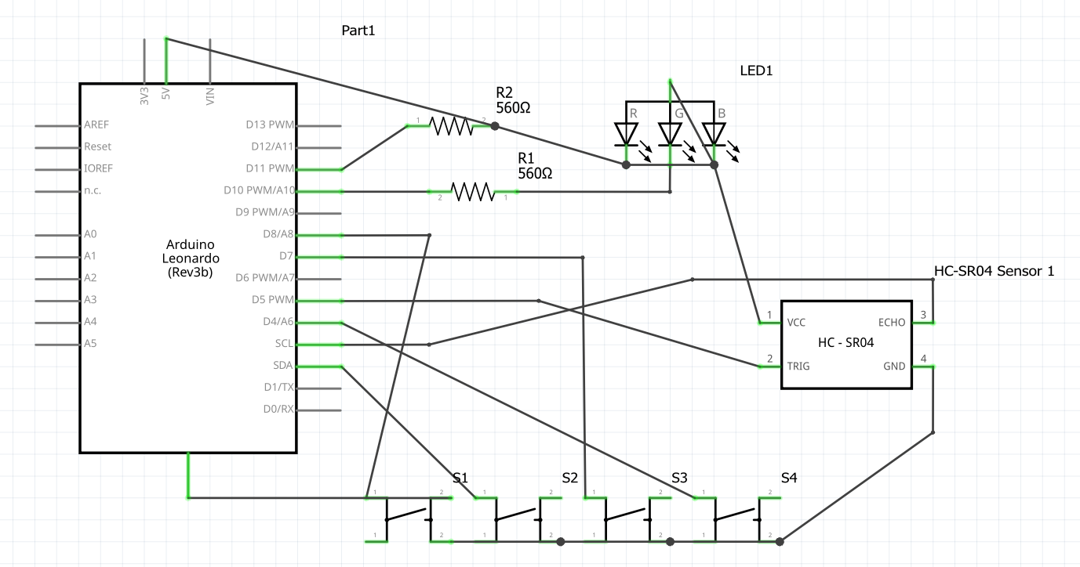 Figure 2: Schematic
Include a diagram/Schematic of your project here. Also include relevant information about type of sensors. What voltage they are producing based on which environmental input. You could refer to their respective datasheets. [2]
Describe the PIN connections for your system here

Pin Connections
Arduino Leonardo Pin | Device | Device Pin
2 | Button (R Key) | One leg of button
3 | HC-SR04 Ultrasonic Sensor | Echo
4 | Button (S Key) | One leg of button
5 | HC-SR04 Ultrasonic Sensor | Trig
7 | Button (W Key) | One leg of button
8 | Button (Safety) | One leg of button
10 | Piranha RGB LED (Common Anode) | Green
11 | Piranha RGB LED (Common Anode) | Red

Project Structure

The code is divided into several modules. Describe these here and any libraries that you used for example servo.
The code should be split into HW section and Interface. You do not need to copy and paste the entire codebase but it should include a walkthrough how the system functions. You can point to key functions that support the function of your system:
- Arduino code
- Processing or other platform

User Testing
Describe the user tests conducted, please see the separate file game_controller testing.

Reflection
What you have learnt during this project. Where did you encounter difficulties, how did you overcome them. How you could develop this project further.

References
[1] Available at: http://arduino.cc/en/Tutorial/Blink
Accessed 25th January 2012
[2] http://www.vishay.com/docs/29046/29046.pdf
Accessed 25th January 2012

