#### Roger Williams University

#### ENGR 430 Computer Vision

#### Homework 2 Selfie Transformations

#### 25 Points

Please name each file according to the homework and problem number, for example H2P1.py, H2P2.py, H1P1.JPG, etc. Bridges automatically places the submissions of each student in a separate folder, so please do not submit as a compressed folder. Any files your scripts need to run, for example the original image files, must also be uploaded to Bridges. Put a header like the example shown on each script file submitted:

############################

# Ash Ketchum

# ENGR430 Computer Vision H2P1.py

# 9/15/2017

#############################

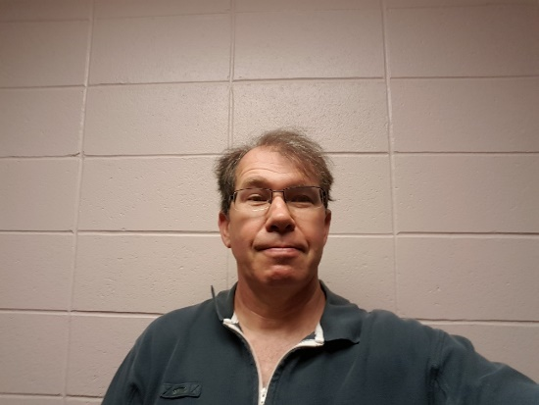Take a selfie with your phone roughly similar to the one shown here and save it as a JPEG 1000 pixels wide. Transfer this image to the Raspberry Pi by any means (rcp, mail to yourself, Bridges, etc.)

2.1 Complete the project begun in class of drawing patriotic stripes on yourself, as shown below. If you completed this project in class you may just submit the file, but ensure it is correctly named and has the header shown above.

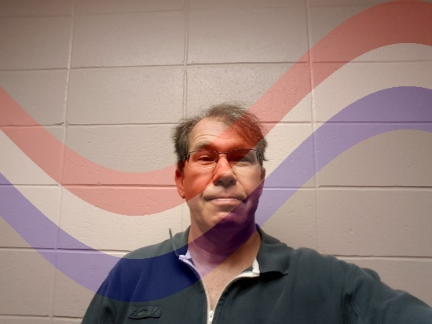

2.2 Add vertical stripes to your outfit, as simulated below. Stripes must only appear on your clothing and must be of sufficient size, quantity and color to make you look silly. In the unlikely event that you were already wearing vertical stripes, change them to horizontal stripes. Python script must show the completed image with imshow command. Submit python file and JPEG image. The JPEG image will be considered for awarding partial credit only if your python script fails to run.



2.3 Create a beatific image of yourself by placing a glowing halo around your head, something like the simulated image below (constructed in MS word). The halo must have a semi-transparent gradient glow as shown. Choose any appropriate colors. Python script must show the completed image with imshow command. Submit python file and JPEG image. The JPEG image will be considered for awarding partial credit only if your python script fails to run.



2.4 Creative Transformation. Transform your selfie in a creative and interesting way. I will award +2 bonus points to the three images I consider the most creative and deduct 2 points if your submission is lame. Python script must show the completed image with imshow command. Submit python file and JPEG image. The JPEG image will be considered for awarding partial credit only if your python script fails to run.