#### Roger Williams University

#### ENGR 430 Computer Vision

#### Homework 3 Hough Lines

#### 25 Points

Please name each file according to the homework and problem number, for example H3P1.py, H3P2.py, H3P1.JPG, etc. Bridges automatically places the submissions of each student in a separate folder, so please do not submit as a compressed folder. Any files your scripts need to run, for example the original image files, must also be uploaded to Bridges. Put a header like the example shown on each script file submitted:

############################

# Ash Ketchum

# ENGR430 Computer Vision H2P1.py

# 9/15/2017

#############################

3.1 Take three pictures of a hallway going off to the left, center and right, similar to those shown below. To keep processing time manageable, save the pictures as JPEG 512 pixels wide.

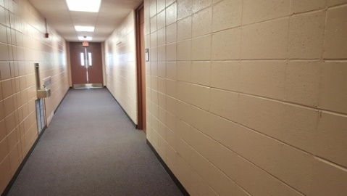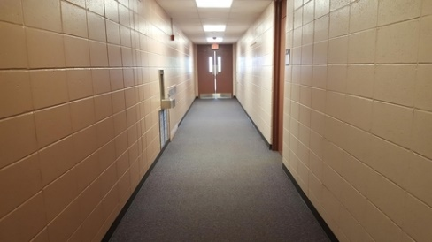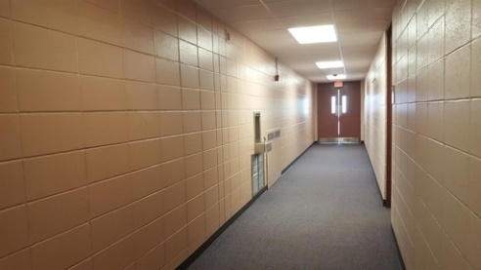

Complete the Hough Lines project begun in class, using the built-in Canny edge detector, extracting the most prominent lines and finding the intersection of these lines to estimate the predominant direction of the hallway. Although the algorithm will be mostly completed in class, you will be responsible for taking appropriate pictures and setting parameters that produce a successful result in each image. Place a custom marker of your own design in the bottom center of the image to indicate hallway direction. This indicator must be located on the bottom center of the image and must display an angle consistent with the picture. Some simulated suggestions are shown below:



Your python script must accept the image file name as an argument. Name the images Hall01.jpg Hall02.jpg and Hall03.jpg. Points will be deducted if the images are not exactly these names. The hallway direction indicator must show the predominant hall direction even when the three file names are shuffled by the instructor. Submit python script and the three image files. You may also submit JPEG images of the results for consideration for partial credit if the script does not execute.

3.2 Somewhat similar to those shown below, take two pictures of a campus building at recognizably different angles. Use Hough lines to detect a dominant architectural feature of your choosing such as number of floors, number of doors, number of windows, etc. Your submission must report the same number of features for both images, even if the image file names are swapped. Script must take the image file name as an argument, must display the image with Hough lines superimposed using imshow and must print out the detected architectural features to the command window.

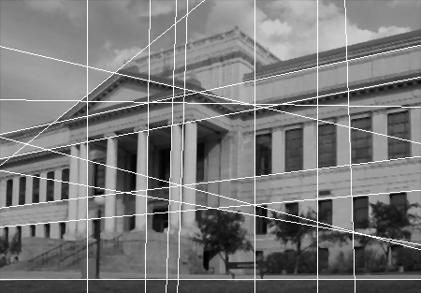

Name the images Buiding01.jpg and Building02.jpg. Points will be deducted if the images are not exactly these names. Submit python script and the image files. You may also submit JPEG images of the results for consideration for partial credit if the script does not execute.

3.3 Creative Application. Take an image where the superposition of Hough lines produces an interesting result. I will award +2 bonus points to the three students submitting images I consider the most interesting and deduct 2 points if your submission is lame. Python script can use hard-coded image file name but must show the completed image with imshow command. Submit python file and the original JPEG image. A completed JPEG image may also be submitted for awarding partial credit.