# User Interface Design

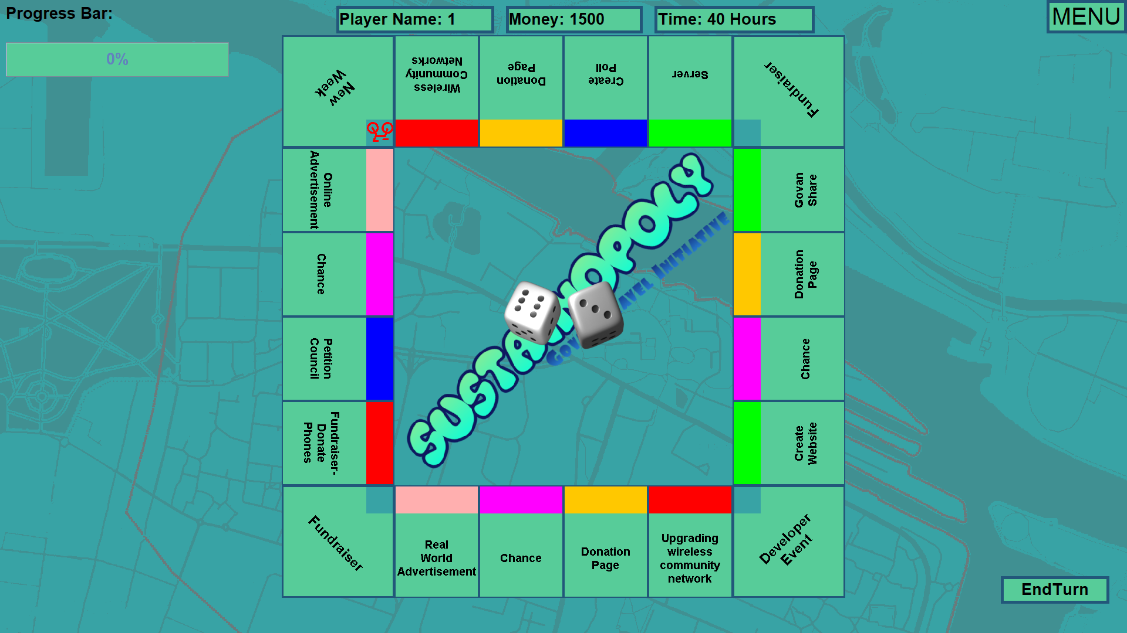

Progress Bar

This is the menu in the form of a dropdown

This is an example square

Clear display of user information

Animated Dice

End turn button

Background of the map of Govan and formatted title text as title of the game “Sustainopoly Govan Travel” Initiative

Unique icon/colour

This is the final board consisting of all the different squares, completion bar display, dice roll animation, menu dropdown, clear display of player name, money and time left with lots of added features to improve the interactivity of the game. The labels above highlight and describe each feature. Below is a in depth description of each feature of the game.

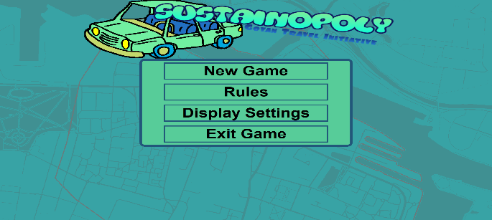

This is the start menu screen. It allows users to start a new game, access the rules of the game, select display settings to change the background colour or exit the game. Includes formatted text and picture to highlight our aim to improve travel in Govan

This is the rules section that inform the user on how the game works. This is canned text as it never changes or varies. The next, back and close buttons allow the user to navigate through the rules

These are the display settings. It gives the user a dropdown menu to select the desired background colour scheme (light mode/light mode contrast dark mode/dark mode contrast. Also user has the option as a tick box to display the game in borderless full screen or not

This is the screen that appears to the user once “new game” button is pressed in the start menu screen. Each player is prompted to enter player name, a unique colour and icon (to help distinguish between players). They also have the opportunity to add or remove players. Continue button starts the game when the user is ready. There is validation to ensure the name field isn’t left blank. Canned text appears “Each player must have a name” if the validation fails

Menu screen also allows the user to exit the game straightaway after opening the game

Features of the game

This is the progress bar which is a measure of how the users have advanced through the game. It works in the way that when a player has invested time/money in a square the progress bar ticks along. Once it reaches 100% the game is won and the game ends

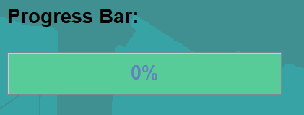

These are animated dice that roll and display the random outcome of the dice roll to the user (once clicked by the user). The number on the dice automatically moves the player to the correct square. The purpose of these is to add interactivity and that they are added features that are not part of the core functionality of the game but meet the user stories/requirements set out

This is just the title of the game “SUSTAINOPOLY GOVAN TRAVEL INITIATIVE”. This is in the centre of the board with the dice. It is not part of the core functionality of the game but again is another added feature

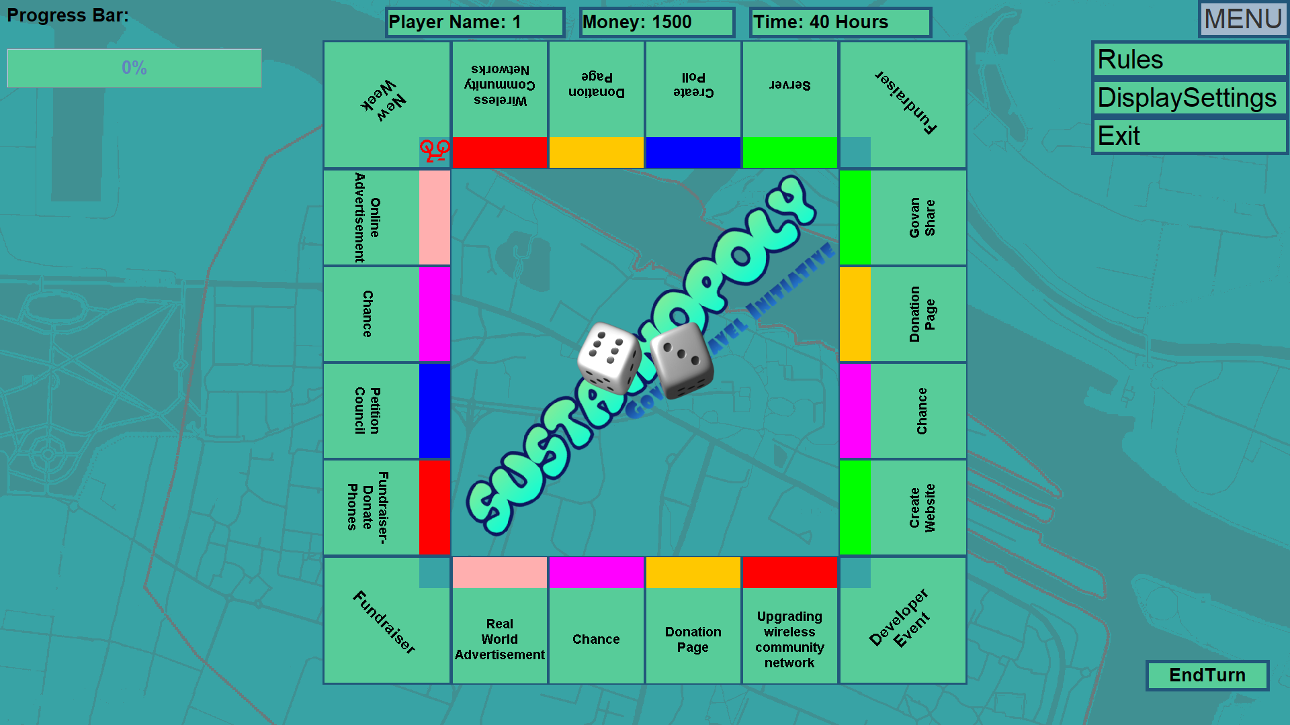

This is the menu that is accessible to users while playing the game. This is part of the core functionality of the game. The menu is in the form of a dropdown which makes each option clear to the user (“RULES”, “DISPLAY SETTINGS”, and “EXIT”)

This is a useful user friendly display of the player name, money left and time remaining. For each player the player’s name is canned text although the money and time information will vary depending on how much the players have invested. This is located at the top centre of the screen so that it is easily visible to the user



This is an example square showing the player unique icon that appears if the user lands on that square. This is another added feature but is useful for the user to distinguish between players if multiple people are playing the game.

This is another added feature which gives the user the ability to zoom and rotate (if required) to focus in on a square (once clicked on) and the game displays information about that square (Task area and square specific information). The purpose for the zooming feature is that it will assist visually impaired user to interact with the game. The text that appears is canned text and does not change as it is just a description of the square

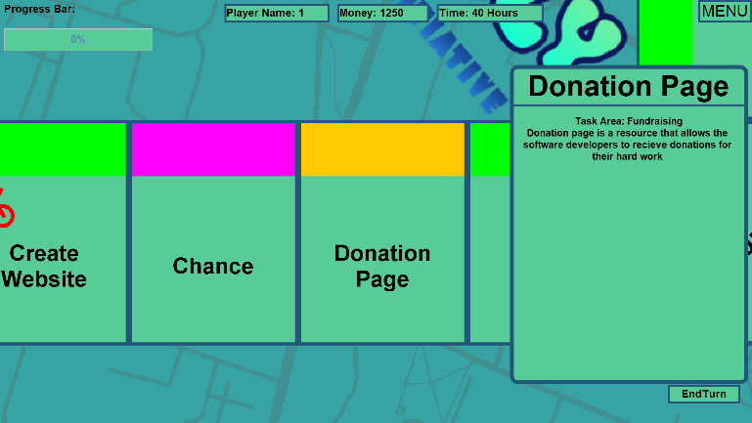

The background of the board is set to a map of Govan which is another interesting and value-added feature.

This is the end turn button. This must be pressed once the player is finished with their turn before moving onto the next player

Once the player lands on a square they can invest in they are shown the following display with sliders that allow the users to easily select the amount of resources they want to invest. The “SUBMIT RESOURCES” button is then pressed to confirm the investment. This is another added feature that improves the quality of the GUI

