­­­­­

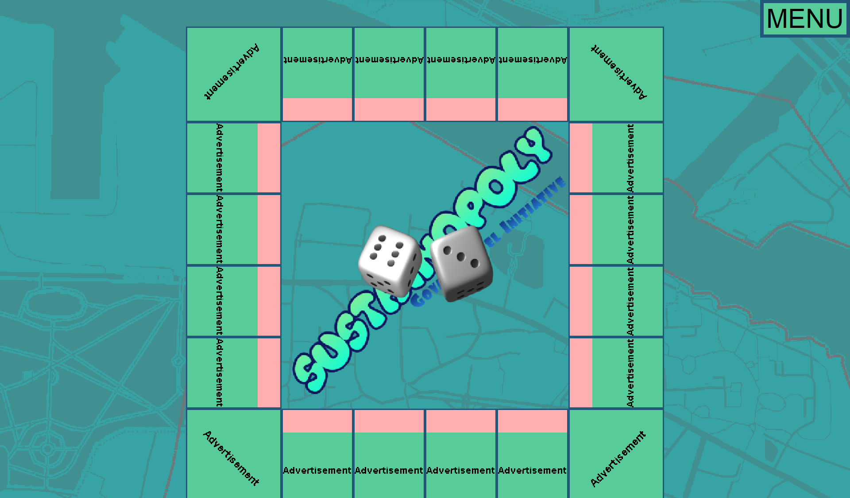

The Menu Button: Allows access to Rules, Accessibility and Exit buttons

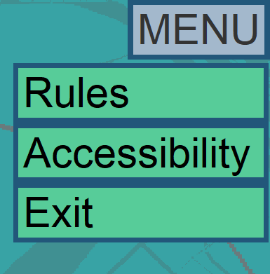

Dice: By clicking on them you can roll the dice, and then whatever you have rolled (e.g. here a six and a three) will be displayed in the middle of the board

Squares: The spaces on the board where players move. Each one will have a different result, all of them will be a way to positively impact the community.

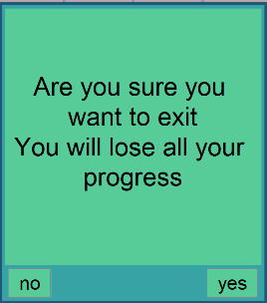

This shows the default layout of the board.

From the Accessibility Menu, you can access different colours of board. There are many options, shown here are a dark mode, a plain white mode and a blue and grey mode.