**Wi-Free App**

Developed by ICT Success

Date: 28-05-2020

Table of Contents:

|  |  |
| --- | --- |
| Title | Page |
| Methodology | 3 |
| Software | 4 |
| Software Requirement Specification (SRS) | 5 |
| Software Requirement Specification (SRS) continued | 6 |
| Work Breakdown Structure (WBS) | 7 |
| Desired Outcomes | 8 |

**Methodology**

Chosen Methodology

As per industry standard, for this project we are choosing to use the Agile Methodology for this project. This is a widely used methodology for many different companies and types of projects, as it is very versatile, well planned, and is easily possible to make changes on the go. Agile has many different types of frameworks included within it that have been proven to be reliable for development.

Benefits

Agile SDLC (Software Development Life Cycle) uses iterations comprised of 4 steps, that can be used for adding additional features later on. The steps are, Plan, Design, Develop, Test. A relatively simple idea, that is very useful for software, as it allows you to update, or make changes following a path that can keep you on track. Once the application is ready, and has been through all iterations, it then moves onto the final iteration and build, which is then just maintained, and kept up to date. This SDLC method will allow us to make updates, and changes during the projects development stages.

Comparison

Comparing to another methodology, such as the Waterfall Method, which, while useful, is very limited, as it requires phases for development, such as, plan > design > develop > deploy. However it does not account for the ability to go back into the project to make changes or updates, as you would need to go back to the beginning. It simply relies on one department doing their part, and passing it onto the next department and when problems arise (which they often do) it is difficult to go back and make changes.

Criteria

As already explained above, the criteria for choosing this methodology was simple, as it offers the most versatile methods and frameworks in order to develop software. Being able to go back into the project during iterations in order to make changes and updates is very beneficial. And once the application is complete, updates, and maintenance will be less complicated.

**Software**

Project Management Software

The chosen PMS we are using is Trello. Trello is a widely used and recommended management software as it makes it simple to see what tasks need to be done, who is working on what, and where something within a process. It has simple drag and drop interface and uses card like elements for organization. You can simply add tasks, assign team members to those tasks, timelines, and so on. All of this makes it easy to follow, and great for managing projects.

Source Control

The chosen source control is Git/GitHub. It is an industry standard for source control within software development, it is used by thousands of companies and small development teams across the world. The reason for using Git is that it makes it easy to share, alter, and update projects. This is done by pulling from a branch, making changes to that branch, and then committing those changes back into the project. A user simply needs to make a pull request for the branch, edit, or update the software, then commit back to the main source. The changes can then be approved by a project manager or assigned admin, which then adds those changes to the base software code.

Collaboration Software

For collaboration we will be using Slack, as it offers many benefits over other competitors. Slack is a tool that allows you to manage a team of individuals by condensing several tools into one interface. It is great for managing team members, marketing, and file management. Other benefits include, email, Trello, GitHub and other software integration into the interface.

**Software Requirement Specification (SRS)**

**Introduction**

**Purpose**

The purpose of this application is to provide users with a way to locate, share, and rate available free to use wi-fi hotspots in order for them to be able to work remotely.

**Intended Audience**

The intended user base is anyone that requires internet access while away from home, or while traveling and working.

**Project Scope**

The main goal for this project is to create an application for people that work remotely, or on the go. The users will be able to locate, share, rate, and comment on available hotspots in order for people to find the most suitable hotspot for them. The application should be easy to use, have a clean user interface, and provide an overall good user experience.

**Description**

The application will have a simple but functional user interface, the user will open it, and be greeted with a login/register page. A user is required to register as this will help prevent spam accounts, and unwanted traffic. Once signed in, they can use the map to locate a hotspot, search a post code/city, select a possible spot, and then be shown the average rating, and comments on that spot. If a user would like to rate or leave a comment, it should be easy to do by using a 0-5 Star system, and reply function.

**Functional Requirements**

* User registration or login if existing user.
  + Authentication
  + Database of users
* Map integration and location..
  + Integrate Google Maps
  + Allow user location settings
* Rating system.
  + 5 Star rating system.
  + Average of ratings from users.
  + Sort function, based on rating.
* Comments section.
  + Leave a comment.
  + Reply to a comment from another user.

**Non-function Requirements**

* Performance.
* Security for user information.
* Usability.
* User experience.

**User characteristics**

The target audience for this application are work from home, remote workers and digital nomads, that is, people who might work out of a van, while traveling. It is also targeted at people who may just need a solid wi-fi connection while taking meetings or perhaps people who have no phone service and need to use their email, etc.

**Use cases**

Below are some possible tasks a user might perform with the application.

* Provide an invalid email address.
  + Display relevant error.
  + Ask the user to try a valid email.
* Attempt to login with incorrect details (not in the database).
  + Display relevant error.
  + Inform user that information is incorrect.
* Leave a comment, or reply to another users comment.
  + Comment on a hotspot.
  + Reply to a user comment by clicking Reply button.
* Leave a rating.
  + Leave a rating between 0 and 5 stars.
  + Overall rating will be the average of user ratings.

**Work Breakdown Structure (WBS)**

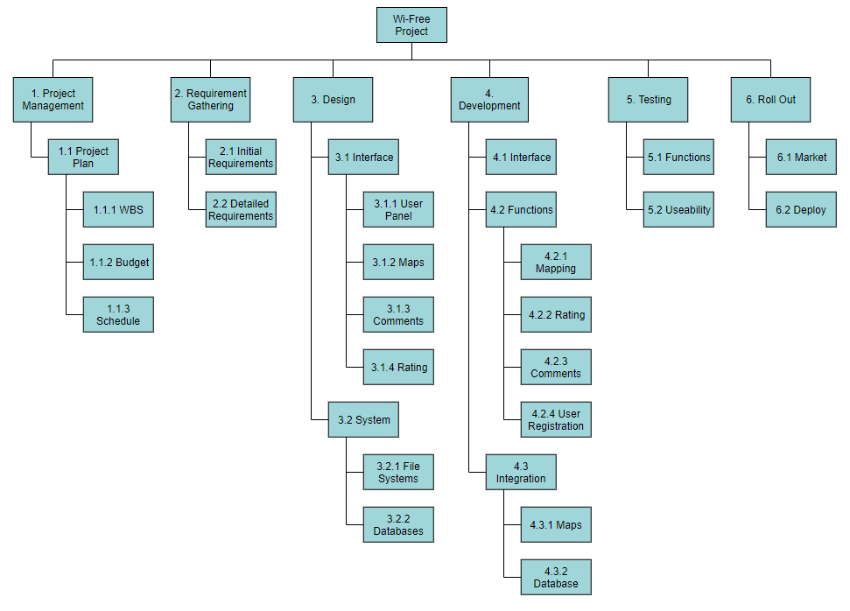

**Desired Outcomes**

1. **Project Management.**
   1. Once the Project Plan is completed, including the budget and schedule, and it is approved, work can commence.
2. **Requirement Gathering.**
   1. Research and document the initial requirements, and detailed requirements of the project.
3. **Design.**
   1. Design a user interface that is easy to use, includes the map, rating, comment features. Ensure the user knows where to go when they want to preform a task.
4. **Development.**
   1. Integrate the designed interface.
   2. Create relevant functions for mapping, location services, rating and comment systems.
   3. Integrate Google Maps API.
   4. Create the database for user information and hotspot information.
5. **Testing.**
   1. Test all functions to ensure they are correct.
   2. Test the overall usability to ensure the average user can easily use it.
6. **Roll Out.**
   1. Market the application on relevant stores. (Google Play, Apple).
   2. Deploy application.