Colour Segmentation

Colour segmenting is perhaps one of the simplest computer vision processes. Each pixel in an image has associated with it three values between 0 and 255 (for an 8-bit image, since 2⁸ = 256). Each value indicates the intensity for that pixel’s red, green and blue colours, with the final pixel colour determined by a linear combination of these three values.

Let’s extract one pixel from MiRo’s collar in below image and show its RGB values:
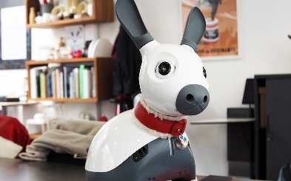
R = 127
G = 17
B = 18

As expected, there is a stronger intensity of the red pixel value vs. green and blue.

When we segment the image according to some RGB boundaries, we’re selecting only those pixels with which the RGB values exist within those boundaries.

E.g., let’s set a lower boundary of R = 0, G = 0, B = 0 and an upper boundary of R = 255, G = 150, B = 150. Our boundaries are therefore:

Lower limit = [0, 0, 0]
Upper limit = [255, 150, 150]

We pass through each pixel in the image, test whether it’s three values exist within this range, and remove (i.e. set its pixel value to [0, 0, 0]) any pixel outside of this range. What should we expect to see with the above limits applied? Try it in the GUI!

Colour segmentation can be a useful pre-processing task in order to extract regions of interest for which further processing can be performed on.

