BBIM713 CAPSTONE PROJECT:
Research Project Report

Christian Tolentino 764706771 (Team Leader),
Matthew Tima 764705436,
Juthaphat Apinanpisut 764702333
Internal Supervisor: Dr Sara Zandi
Capstone Project Leader: Dr Sara Zandi
External Supervisor: Dr Louis Boamponsam


School of Tech
Bachelor of Business Information Management Cover Sheet and Student Declaration
This sheet must be signed by the student and attached to the submitted assessment.

Course Title: | Capstone Project (DA) | Course code: | BBIM713
Student Name: | Matthew Tima,  Christian Tolentino,  Juthaphat Apinanpisut | Student ID: | 764705436,  764706771,  764702333
Assessment No  & Type: | Assessment 2, Research Project Report | Cohort: | BBIM7123C
Due Date: | 12/12/2025 | Date  Submitted: | 9/12/2025
Tutor’s Name: | Dr Sara Zandi, Eric Ma
Assessment  Weighting | 65%
Total Marks | 100
Student Declaration:
I declare that:
- I have read the New Zealand School of Education Ltd policies and regulations on assessments and understand what plagiarism is.
- I am aware of the penalties for cheating and plagiarism as laid down by the New Zealand School of Education Ltd.
- This is an original assessment and is entirely my own work.
- Where I have quoted or made use of the ideas of other writers, I have acknowledged the source.
- This assessment has been prepared exclusively for this course and has not been or will not be submitted as assessed work in any other course.
- It has been explained to me that this assessment may be used by NZSE Ltd, for internal and/or external moderation.
Student signature:
Date:
Assessor only to complete:
Assessment results:
Assessment results: | Total Marks: |  | /100
LO1 Requirements | Met  Not Met | ☐  ☐ |  | Assessor Signature
LO2 Requirements | Met  Not Met | ☐  ☐ |  | Assessor Signature
LO3 Requirements | Met  Not Met | ☐  ☐ |  | Assessor Signature

LO4 Requirements | Met ☐  Not Met ☐ | Assessor Signature
LO5 Requirements | Met ☐  Not Met ☐ | Assessor Signature

Table of Contents:

Abstract: 3
Introduction: 4
Project Questions: 5
LITERATURE REVIEW: 6
Project Design: 7
Data Sources: 9
Data Ingestion & Storage: 10
Data Processing & Feature Engineering: 10
Modelling Pipeline: 10
Output and Visualisation: 11
Integration and System Architecture Overview: 11
Security, Ethics, and Compliance: 11
Project Development: 12
Implementation Integration: 12
Data Engineering: 12
Testing and Evaluation 15
Model Development & Tuning: 15
Maintenance and Scaling: 21
Feedback Loop and Continuous Learning: 22
Streamlit App: 22
DISCUSSION 22
Reflection: 22
CONCLUSION 24
Findings: 24
Health & Compliance Implications: 25
Policy & External Factors: 26
Industry Impact: 26
FUTURE DIRECTIONS: 26
References: 27
Github: 5

Abstract:

Air quality monitoring has been carried out throughout the year with ongoing exceedances of major pollutants at many sites around Auckland, although these exceedances have occurred when pollution standards were still met. This research examined data collected by air quality monitors across Auckland's entire network of monitor sites to assess (1) how often, and where, such exceedances have occurred in relation to time, and location, (2) what temporal and spatial factors drive exceedances, and (3) to develop predictive models for assessing exceedance risk to provide information to inform decisions.
The analytical pipeline combined the data from each of the site monitors (one 1C and one 2C file per site), removed erroneous or missing data, added lagged variables and weather-related features, and applied a multi-model ensemble that uses combinations of Gradient Boosting, Random Forest, and Long-Short Term Memory (LSTM) models to produce a prediction of exceedance risk for the next 30 days; ARIMA/SARIMA models were also employed to characterize seasonal trends.
Based on the qualitative evaluation of the predictive models demonstrated a strong predictive performance between PM2.5 and NO2 pollutants. The ensemble of combining three machine learning such as Random Forest, Gradient Boosting, and LSTM produced a stable short-term prediction with CI and no predictive exceedance within the evaluated 3 days for PM2.5 which the ensemble reaches MAE of 0.91, RMSE of 1.57, and R2 of 0.82 with predicted values continuously being far below the 25 µg/m³ NESAQ 24-hour threshold. NO2 forecasting showed the same high accuracy as MAE of 3.11, RMSE of 4.55, and R2 of 0.85, and forecasted the concentration below the NESAQ threshold of 100µg/m³. These measurements show that the models accurately captured the underlying pollutant behaviour, giving valid early-warning signals for potential of exceedance.

Keywords: Air quality; NESAQ; PM₂.₅; NO₂; hybrid forecasting; Random Forest; Gradient Boosting; LSTM; Streamlit; Auckland

Introduction:

Urban pollution and the air quality in major cities are some of the most important factors in assessing the quality of life for residents of those cities. A good example of this would be Auckland, New Zealand's largest urban area. Auckland has many pollution challenges from vehicles, ports, industry, and home heating. Although there are regulations (NESAQ) that outline allowable limits of pollutants (PM₁₀, PM₂.₅, NO₂, CO, O₃, SO₂), there have been continuous exceedances in some areas of the city. Exceedances lead to both human health issues and monetary expenses. The Ministry for the Environment and Auckland Council have stated that there continue to be localized risks from PM₂.₅ and NO₂ that correlate with traffic and seasonal weather patterns.
This capstone project addresses the operational needs of the Auckland Council to transition from providing only descriptive exceedance reports to providing predictive and actionable intelligence. Using the council’s collected monitoring data (completely merged 1C and 2C site datasets throughout the entire monitoring network), we will: measure the spatial and temporal exceedance frequencies; analyse and determine if any of the causal drivers (traffic volumes, wind direction, temperatures, humidity, black carbon) contributed to exceedance events; and create a real-time compatible forecasting model. Ultimately, our goal is to create a decision-making tool using Streamlit to allow non-technical users to visually review trends and forecast exceedance risks, allowing them to target specific mitigation strategies.
The project’s Minimum Viable Product (MVP) is an operational Streamlit dashboard which enables non-technical users within the Council to:
- Explore Exceedances across all monitoring sites,
- Showcasing the spatial and temporal patterns, and
- look at hybrid-model exceedance forecasts produced by the Gradient Boosting, Random Forest, and LSTM ensemble modelling.
In essence, this MVP converts raw monitoring data into actionable intelligence. This enables the Council to make decisions around issues like transportation planning, emissions management, and winter season public health warnings, along with longer term environmental planning.
Christian Tolentino is the team leader and oversees the overall technical direction of this project; he responsible for the integration of the forecasting models into the Streamlit dashboard. Matthew Tima co-leader/project manager, in addition to coordinating with the team on meeting deadlines and developing team's progress, is managing the datasets and clean-up, and has developed the Random Forest and Gradient Boosting components of the LSTM forecasting model. Juthaphat Apinanpisut researcher/writer is leading the research, literature review, and writing the documentation for this project to ensure that the theoretical framework is correct and the story is coherent. As a result of working together as a team, across data engineering, analytics, machine learning, and systems delivery, they can meet the Council's operational needs.
Project Objectives:
Create clean and well-documented datasets for each monitoring site so they can be reused by the Auckland Council.
Measure exceedance events for each pollutant at each location over time and display the information through interactive visualizations.
Develop and test hybrid forecasting models (Gradient Boosting, Random Forest, LSTM Ensemble) and baseline ARIMA/SARIMA models for the seasonal aspect.
Present the outputs within a Streamlit dashboard and describe how the ethical and compliance aspects of the data were handled.
The remainder of this report outlines the rationale, methodology, developmental process, and recommendations for the project. Section 4-6 explains research questions, background literature, and system design. Section 7-9 details data and analytical processes, and sections 10-11 outline interpretations, limitations, and recommendations.
Data cleaning (i.e., removal of invalid or negative values, timestamps aligned, and merged), exploratory data analysis, and initial forecasting development were conducted using Python. The project is currently creating ARIMA, Decision Trees, Random Forest, and Long Short-Term Memory (LSTM) models to predict exceedance risks for PM₂.₅ and NO₂. All results will be displayed through an interactive Streamlit dashboard created for Auckland Council, converting raw monitoring data into a usable decision-making tool.
The ultimate objective of this project is to transform the way Auckland reports on its air quality from merely monitoring (descriptive) to actively forecasting (proactive), thus enabling the city to make informed decisions about public health, transportation, and environmental policies.

Project Questions:

Council requires predictive insights to satisfy both its legal compliance and public health obligations as they relate to NESAQ. The following are five of the very complex business questions this project will frame:

- Exceedances:
Question: At what times and at which places did the Air Pollutants in Auckland (PM₂.₅, NO₂, CO, O₃, SO₂, PM₁₀) exceed the threshold values set by NESAQ during the monitoring period, and how often?

- Temporal Patterns:
Question: Are there seasonal, monthly, weekly and daily temporal patterns that can be identified from the excesses data?

- Spatial Distribution:
Question: Which monitoring locations or small areas of Auckland consistently record high levels of PM2.5/NO2 concentrations?

- Policy & External Factors:
Question: How has the introduction of new policies and regulations in New Zealand affected the frequency and intensity of exceedances of PM2.5 and NO2?

- Health & Regulatory Implications (Scope of Context):
Question: What are the broad implications of exceedances for public health and NESAQ compliance?

- Predictive Modelling:
Can an integrated forecasting system (hybrid of Gradient Boosting, Random Forest and Long Short-Term Memory) provide accurate early warning signals of when PM2.5 and NO2 exceedances are likely to occur, and how should these be best communicated by Auckland Council to maximize its use as a tool for decision making?

Together, these question types will help provide Auckland Council with the knowledge it needs to determine where and at what time exceedances are occurring; how patterns in temporal and spatial risks differ from one area to another; recognize the impact of significant environmental/infrastructure developments; and understand the implications on public health. More importantly, the answers to these question types of support developing an accurate forecasting model that can support proactive decision making; targeted interventions to address non-compliance with NESAQ standards; and, ultimately, improve compliance.

LITERATURE REVIEW:

- Regulatory Background: NESAQ (2004), regulates responses to monitoring data. The most recent studies on local air quality (MFE, 2024) state that both PM₂.₅ and NO₂ remain significant urban pollution problems.

- Health Impacts: Exposures to PM₂.₅ & NO₂ increase cardiovascular and respiratory mortality and morbidity (WHO, 2024). Both a national health burden and the economic costs of PM₂.₅ & NO₂ warrant proactive measures.

- Main Contributors: Vehicle emissions and industrial activity dominate urban sources of PM₂.₅; Meteorology causes most seasonal peaks due to temperature inversions, low wind (Boamponsem, 2024).

- Forecasting Methods: Statistical models such as ARIMA/SARIMA are still popular for air-quality forecasting due to their ability to model trends and seasonal patterns. Nonetheless, previous research has illustrated that they have been ineffective in modelling the non-linear behaviour of pollutants and the rapid shifts in pollutant concentrations due to factors including meteorological events and traffic (M.A. Mujtaba a, 2024). A major disadvantage of these statistical models is their linear assumptions and requirement for stationary data; both limitations fail to provide a complete representation of the dynamic nature of air pollution in the real world.

- Traditional statistical approaches are no longer sufficient; recent studies employing Machine Learning based methods, including Random Forest (RF), and Gradient Boosting (GB) have achieved superior results in predicting short term Air Quality Events. This is because Machine Learning can identify both the linear and non-linear relationship between the independent variables and the dependent variable(s) when dealing with many variables. In terms of outliers, RF is generally robust to outliers but potentially under-represents extreme events while GB is very sensitive to its parameters to be able to predict the number of days an exceedance will occur with higher accuracy than RF (Chunrong Jia, 2023).
- LSTM's ability to recognize long term patterns in pollution time series has been demonstrated through numerous research papers where the temporal pattern of the pollutant time series shows strong memory characteristics, e.g. weekly cycles, and weather fluctuation, etc. LSTM models perform better than ARIMA and tree-based models. However, LSTMs require large quantities of good quality data and significant computational resources to train which makes it difficult for researchers to use these models to analyse their data set especially if there are data gaps in the data, which is common for the Auckland Air Quality Monitoring Network(Xiaoli Su, 2022).

- Although each approach has its own advantages and disadvantages, researchers recently recommended hybrid ensemble models that combine statistical models (such as ARIMA) and machine learning models. The hybrid models utilize ARIMA to capture the seasonal components of the time series while utilizing machine learning models to capture non-linear deviations from that seasonality. Studies have shown that the hybrid models perform better than single model approaches for predicting exceedances (Sarah J. Hanna, 2018). The main disadvantage to hybrid models is that they can be more complex to develop and require significantly more computational power.

Project Design:

Below are a description of this sections architecture and the reasoning behind it: the various components of the data supply chain including data sources, ingestion into the system, storage of the data, processing of the data, model pipeline and deployment of the model and lastly data governance.

Figure 1.
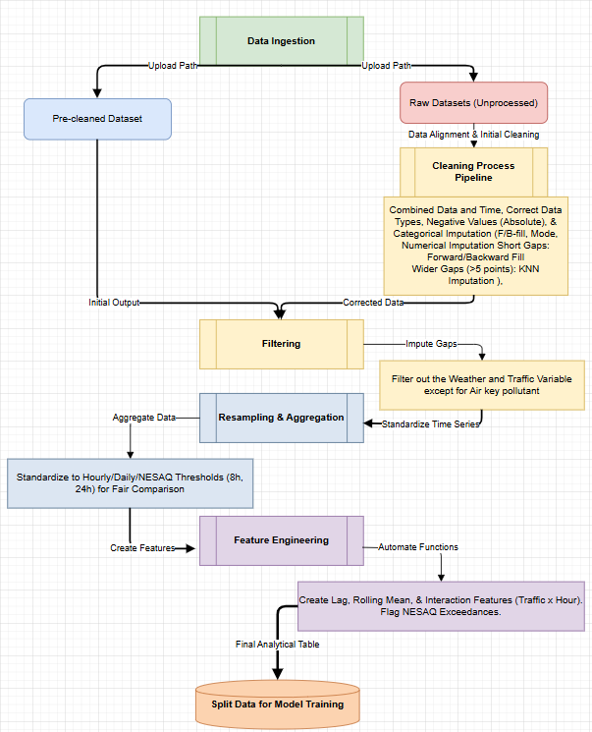
System Architecture for Air Quality Forecasting Pipeline

In this project, the screenshot is an example of how we have implemented a complete end-to-end data pipeline. The raw and cleaned datasets are processed from Ingestion to Cleanliness, Imputation, Resample and Feature Engineering before they are converted into analytical tables that can be fed into model training. With the structured workflow process, we will be able to obtain high-quality, reproducible forecasts and ensure all data is integrated into our hybrid machine learning environment and Streamlit dashboard.

Data Sources:

The use of this project incorporates all existing historical 1C and 2C datasets from Auckland Council's monitoring network (12+ sites) to provide the necessary pollutant measures as well as the required explanatory variables to create models. The major pollutant metrics used are as follows:
- NO, NO₂, NOx, PM₁₀, PM₂.₅, SO₂, O₃, BC(370), and BC(880)
And the major meteorological and activity factors are as follows:
- temperature, relative humidity (RH), wind speed (WS), wind direction (WD), and traffic volume (TrafficV).
all data were received in csv and merged by site x time stamp, ensuring that all variables temporally aligned with each other.

Data Ingestion & Storage:

A Python based ingest layer (using Pandas) reads the raw CSVs; the ingest layer standardizes the time stamps (into ISO format); normalizes the names of the pollutants and their respective units; and records all ingest actions so that the process can be replicated. For development purposes, the files will be stored on local file systems with versioning via Git; production ready configurations include transitioning to cloud storage (AWS S3 or Google Cloud Storage) and using an SQL for querying the data.

Data Processing & Feature Engineering:

Automated functions that pre-process all data are created so they can be reused. This includes.
- Removing any pollutant readings with negative/invalid values or any traffic counts that don't make sense,
- standardizing all datasets to have an hourly time series by resampling as necessary,
- filling in missing values from small gaps with either forward/backward fill, and flagging large gaps (causes include failure of sensors, upgrade of stations and roadwork/construction interference),
- creating new features that are engineered such as lag1 – lag N, rolling means (for example, 24-hour average) and interactions between wind and traffic,
- using official NESAQ thresholds to label exceedances.
This creates a clean analytical dataset for each monitoring site to model.

Modelling Pipeline:

Seasonal Baseline Modelling using ARIMA/SARIMA is used as a first step to assess longer term trends and seasonal patterns for baseline prediction of pollutant concentration; A Hybrid Machine Learning Ensemble model was developed by integrating Random Forest Regressor and Gradient Boosting Regressor and LSTM models to predict pollutant concentration. This ensemble model utilizes an average of the predictions generated by each individual model to provide final predictions, and this process is facilitated by Streamlit. Techniques such as time series cross validation, grid search for parameters for tree-based models and early stopping for LSTMs were also applied to optimize the models' performance. Performance was measured by metrics including mean absolute error, root mean square error, and precision/recall for exceedance classifications.

Output and Visualisation:

Auckland Council will utilize a Streamlit Web Application to access air quality data interactively. The application will feature line and bar charts displaying Exceedance Events, daily averages, and long-term trends, along with Exceedance Forecasts for pollutant levels based on a hybrid machine learning model. This dynamic platform allows users to view updated results in their preferred format, enhancing data accessibility and usability.

Integration and System Architecture Overview:

The system is a like a step-by-step pipeline. It starts with data ingestion, then moves on to data cleaning, feature engineering, model training, prediction, and finally, visualization. Data goes from the ingestion layer to the processing stage. Here, it gets cleaned and transformed before entering both forecasting and classification models. The outputs from the models flow into Streamlit’s visualization layer. This gives end users live charts and predictions.

Security, Ethics, and Compliance:

In this research project, all activity was conducted using a professional data governance framework that used data from Auckland Council’s Public Data Sets; use of these data sets was under a strictly confidential basis; no personal identifiable information is contained within the data, and it is securely stored and only accessible by authorized personnel. The privacy and compliance for both the New Zealand Privacy Act 2020 and Massey University's ethics policy were followed during the duration of the capstone requirement. After completion of the capstone requirements, the data and source code will be returned to Auckland Council (if necessary) or deleted.

Project Development:

Implementation Integration:

The system is designed to function in unison through a single analytical pipeline from the ingestion of raw data through the generation of forecasted values to the display of graphical outputs for visualization. Upon upload of the merged 1C/2C dataset, the Streamlit based application will run the complete workflow automatically.

Data Engineering:

- Cleaning and Standardization

Figure 2.
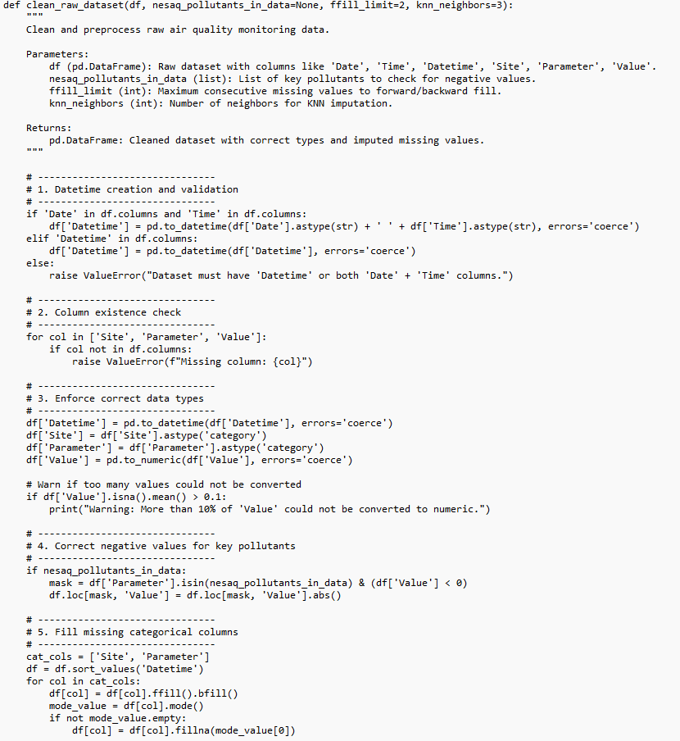

Figure 3.
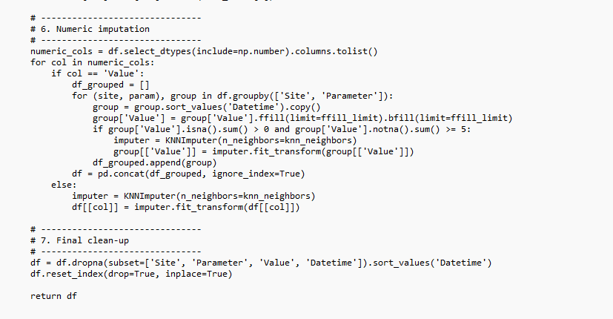

The ingestion portion of the pipeline takes raw data, cleans it by establishing consistent timestamp formatting and standardized labelling of parameters, then passes the cleaned data to the processing layer. The processing layer includes functionality to synchronize time intervals between different data sources, fill data gaps using statistical methods, and generate lagged features that can be used in the modelling process. The cleaning process pipeline has:
Data and time aggregation to make sure every measurement has an accurate point of time since forecasting and correlation visualisation depends on determining exactly when reading occurred.
Correcting data types such as parameters columns which converted to numeric values.
Negatives data for air key pollutants such as PM10 or NO2 are corrected by using absolute values which a common practices when sensors misinterpret or misreport the data especially pollutant couldn’t have negative value.
Categorical Variables columns like Site and Parameter are essential for grouping and filtering.
Missing values are forward-filled and backward-filled for instance, if a row is missing a site name, it guesses it’s the same as the preceding or next valid row.
Remaining gaps are filled with the most common value mode to prevent losing data unnecessarily.

- Handling Missing Data
Environmental data typically has gaps because of sensor failure or transmission issues. So, we apply two techniques for short and long gaps.
For short gaps of 1–2-time steps, it uses forward or backward fill values.
For long gaps like If missing data persists but there’s enough historical information at least 5 valid points, we use KNN imputation.

- Resampling and Aggregation
For temporal or correlation analysis, we resample the data daily or according to NESAQ thresholds like 8-hour or 24-hour averages.
This standardises irregular time series, accommodates missing periods, and allows for fair comparisons across sites and variables.

- Feature detection

After the cleaning, the dashboard automatically uncovers key variables.
NESAQ pollutants include PM2.5, PM10, NO2, O3, CO, and SO2.
Weather variables include temperature, wind speed, wind direction, humidity, and so on.
Traffic variables like TrafficV.
Lag features included as well which is the past values of the pollutant to train the ensemble to capture temporal dependencies.
This allows downstream analysis (correlation, forecasting, visualization) to be dynamic.

The processed data are then fed into the modelling layer where an ARIMA/SARIMA models the seasonal baseline, and a hybrid ensemble (Random Forest + Gradient Boosting + LSTM) is used to develop multiple day ahead forecasts. Finally, the results of the modelling process are sent to the visualization layer within the Streamlit application where users can view dynamic graphical displays, threshold violation flags, and insights generated from the models. This architecture ensures that each component of the analytical pipeline functions in conjunction with each other as a single entity, providing a continuous, end-to-end analytical capability, versus individualized components.

Testing and Evaluation

Model Development & Tuning:

- The forecasting section forecasts air pollution concentration using a combination of Random Forest, Gradient Boosting, and LSTM neural networks. Each model has its unique set of strengths, which allow us to make more precise and dependable projections.

- These two models such as Random Forest and Gradient Boosting function like expert analysts. They use historical pollution, weather, and traffic patterns to generate forecasts about the future. Their hyperparameters are carefully set to increase accuracy, allowing the models to train successfully. The training procedure adheres to the time sequence of the data, so predictions never cheat by looking ahead. This ensures that the outcomes are both practical and trustworthy.

- The LSTM model is intended to understand sequences and patterns across time. It recalls the progression of pollution levels and understands how they change day to day. For learning, input values are scaled, and the network trains for 20 passes epochs to capture important patterns. When forecasting numerous days ahead, it forecasts one day at a time, with each prediction providing as a starting point for the next. This method enables the model to follow the natural flow of data.

- For each model, we carefully modified essential hyperparameters to improve accuracy while avoiding overfitting. Random Forest applied n_estimators, max_depth, and min_samples_split to manage tree size and stability. Gradient Boosting optimised learning_rate, n_estimators, max_depth, and subsample to strike a compromise between speed and generalisation. LSTM tuned hidden units, learning rate, batch size, and epochs to successfully capture temporal trends. We used GridSearchCV, RandomizedSearchCV, and validation performance to find the optimum settings for each model.

- To produce stronger prediction accuracy, we aggregate multiples predictive such Random Forest, Gradient Boosting, and LSTM models to generate hybrid model. The ensemble approach balances each model's strengths and weaknesses. It also allows us to calculate confidence intervals, which illustrate the range of possible real values. Days anticipated to exceed NESAQ limits are immediately reported, allowing the council to quickly recognise potential air quality issues.

Figure 4.
The ensemble model effectively predicts PM2.5, with MAE of 0.68 indicating that the forecasts are less than 1 µg/m³ off on average. The RMSE is slightly elevated due to its penalty for larger errors yet remains low. A MAPE of 15.7% reflects moderate relative error, while an R² value of 0.79 demonstrates that 79% of the variance in PM2.5 is accounted for, indicating strong performance without apparent overfitting.

Figure 5.
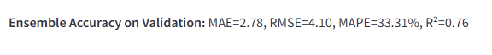
With an MAE of 2.78, RMSE of 4.10, and MAPE of 33%, the model performs reasonably well for NO₂, showing modest relative error. Given the volatility of NO₂, the model explains 76% of the variance, as indicated by the R² value of 0.76.

Figure 6.
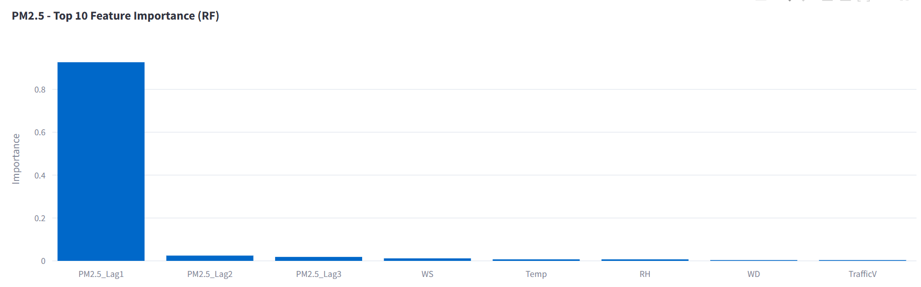
The higher the feature is the most contributor for the models’ predictions as Top features are the key drivers. Based on the Bar graph presented above that the highest contributor for the predictions is PM2.5 lag1.

Figure 7.
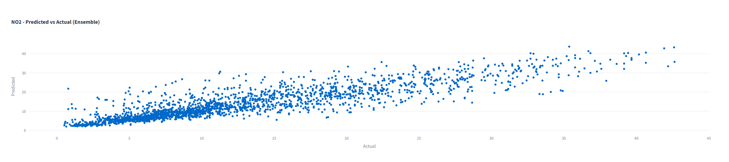
The ensemble model effectively predicts NO₂ levels, closely matching actual values as indicated by the Predicted vs Actual plot. Points align near the diagonal line, showing that the model predicts high NO₂ levels accurately when real values are high and vice versa. The model demonstrates strong accuracy at low concentrations, although it faces challenges with extreme pollution events, evident in wider spread at higher concentrations. Despite some outliers, the model’s performance is validated with strong metrics R² = 0.76, indicating reliable forecasts across typical NO₂ levels.
When a model overfits, it performs poorly on unknown data because it learns noise in the training data rather than its underlying patterns. Overfitting is a major issue in air quality forecasting because of noisy data and sudden spikes. We apply approaches like a training-validation split to evaluate generalisation, regularisation methods like limiting tree depth in models, and cross-validation during hyperparameter tuning to address this problem.

Figure 8.
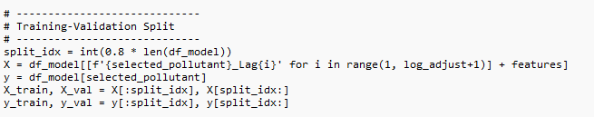
We divided the dataset chronologically into a training set 80% for the model to learn from historical patterns and a validation set 20% to test predictions of unseen future values. This method prevents the model from accessing future information, thus avoiding inflated accuracy and reducing overfitting risk.
For the LSTM model designed for air quality data, we established a configuration tailored to the time-dependent and noisy nature of the dataset. A sequence length parameter (log_adjust) was utilized to help the model grasp short-term temporal dependencies, ensuring that recent pollutant measurements inform subsequent predictions. The model features between 32 and 128 LSTM units, optimized via randomized search to balance memory capacity against the possibility of overfitting, which is critical due to the limited size of the dataset.
The tanh activation function was selected for its ability to stabilize training by maintaining outputs within a bounded range. This was integrated with the Adam optimizer, which employed a carefully tuned learning rate to facilitate efficient and reliable convergence. We used moderate batch sizes and epochs to allow sufficient learning without the risk of overfitting. To assess model performance, we applied a TimeSeriesSplit cross-validation method, aligning with the chronological order of the data to create realistic forecasting conditions. Finally, the target values were scaled to enhance numerical stability and improve the model’s learning of patterns.
This well-considered configuration assures that the LSTM model can successfully learn the temporal patterns of PM2.5 and NO₂ concentrations while maintaining robustness and generalizability.

Figure 9.
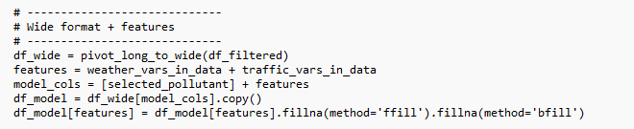
This code of block organised the table with columns for PM2.5, wind, temperature, and traffic. Any missing values for weather and traffic are filled in by looking at nearby dates.

Figure 10.
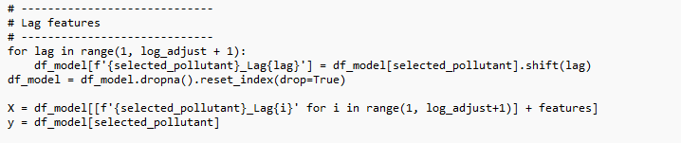This block creates a log version of the pollutant for example, yesterday, 2 days ago or more. This lag feature is essential for training the model to learn the pattern of the past value of the pollutant to predict the future.

Figure 11.
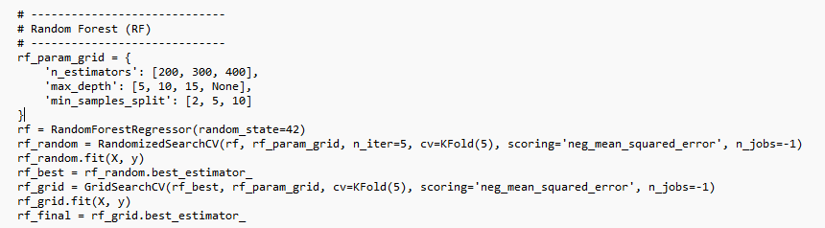Random Forest used ensemble decision tree which combining multiple single three to produce a stronger model which provide more accurate and stable outcome than an individual tree can reach. Hyperparameter tuning picks the combination that balances accuracy and generalization.

Figure 12.
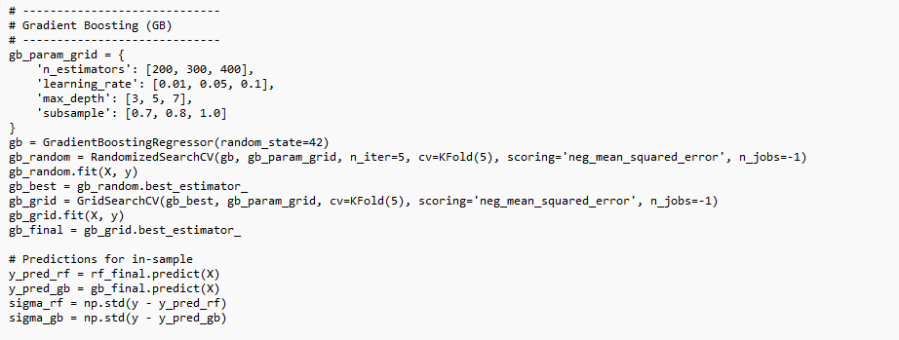
Gradient Boosting improve the accuracy predictions by building models sequentially which correcting the error from the previous one. This able to capture complex pollution behaviour. The hyperparameters decide how many steps, how big the corrections, and how detailed each step should be.

Figure 13.
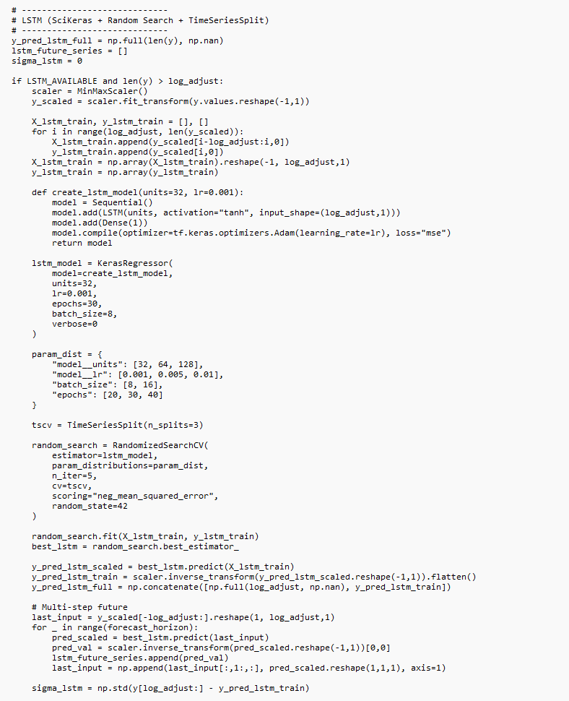
It trains deep learning LSTM model using the past pollutant series. Air quality changed overtime, LSTM is suitable for learning and understanding temporal patterns. This model recalls long-term sequences such as trends over weeks and more.

Figure 14.
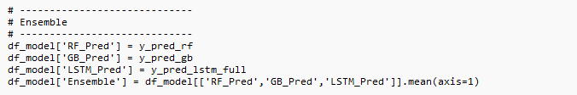
Ensemble is the three types of machine learning combined. The ensemble usually improves overall prediction accuracy and provides a more robust forecast than any standalone model.

Figure 15.
These metrics shows the accuracy of the ensemble performances.

In order to ensure ethical standards and professional conduct were met at all times, evaluation of data privacy obligations were undertaken in conjunction with evaluation of ethical standards and professional conduct to confirm that modelling and cleaning techniques did not overstate exceedance rates or distort environmental trends and therefore data privacy obligations were met by storing only publicly available Auckland Council datasets and following New Zealand's Privacy Act 2020 as a framework for responsible data management.

Maintenance and Scaling:

Auckland Council can utilize this system for maintaining and extending it over time, so they can use their reusable Python functions to ingest new datasets. This system will automatically retrain its forecasting module based upon the new data entering it, which will enable it to be "future proofed" as the amount of monitoring history continues to grow. A scalable architecture exists in this system with the capability to easily move to cloud storage solutions and deploy on many different remote server platforms. Additionally, by using Git version control the debugging and maintenance of this system are made easier; and due to a modular design, this system may have some or all of its modules updated at any given time without having to update the entire system, thus making this system capable of adapting to any changes to the underlying infrastructure as well as new pollutants.

Feedback Loop and Continuous Learning:

Auckland Council's continuous releases of data will continue to evolve the project’s feedback loop and ongoing learning cycle. Understanding how Auckland Council tracks and manages their air quality data parameters will allow for a smooth integration of future datasets. In addition to running the pipeline in an automatic manner to capture and process new data acquisitions, it will clean all data (e.g., eliminate any negative or missing values), make data consistent over time (e.g., align by date) and normalize all units before retraining the model.

Streamlit App:

The application has Five tabs in it: Overview, Temporal Analysis, Spatial Comparison, Weather & Traffic Insights, and Forecasting.
- Overview: Gives comprehensive information of the dataset uploaded in the prototype such as number of sites, pollutant, records, and NESAQ Thresholds.
- Temporal Analysis: It has interactive plot where it visualizes Annual, daily, and monthly exceedances of pollutants using NESAQ thresholds per periods along with highlighting the breach in red.
- Spatial Comparison: This tab compares two or more sites to identify which sites has the most exceedances using the average pollutant levels.
- Weather and Traffic Insights: This tab aggregates data daily to showcase the relationships between pollutants, weather, and traffic variables. It highlights the strong and relationship which provides an insight which weather and traffic contribute to pollutant levels.
- Forecasting: The forecasting tab on the dashboard enables the council to monitor future air quality like PM2.5 and NO2 and adjusting parameters like lag days and forecast horizon. It used a combined ensemble model using Random Forest, Gradient Boosting, and LSTM for enhanced prediction accuracy. The forecasts include confidence intervals and highlight days that may exceed air quality limits. Additionally, the dashboard provides training metrics, such as MAE and RMSE, to build user trust in the model's performance.

DISCUSSION

Reflection:

Discussion by Christian
As a main technical of the team building the prototype pushed me in ways that I didn’t expect. As the challenged was the LSTM model I trusted simply couldn’t handle our real-world dataset as it has a big gap and sensor error which broke the model. It was frustrating but it taught me a valuable lesson that real world forecasting isn’t about perfect but about creating a model that can handle imperfect data.
Another challenge was managing my technical tasks and team leadership. On certain days, even though I was deeply working in debugging, I still had to lead the team through design choices or explain why some models didn't work. Although it wasn't simple, it improved my clarity, patience, and communication skills.
The prototype also highlighted our shortcomings. Certain pollutants reacted unexpectedly, data quality was not always dependable, and our confidence intervals were less than optimal. These gaps highlighted where we needed to improve such as better data cleaning, pollutant-specific features, and more robust uncertainty modelling.
Overall, this prototype taught me how to be flexible, realistic, and patient with both the data and me. It reminded me that developing something helpful is far more important than building something flawless.

Discussion by Matthew

I worked as both co-leader and technical member, providing support as the project manager in coordinating this project while also completing all technical analysis, such as cleaning the data, developing LSTM (long short-term memory) for forecasting purposes. The goal here is to ensure that the data is reliable, so we can address potential data gaps caused by sensor failure and/or lack of maintenance. Working with missing data has changed how I think about missing data and how it relates to physical limitations.
When I integrated the LSTM model into a hybrid ensemble, I realized that there are some real limitations to using deep learning when you have irregularly sampled data and very large gaps between samples. When these conditions exist, deep learning models can cause instability in your results. In contrast, decision trees were found to be much better suited for this type of problem. As well, KNN (k-nearest neighbour) imputation introduced significant biases, and if more advanced techniques (like spline or seasonal decomposition) had been applied to improve data quality would have greatly improved data integrity. My dual roles helped me to develop my ability to manage projects effectively and to communicate with other team members and stakeholders to provide strategic support to our project.

Discussion by Juthaphat
For this project my main responsibilities were data preparation and imputation testing. Additionally, I set up GitHub, wrote reports, and did project development. I spent a lot of time in Jupyter Notebook checking where each station had gaps by year and month, then lining up the data so the time periods made sense for forecasting. After that we compared different ways of filling missing values, mainly forward fill, backfill, and k-NN. When we were working on this, it made me realise that imputation can be difficult because each method slightly changes the shape of the time series. These changes can affect exceedance counts and model accuracy. I also helped create the GitHub section and portfolio for our code, providing clear explanations. GitHub provides useful features such as access control and bug tracking. It allows us to store, manage, and collaborate on code. Some coding parts took me longer than I expected. I often had to go back to my old notebook and ask my teammates or supervisors when I got stuck. Even though it was stressful at times, it pushed me to improve my skills. For example, problem solving, accountability, and the ability to communicate effectively. Overall, this project showed me the importance of data analytics, documentation, and project management.

CONCLUSION

Findings:
Figure 16.
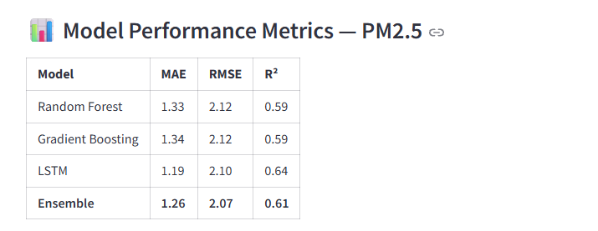
We examined the four Machine Learning models for predicting PM2.5 air pollution and found out that the best preforming model was LSTM, with fewer errors and the largest variety in the data. The ensemble model was a close second especially good at avoiding significant errors, with tree-based models trailing marginally. Overall, all the models were relatively accurate, although the LSTM time-aware character provided it an advantage in this forecasting challenge. This means that using LSTM or the ensemble may produce the most dependable findings for an air quality warning system or application.

Figure 17.
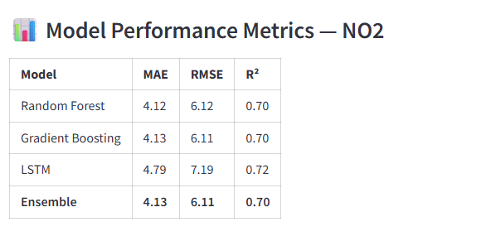
Based on the metrics provided for examining NO2 for predicting air quality show that the best model was Random Forest and Ensemble especially were the most accurate and had a fewer error. The LSTM model was less accurate even though it offered a better explanation of data patterns. This suggests that, in contrast to PM2.5, time-based patterns are less significant for NO2 prediction because of its precision and reliability, the ensemble model is suggested as the best options.

Health & Compliance Implications:

Levels of PM₂.₅ and NO₂ are consistently high at traffic-heavy areas like Customs Street and Khyber Pass, as reported by the Ministry for the Environment and NIWA. Increases in fine particulate matter are associated with heightened risks of asthma, cardiovascular diseases, and mortality. Although health data is unavailable, the frequency of exceedances suggests a significant public health risk in Auckland, indicating potential challenges in meeting NES-AQ compliance. Targeted reduction strategies during peak risk times are necessary.

Policy & External Factors:

There is a correlation between multiple output peaks and factors indicating that new policies and improved infrastructure significantly enhanced air quality. A high NO2 reading during construction related to the City Rail Link was attributed to increased congestion and emissions, according to NIWA. Although explicit models are not available in the dashboard to show how each policy impacts air quality, Auckland Council can utilize the correlations from transport interventions, construction, and seasonal conditions to assess the effectiveness of current and future strategies aimed at reducing pollution.

Industry Impact:

The Project enhances Auckland Council's ability to manage PM₂.₅ and NO₂ exceedances by transforming monitoring from a descriptive function to an early warning system. It identifies when and where exceedances happen, their possible causes, and forecasts future occurrences, allowing for proactive management. The project will convert technical data into actionable intelligence for interventions during peak exceedance times. A Streamlit prototype will enable non-technical staff to access this intelligence, while a Hybrid Model will illustrate how various factors impact air quality management. This framework will support data-driven decision-making for regulatory compliance, risk forecasting, and strategic environmental planning.

FUTURE DIRECTIONS:

- Operational Deployment of the Pipeline
The Streamlit app will also help Auckland Council by providing a deployable product within their own production environments such as Azure, AWS, or Council's own analytic servers. The application can ingest new monitoring data automatically every week, and perform automated retraining based on a schedule to provide an evolving model without need for ongoing supervision - thereby meeting the requirements outlined in Q6 for predictive capabilities.

- Targeted Mitigation Strategies
The results from the forecasts can be applied directly to operations. Examples include:
• Proactive traffic control measures before forecasted NO₂ peaks to mitigate congestion (Q3& Q4).
• Public health advisories prior to forecasted periods when levels are expected to exceed PM₂.₅ thresholds (Q5).
In addition to using the results from the model to determine if there is a problem and where it exists, these actions will complete the loop of notification and response.

- Model Enhancements
There are several ways that future research can improve the science behind the models to make them more accurate and reliable. These include:
• Creating probabilistic forecasts so that you can know not only what the level of pollution is likely to be but also the confidence interval (i.e., what the uncertainty is); e.g., Quantile Regression Forests, Bayesian Long Short-Term Memory (LSTM)
• Using transfer learning which will enable a model that has been developed to handle good sites to improve the reliability of a model for sites that have little data available.
• Developing feature attribution methods to understand how much each of the meteorological factors contributes to exceedances, i.e., What is the relative contribution of wind direction, temperature, etc., to exceedances? (Q4)
• Developing spatial-temporal models that link neighbouring sites together to model the movement of pollutants across space and time.

4. Sensor Network Expansion
By adding additional low-cost sensors in locations known to experience high levels of exceedance (Customs St, Khyber Pass), the amount of data collected and therefore the accuracy of the forecasts will increase. This will address Q1-Q3 by increasing both the frequency and quality of data being collected at higher spatial and temporal resolutions.

Github:
https://github.com/bbim713-capstone-group/auckland-air-quality-capstone

References:

Boamponsem, L. (2024). Auckland air quality – 2023 annual data report. Retrieved from knowledgeauckland: https://www.knowledgeauckland.org.nz/publications/auckland-air-quality-2023-annual-data-report/
Chunrong Jia, X. F. (2023). Comparison of generic Tenax and specialized PAH tubes for monitoring polycyclic aromatic hydrocarbons in the ambient air. Retrieved from ScienceDirect: https://www.sciencedirect.com/science/article/abs/pii/S1309104223001344?via%3Dihub
CSM. (2025, March 27). The Rise of Data-Driven Governance: How State Dashboards Lead the Way. Retrieved from CSM: https://www.csm.tech/blog-details/the-rise-of-data-driven-governance-how-state-dashboards-lead-the-way
Jiaming Zhu, P. W. (2018, September). A Hybrid Forecasting Approach to Air Quality Time Series Based on Endpoint Condition and Combined Forecasting Model. Retrieved from ResearchGate: https://www.researchgate.net/publication/327478457_A_Hybrid_Forecasting_Approach_to_Air_Quality_Time_Series_Based_on_Endpoint_Condition_and_Combined_Forecasting_Model
M.A. Mujtaba a, M. A. (2024). Using machine learning for air quality prediction and sustainable urban planning. Retrieved from ScienceDirect: https://www.sciencedirect.com/science/article/pii/S2666188825005453?via%3Dihub
MFE. (2024, October 9). Our air 2024. Retrieved from Ministry for the Environment: https://environment.govt.nz/publications/our-air-2024/
Sarah J. Hanna, J.-W. X. (2018). Refractory black carbon at the Whistler Peak High Elevation Research Site – Measurements and simulations. Retrieved from ScienceDirect: https://www.sciencedirect.com/science/article/abs/pii/S1352231018301262?via%3Dihub
WHO. (2024, October 24). Ambient (outdoor) air pollution. Retrieved from Wolrd Health Organization: https://www.who.int/news-room/fact-sheets/detail/ambient-(outdoor)-air-quality-and-health
Xiaoli Su, Q. L. (2022). A new GPU-accelerated coupled discrete element and depth-averaged model for simulation of flow-like landslides. Retrieved from ScienceDirect: https://www.sciencedirect.com/science/article/pii/S1364815222001189?via%3Dihub

Appendix 4: Checkpoint Checklist #
Purpose
This checklist ensures that a selected Capstone Project is progressing as intended for the student and business organization. The Checklist will be completed by the NZSE Project Leader in conjunction with the student and the Capstone Project Supervisors.

Criteria | Yes/No | Initials
Are the students and Capstone Project Supervisors free from any performance or other issues? If not, please comment below. | Yes | JA
Have the Capstone Project Supervisors and students developed work- based expectations/goals for the Capstone Project period? | Yes | JA
Does the student’s physical workplace remain suitable for the Capstone Project placement? | Yes | JA
Does the student have a clear understanding of expectations required to complete the Capstone Project? | Yes | JA
Has the student received input from their Capstone Project Supervisors on how to complete any required reports/assignments? | Yes | JA
Have you asked for feedback on how to improve the placement? Please comment below. | Yes | JA
Do you recommend continuing with the Capstone Project assignment? | Yes | JA

Feedback from Student
From the start, the requirements, expectations, and objectives were clearly explained. Capstone project has been a great experience for us. The supervisors have been approachable and give practical feedback.

Feedback from Capstone Project Supervisors

Student Signature Date 8/12/2025

Capstone Project Supervisor(s) Signature Date

NZSE Capstone Project Leader Signature Date
Appendix 5: Capstone Project Weekly Work Log#
Between: (Student Name)
And
(Name of Company, Supervisors/Capstone Project Leader Details, Address of company, contact details of Supervisors) Hours Log
Date | Hours worked | Work done (itemised) | Student Initials
22/8/2025 | 6 Hours | Brainstorming about the air quality/ Make a Draft | JA/CT/MT
25/8/2025 | 6 Hours | Writing 2 literature reviews | JA/CT/MT
1/9/2025 | 4 Hours | Exploring the dataset | JA/CT/MT
2/9/2025 | 4 Hours | Clean the dataset | JA/CT/MT
12/9/2025 | 6 Hours | Writing project proposal | JA/CT/MT
20/9/2025 | 4 Hours | Implementing supervisors’ feedback | JA/CT/MT
29/9/2025 | 8 Hours | Started Building the prototype/ Research about the gaps | JA/CT/MT
4/10/2025 | 8 Hours | Implementing supervisors’ feedback | JA/CT/MT
9/10/2025 | 3 Hours | Removing negative pollutant readings | JA/CT/MT
17/10/2025 | 7 Hours | Coding/making dashboard | JA/CT/MT
24/10/2025 | 8 Hours | Started Building the prototype/ Research about the gaps | JA/CT/MT
28/10/2025 | 6 Hours | Implementing supervisors’ feedback | JA/CT/MT
3/11/2025 | 7 Hours | Researching about the data gaps/ rebuilding the forecasting section | JA/CT/MT
21/11/2025 | 6 Hours | Finalize assessment 2 | JA/CT/MT
26/11/2025 | 4 Hours | Making presentation | JA/CT/MT
7/12/2025 | 2 Hours | Setting up GitHub | JA/CT/MT

Total Hours of Capstone Project = 81 Hours
Student Signature: Date: 8/12/2025
Capstone Project Supervisor(s) Signature: Date:

Appendix 6: Capstone Project Supervisors Evaluation#
This evaluation form is to obtain feedback on individual student’s performance during the Capstone Project from their Capstone Project Supervisors. The feedback collected will contribute to the assessment of the students concerned.

Student Name: |  | ID:
Organization Name:
Capstone Project Supervisors
Name:
Capstone Project Supervisors
Position:
Capstone Project Supervisors  Email: |  | Contact No.:

Feedback on the performance of the student: (Please tick the appropriate box)
(SD = Strongly disagree, D = Disagree, N = Neutral, A = Agree, SA = Strongly Agree)

Questions | SD | D | N | A | SA
1. The student demonstrated the ability to design, implement, and evaluate a network-based system, process, component, or programme to meet desired
needs.
2. The student performed his/her function effectively in teams.
3. The student demonstrated the ability to identify, analyse a problem and define the networking requirements appropriate to its solution.
4. The student was able to understand and follow professional, social, legal, ethical and cultural responsibilities during the internship.
5. The student was able to communicate effectively with a range of audiences.
6. The student was able to understand the impact of tasks in a local and/or societal context.
7. The student demonstrated an ability to recognize the need for, and to engage in lifelong learning.
8. The student demonstrated an ability to put knowledge into practice.
9. The student was capable of using current techniques, skills, and tools necessary for tasks with an understanding of the limitations.
10. The overall performance of the student was satisfactory.

Additional Remarks:

out of 10 marks (please fill in marks for your intern)

Capstone Project Supervisors signature: Date:
**If e-mailed directly from the Capstone Project Supervisors, then no signature is necessary.
This report has been discussed with the student: Yes / No (circle the appropriate)
Please evaluate the student intern in English communication skills. (Check all that apply)
◻The student’s command of the English language is adequate for performing his/her duties.
◻Understands spoken instructions.
◻ Requires instructions to be repeated.
◻Comprehends written instructions.
◻Needs help reading English.

Appendix 7: Student Capstone Project Evaluation#
In order to provide quality and innovative work experiences, on-going evaluation is important. Your opinion, recommendations and comments help us monitor placements and provide feedback to the business organisation, Capstone Project Supervisors and NZSE Capstone Project Leader.
Cohort: BBIM7123C Capstone Project commencement date: 1/6/2025
Course: BBIM713 Business organisation: Auckland Council
NZSE Capstone Project Leader: Sara Zandi
Please rate the placement using the following criteria:

Organisation | Strongly  Agree | Agree | Disagree | Strongly  Disagree | Uncertain  N/A
Was expecting me.
Orientation was well organised and included Health and Safety briefing.
Provided guidelines around their expectations.
Gave me the type of work specified in my project proposal (MOU).
Provided access to resources (research resources, dataset, etc.)
Capstone Project Supervisors | Strongly Agree | Agree | Disagree | Strongly Disagree | Uncertain N/A
Is willing to guide
Provides opportunities to ask questions.
Is actively involved in helping me reach the course objectives & LOs.
Is friendly and approachable.
Is sensitive to my needs.
Has a thorough knowledge of their area of practice/expertise.
NZSE Capstone Project Leader | Strongly Agree | Agree | Disagree | Strongly Disagree | Uncertain N/A
Provided guidance on the assessment requirements.
Actively involved in helping me reach my objectives & Los in class.
Facilitated learning experiences.
Maintained a good relationship with the business organisation.
Provided timely and constructive feedback.

