**A Student-Centered Blog Platform for Strathmore University**

**Barot Hetvi Dipen 169208**

**Wachira Matthew**

**151733**

**ICS 3 GROUP B**

**SUPERVISOR: Emmanuel Olang**

**An Informatics Project Proposal Submitted to the School of Computing and Engineering Sciences (SCES) in partial fulfilment of the requirements for the award of a Degree in Informatics and Computer Sciences**

**School of Computing and Engineering Science**

**Strathmore University**

**Nairobi, Kenya**

# Declaration and Approval

We declare that this work has not been previously submitted and approved for the award of a degree by this university or any other university. To the best of our knowledge and belief, the research proposal contains no material previously published or written by another person except where due reference is made in the research proposal itself.

Student Name: Barot Hetvi Dipen

Admission Number: 169208

Student Signature: _________________________ Date: ________________________

Student Name: Wachira Matthew Mwangi

Admission Number: 151733

Student Signature: _________________________ Date: ________________________

Supervisor Name: Emmanuel Olang’

Supervisor Signature: ________________________ Date: ________________________

# Abstract

The Strathmore University students lack a centralized space where they can share ideas, academic insights, and personal experiences in a secure, student-centered, online environment. With this project we aim to develop a blog platform tailored to the specific needs of Strathmore University students. It will provide a space where the students can post, read and comment on blog content.

While there are existing platforms such as the Strathmore VC Blog, the focus in these cases is on top-down communication which is administrative and does not feel like a safe space for students to freely express themselves. Our solution will empower students to create and share content, which truly depicts their academic journeys, interests, and campus life, keeping the needs of the students as our focal point.

The platform is built using React JS for frontend and Firebase services for backend. An ObjectOriented Analysis and Design (OOAD) is applied and follows the Agile Scrum methodology. The primary focus is to ensure functionality, reliability and usability.

This blog platform will enhance the student voice, encourage peer interaction, hence providing a digital space catering to the real needs of the university community.

**Table of Contents**

Declaration and Approval ii

Abstract ii

List of Figures vii

List of Abbreviations viii

Chapter 1: Introduction 1

1.1 Background 1

1.2 Problem Statement 2

1.3 Aim/General Objective 2

1.3.1 Specific Objectives 2

1.3.2 Research Questions 3

1.4 Justification 3

1.5 Scope 3

1.6 Limitations 4

1.7 Delimitations 4

Chapter 2: Literature Review 5

2.1 Introduction 5

2.2 Communication and Collaboration Needs Among University Students 5

2.3 Limitations of Existing Platforms in Student Engagement and Academic Support 6

2.4 Review of existing systems 6

2.4.1 VC BLOG (Strathmore) 6

2.4.2 University of London Student Blog 7

2.4.3 University of Edinburgh blog 8

2.6 Conceptual Framework 10

Chapter 3: Methodology 11

3.1 Introduction 11

3.2 Methodology & Paradigm 11

3.2.1 Product Backlog & Requirement Gathering 12

3.2.2 Sprint Planning 12

3.2.3 Daily Stand-ups 12

3.2.4 Sprint Review 12

3.2.5 Sprint Retrospective & Release 12

3.3 System Analysis 12

3.3.1 Use Case Diagram 13

3.3.2 Sequence Diagram 13

3.3.3 Entity Relationship Diagram 13

3.3.4 Class Diagram 13

3.4 System design 13

3.4.1 Database schema 13

3.4.2 Wireframes 14

3.4.3 System architecture 14

3.5 System development tools and techniques 14

3.5.1 Visual Studio code (IDE) 14

3.5.2 React.js framework(frontend) 14

3.5.3 Firebase (backend) 14

3.5.4 Git + GitHub 14

3.6 Deliverables 15

3.6.1 Concept Note 15

3.6.2 Project proposal 15

3.6.3 Final Documentation 15

3.6.4 Log in Module 15

3.6.5 Student profile module 15

3.6.6 Homepage module 15

Chapter 4: System Analysis and Design 16

4.1 Introduction 16

4.2 Requirements analysis 16

4.2.1 Functional requirements 16

4.3 Diagrams 16

4.3.1 Use Case Diagram 16

4.3.2 Sequence Diagram 18

4.3.3 Entity Relationship Diagram 20

4.3.4 Class Diagram 20

References 22

Appendix 24

Appendix 1: Gantt chart 24

# List of Figures

Figure 2.1: VC Blog Landing Page............................................................................................ 7

Figure 2.2: The University of London Blog Webpage .............................................................. 8

Figure 2.3: The University of Edinburgh Blog Website ............................................................ 8

Figure 2.4: Conceptual Diagram ............................................................................................. 10

Figure 3.1: Scrum Framework Diagram .................................................................................. 11

Figure 4.1: Use Case Diagram .................................................................................................

Figu

# List of Abbreviations

CUNY – City University of New York

HTML – Hypertext Markup Language

CSS – Cascading Style Sheets

OOAD – Object-Oriented Analysis and Design

SQL – Structured Query Language

# Chapter 1: Introduction

## 1.1 Background

We are living in a digital age where the students at university heavily rely on technology for collaborations, research, and learning; despite this, Strathmore University lacks a centralized, student-led digital space that addresses these needs. This project addresses that gap by developing a dedicated blog website where students can connect, exchange ideas, and engage with the wider university community. Unlike administratively controlled websites or distracting social media platforms, this blog will encourage peer-to-peer learning, creativity, and networking. Digital platforms can significantly enhance student engagement and community building, making this initiative both relevant and impactful (Tess, 2013).

The real problem is that there is no student-led platform at Strathmore, which limits the ability of students to share ideas, connect with other students in the university, as well as support each other outside academic settings. Right now, the students just rely on other social media platforms, which are full of distractions and not directed to academic and personal growth. The university website, on the other hand, is controlled by administrators, leaving very little room for students' voices. When students aren’t actively involved in creating their digital spaces, learning can feel disconnected and less meaningful (Selwyn, 2012). This clearly shows a need for a student-centred space, one they can call truly theirs.

The students are the main group affected by the lack of a student-led platform, as they do not have a space where they can freely share ideas, collaborate, or stay updated on campus events. The university as a whole is also impacted as it misses the opportunity to foster a stronger community in the student body, furthermore, it also impacts the long run as businesses that recruit from Strathmore will receive graduates who are less prepared in key areas like communication and digital literacy.

Many universities in the world, including Princeton and Harvard, have employed blog websites for various reasons, such as allowing students to share research, life updates, as well as news. They have worked out to be highly appreciated by the students and used by a majority, which shows how important it is for students to share insights on academic and extracurricular activities. These websites are, however, a bit more limiting than we want for the Strathmore students. we want a more liberating experience for Strathmore students, allowing them to express themselves freely. Strathmore lacks such a platform; this project, therefore, aims to address this gap by creating a student blog that will encourage meaningful interaction between the students, hopefully helping them develop their personal and professional skills.

## 1.2 Problem Statement

The core problem is the lack of a centralized, student-driven platform that caters to the students’ academic and professional needs. Currently, the students are using platforms like WhatsApp, which are generic. This needs to be addressed as a lack of a cohesive platform for the students leads to missed opportunities and a broken community.

The lack of such a platform is a problem as it leaves students disconnected from each other and leads to missed opportunities for peer-to-peer learning. The existing social media platforms do not offer a focused environment to do this as there is a lot of miscellaneous content. This gap has a direct effect on students’ sense of belonging and their ability to use digital tools to gain academic and personal success.

The lack of a unified platform in the university for the students puts at risk an environment where the students are not connected to each other and to their academic lives. This platform will foster collaboration and greater student involvement in campus activities.

## 1.3 Aim/General Objective

To create a web-based blog for Strathmore University students to share experiences, find support for their studies and connect with other like-minded students to address the lack of centralized, ormal space for students to interact.

#### 1.3.1 Specific Objectives

1. To analyse the communication and collaboration needs and challenges that Strathmore University students face through researching the users and reviewing online resources and articles.
2. To evaluate other existing platforms and identify gaps in how students share experiences and receive academic support
3. To design a web-based platform that will enable blogging, messaging and group discussions to address their university needs
4. To develop a well-functioning platform that meets student needs based on the approved system design
5. To perform multiple tests with real users to ensure functionality, reliability and usability.

#### 1.3.2 Research Questions

i. What are the communication and collaboration challenges that Strathmore University students normally face? ii. What are the limitations of the current existing platforms in supporting student interaction and academic support? iii. How can the platform be designed effectively to support blogging, messaging and group discussions for the students?

1. How can we use modern web technologies to develop a secure and user-friendly platform?
2. Are there any features that users may misunderstand or fail to locate?

## 1.4 Justification

There is a growing need for a secure, centralized platform where university students can share their experiences, collaborate and seek academic support. Existing platforms often fail to provide a focused, university-specific platform where students can freely perform such interactions. For instance, the CUNY Academic Commons was created to address communication gaps across campuses, fostering better collaboration and community-building among students within the City University of New York system (CUNY Academic Commons, 2025). Likewise, BlikBook has been used in higher education especially in Uk and Ireland, to enhance student engagement by connecting the students and lecturers based on their learning needs (BlikBook, 2025). This project will benefit Strathmore University students by enhancing communication and collaboration, which will ultimately create a more connected and informed student body. It also supports the university's academic goals. Additionally, it may inform higher education professionals and institutions on more effective strategies for improving student engagement and academic support through digital platforms.

## 1.5 Scope

The proposed study focuses on building a web-based blog platform for Strathmore University students to enhance peer interaction, academic support and sharing experiences. It includes identifying student needs, designing and implementing the platform, and evaluating its potential impact. The stake holders of this project are Strathmore University students. It will use tools such as surveys, and physical interviews for collecting data and web development technologies which are React JS for the frontend and Firebase for the backend for hosting, storing data and authentication. The scope covers research, design, system development and medium-scale launch but excludes mobile versions and long-term maintenance.

## 1.6 Limitations

One challenge expected is users with limited or unstable internet access, which may affect their ability to connect with the platform in real time. Some students may face issues with recovering their university email credentials needed for authentication. Moreover, there is varying levels of digital literacy among the students which may impact their ease of navigating and using the platform effectively.

## 1.7 Delimitations

To address these challenges, the platform will be optimized for low-bandwidth environments where possible and offer a responsive design. Clear guidance and help sections will be provided to help users with less digital experience. Lastly, Firebase Authentication will ensure secure and straightforward logins with university emails, with support for users facing login issues.

# Chapter 2: Literature Review

## 2.1 Introduction

We are going to explore the communication and collaboration challenges that are faced by the university students, while using existing blog platforms. Students tend to use platforms such as WhatsApp and Discord, which we have found to lack academic focus and structure. The existing blog websites for other universities feel restrictive and fail to support open student expression as per limited by formality and administrative control. We aim to tackle this problem with our student-centered Strathmore Blog System.

## 2.2 Communication and Collaboration Needs Among University Students

Effective communication and collaboration are essential parts of the university experience, especially for academic and social development. Most communication among Strathmore University students happens through informal platforms like WhatsApp, Instagram and Discord, which, while convenient to use, are not effectively designed for academic focus and student life engagement. These platforms are decentralized and lack proper structure, making it harder to track important discussions and find relevant support. Additionally, platforms officially run by institutions may not feel open enough for students to freely express themselves. Communication skills are essential for academic success. Students need to be able to communicate their ideas effectively in order to participate in class discussions, give presentations, and write papers (lancehgs, 2023). This highlights a clear gap for a studentbased, university platform that encourages purposeful conversation while maintaining freedom of expression.

This project focuses on sharing academic and university-related content among University students. Students normally join various groups, often on WhatsApp, based on their interests, assignments or classes. These groups are often scattered, temporary and lack continuity. There is no combined online space where university students can contribute and find content related to their student lives and needs.

Communication platforms should be inclusive, student-driven and support academic and social interactions. What is currently being compromised is the quality and depth of student interaction in the current platforms they use, such as WhatsApp and Discord. They fail to provide a structured, academically supported environment for the students. Ideally, the platform should be a space for intentional collaboration, sharing relatable student content and learning. However, these platforms are filled with casual personal conversations, without any separation from meaningful collaboration (Pimmer, Linxen, Gröhbiel, & Jha, 2012). Consequently, students might miss out on rich collaboration experiences, which affects their ability to build strong professional networks with other students which are necessary for postgraduate success. (Greenhow & Lewin, Social media and education: reconceptualizing the boundaries of formal and informal learning, 2016). This compromise highlights the need for a dedicated, student-run platform focusing on academic and professional development.

## 2.3 Limitations of Existing Platforms in Student Engagement and Academic Support

Many of the digital platforms such as WhatsApp and Discord, that are used by university students, do not support academic work and meaningful engagement. These platforms which are real-time, fast-paced and informal, which makes them useful for casual conversation but not deeper academic engagement and student collaboration. Platforms that are run officially by institutions tend to feel formal and restrictive, which prevents students from expressing themselves freely and authentically (Greenhow & Robelia, Old Communication, New Literacies: Social Network Sites as Social Learning Resources, 2009). This creates a gap in student engagement, where students lack a space that is academically enriching and socially supportive, which weakens their sense of engagement and collaboration.

Although digital platforms such as Piazza, BlikBook, and CUNY Academic Commons were created to try and fill this gap, they have their limitations. Piazza focuses on coursework only and lacks personal interaction. BlikBook encourages student questions but relies on the presence of instructors to function. CUNY Academic Commons supports student collaboration but operates with a formal university oversight, which limits authentic, spontaneous expressions from the students. This results in a disconnect between the students' communication needs and the current platforms they use. It highlights the need for a studentdriven online space that is both free and functional for academic and personal growth (Junco, 2012).

## 2.4 Review of existing systems

In this section, we will look at systems that are similar to what we intend to design.

#### 2.4.1 VC BLOG (Strathmore)

The Strathmore VC Blog is supposed to inform students about university activities with information directly from the Vice-Chancellor's office. At its core, the VC blog aims to inspire, empower, and create a ripple effect of impact within Strathmore University and beyond (university, n.d.). However, this platform is not student-centered; there is no space for feedback from students, as well as a space for students to share their own personal experiences. The system is built with JavaScript for the backend and uses HTML and CSS styling for the front end. These are efficient, and we intend to use a similar approach for our system, which will provide a more interactive interface built around things the students want and will be a part of.

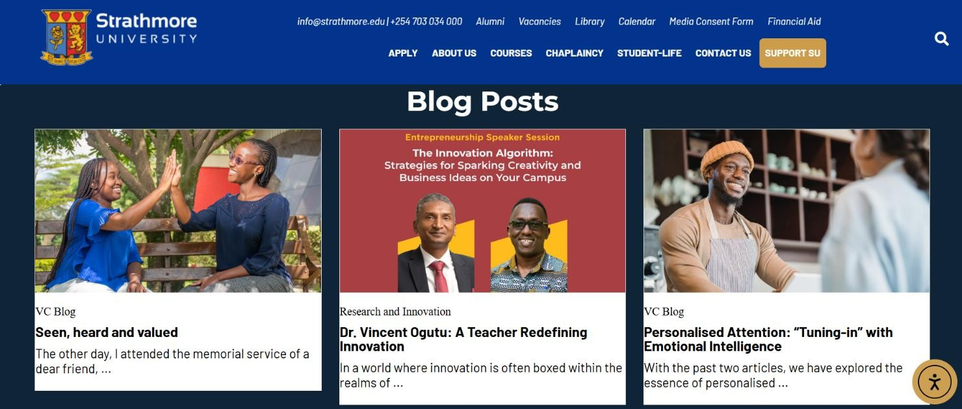

*Figure 2.1: VC Blog Landing Page (university, n.d.)*

### 2.4.2 University of London Student Blog

This system is a great space for students from the University of London to share their personal experiences and study tips. Student bloggers come from all walks of life, from a range of countries, some study independently, and others on campus at Recognized Teaching Centres. All are enrolled in a diverse range of programs (London, n.d.). However, the blog does not allow readers to leave comments on the blog which makes it more like a one-way conversation rather than being interactive. Therefore, we intend to add features like comments or live discussions to make the platform more engaging and supportive to students who want to connect with each other all over campus.

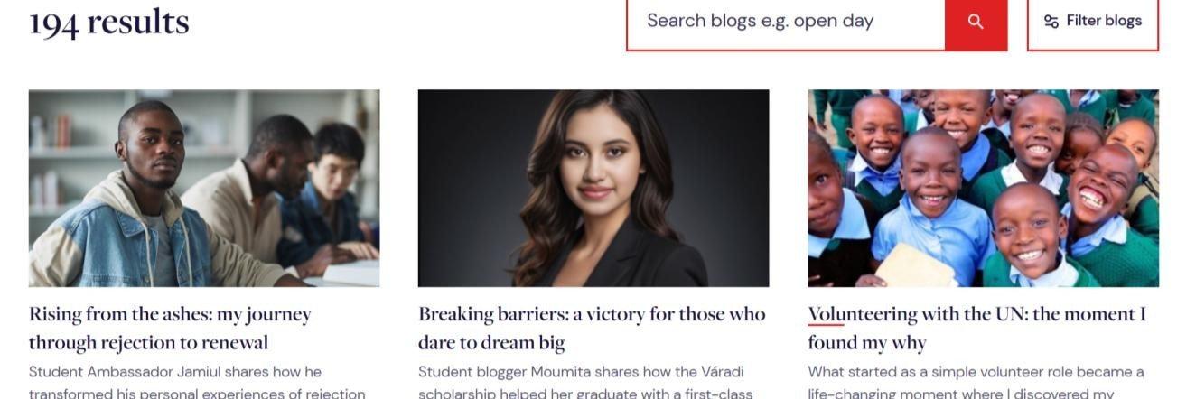

*Figure 2.2: The University of London Blog Webpage (London, n.d.)*

#### 2.4.3 University of Edinburgh blog

The University of Edinburgh's blog is robust and tackles many common challenges like making content easy to find, allowing comments and interactions, also encourages real-time feedback. On the webpage, you will find a range of ever-expanding content about life at the University, from societies and studying, to internships and living in the city of Edinburgh (Edinburgh, n.d.). it is not very intuitive, and the feel of the blog is quite administrative. Despite the personal stories, the website feels administrative, We aim to make our system much more user-friendly.

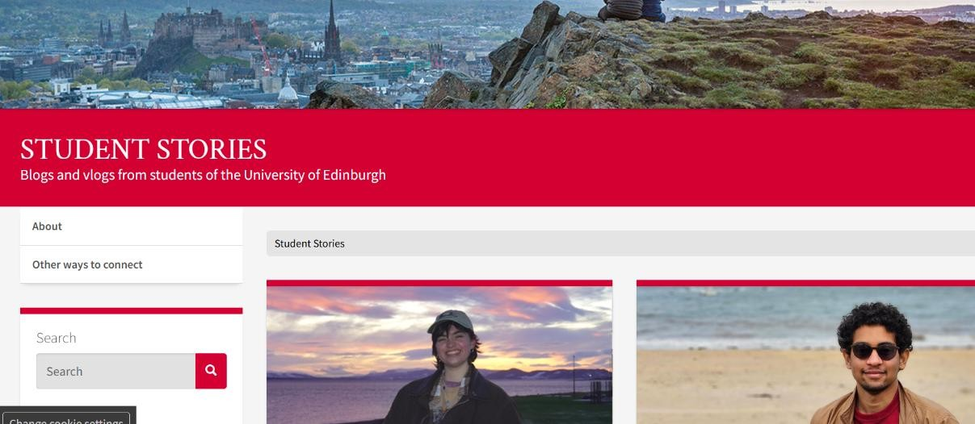

*Figure 2.3: The University of Edinburgh Blog Website (Edinburgh, n.d.)*

**2.5 Gaps in existing systems**

The systems that currently exist offer platforms for student expressions, provide insights into university leadership like the Strathmore VC blog, and try to encourage student involvement; they are all primarily administrative, pushing their universities' agendas. This approach aligns with the need for more inclusive and representative platforms in higher education, as highlighted by recent discussions on accent bias and class-based discrimination at the University of Edinburgh (Horne, 2024)in contrast, our system will aim to be fully studentcentered and allow the students to freely express themselves without a shadow cast by the university’s administrative goals.

## 2.6 Conceptual Framework

The system will provide digital space where students will post, comment and interact on both academic and social topics addressing the limitations of the current platforms which are too structured and limit free expression. The actors will be unregistered users who can only view the posts, registered students who will be able to post, like and comment on other posts and delete their posts and profiles, and administrators who will maintain the systems and control the user activity; for example taking down accounts of users who are posting offensive/explicit content. The inputs will include student generated content, the registered students profile data, and upload media like images. The process will include creating and submitting content, categorizing and tagging in posts, real-time notifications and alerts and searching and filtering for specific content. Storage requirements will be a user database which contains the user profile and credentials, a database for the content like the blog posts and media. The outputs will be a public blog feed with posts by the registered users, notifications for the users likes, comments and mentions and search results based on filters and keywords. Within the system, the user will be able to register/login, once logged in they can post blogs, like, comment on other users blogs and they will be able to receive notifications and alerts via email. Furthermore, the system will be able to store the user data, posts and media

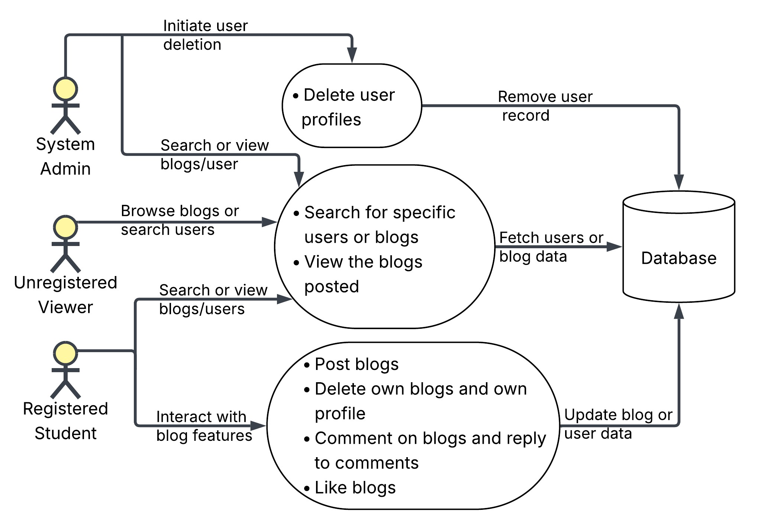

*Figure 2.4: Conceptual Diagram (Novriansyah, 2024)*

# Chapter 3: Methodology

## 3.1 Introduction

To create this blog platform, where students can interact with each other, we intend to use a flexible approach (Agile Scrum methodology) to build the system step-by-step, leaving room for feedback as we go. We are using object-oriented analysis design(OOAD), which will allow us to break the process into smaller, more manageable parts. Furthermore, we intend to build the platform using React for the frontend and Firebase for the backend, as we found them to be user-friendly and easy to maintain (Prajapati, 2024).

# 3.2 Methodology & Paradigm

This project shall implement the Object-Oriented Analysis and Design(OOAD) approach, as it allows us to build complex systems in a flexible and scalable way, by breaking them into smaller, manageable components. Since our platform will have multiple user roles and interactive features such as posting a blog and commenting on a blog, OOAD will help organize these features into logical, maintainable components. (Kumari, 2024)

For this project, we have chosen the Agile Scrum methodology, more specifically the Scrum framework, because of its flexibility and continued improvement, which will allow us to gather user feedback and implement changes before making the final product. Since our platform will evolve according to user needs and feedback, Scrum’s regular sprints allow us to adjust as required. This method ensures that we can quickly adapt to changes, make regular improvements as we work towards building an efficient user-centered platform (Karabul & Ergun, 2018).

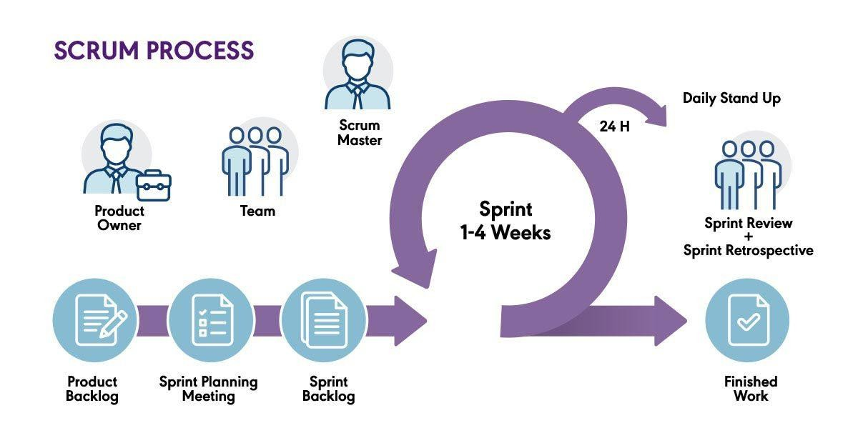

*Figure 3.1: Scrum Framework Diagram (Novriansyah, 2024)*

### 3.2.1 Product Backlog & Requirement Gathering

We will start by compiling a product backlog which is an outline of the platform’s key features, such as creating accounts, posting blogs, commenting and search functionality. These features have been gathered through user needs, research and input from our supervisor. The product backlog will serve as the foundation for sprint planning.

### 3.2.2 Sprint Planning

At the start of each sprint cycle, we shall have a sprint planning session, to select tasks from the backlog that we aim to complete. Tasks will be chosen based on priority, complexity and feedback from our supervisor. This process ensures that each sprint focuses on the most important features needed for our platform’s progress.

### 3.2.3 Daily Stand-ups

Brief, daily stand-up meetings will be held to track progress, address challenges and keep our team aligned. These meetings will help maintain steady progress and address issues early.

Regular meetings with our supervisor will also ensure that we are up to date.

### 3.2.4 Sprint Review

At the end of each sprint, we will show and demonstrate our completed work to our supervisor. This review will give us necessary feedback, allowing us to improve our product in the next sprint and carry on as planned. It also ensures that the development stays aligned with user expectations and our goals.

### 3.2.5 Sprint Retrospective & Release

We shall hold a retrospective session, to reflect on the sprint – what went right, what went wrong, what can be improved and how can we implement the changes moving forward. This will help in refining our workflow as we progress.

# 3.3 System Analysis

This section describes the different system analysis diagrams that we will use to model the structure and features of our platform. These diagrams help with visualizing the requirements clearly and will serve as a guideline for the design and development process.

### 3.3.1 Use Case Diagram

The Use Case Diagram will illustrate how the different users in our system will interact with each other. It will show the various actions they can perform, which will help define the core functionalities of the system from each user’s perspective.

### 3.3.2 Sequence Diagram

This diagram will model the sequence of interactions between the user and the system over time. For instance, it will show the entire process when registered users post a blog, and how the system will respond. This helps capture the logic and order of user actions and the system responses.

### 3.3.3 Entity Relationship Diagram

The Entity Relationship Diagram shows the relationships between key entities in the system such as users, comments, blogs and user profiles.

### 3.3.4 Class Diagram

The Class Diagram describes the system's structure by showing the system’s classes together with their attributes and methods. It also illustrates the relationships between classes, which will aid in back-end implementation.

# 3.4 System design

In this section we will outline how the Strathmore blog platform will be logically structured.

### 3.4.1 Database schema

We will be using Firebase Firestore database schema (a schema is the structure or organization of a database, it will help us organize data consistently), it is NoSQL and will consist of 2 primary collections:

Users: which will store the students and admin details.

Blogs: which will store the blogs, and the data associated with it.

Each document will be uniquely identified and hence can easily be queried.

### 3.4.2 Wireframes

Wireframes depict a visual layout and flow of the core pages. We will have a homepage which will display the latest blog posts and a search and filter section, such that users can look for what they need, a user authentication page for login and registration, a create/edit blog interface, and an admin dashboard to manage users. Wireframes' main purpose is to help designers visualize the structure; it is done before coding.

### 3.4.3 System architecture

The system architecture will follow a client-server model, the front end will use React.js, HTML, and CSS, using Firebase on the backend. firebase will be used to handle authentication and hosting.

# 3.5 System development tools and techniques

In this section, we will look at the tools used in the project along with justifications for why they were selected.

### 3.5.1 Visual Studio code (IDE)

It is lightweight, supports git integration and can be used to write frontend (HTML,CSS, React.js) and backend (Node.js/express) code.

### 3.5.2 React.js framework(frontend)

It supports the building of dynamic user interfaces and allows the use of reusable components.

It will be used to create interactive UI components.

### 3.5.3 Firebase (backend)

This is an all-in-one backend platform with will integrate seamlessly with React.js, it can be used for storing the data, for authentication as well as hosting, making it perfect for our project.

### 3.5.4 Git + GitHub

We will use this for collaboration and remote code storage, keeping the project manageable and organized. The main use will be version control, pull requests, and storing project history.

# 3.6 Deliverables

### 3.6.1 Concept Note

This entailed the initial planning and justification of our idea; the student-centered blog website for Strathmore students. We included the problem definition, the objectives as well as the target users and proposed technologies in this concept note.

### 3.6.2 Project proposal

A detailed document highlighting the planning and elaborating the concept note. It includes: the introduction, literature review as well as the methodology described theoretically. Furthermore, includes any relevant diagrams

### 3.6.3 Final Documentation

A complete and final record of the project outcome, elaborating on all the implemented features, all the design artifacts like wireframes and architectural flow, details about the security and authentication and deployment.

### 3.6.4 Log in Module

Handles core authentication, allowing users to register, login if already registered and reset their password in the event they lose it.

### 3.6.5 Student profile module

Allows users to personalize their profiles, post blogs, delete their blogs and view comments and likes posted on their blogs.

### 3.6.6 Homepage module

The landing page for the website where the users can view the latest blogs posted and search for specific ones using the search bar via usernames of filter categories.

# Chapter 4: System Analysis and Design

## 4.1 Introduction

## 4.2 Requirements analysis

The requirements have been grouped below into functional and nonfunctional requirements

### 4.2.1 Functional requirements

These define what a system should do; our system's functional requirements are highlighted below

1. **Register for account**: The system must allow students from Strathmore to register for an account using their Strathmore email. A verification email should be sent for authentication.
2. **Log in and log out**: The system must verify credentials, start a session, and allow the student/admin to log out at any time.
3. **View blog posts**: Both unregistered guests and registered students must be able to browse and read posted blogs created by others.
4. **Comment on posts**: The system must accept and store comments on visible blog posts.
5. **Delete own account**: The registered students must be able to remove their accounts after confirmation.
6. **Search for users and blogs**: The unregistered guests and students must be able to look for specific blogs or users.
7. **Receive notifications**: the system must alert students when others like, comment on, or flag their blogs, as well as notify them when there's a login to their account.
8. **Delete posts and user accounts**: Admin must be able to remove flagged or inappropriate content.
9. **Generate system reports**: the admin must be able to generate system reports showing insights for the blogs and users' activity.

## 4.3 Diagrams

### 4.3.1 Use Case Diagram

Consists of the actors: registered students who is ssomeone that has signed up and can log in to the system, unregistered guests, who can create an account and admin, who is the system administarator with privileges to manage the platfrom. The rectangle represents the blog system, everything inside it are the use cases that the system provides,

Use Cases for Registered Student:

* **Log in / Log out**: Sign into and out of their account.
* **Post blog / Edit blog**: Write or update blog content.
* **Comment / Reply to comment**: Engage with blog posts by adding or responding to comments.
* **Like blog**: Show appreciation for posts.
* **Delete account**: Remove their own profile from the system.
* **Search for blogs**: Use keywords to find specific posts or users.

Use Cases for Unregistered Guest:

* **Create account**: Sign up and become a registered student.
* **Search for blogs**: Even without logging in, guests can browse content.

Use Cases for Admin:

* **Log in**: Access the system as an administrator.
* **Delete users**: Remove problematic or flagged student accounts.
* **Generate user reports**: Produce summaries of student activity, post stats, etc.

This is shown in Figure 4.1 below

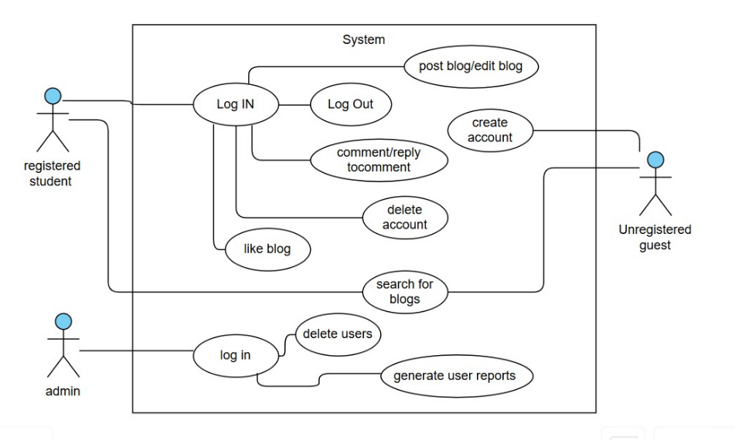

Figure 4.1 Use case diagram

### 4.3.2 Sequence Diagram

This sequence diagram shows how the various actors: Admin, Registered Student, and Unregistered Guest, interact with the blog system across various processes.

**Unregistered Guests** can register by submitting their details, which are authenticated; if verified, their profile is saved to the database, otherwise, they are prompted to try again. Once logged in.

**Registered Students** can post blogs, like blogs, comment, flag inappropriate posts, and search for content by username or category. The system handles authentication and database storage throughout.

**Admins** log in separately, and if verified, they gain access to delete users and generate user activity reports.

This is shown in Figure 4.2 below

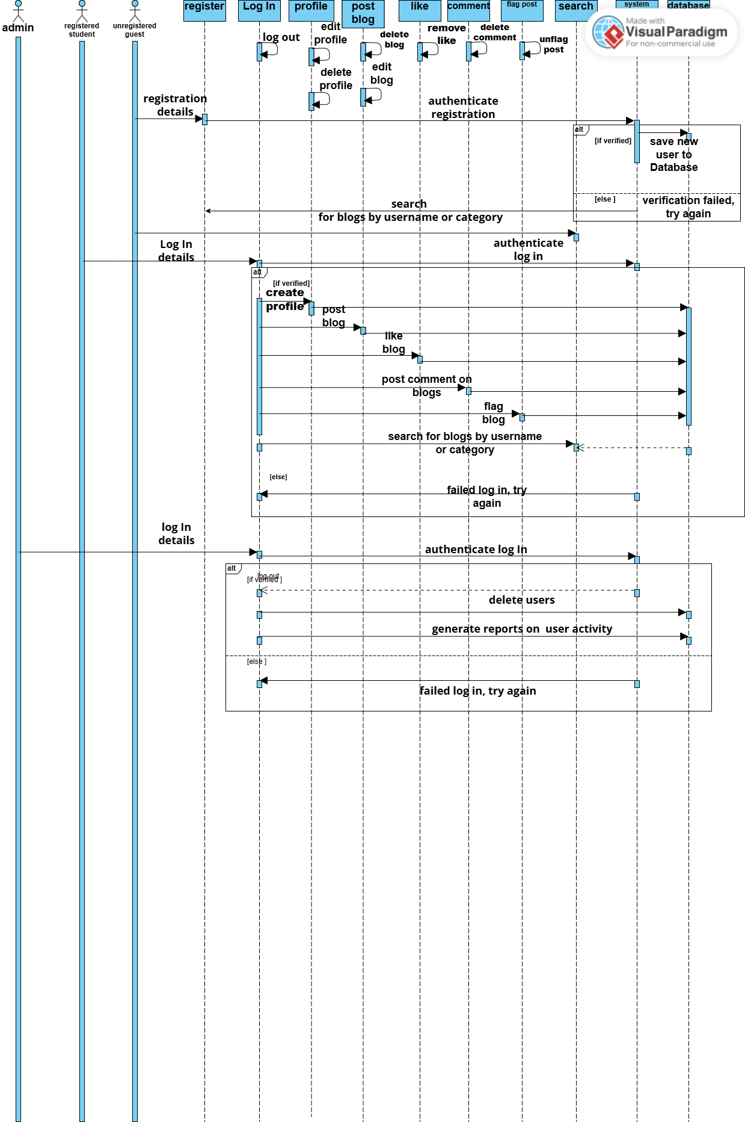

Figure 4.2 sequence diagram

## 4.3.3 Entity Relationship Diagram

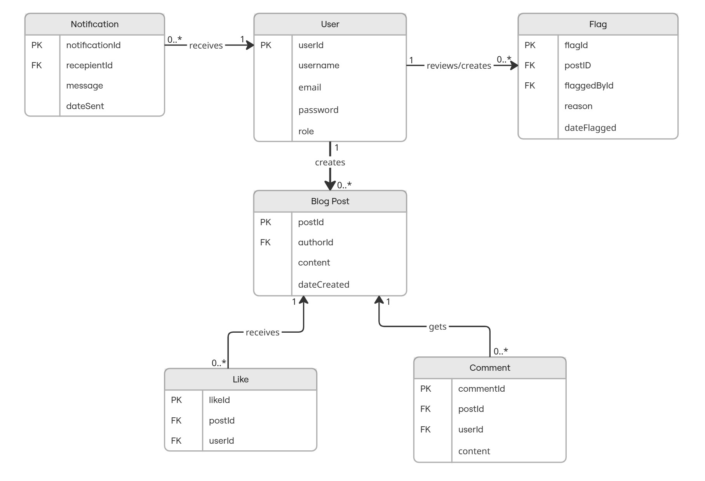

Figure 4.3 Entity Relationship Diagram

## 4.3.4 Class Diagram

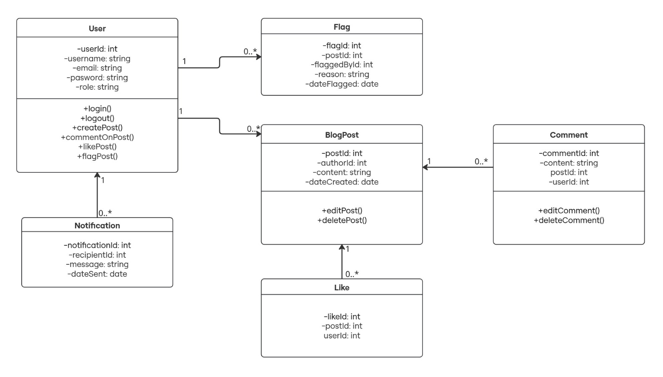

Figure 4.4 Class Diagram

# References

*BlikBook. (2025, April 28). Retrieved May 4, 2025, from Wikipedia:*

*https://en.wikipedia.org/wiki/BlikBook*

*CUNY Academic Commons. (2025, April 25). Retrieved May 4, 2025, from Wikipedia: https://en.wikipedia.org/wiki/CUNY_Academic_Commons*

*Edinburgh, U. o. (n.d.). Student Stories. Retrieved 2025, from Blogs:*

*https://blogs.ed.ac.uk/studentstories/*

*Greenhow, C., & Lewin, C. (2016). Social media and education: reconceptualizing the boundaries of formal and informal learning. Learning, Media and Technology, 41(1).*

*Retrieved from*

*https://www.tandfonline.com/doi/full/10.1080/17439884.2015.1064954?scroll=top&n eedAccess=true*

*Greenhow, C., & Robelia, B. (2009, July 1). Old Communication, New Literacies: Social*

*Network Sites as Social Learning Resources. Journal of Computer-Mediated*

*Communication, 14(4), 1130-1161. Retrieved from https://doi.org/10.1111/j.10836101.2009.01484.x*

*Horne, M. (2024, november 18). Edinburgh University tackles 'accent bias' amid claims of snobbery. Retrieved 2025, from The Times:*

*https://www.thetimes.com/uk/scotland/article/edinburgh-university-accent-snobberysymposium-d7smpkvbx?region=global*

*Junco, R. (2012, January). The relationship between frequency of Facebook use, participation in Facebook activities, and student engagement. Computers & Education, 58(1), 162-*

*171. Retrieved from*

*https://www.sciencedirect.com/science/article/abs/pii/S0360131511001825*

*Karabul, T., & Ergun, E. (2018, January). A NEW WAY OF MANAGEMENT: A SCRUM MANAGEMENT. International Journal of Commerce and Finance, 4(2), 108-117.*

*Kumari, S. (2024, April 30). Object-Oriented Analysis and Design (OOAD) - Naukri Code 360. Retrieved from Naukri: https://www.naukri.com/code360/library/object-orientedanalysis-and-design-ooad*

*lancehgs. (2023, May 10). importance of communication skills for students. Retrieved 2025, from lancersarmyschools: https://lancersarmyschools.com/importance-ofcommunication-skills-for-students/*

*London, U. O. (n.d.). Student Blog. Retrieved 2025, from University of london: https://www.london.ac.uk/news-events/student-blog*

*Novriansyah, N. (2024, August 16). Understanding the Scrum Framework: What, Why, How, and Best Practices | by Nova Novriansyah | NovAI- Agile & DevOPS 101 | Medium. Retrieved from Medium: https://medium.com/novai-devops-101/understanding-thescrum-framework-what-why-how-and-best-practices-b8d83a4c8c9f*

*Pimmer, C., Linxen, S., Gröhbiel, U., & Jha, A. K. (2012, November). Mobile learning in resource-constrained environments. A case study of medical education. Educational*

*Technology & Society, 15(3), 1–13. Retrieved from*

*https://www.researchgate.net/publication/235719234_Mobile_learning_in_resourceconstrained_environments_A_case_study_of_medical_education_DOI103109014215 9X2012733454*

*Prajapati, h. k. (2024, October 28). Understanding Google Firebase - Everything you need to know. Retrieved 2025, from Medium:*

*https://medium.com/@hemantkumarceo001/understanding-google-firebaseeverything-you-need-to-know-3a443650aaa3*

*Selwyn, N. (2012). Education and Technology: Key Issues and Debates. London, UK: Bloomsburry Academic.*

*Tess, P. A. (2013, September). The role of social media in higher education classes (real and virtual) – A literature review. Computers in Human Behavior, 29(5), A60-A68.*

*Retrieved from*

*https://www.sciencedirect.com/science/article/abs/pii/S0747563212003743 university, S. (n.d., n.d n.d). Vice chancellors blog. Retrieved 2025, from Strathmore university:*

*https://strathmore.edu/vice-chancellors-blog/*

# Appendix

# Appendix 1: Gantt chart

