Matthew Walters, Steven Koprowicz

Lab 3 Report

In this project, we trained different Neural Network structures and methods for classification tasks based on the FairFace dataset, from which we used 86744 faces for training, and 10955 faces for testing, with 32x32 pixels for each, and they were in grayscale. For each Task, we classified (a) the Gender of a given face, and (b) the Race of the person in the image. We also created a variational auto-encoder (VAE) that can generate a 32x32 greyscale image based on it’s training. Some of our networks took over 100 seconds per epoch, we only trained for 50 epochs, when we originally planned on 100.

1. Task 1: Using the Fully-Connected Neural Network given, with a learning rate of 0.05, a batch size of 21, and 50 epochs, here are the results for each classification
   1. Gender Classifier
      1. Final Loss Training Data: 0.6515
      2. Final Accuracy Training Data: 0.6099
      3. Final Loss Validation Data: 0.7601
      4. Final Accuracy Validation Data: 0.5288
   2. Race Classifier
      1. Final Loss Training Data: 1.8164
      2. Final Accuracy Training Data: 0.2941
      3. Final Loss Validation Data: 2.2882
      4. Final Accuracy Validation Data: 0.1886
2. Task 2: Using the given Convolutional Neural Network, with learning rate 0.05 and batch size 21, 50 epochs
   1. Gender Classifier
      1. Final Loss Training Data: 0.5481
      2. Final Accuracy Training Data: 0.7153
      3. Final Loss Validation Data: 0.5872
      4. Final Accuracy Validation Data: 0.6872
   2. Race Classifier
      1. Final Loss Training Data: 1.6376
      2. Final Accuracy Training Data: 0.3695
      3. Final Loss Validation Data: 1.9426
      4. Final Accuracy Validation Data: 0.2917
3. Task 3: We made 2 separate Convolutional Neural Networks to perform better than Task 2, each had learning rate 0.05, batch size 21, only 50 epochs.
   1. Gender Classifier
      1. Final Loss Training Data: 0.5377
      2. Final Accuracy Training Data: 0.7195
      3. Final Loss Validation Data: 0.8268
      4. Final Accuracy Validation Data: 0.5773
   2. Race Classifier
      1. Final Loss Training Data: 1.7094
      2. Final Accuracy Training Data: 0.3413
      3. Final Loss Validation Data: 1.9881
      4. Final Accuracy Validation Data: 0.2656

For Task 3’s Gender Classifier, here is the network structure we used. (Unfortunately, neither of our structures performed better than Task 2. In our initial testing they were working better, but when working with the full data set, they performed slightly worse. Plus, training in Task 3 took about 3.5 hours total, so we couldn’t re-work the structure and test it again with our time constraints.)

Layer 1: Convolution layer, 50 filters, 7x7 kernel, reLu activation, stride 1, padding same

Layer 2: Max Pooling layer, 2x2, stride 2, padding valid

Layer 3: Convolution layer, 100 filters, 3x3 kernel, reLu activation, stride 1, padding valid

Layer 4: Flatten layer

Layer 5: Fully-Connected layer, 256 neurons, reLu activation

Layer 6: Fully-Connected layer, 64 neurons, reLu activation

Layer 7: Fully-Connected layer, 2 neurons, softmax activation

For the Race Classifier, the structure was a bit different

Layer 1: Convolution layer, 50 filters, 7x7 kernel, reLu activation, stride 1, padding same

Layer 2: Max Pooling layer, 2x2, stride 2, padding valid

Layer 3: Convolution layer, 50 filters, 3x3 kernel, reLu activation, stride 1, padding valid

Layer 4: Flatten layer

Layer 5: Fully-Connected layer, 120 neurons, reLu activation

Layer 6: Fully-Connected layer, 7 neurons, softmax activation

For Task 4, the network looked like this

Layer 1: Convolution layer, 50 filters, 7x7 kernel, reLu activation, stride 1, padding same

Layer 2: Max Pooling layer, 2x2, stride 2, padding valid

Layer 3: Convolution layer, 100 filters, 3x3 kernel, reLu activation, stride 1, padding valid

Layer 4: Flatten layer

Layer 5 (Gender Branch): Fully-Connected layer, 100 neurons, reLu activation

Layer 5 (Race Branch): Fully-Connected layer, 100 neurons, reLu activation

Layer 6 (Gender Branch): Fully-Connected layer, 2 neurons, softmax activation

Layer 6 (Race Branch): Fully-Connected layer, 7 neurons, softmax activation

1. Task 4: Here, we made one large Network that split and classified both the Gender and Race, here we used learning rate 0.05, batch size 11, and 50 epochs
   1. Gender Classifications
      1. Final Loss Training Data: 0.6110
      2. Final Accuracy Training Data: 0.6602
      3. Final Loss Validation Data: 0.6015
      4. Final Accuracy Validation Data: 0.6765
   2. Race Classifications
      1. Final Loss Training Data: 1.7083
      2. Final Accuracy Training Data: 0.3225
      3. Final Loss Validation Data: 2.5440
      4. Final Accuracy Validation Data: 0.2095

Considering this network had to perform both classification tasks, the performance it achieved compared to tasks 2 and 3 is rather impressive.

1. Task 5: For our Variational Auto-Encoder, we used latent dimension 8, intermediate dimension 512, batch size 2, learning rate 0.01, 100 epochs
   1. Final Loss: 25.9039

Here are some faces the VAE generated with input

Here are faces it generated without input

 It’s interesting to see certain facial features in these

**Confusion Matrices:**

Task 3: 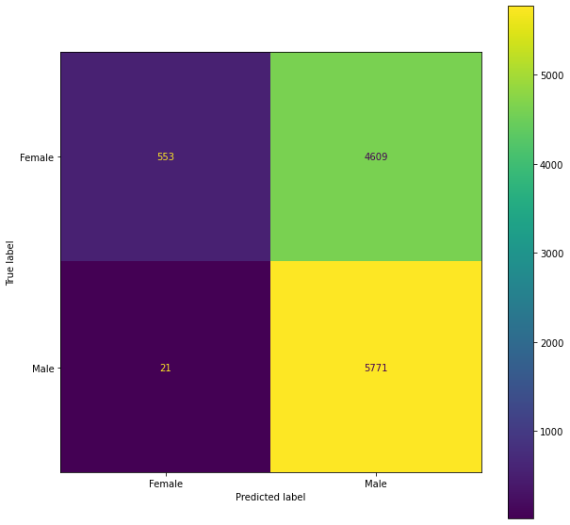

Model Training Accuracy/Loss Graphs:

Task 1:

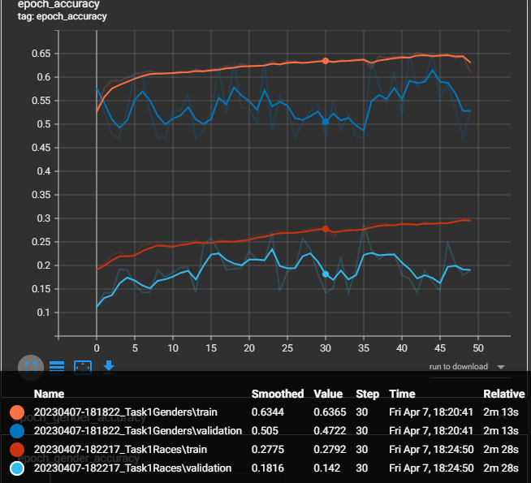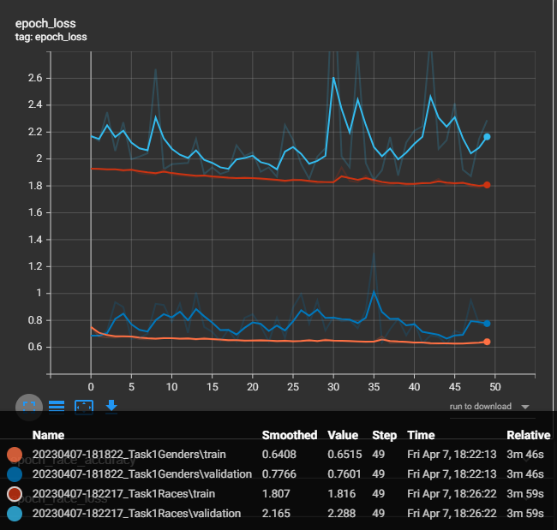

Task 2:

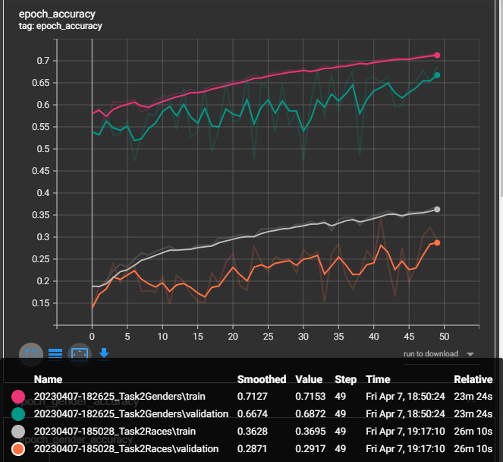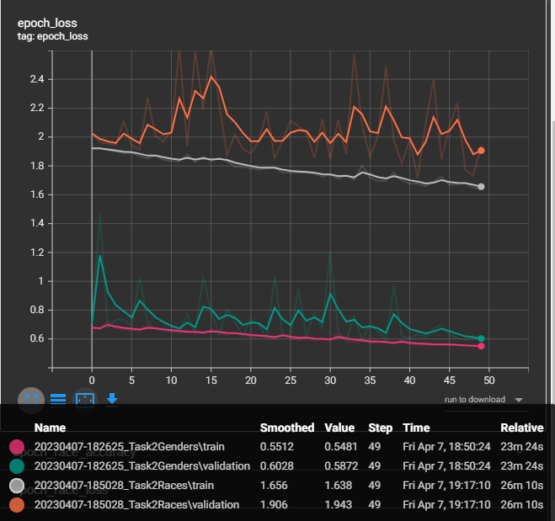

Task 3:

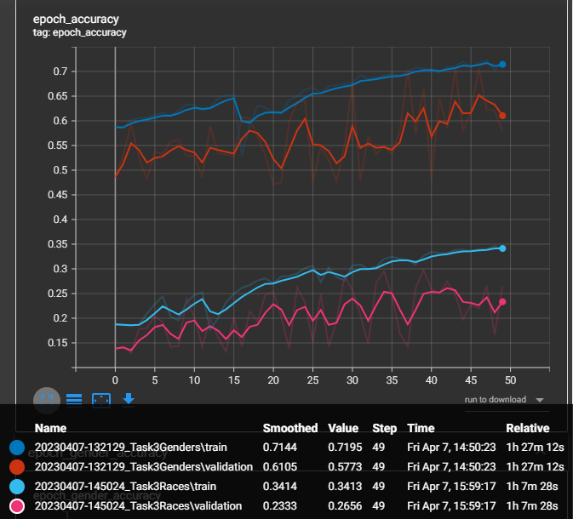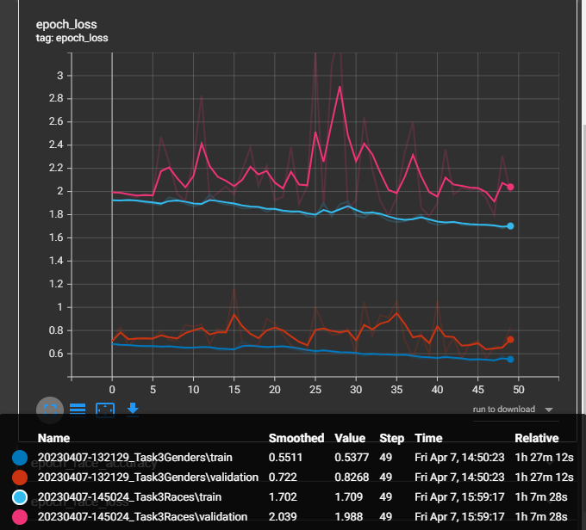

Task 4:

