SAML Assertion Generation Using OpenSAML3 libraries

Notes:
- The instructions are valid only for internal to Nationwide though relevant to all other environments.
- This document is prepared from several other sources, but the following are a few.
- https://en.wikipedia.org/wiki/SAML_2.0
- https://support.microfocus.com/kb/doc.php?id=7022204
- https://docs.oracle.com/cd/E19798-01/821-1841/gjrgy/
- https://support.globalsign.com/customer/en/portal/articles/2121490-java-keytool---create-keystore
- https://coderwall.com/p/3t4xka/import-private-key-and-certificate-into-java-keystore

Requirements:
- Java 1.8.x or higher is installed and configured “JAVA_HOME” variable in windows environment
- Login access to internal Nationwide certificates repository (https://pkicms.nwie.net/CMSAdminEnroll#)
- Maven is installed and configured “M2_HOME” variable in windows environment

Option 1: Using CA approved Certificate and Private Key.
Please visit “How to obtain certificate from Nationwide’s Web Middleware support team” section, below, to obtain a new Digi Cert (CA approved) certificate for Nationwide applications.
  - Create a PKCS12 file using OpenSSL:
    - Manually copy the private key (xyz.key) and SSL certificate (xyz.cer) to a plain text file (xyz.cer_and_key.txt). Please note that the private key should go on top with the SSL certificate below.
    - Run the following command to generate a PKCS12 (p12) file.
openssl pkcs12 -export -in xyz.cer_and_key.txt -out xyz.cer_and_key.p12
    - Type a new password when you see “Enter Export Password:”
    - Re-type the password when you see “Verifying - Enter Export Password:”
  - Run the following command to create a new JKS (Java Keystore) file
keytool -importkeystore -deststorepass <STOREPASS_PASSWORD> -destkeystore xyz.jks -srckeystore xyz.cer_and_key.p12 -srcstoretype PKCS12
- Type keystore password when you see “Enter source keystore password:”
If the command is successful observe the following output
Output: Import command completed: 1 entries successfully imported, 0 entries failed or cancelled
  - Raise a “Auxiliary Service Request” in ServiceNow and assign to “IAM-Support-Access”. Provide additional instructions for IAM team to install the .cer in appropriate environment of PING Fed with Issuer ID.
- Attach “xyz.cer” Or “xyz.cer.txt” to avoid the filtering
- SAML issuer Id (Entity) retrieved from sample SAML assertion:
e.g. CN=ESS B2BSecurityDemoPT,OU=ESS,O=Nationwide,L=Scottsdale,ST=Arizona,C=US
  - The requestor is required to fill in “SAML SSO Engagement Questionnaire.xlsx”) for IAM team to understand the request before installing the certificate in Nationwide PT (non-prod) environment.

Option 2: Using self-signed certificate (Private key and CSR) and Java Keystore
- Create JKS (Java KeyStore) file using Keytool.exe with RSA algorithm. Remember the input such alias, passwords of storepass and keypass, and keystore (.jks file path)

Example in Windows:
C:\innovation\a\jdk1.8.0_71\bin>keytool -genkey -keyalg RSA -alias ESS_B2B_SECURITY_DEMO_PT -keystore C:\work\ESS-B2B-workspace\ess-b2b-security-demo\src\main\resources\ESS_B2B_SECURITY_DEMO_PT_SAML.jks -storepass password1 -keypass password1

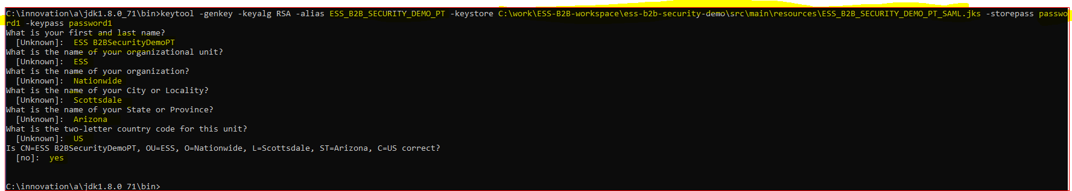

Please observe that a .jks file is being created in given folder
e.g. C:\work\ESS-B2B-workspace\ess-b2b-security-demo\src\main\resources\ESS_B2B_SECURITY_DEMO_PT_SAML.jks
- Generate the certificate.
  - To generate a certificate, sign the generated .JKS file.
Example in Windows:
C:\innovation\a\jdk1.8.0_71\bin>keytool -certreq -alias ESS_B2B_SECURITY_DEMO_PT -keystore C:\work\ESS-B2B-workspace\ess-b2b-security-demo\src\main\resources\ESS_B2B_SECURITY_DEMO_PT_SAML.jks -keysize 4096

Please note that same alias is used for both JKS and Certificate.
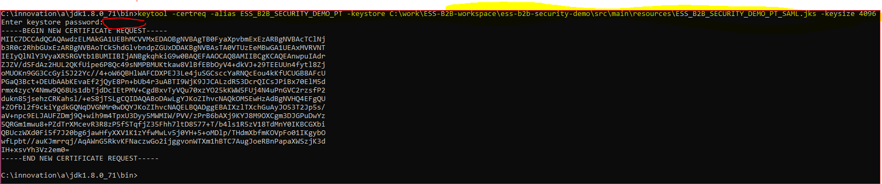
  - Please provide the keystore password when asked, which is chosen in during generation of .jks file

  - Copy the above certificate output from “--- BEGIN”

- Upload the generated Certificate output into Nationwide certificate repository.
  - Login to https://pkicms.nwie.net/CMSAdminEnroll#
  - Click on “Request a Certificate” link
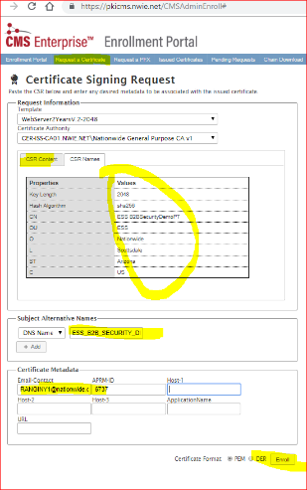
  - Fill in the following fields
- “Template”
- “Certificate Authority”
- Paste copied certificate data into “CSR Content” tab, the application reads it and shifts to “CSR Names” tab to verify .
- “DNS Name” : enter alias chosen during certificate generation
- Fill in Certificate Metadata
- Choose the default (PEM) Certificate Format.
- Click on “Enroll” button
- The application will automatically download .cer file
- Open and verify the downloaded .cer file from Nationwide
  - Navigate to the .cer file
  - Browse all 3 tabs to see the certificate status.
  - Notice the structure of “Certification Path”. In next step it is required to download all of it.
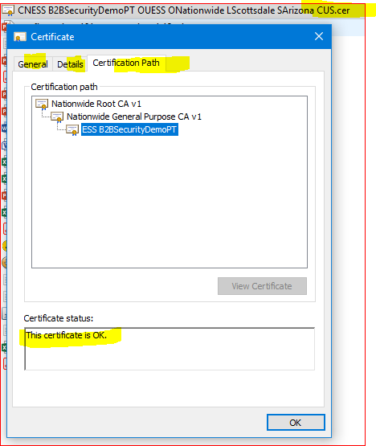
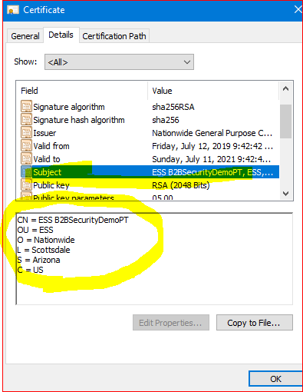

- Download the structure of “Certification Path” of .cer file
  - Login to https://pkicms.nwie.net/CMSAdminEnroll#
  - Click on “Chain Download” link from menu
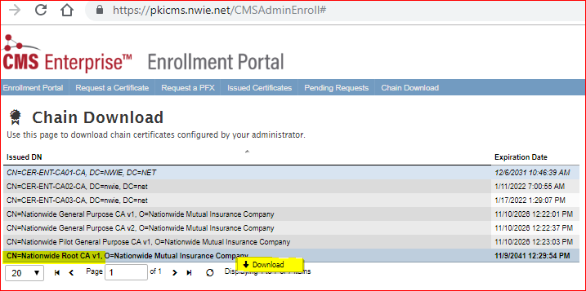
- Select and Download (context-menu/right-click) “Nationwide Root CA v1”
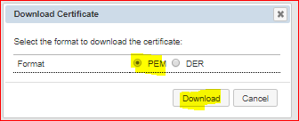
    - Select and Download (Context-menu/right-click) “Nationwide General Purpose CA v1”
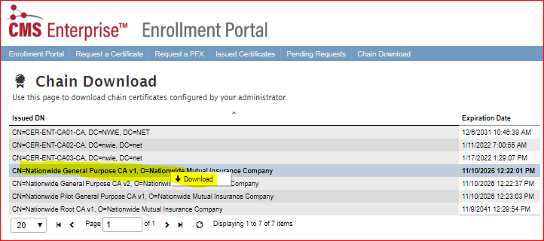
    - Assuming three .cer files are downloaded.
    - Renamed the downloaded .cert files (3) to remove the spaces so that Windows commands can be executed.
- Installing SSL Certificate Chain (Root, Intermediate(s) and the End Entity)
Import the renamed certificates (3) to JKS in a sequence as trusted with correct aliases
  - Import Root certificate (”CNNationwideRootCAv1ONationwideMutualInsuranceCompany.cer”) into “ESS_B2B_SECURITY_DEMO_PT_SAML.jks”

Example in Windows OS:
C:\innovation\a\jdk1.8.0_71\bin> keytool -import -trustcacerts -alias intermediate -file C:\work\ESS-B2B-workspace\ess-b2b-security-demo\src\main\resources\CNNationwideRootCAv1ONationwideMutualInsuranceCompany.cer -keystore C:\work\ESS-B2B-workspace\ess-b2b-security-demo\src\main\resources\ESS_B2B_SECURITY_DEMO_PT_SAML.jks

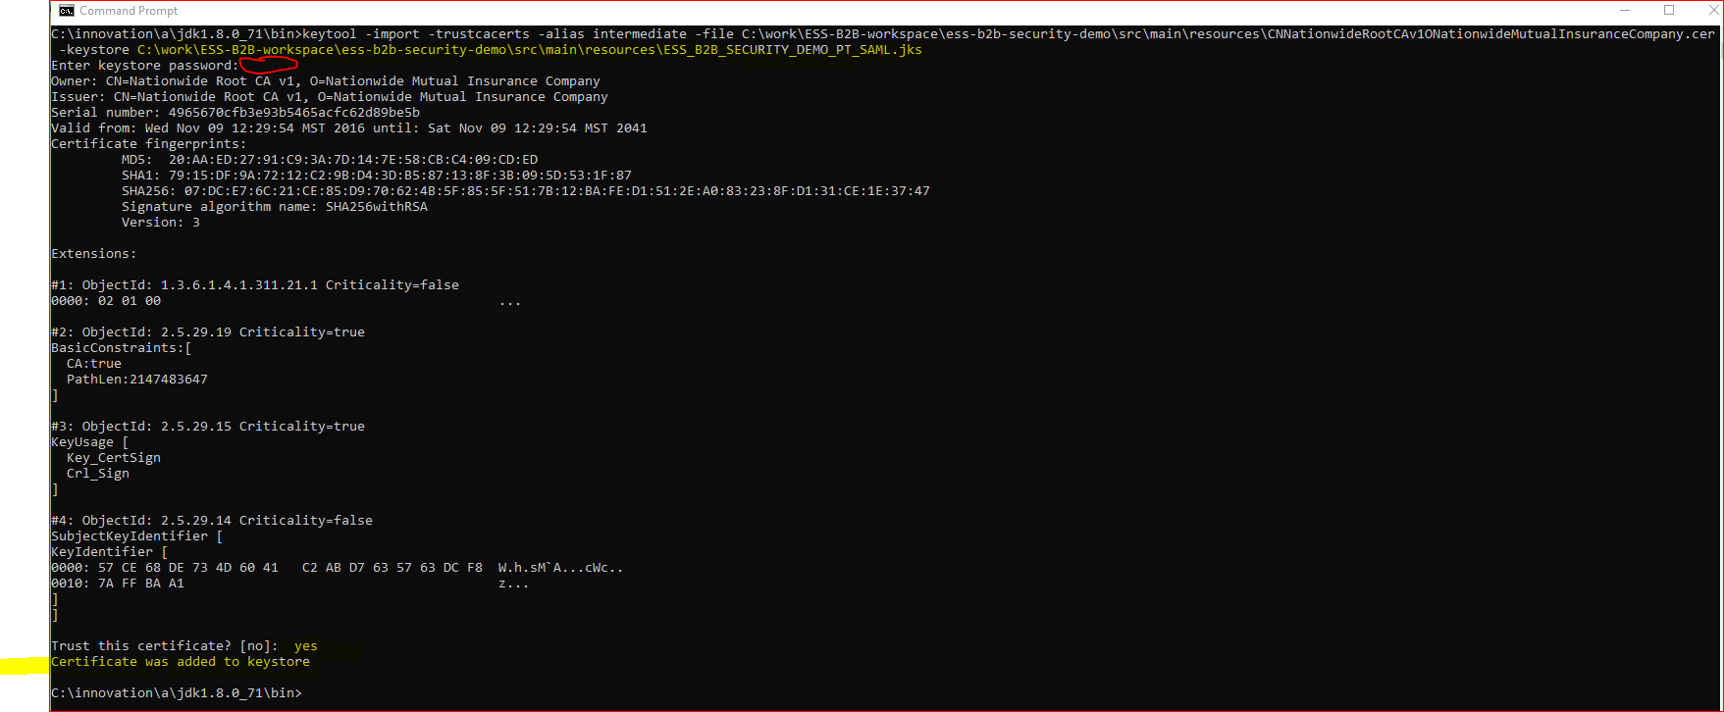
  - Import Intermediate(s) (”CNNationwideGeneralPurposeCAv1ONationwideMutualInsuranceCompany.cer”) into “ESS_B2B_SECURITY_DEMO_PT_SAML.jks”

In Windows OS:
C:\innovation\a\jdk1.8.0_71\bin>keytool -import -trustcacerts -alias intermediate1 -file C:\work\ESS-B2B-workspace\ess-b2b-security-demo\src\main\resources\CNNationwideGeneralPurposeCAv1ONationwideMutualInsuranceCompany.cer -keystore C:\work\ESS-B2B-workspace\ess-b2b-security-demo\src\main\resources\ESS_B2B_SECURITY_DEMO_PT_SAML.jks

Enter keystore password of JKS chosen earlier.
  - Import ”CNESS B2BSecurityDemoPTOUESSONationwideLScottsdaleSArizonaCUS.cer” into “ESS_B2B_SECURITY_DEMO_PT_SAML.jks”

Please use the correct alias that is chosen during generation of certificate
Example in Windows:
C:\innovation\a\jdk1.8.0_71\bin>keytool -import -alias ESS_B2B_SECURITY_DEMO_PT -file C:\work\ESS-B2B-workspace\ess-b2b-security-demo\src\main\resources\CNESSB2BSecurityDemoPTOUESSONationwideLScottsdaleSArizonaCUS.cer -keystore C:\work\ESS-B2B-workspace\ess-b2b-security-demo\src\main\resources\ESS_B2B_SECURITY_DEMO_PT_SAML.jks

- Install Certificate in Ping IAM (IDP Connection) server
  - Raise a “Auxiliary Service Request” in ServiceNow and assign to “IAM-Support-Access”. Provide additional instructions for IAM team to install the .cer in appropriate environment of PING Fed with Issuer ID.
- Attach “xyz.cer” Or “xyz.cer.txt” to avoid the filtering
- SAML issuer Id (Entity) retrieved from sample SAML assertion:
e.g. CN=ESS B2BSecurityDemoPT,OU=ESS,O=Nationwide,L=Scottsdale,ST=Arizona,C=US
  - The requestor is required to fill in “SAML SSO Engagement Questionnaire.xlsx”) for IAM team to understand the request before installing the certificate in Nationwide PT (non-prod) environment.

Run the Utility:
  - Generate SAML Assertion using Java Program:
Run the following commands.
- git clone https://github.nwie.net/Nationwide/opensaml3-utils
- git checkout <branch>
- mvn clean
- mvn package
- Run the Java application to generate SAML assertion.
- To generate a sample SAML assertion using default (a test certificate is available in github repo) input:
Run OpenSaml3AssertionAppTest.main() method
- To generate a sample SAML assertion with custom input: Supply all the required arguments such as JKS File, JKSpassword, KeyPassword etc..

Run new OpenSaml3AssertionApplication.buildSAMLObjects(String jksFilePath, String jksKeystorePassword,String keyPassword, String certAlias, String issuerID, String entityID, String audienceRestrictionURL, String samlAuthType,int assertionTimeoutInMin)

Output: A Java.util.Map is returned with following four key-value pairs.
- "SAML_RESPONSE” = A string representation of SAML XML Response
- "SAML_ASSERTION” = A string representation of SAML Assertion Extracted from value of SAML_RESPONSE object
- "SAML_ASSERTION_BASE64_ENCODED” = A Base64 Encoded value of SAML_ASSERTION object
- "SAML_ASSERTION_URLENCODED_BASE64” = A URL Encoded value of SAML_ASSERTION_BASE64_ENCODED object

How to obtain certificate from Nationwide’s Web Middleware support team
- While generating the CSR use the information in the following image.
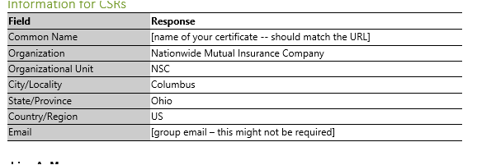
- As an Administrator user, open OpenSSL (64-bit) and execute the command to generate the CSR. Please see the input I’ve used to generate a certificate for ExpressConnect2 API.

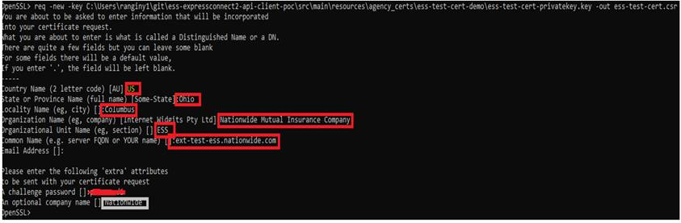

- Sign into Service Now, navigate to “Service Catalog”, search for “Web Middleware Support” and select “SSL Certificate”.
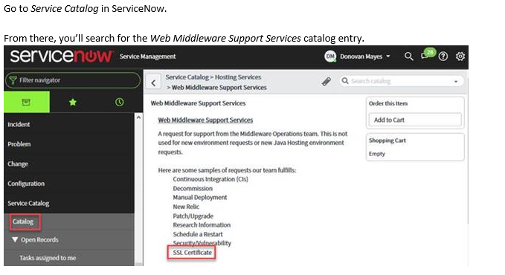
- Below is the information required to submit the form to create a.CER from CSR. You can get the same information by referring to TASK1278872 in ServiceNow.
Request Type: SSL Certificate
Certificate Type: External
Code Signing Certificate: No
CI Name: (This is the name of your application)
Production: (Your choice)
- If you choose production, it will ask for a Test Request Number, you should theoretically have one, but if you don’t, just put N/A, nobody is going to question it.
- If you don’t choose production, choose your environment as necessary.
Product: (If your product isn’t there, just get as close as you can)
Application URL: (The common name you chose for your CSR)
Platform: (Your choice, if neither Middleware nor Java Hosting, just choose Middleware)
Validator Name: (This is who gets the certificate)
Implementation Start/End Date/Time: (Match their SLA and move on)
Effective Date: (Match their SLA and move on)
Instructions: Requesting a certificate signed by an external CA for use with {insert application name here}. CSR included.
Contact Required: Yes
Server Name: (If the list doesn’t specifically have the one you plan to put the certificate on, then
just put in some other server your area owns)
Certificate Signing Request (CSR): (Copy the content from your CSR file)

Add to Cart and Submit the Order, then wait about 1-3 days.
- A resource from Web Middleware Support team will receive the ticket and will mostly contact you to understand the need for a certificate. You will have the following options, chose the appropriate one
- Get CER for CSR from middleware and you create the PFX files
- GET PFX files for CSR from middleware
- If all goes well, the resource will submit a new request to DigiCert to obtain a .CER from CSR. With an SLA of two days, you will either receive a .CER or .PFX
- Get the cert chain (3 certs): Obtain the DigitCert Root or Intermediate Certificate from provided .Cer file (end user certificate).

Support
For issues related to Enterprise User Auth (EUA), email api-infrastructure@nationwide.com.
For issues related to Ping, assign a ServiceNow incident or service request to IAM group.

