**Title**

**Reconstitution of actinorhodopsin from acI actinobacteria**

Jeff, Dave, Daniel, Trina, Katy – No data from Josh or Shaomei is included

**Introduction**

* Freshwater ecosystems focusing on lakes
* acI dominance and habitat not explained by heterotrophic genome
* Presence of opsin may imply phototrophy
* Carotenoid and opsin background

**Methods**

* Bioinformatic analysis
* Cloning
* Production of chromophores – CrtEBIY from Pantoea ananatis
* Extraction, UV-Vis, HPLC/MS Analysis
* Production of Rhodopsin

**Results**

* **Bioinformatics acI SAGs cassette**
  + Conserved gene clusters
    - Precursors toward lycopene
    - Opsin/retinal fusion based on other acI SAGs OR opsin and retinal
    - **Q: divergence from or convergence to a fused operon?**



* + Gene homology table and predicted assembly of an actinorhodopsin

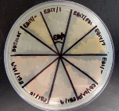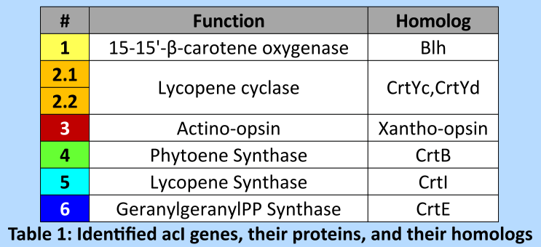

* **Genes 6, 4, 5 produce lycopene (uninduced, 37C, 645/- plasmid)**
  + Cell Color control, due to low concentration
  + UV-Vis lycopene (vs standard lycopene)
  + HPLC/MS lycopene (vs standard lycopene)

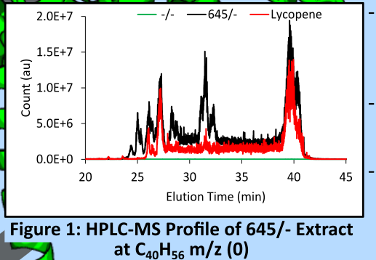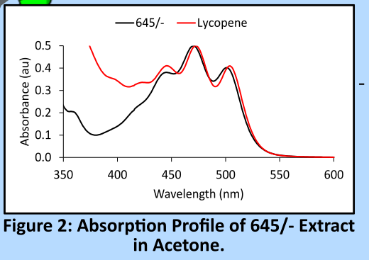

* **Genes 6, 4, 5 combined with CrtY produce β-zeacarotene (uninduced, 37C, 645/Y plasmid)**
  + CrtY is a di-cyclase, β-zeacarotene is ɣ-carotene with 1 less desaturation at the non-cyclized end
  + Cell Color control, due to low concentration
  + UV-Vis extreme blue shift vs lycopene and β-carotene
  + HPLC/MS needed

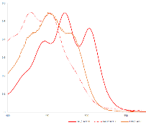

+ HPLC/MS Data

* **Genes 2.1,2.2 may produce β-carotene or ɣ-carotene (645/ or EBI/ with /2, 2*, 2*rbs2*, 2*tm2*)**
  + 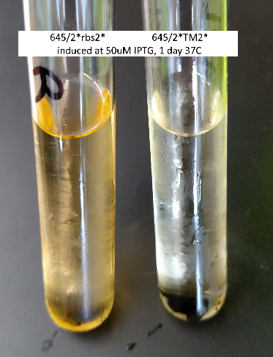Color All CrtEBI are red, all 645 are control
  + UV-Vis No significant differences
    - **Q: Does 645/2*tm2* shows interference in production of lycopene? See right**
    - Uv-Vis of 645/2*tm2* shows higher background at lower wavelengths (not shown, may be background from other chromophores due to more sample concentration)
  + HPLC/MS needed
  + **Q: Switch to B. subtilis? Add preformed lycopene onto induced cells containing a 2 only construct? Shake cells containing a full carotenoid plasmid longer?**

+UV-Vis HPLC/Data

+ Production

+ HPLC/MS Data

* **Gene 1 produces retinal (uninduced, 37C, EBIY/1 plasmid, higher rpm)**
  + Cell color Yellow not orange like EBIY
  + UV-Vis Retinol with traces of β-carotene like molecule (vs standard retinal and retinol
  + HPLC/MS More retinol than retinal, but both above background (vs standard retinol and retinal
  + 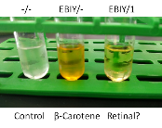**Q: Can lycopene be the substrate?**
    - **A: No. EBI/1 is still red like EBI cells**
  + **Q: Can a monocyclized carotenoid be the substrate?**
    - **A:**
  + **Q: Is it novel for an actinobacterium to have this gene**
    - **A:**
    - R. laciciola reported not to have gene and cells did not produce

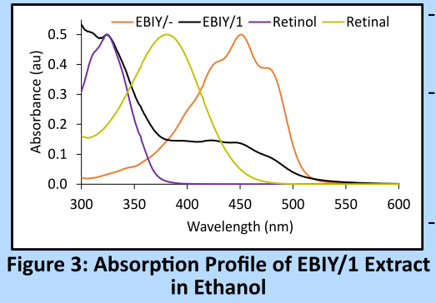

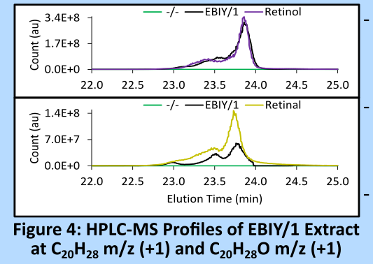

* Gene 3 is an opsin (L063*leh6 not O223, EBIY/1 + L063*leh6)
  + Homology with other assumed or confirmed proton pumping opsins or rhodopsins
    - Conserved residues: lysine, acidic shuttles
    - Member of xR supergroup, rather than bR and pR groups
      * **Q: What are the major differences and where?**
      * **A:**
      * **Q: How is/was an actino-opsin defined? Redefine?**
      * **A:**
  + W-G variance is conditionally meaningful - position and structure
    - **Q: What does this mean**
    - **A: At helix end, may bind a carotenoid antenna**
    - **A: Mining for genes and/or testing: ketolase, hydrophobic residues pointing into lipids**
    - **A: Table of W to G variance?**
  + Forms rhodopsin when expressed with retinal-producing genes (uninduced, 37C)
    - Cell Color redder vs EBIY/1, opsin has no color
    - UV-Vis 512ish nm peak in solubilized membranes (544nm cell free vs 528nm Maresca)
      * 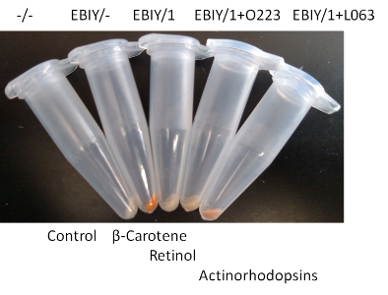**Q: Are solubilization conditions the same?**
      * **A:**
    - HPLC/MS needed
      * **Q: show covalent attachment?**
      * **A:**
    - Ni-NTA pulldown from solubilized membranes

+micro pH trace

* + - * Ni-NTA beads appear red
  + Rhodopsin is a proton pump
    - 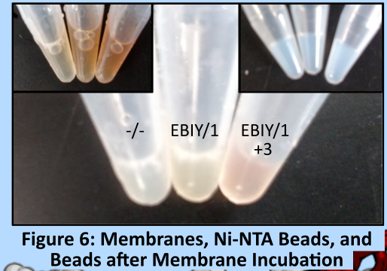acidifies solution upon exposure to light/certain light

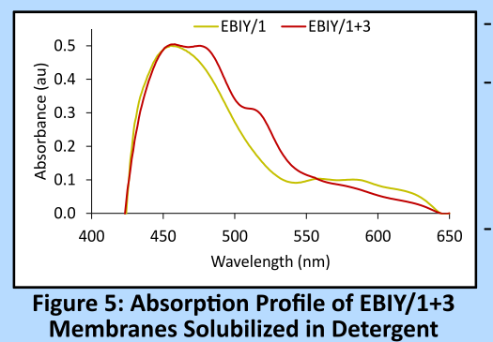

* **Other Info**
  + Remaining predicted gene products make a secondary carotenoid that may/may not bind actinorhodopsin
    - **Q: Is gene 7 a ketolase or a desaturase?**
    - **A: Homology indicated high similarity to desaturase. A ketolase is needed for the hook to bind a rhodopsin.**
    - The actinorhodopsin pathway may branch at cyclization for its synthesis
  + Antenna rhodopsins
    - S ruber (xR and SX), Luecke (2008) PNAS – structure, Balashov (2005) Science – first
    - G violaceus (gR and echinenone), Imasheva (2009) Biochemistry – SX, Balashov (2010) Biochemistry – echinenone
    - **Q: Is an antenna rhodopsin carotenoid a C50?**
    - **A: No. It is C40 like salinixanthin. C50 is like bacterioruberin. R lacicola has the W-G variance but no ketolase is present in the genome**
  + Precursor genes
    - Steiger (2005) ArchMicro – Crt-I-like phytoene desaturase, not the typical cyanobacterial set

found cluster of genes for “C50” carotenoid that has differential expression under light/dark

* + - **Q: Is mismatch (not acI) of gram (-) plant pathogen enzymes for lycopene synthesis bad?**
    - **A: Might be relevant for the acI lycopene cyclase peptides (2.1,2.2)**
    - **A: P ananatis is a gram negative facultive ananerobe. Its CrtI is similar to 5. Other organisms use more enzymes than just CrtI to make lycopene.**
  + Maresca actino cultures from Martin Hahn
    - R lacicola with aR that doesn't contain typical β-carotene cleavage enzyme
    - light-driven H+ pumping with added retinal in E. coli and pure culture
    - actino has differential growth rates under light/dark
  + Keeping clade/tribe the same
    - **Q: What was the final verdict about keeping clade/tribe the same?**
    - A: It would be so much cleaner if we had genes all from one. DNA in the freezer from Mendota and with good primers we could amplify out any clade you want.
    - **A: L06-3 is from acI-B1 of Mendota. All other work is from O22, acI-A1 of Damariscotta. All the carotenoid cassette genes are the same except possibly 11.**

