МИНИСТЕРСТВО ОБРАЗОВАНИЯ РЕСПУБЛИКИ БЕЛАРУСЬ
БЕЛОРУССКИЙ НАЦИОНАЛЬНЫЙ ТЕХНИЧЕСКИЙ УНИВЕРСИТЕТ
Факультет информационных технологий и робототехники

Отчет по лабораторной работе № 25. Вариант 2 & 7
на тему «Создание и использование пользовательских библиотек в Linux»
по дисциплине «Системное программирование»
Кафедра программного обеспечения информационных систем и технологий

Выполнили:
студенты группы 10701222
М. К. Зданевич
Д. И. Гришко
Проверил:
Н. В. Давыденко

Минск, 2024

Задание 1. Создание статической библиотеки

Вариант 2 (сортировка массива слиянием):
- Исходный код (merge_sort.h):
#ifndef MERGE_SORT_H
#define MERGE_SORT_H

#include <stdio.h>
#include <stdlib.h>
#include <pthread.h>

typedef struct {
int *array;
int left;
int right;
} ThreadData;

void* insertion_sort(void* arg);
void merge(int* array, int left, int mid, int right);
void merge_sort(int* array, int left, int right);

#endif // MERGE_SORT_H
- Исходный код (merge_sort.c):
#include "merge_sort.h"

void* insertion_sort(void* arg) {
ThreadData* data = (ThreadData*)arg;
int* array = data->array;
int left = data->left;
int right = data->right;

for (int i = left + 1; i <= right; i++) {
int key = array[i];
int j = i - 1;

while (j >= left && array[j] > key) {
array[j + 1] = array[j];
j--;
}
array[j + 1] = key;
}

pthread_exit(NULL);
}

void merge(int* array, int left, int mid, int right) {
int n1 = mid - left + 1;
int n2 = right - mid;

int* leftArray = malloc(n1 * sizeof(int));
int* rightArray = malloc(n2 * sizeof(int));

for (int i = 0; i < n1; i++)
leftArray[i] = array[left + i];
for (int j = 0; j < n2; j++)
rightArray[j] = array[mid + 1 + j];

int i = 0, j = 0, k = left;

while (i < n1 && j < n2) {
if (leftArray[i] <= rightArray[j]) {
array[k++] = leftArray[i++];
} else {
array[k++] = rightArray[j++];
}
}

while (i < n1) {
array[k++] = leftArray[i++];
}

while (j < n2) {
array[k++] = rightArray[j++];
}

free(leftArray);
free(rightArray);
}

void merge_sort(int* array, int left, int right) {
if (left < right) {
int mid = left + (right - left) / 2;

ThreadData data1 = {array, left, mid};
ThreadData data2 = {array, mid + 1, right};

pthread_t thread1, thread2;

pthread_create(&thread1, NULL, insertion_sort, &data1);
pthread_create(&thread2, NULL, insertion_sort, &data2);

pthread_join(thread1, NULL);
pthread_join(thread2, NULL);

merge(array, left, mid, right);
}
}
- Исходный код (main.c):
#include "merge/merge_sort.h"

int main() {
int array[] = {38, 27, 43, 3, 9, 82, 10};
int size = sizeof(array) / sizeof(array[0]);

printf("Original array: ");
for (int i = 0; i < size; i++) {
printf("%d ", array[i]);
}
printf("\n");

merge_sort(array, 0, size - 1);

printf("Sorted array: ");
for (int i = 0; i < size; i++) {
printf("%d ", array[i]);
}
printf("\n");

return 0;
}
- Результаты:

Вариант 7 (программа-клиент/сервер с использованием сокетов):
- Исходный код (client.h):
#ifndef CLIENT_H
#define CLIENT_H

#include <arpa/inet.h>
#include <stdio.h>
#include <stdlib.h>
#include <string.h>
#include <unistd.h>

#define PORT 8080
#define BUFFER_SIZE 1024

int client_connect(const char *server_ip);
void client_send_receive(int sock);

#endif
- Исходный код (client.c):
#include "client.h"

int client_connect(const char *server_ip) {
int sock;
struct sockaddr_in addr;

sock = socket(AF_INET, SOCK_STREAM, 0);
if (sock == -1) {
fprintf(stderr, "Error: socket()\n");
return -1;
}

addr.sin_family = AF_INET;
addr.sin_port = htons(PORT);
if (inet_pton(AF_INET, server_ip, &addr.sin_addr) == -1) {
fprintf(stderr, "Error: inet_pton()\n");
close(sock);
return -1;
}

if (connect(sock, (struct sockaddr *)&addr, sizeof(addr)) == -1) {
fprintf(stderr, "Error: connect()\n");
close(sock);
return -1;
}

return sock;
}

void client_send_receive(int sock) {
char buffer[BUFFER_SIZE];
int bytes_received;

printf("Enter a message to send to the server: ");
fgets(buffer, BUFFER_SIZE, stdin);
send(sock, buffer, strlen(buffer), 0);

bytes_received = recv(sock, buffer, BUFFER_SIZE, 0);
if (bytes_received > 0) {
buffer[bytes_received] = '\0';
printf("Message received from the server: %s", buffer);
} else {
printf("No response from server.\n");
}

close(sock);
}
- Исходный код (server.h):
#ifndef SERVER_H
#define SERVER_H

#include <arpa/inet.h>
#include <pthread.h>
#include <stdio.h>
#include <stdlib.h>
#include <string.h>
#include <unistd.h>

#define PORT 8080
#define BUFFER_SIZE 1024
#define QUEUE_LENGTH 10

void server_start();
void *handle_client(void *client_socket);

#endif
- Исходный код (server.c):
#include "server.h"

static pthread_mutex_t lock;

void *handle_client(void *client_socket) {
int sock = *(int *)client_socket;
free(client_socket);
char buffer[BUFFER_SIZE];

while (1) {
int read_size = recv(sock, buffer, BUFFER_SIZE, 0);
if (read_size <= 0) break;

buffer[read_size] = '\0';
printf("Received message: %s\n", buffer);

pthread_mutex_lock(&lock);
send(sock, buffer, strlen(buffer), 0);
pthread_mutex_unlock(&lock);
}

close(sock);
return NULL;
}

void server_start() {
int server_sock, client_sock, *new_sock;
struct sockaddr_in server_addr, client_addr;
socklen_t client_len = sizeof(client_addr);

pthread_mutex_init(&lock, NULL);

server_sock = socket(AF_INET, SOCK_STREAM, 0);
if (server_sock == -1) {
fprintf(stderr, "Error: socket()\n");
exit(EXIT_FAILURE);
}

server_addr.sin_family = AF_INET;
server_addr.sin_port = htons(PORT);
server_addr.sin_addr.s_addr = INADDR_ANY;

if (bind(server_sock, (struct sockaddr *)&server_addr, sizeof(server_addr)) == -1) {
fprintf(stderr, "Error: bind()\n");
close(server_sock);
exit(EXIT_FAILURE);
}

if (listen(server_sock, QUEUE_LENGTH) == -1) {
fprintf(stderr, "Error: listen()\n");
close(server_sock);
exit(EXIT_FAILURE);
}

printf("Server listening on port %d\n", PORT);

while ((client_sock = accept(server_sock, (struct sockaddr *)&client_addr, &client_len))) {
pthread_t client_thread;
new_sock = malloc(sizeof(int));
*new_sock = client_sock;

pthread_create(&client_thread, NULL, handle_client, (void *)new_sock);
pthread_detach(client_thread);
}

pthread_mutex_destroy(&lock);
close(server_sock);
}
- Исходный код (main_client.c):
#include "client.h"

int main(void) {
int sock = client_connect("127.0.0.1");
if (sock == -1) {
return 1;
}

client_send_receive(sock);
return 0;
}
- Исходный код (main_server.c):
#include "server.h"

int main(void) {
server_start();
return 0;
}
- Результаты:

Вывод списка зависимостей:
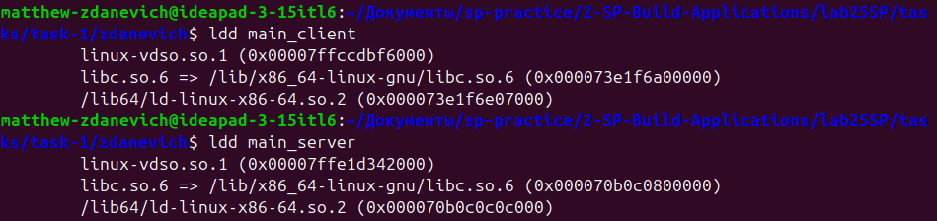

Размеры файлов проекта:
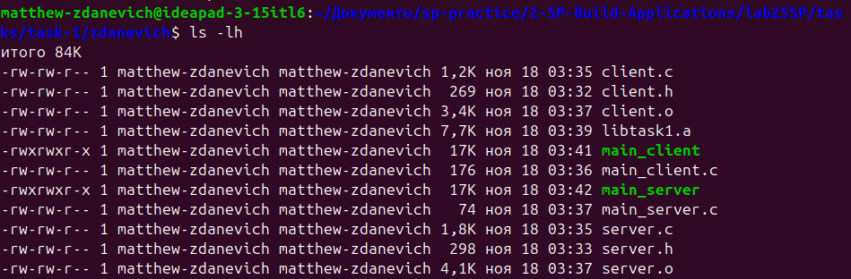

Задание 2. Создание динамической библиотеки со статическим вызовом

Вариант 2 (сортировка массива слиянием):
- Исходный код (merge_sort.h):
#ifndef MERGE_SORT_H
#define MERGE_SORT_H

#include <stdio.h>
#include <stdlib.h>
#include <pthread.h>

typedef struct {
int *array;
int left;
int right;
} ThreadData;

void* insertion_sort(void* arg);
void merge(int* array, int left, int mid, int right);
void merge_sort(int* array, int left, int right);

#endif // MERGE_SORT_H
- Исходный код (merge_sort.c):
#include "merge_sort.h"

void* insertion_sort(void* arg) {
ThreadData* data = (ThreadData*)arg;
int* array = data->array;
int left = data->left;
int right = data->right;

for (int i = left + 1; i <= right; i++) {
int key = array[i];
int j = i - 1;

while (j >= left && array[j] > key) {
array[j + 1] = array[j];
j--;
}
array[j + 1] = key;
}

pthread_exit(NULL);
}

void merge(int* array, int left, int mid, int right) {
int n1 = mid - left + 1;
int n2 = right - mid;

int* leftArray = malloc(n1 * sizeof(int));
int* rightArray = malloc(n2 * sizeof(int));

for (int i = 0; i < n1; i++)
leftArray[i] = array[left + i];
for (int j = 0; j < n2; j++)
rightArray[j] = array[mid + 1 + j];

int i = 0, j = 0, k = left;

while (i < n1 && j < n2) {
if (leftArray[i] <= rightArray[j]) {
array[k++] = leftArray[i++];
} else {
array[k++] = rightArray[j++];
}
}

while (i < n1) {
array[k++] = leftArray[i++];
}

while (j < n2) {
array[k++] = rightArray[j++];
}

free(leftArray);
free(rightArray);
}

void merge_sort(int* array, int left, int right) {
if (left < right) {
int mid = left + (right - left) / 2;

ThreadData data1 = {array, left, mid};
ThreadData data2 = {array, mid + 1, right};

pthread_t thread1, thread2;

pthread_create(&thread1, NULL, insertion_sort, &data1);
pthread_create(&thread2, NULL, insertion_sort, &data2);

pthread_join(thread1, NULL);
pthread_join(thread2, NULL);

merge(array, left, mid, right);
}
}
- Исходный код (main.c):
#include "merge/merge_sort.h"

int main() {
int array[] = {38, 27, 43, 3, 9, 82, 10};
int size = sizeof(array) / sizeof(array[0]);

printf("Original array: ");
for (int i = 0; i < size; i++) {
printf("%d ", array[i]);
}
printf("\n");

merge_sort(array, 0, size - 1);

printf("Sorted array: ");
for (int i = 0; i < size; i++) {
printf("%d ", array[i]);
}
printf("\n");

return 0;
}
- Результаты:

Вариант 7 (программа-клиент/сервер с использованием сокетов):
- Исходный код (client.h):
#ifndef CLIENT_H
#define CLIENT_H

#include <arpa/inet.h>
#include <stdio.h>
#include <stdlib.h>
#include <string.h>
#include <unistd.h>

#define PORT 8080
#define BUFFER_SIZE 1024

int client_connect(const char *server_ip);
void client_send_receive(int sock);

#endif
- Исходный код (client.c):
#include "client.h"

int client_connect(const char *server_ip) {
int sock;
struct sockaddr_in addr;

sock = socket(AF_INET, SOCK_STREAM, 0);
if (sock == -1) {
fprintf(stderr, "Error: socket()\n");
return -1;
}

addr.sin_family = AF_INET;
addr.sin_port = htons(PORT);
if (inet_pton(AF_INET, server_ip, &addr.sin_addr) == -1) {
fprintf(stderr, "Error: inet_pton()\n");
close(sock);
return -1;
}

if (connect(sock, (struct sockaddr *)&addr, sizeof(addr)) == -1) {
fprintf(stderr, "Error: connect()\n");
close(sock);
return -1;
}

return sock;
}

void client_send_receive(int sock) {
char buffer[BUFFER_SIZE];
int bytes_received;

printf("Enter a message to send to the server: ");
fgets(buffer, BUFFER_SIZE, stdin);
send(sock, buffer, strlen(buffer), 0);

bytes_received = recv(sock, buffer, BUFFER_SIZE, 0);
if (bytes_received > 0) {
buffer[bytes_received] = '\0';
printf("Message received from the server: %s", buffer);
} else {
printf("No response from server.\n");
}

close(sock);
}
- Исходный код (server.h):
#ifndef SERVER_H
#define SERVER_H

#include <arpa/inet.h>
#include <pthread.h>
#include <stdio.h>
#include <stdlib.h>
#include <string.h>
#include <unistd.h>

#define PORT 8080
#define BUFFER_SIZE 1024
#define QUEUE_LENGTH 10

void server_start();
void *handle_client(void *client_socket);

#endif
- Исходный код (server.c):
#include "server.h"

static pthread_mutex_t lock;

void *handle_client(void *client_socket) {
int sock = *(int *)client_socket;
free(client_socket);
char buffer[BUFFER_SIZE];

while (1) {
int read_size = recv(sock, buffer, BUFFER_SIZE, 0);
if (read_size <= 0) break;

buffer[read_size] = '\0';
printf("Received message: %s\n", buffer);

pthread_mutex_lock(&lock);
send(sock, buffer, strlen(buffer), 0);
pthread_mutex_unlock(&lock);
}

close(sock);
return NULL;
}

void server_start() {
int server_sock, client_sock, *new_sock;
struct sockaddr_in server_addr, client_addr;
socklen_t client_len = sizeof(client_addr);

pthread_mutex_init(&lock, NULL);

server_sock = socket(AF_INET, SOCK_STREAM, 0);
if (server_sock == -1) {
fprintf(stderr, "Error: socket()\n");
exit(EXIT_FAILURE);
}

server_addr.sin_family = AF_INET;
server_addr.sin_port = htons(PORT);
server_addr.sin_addr.s_addr = INADDR_ANY;

if (bind(server_sock, (struct sockaddr *)&server_addr, sizeof(server_addr)) == -1) {
fprintf(stderr, "Error: bind()\n");
close(server_sock);
exit(EXIT_FAILURE);
}

if (listen(server_sock, QUEUE_LENGTH) == -1) {
fprintf(stderr, "Error: listen()\n");
close(server_sock);
exit(EXIT_FAILURE);
}

printf("Server listening on port %d\n", PORT);

while ((client_sock = accept(server_sock, (struct sockaddr *)&client_addr, &client_len))) {
pthread_t client_thread;
new_sock = malloc(sizeof(int));
*new_sock = client_sock;

pthread_create(&client_thread, NULL, handle_client, (void *)new_sock);
pthread_detach(client_thread);
}

pthread_mutex_destroy(&lock);
close(server_sock);
}
- Исходный код (main_client.c):
#include "client.h"

int main(void) {
int sock = client_connect("127.0.0.1");
if (sock == -1) {
return 1;
}

client_send_receive(sock);
return 0;
}
- Исходный код (main_server.c):
#include "server.h"

int main(void) {
server_start();
return 0;
}
- Результаты:

Вывод списка зависимостей:
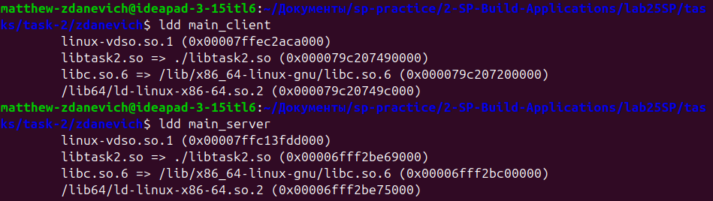

Размеры файлов проекта:
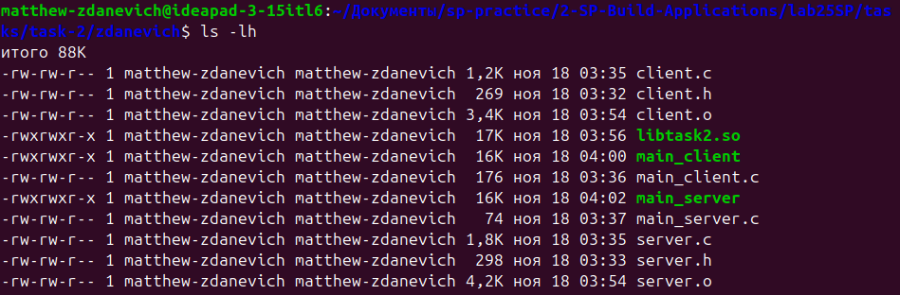

Задание 3. Создание динамической библиотеки с динамическим вызовом

Вариант 2 (сортировка массива слиянием):
- Исходный код (merge_sort.h):
#ifndef MERGE_SORT_H
#define MERGE_SORT_H

#include <stdio.h>
#include <stdlib.h>
#include <pthread.h>

typedef struct {
int *array;
int left;
int right;
} ThreadData;

void* insertion_sort(void* arg);
void merge(int* array, int left, int mid, int right);
void merge_sort(int* array, int left, int right);

#endif // MERGE_SORT_H
- Исходный код (merge_sort.c):
#include "merge_sort.h"

void* insertion_sort(void* arg) {
ThreadData* data = (ThreadData*)arg;
int* array = data->array;
int left = data->left;
int right = data->right;

for (int i = left + 1; i <= right; i++) {
int key = array[i];
int j = i - 1;

while (j >= left && array[j] > key) {
array[j + 1] = array[j];
j--;
}
array[j + 1] = key;
}

pthread_exit(NULL);
}

void merge(int* array, int left, int mid, int right) {
int n1 = mid - left + 1;
int n2 = right - mid;

int* leftArray = malloc(n1 * sizeof(int));
int* rightArray = malloc(n2 * sizeof(int));

for (int i = 0; i < n1; i++)
leftArray[i] = array[left + i];
for (int j = 0; j < n2; j++)
rightArray[j] = array[mid + 1 + j];

int i = 0, j = 0, k = left;

while (i < n1 && j < n2) {
if (leftArray[i] <= rightArray[j]) {
array[k++] = leftArray[i++];
} else {
array[k++] = rightArray[j++];
}
}

while (i < n1) {
array[k++] = leftArray[i++];
}

while (j < n2) {
array[k++] = rightArray[j++];
}

free(leftArray);
free(rightArray);
}

void merge_sort(int* array, int left, int right) {
if (left < right) {
int mid = left + (right - left) / 2;

ThreadData data1 = {array, left, mid};
ThreadData data2 = {array, mid + 1, right};

pthread_t thread1, thread2;

pthread_create(&thread1, NULL, insertion_sort, &data1);
pthread_create(&thread2, NULL, insertion_sort, &data2);

pthread_join(thread1, NULL);
pthread_join(thread2, NULL);

merge(array, left, mid, right);
}
}
- Исходный код (main.c):
#include <stdio.h>
#include <stdlib.h>
#include <dlfcn.h>

#define LIBRARY_NAME "./libtask3.so"

typedef void (*merge_sort_t)(int* array, int left, int right);

int main() {
void *handle;
merge_sort_t merge_sort;

handle = dlopen(LIBRARY_NAME, RTLD_LAZY);
if (!handle) {
fprintf(stderr, "Error: %s\n", dlerror());
return 1;
}

merge_sort = (merge_sort_t)dlsym(handle, "merge_sort");
if (!merge_sort) {
fprintf(stderr, "Error: %s\n", dlerror());
dlclose(handle);
return 1;
}

int array[] = {38, 27, 43, 3, 9, 82, 10};
int size = sizeof(array) / sizeof(array[0]);

printf("Original array: ");
for (int i = 0; i < size; i++) {
printf("%d ", array[i]);
}
printf("\n");

merge_sort(array, 0, size - 1);

printf("Sorted array: ");
for (int i = 0; i < size; i++) {
printf("%d ", array[i]);
}
printf("\n");

dlclose(handle);

return 0;
}
- Результаты:

Вариант 7 (программа-клиент/сервер с использованием сокетов):
- Исходный код (client.h):
#ifndef CLIENT_H
#define CLIENT_H

#include <arpa/inet.h>
#include <stdio.h>
#include <stdlib.h>
#include <string.h>
#include <unistd.h>

#define PORT 8080
#define BUFFER_SIZE 1024

int client_connect(const char *server_ip);
void client_send_receive(int sock);

#endif
- Исходный код (client.c):
#include "client.h"

int client_connect(const char *server_ip) {
int sock;
struct sockaddr_in addr;

sock = socket(AF_INET, SOCK_STREAM, 0);
if (sock == -1) {
fprintf(stderr, "Error: socket()\n");
return -1;
}

addr.sin_family = AF_INET;
addr.sin_port = htons(PORT);
if (inet_pton(AF_INET, server_ip, &addr.sin_addr) == -1) {
fprintf(stderr, "Error: inet_pton()\n");
close(sock);
return -1;
}

if (connect(sock, (struct sockaddr *)&addr, sizeof(addr)) == -1) {
fprintf(stderr, "Error: connect()\n");
close(sock);
return -1;
}

return sock;
}

void client_send_receive(int sock) {
char buffer[BUFFER_SIZE];
int bytes_received;

printf("Enter a message to send to the server: ");
fgets(buffer, BUFFER_SIZE, stdin);
send(sock, buffer, strlen(buffer), 0);

bytes_received = recv(sock, buffer, BUFFER_SIZE, 0);
if (bytes_received > 0) {
buffer[bytes_received] = '\0';
printf("Message received from the server: %s", buffer);
} else {
printf("No response from server.\n");
}

close(sock);
}
- Исходный код (server.h):
#ifndef SERVER_H
#define SERVER_H

#include <arpa/inet.h>
#include <pthread.h>
#include <stdio.h>
#include <stdlib.h>
#include <string.h>
#include <unistd.h>

#define PORT 8080
#define BUFFER_SIZE 1024
#define QUEUE_LENGTH 10

void server_start();
void *handle_client(void *client_socket);

#endif
- Исходный код (server.c):
#include "server.h"

static pthread_mutex_t lock;

void *handle_client(void *client_socket) {
int sock = *(int *)client_socket;
free(client_socket);
char buffer[BUFFER_SIZE];

while (1) {
int read_size = recv(sock, buffer, BUFFER_SIZE, 0);
if (read_size <= 0) break;

buffer[read_size] = '\0';
printf("Received message: %s\n", buffer);

pthread_mutex_lock(&lock);
send(sock, buffer, strlen(buffer), 0);
pthread_mutex_unlock(&lock);
}

close(sock);
return NULL;
}

void server_start() {
int server_sock, client_sock, *new_sock;
struct sockaddr_in server_addr, client_addr;
socklen_t client_len = sizeof(client_addr);

pthread_mutex_init(&lock, NULL);

server_sock = socket(AF_INET, SOCK_STREAM, 0);
if (server_sock == -1) {
fprintf(stderr, "Error: socket()\n");
exit(EXIT_FAILURE);
}

server_addr.sin_family = AF_INET;
server_addr.sin_port = htons(PORT);
server_addr.sin_addr.s_addr = INADDR_ANY;

if (bind(server_sock, (struct sockaddr *)&server_addr, sizeof(server_addr)) == -1) {
fprintf(stderr, "Error: bind()\n");
close(server_sock);
exit(EXIT_FAILURE);
}

if (listen(server_sock, QUEUE_LENGTH) == -1) {
fprintf(stderr, "Error: listen()\n");
close(server_sock);
exit(EXIT_FAILURE);
}

printf("Server listening on port %d\n", PORT);

while ((client_sock = accept(server_sock, (struct sockaddr *)&client_addr, &client_len))) {
pthread_t client_thread;
new_sock = malloc(sizeof(int));
*new_sock = client_sock;

pthread_create(&client_thread, NULL, handle_client, (void *)new_sock);
pthread_detach(client_thread);
}

pthread_mutex_destroy(&lock);
close(server_sock);
}

- Исходный код (main_client.c):
#include <stdio.h>
#include <stdlib.h>
#include <dlfcn.h>

#define LIBRARY_NAME "./libtask3.so"

typedef int (*client_connect_t)(const char *server_ip);
typedef void (*client_send_receive_t)(int sock);

int main(void) {
void *handle;
client_connect_t client_connect;
client_send_receive_t client_send_receive;

handle = dlopen(LIBRARY_NAME, RTLD_LAZY);
if (!handle) {
fprintf(stderr, "Error: %s\n", dlerror());
return 1;
}

client_connect = (client_connect_t)dlsym(handle, "client_connect");
if (!client_connect) {
fprintf(stderr, "Error: %s\n", dlerror());
dlclose(handle);
return 1;
}

client_send_receive = (client_send_receive_t)dlsym(handle, "client_send_receive");
if (!client_send_receive) {
fprintf(stderr, "Error: %s\n", dlerror());
dlclose(handle);
return 1;
}

int sock = client_connect("127.0.0.1");
if (sock == -1) {
dlclose(handle);
return 1;
}

client_send_receive(sock);

dlclose(handle);
return 0;
}
- Исходный код (main_server.c):
#include <stdio.h>
#include <stdlib.h>
#include <dlfcn.h>

#define LIBRARY_NAME "./libtask3.so"

typedef void (*server_start_t)(void);

int main(void) {
void *handle;
server_start_t server_start;

handle = dlopen(LIBRARY_NAME, RTLD_LAZY);
if (!handle) {
fprintf(stderr, "Error: %s\n", dlerror());
return 1;
}

server_start = (server_start_t)dlsym(handle, "server_start");
if (!server_start) {
fprintf(stderr, "Error: %s\n", dlerror());
dlclose(handle);
return 1;
}

server_start();

dlclose(handle);
return 0;
}
- Результаты:

Вывод списка зависимостей:
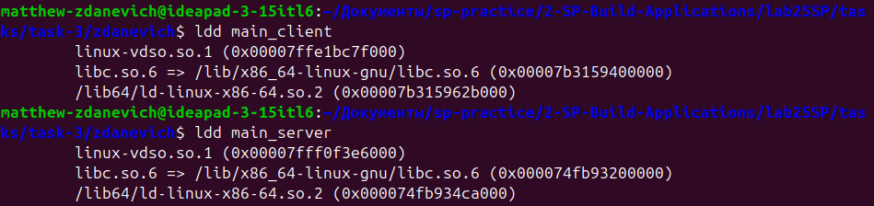

Размеры файлов проекта:
