PART 3:

**What is GitHub?**

It is a version control system, or VCS. A code-hosting platform than enhances a user’s ability to track version control and collaborate with others anywhere in the world. It is a web-service that provides Git repositories.

**When was it created?**

Git was created by Linus Torvald (who also created Linux) in 2005 (Lecture Notes).

GitHub was developed by Chris Wanstrath, P. J. Hyett, Tom Preston-Werner and Scott Chacon using Ruby on Rails, and started in February 2008. (Neumann, Alexander. "GitHub populärer als SourceForge und Google Code". heise Developer.

**Why?**

Project hosting, issue tracking, website-hosting, project analytics, open-source contributions.

According to their official website, the developers created GitHub to “We make it easier for developers to be developers: to work together, to solve challenging problems, to create the world’s most important technologies. We foster a collaborative community that can come together—as individuals and in teams—to create the future of software and make a difference in the world”.

**By who?**

Git - Linus Torvald

GitHub - Chris Wanstrath, P. J. Hyett, Tom Preston-Werner and Scott Chacon

**What similar platforms exist?**

CVS, SVN, Mercurial, Monotone, Bazaar

**Why would you use such a platform?**

Provides a means of tracking the changes in code so that if something goes wrong, we can make comparisons in different code versions and revert to any previous version. It is especially useful when multiple developers are working on the same code.

PART 4:

git commit

git branch bugFix

git checkout bugFix

git checkout -b bugFix

git commit

git checkout master

git merge bugFix

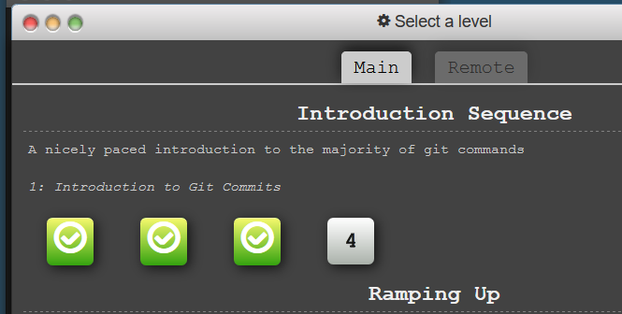

PART 5:

**Push** – Pushing refers to sending your committed changes to a remote repository, such as a repository hosted on GitHub.

**Branch** – A branch is a parallel version of a repository.

**Fork** – A personal copy of someone else’s project.

**Merge** – When code is merged into a master branch.

**Clone** - A clone is a copy of a repository that lives on your computer instead of on a website's server somewhere, or the act of making that copy.

**Pull** - Pull refers to when you are fetching in changes and merging them.

**Pull request** - Pull requests publicize a project’s ongoing efforts and set the tone for a transparent development process.

PART 7:

Selected “Upload”

Clicked “choose you files”

Navigate to Word doc.

Committed Changes.

Selected “New pull request”

Approved merge.