Jobs Intelligence
AI Sales Tool
Specification Document

Version: 0.1 (Draft)
Date: 2026-05-22
Status: Work in Progress

1. Introduction

1.1 Purpose of this document

This document provides an overview and foundation for the Jobs Intelligence AI Sales Tool project. It outlines the product concept, the data it is built on, the planned features, and the technical approach. It serves as a starting reference point for the project and will be expanded as development progresses.

1.2 Target users

The primary users of the tool are employees at HR companies and staffing agencies - in particular recruiters and HR consultants who are responsible for matching candidates to open positions. A frequent use case is temporary staffing, where recruiters need to quickly identify relevant job openings for a pool of candidates across multiple clients and regions.

HR professionals in this space are typically not data analysts and often struggle with complex analytics or search tools. This tool is designed to bring powerful data capabilities - job market coverage, AI-based matching, rich filtering - down to an intuitive, easy-to-use interface that requires no technical knowledge to operate. The goal is to give HR employees the analytical strength they currently lack, wrapped in a workflow that feels natural to them.

While a management-level view (e.g. reviewing pipeline status across the team) is a natural future extension, it is outside the scope of the current project phase.

1.3 Scope
In scope for this project:
- Web application: job search & filters, CV-based AI matching, results table, saved jobs & pipeline management
- Jobs Intelligence Austria dataset as the data source
- Vector database setup and embedding pipeline using OpenAI
- AI matching and ranking based on CV input
- Single-user workflow (one recruiter, their own saved jobs and pipeline)

Out of scope / future:
- Alerts and notifications
- Multi-user / team features (manager view, shared pipelines)
- Countries beyond Austria
- Direct candidate application management (this is a search tool, not an ATS)

2. Product Specification

2.1 Overview & goals

The Jobs Intelligence AI Sales Tool has the following core goals:

- Match candidates to relevant job openings quickly and accurately, using AI ranking rather than manual search
- Make the full depth of the Jobs Intelligence Austria database accessible through simple, intuitive filtering
- Reduce time-to-match for recruiters handling both permanent and temporary staffing
- Give recruiters a lightweight pipeline to track their outreach and manage job leads
- Deliver all of this without requiring any technical or analytical knowledge from the user

2.2 Feature list

- CV Upload & AI Matching - recruiter uploads a PDF CV or pastes CV text; the tool vectorizes it and returns a ranked list of matching jobs based on skills, location, salary, and job description
- Job Filter Panel - structured filters for job status, region (Bundesland / Bezirk / Ort / PLZ), job criteria (title, occupational group, description, skills, salary, start date, work time, contract type, portal), and company (name, NACE industry, with/without staffing agency)
- Job Results Table - ranked, sortable table showing AI matching score, company, job title, occupational group, salary, work time, contract type, and a link to the original posting
- Map View - interactive map of Austria showing the geographic distribution of matching jobs by region, giving recruiters a quick spatial overview of where opportunities are concentrated
- Saved Jobs & Pipeline Management - recruiter can save jobs, add a comment, set a personal status (in progress / done), and set a next activity date
- Alerts (future) - subscribe to filters and get notified when new matching jobs appear

2.3 User stories / use cases

UC-01: CV-based job matching
A recruiter has a candidate looking for work. They upload the candidate's CV or paste the text directly into the tool. The system returns a ranked list of matching job openings based on the candidate's skills, location, and salary expectations. The recruiter can immediately see which jobs are the best fit without manually searching any portal.

UC-02: Market scanning by profile type
A recruiter regularly places a specific type of candidate - for example logistics workers in Upper Austria. Without a specific CV at hand, they use the filter panel to browse current openings for that profile in that region, getting a real-time view of what the market looks like and which companies are actively hiring.

UC-03: Regional overview with the map
A recruiter wants to understand where job opportunities are geographically concentrated for a given search. They switch to the map view to see a spatial distribution of results across Austrian regions, helping them plan outreach or advise candidates on where opportunities are strongest.

UC-04: Pipeline tracking
After identifying relevant jobs, the recruiter saves the most promising ones. They add a note about the candidate they have in mind, set the status to in progress, and schedule a next activity date as a reminder to follow up. This keeps their workflow organised without needing a separate tool.

UC-05: Proactive market monitoring (future)
A recruiter sets up an alert for a specific combination of industry, region, and job type. When new matching jobs appear in the database, they are notified automatically - allowing them to act before competitors.

2.4 Out of scope / future features

[ To be completed ]

3. Data Foundation

3.1 Source database overview

The Jobs Intelligence Austria database is a MySQL-based system containing 110,086 job listings collected from 335+ Austrian job portals, covering all 9 federal states. Data is continuously scraped, processed, and enriched through a multi-stage pipeline.

The database is organized into three logical layers:

Core jobs layer
The jobs table is the central record for each listing, holding position title, salary, work time, employment type, occupational group, education requirement, portal source, publication date, and processing status. Raw scraped payloads are stored in scrape_cache, and full text descriptions with LLM-generated summaries are stored in text_data. A View_Jobs_Full view joins all layers into a single flat record per job for easy consumption.

Enrichment layer
Each job is linked via junction tables to: standardized location records across all four geographic levels - federal state, district, city, and postal code (2,358 location records); contact persons with name, phone, email, and LinkedIn (43,356 contacts); and company records enriched with industry codes, legal form, and employee category from Creditreform.

Skills layer
The skills layer uses ESCO (European Skills, Competences, Qualifications and Occupations), a standardized EU taxonomy of 13,939 skills split into competences and knowledge types. ESCO skills serve as a standardization and filtering layer - enabling consistent skill-based filtering regardless of how different portals phrase requirements. For AI matching however, job descriptions are the primary signal: they are embedded into the vector database and matched semantically against candidate CVs. Jobs without descriptions fall back to title and occupational group for embedding but will naturally yield lower-confidence matches.

Regional distribution spans all nine Austrian federal states, with Upper Austria (22,734), Lower Austria (16,782), and Styria (13,100) as the three largest markets.

3.2 Data readiness audit

The following table shows field coverage across all 110,086 job records:

Field | Coverage
Publication date | 98.6%
District (municipality) | 98.1%
Postal code | 97.6%
Occupational group | 97.4%
Employment relationship | 91.8%
Salary | 80.2%
Start timeline | 79.7%
Work time | 78.5%
Job description | 75.3%
Skills (raw) | 52.0%
Contacts | 41.0%
NACE industry code | Sparse - enrichment ongoing

Core location and classification fields are near-complete and reliable. Salary, work time, and start timeline sit around 80% coverage - sufficient for filtering but null values should be surfaced clearly in the UI. Job descriptions at 75.3% are the most critical gap for AI matching quality. Contacts at 41% are supplementary. NACE codes from Creditreform are currently sparse and require further enrichment before the company industry filter is fully usable.

3.3 Data gaps & recommendations

Job descriptions (24.7% missing)
Job descriptions are the primary input for AI matching. Jobs without descriptions should still be indexed in the vector database using a fallback composite of position title, occupational group, and available skills. These should be visually flagged in search results so recruiters understand they are lower-confidence matches.

NACE industry codes (sparse)
The company industry filter depends on this field. Until Creditreform enrichment is more complete, a fallback approach should be considered - either deriving industry from occupational group, or hiding the NACE filter for companies where the data is absent rather than showing inaccurate results.

Staffing agency flag (not in data)
The filter to show jobs with or without staffing agencies does not currently exist as a field in the database. It would need to be derived - either via NACE codes once available (NACE 78xx covers HR and staffing activities), or via a manual tagging process on known staffing agency companies.

4. Architecture

4.1 High-level system diagram

The system has two main components that operate independently but share the same underlying data:

Embedding pipeline
A background process reads job records from MySQL, constructs a text representation for each job, and sends it to OpenAI to generate a vector embedding. The resulting embeddings are stored in OpenAI Vector Store. This pipeline runs continuously so that new and updated jobs are embedded and available for matching with minimal delay.

Streamlit web application
The recruiter-facing application is a Python/Streamlit app. It connects directly to MySQL for structured filtering and job data retrieval, and to OpenAI for CV vectorization and similarity search. There is no separate API layer - Streamlit handles both the UI and business logic in a single lightweight service. The app is hosted on AWS EC2.

4.2 Tech stack recommendation

The following technologies make up the planned stack:

Component | Technology / Notes
Data source | MySQL - existing Jobs Intelligence Austria database, no migration needed
Web application | Python / Streamlit - lightweight, no separate frontend or API layer required
Embedding model | OpenAI text-embedding-3-small - multilingual, cost-effective, strong for job and CV text
Vector store | OpenAI Vector Store - native integration with the embedding model, no additional infrastructure
Map component | Folium - Python library for interactive geographic maps, renders directly in Streamlit
Hosting | AWS EC2 - single instance running the Streamlit app and embedding pipeline

4.3 Vector database setup & embedding strategy

Each job record is converted into a single text string before being embedded. The construction logic is:

Primary path (description available):
Job description + position title + occupational group. The description carries the most semantic signal and is the primary basis for matching. Title and occupational group are appended to reinforce the role context.

Fallback path (no description):
Position title + occupational group + available ESCO skills. When no description exists, structured fields are combined to produce the best possible representation. These records will yield lower-confidence matches and are visually flagged in results.

OpenAI text-embedding-3-small is used for all embeddings - both job records and uploaded CVs. The model handles German and English text natively, which is important given that job postings and CVs in the Austrian market often mix both languages. When a recruiter uploads a CV, it is vectorized using the same model and the resulting vector is used to query the store for the nearest neighbours.

To understand what an embedding is: every text - whether a job description or a CV - contains meaning. An embedding converts that meaning into a list of numbers (a vector) that a computer can work with mathematically. Words and phrases with similar meaning end up as similar numbers, so Staplerfahrer and forklift operator land close together in this number space, while Buchhalter (accountant) lands far away. This works across languages - the model understands German and English in the same vector space. The diagram below shows the full matching process with a real example:

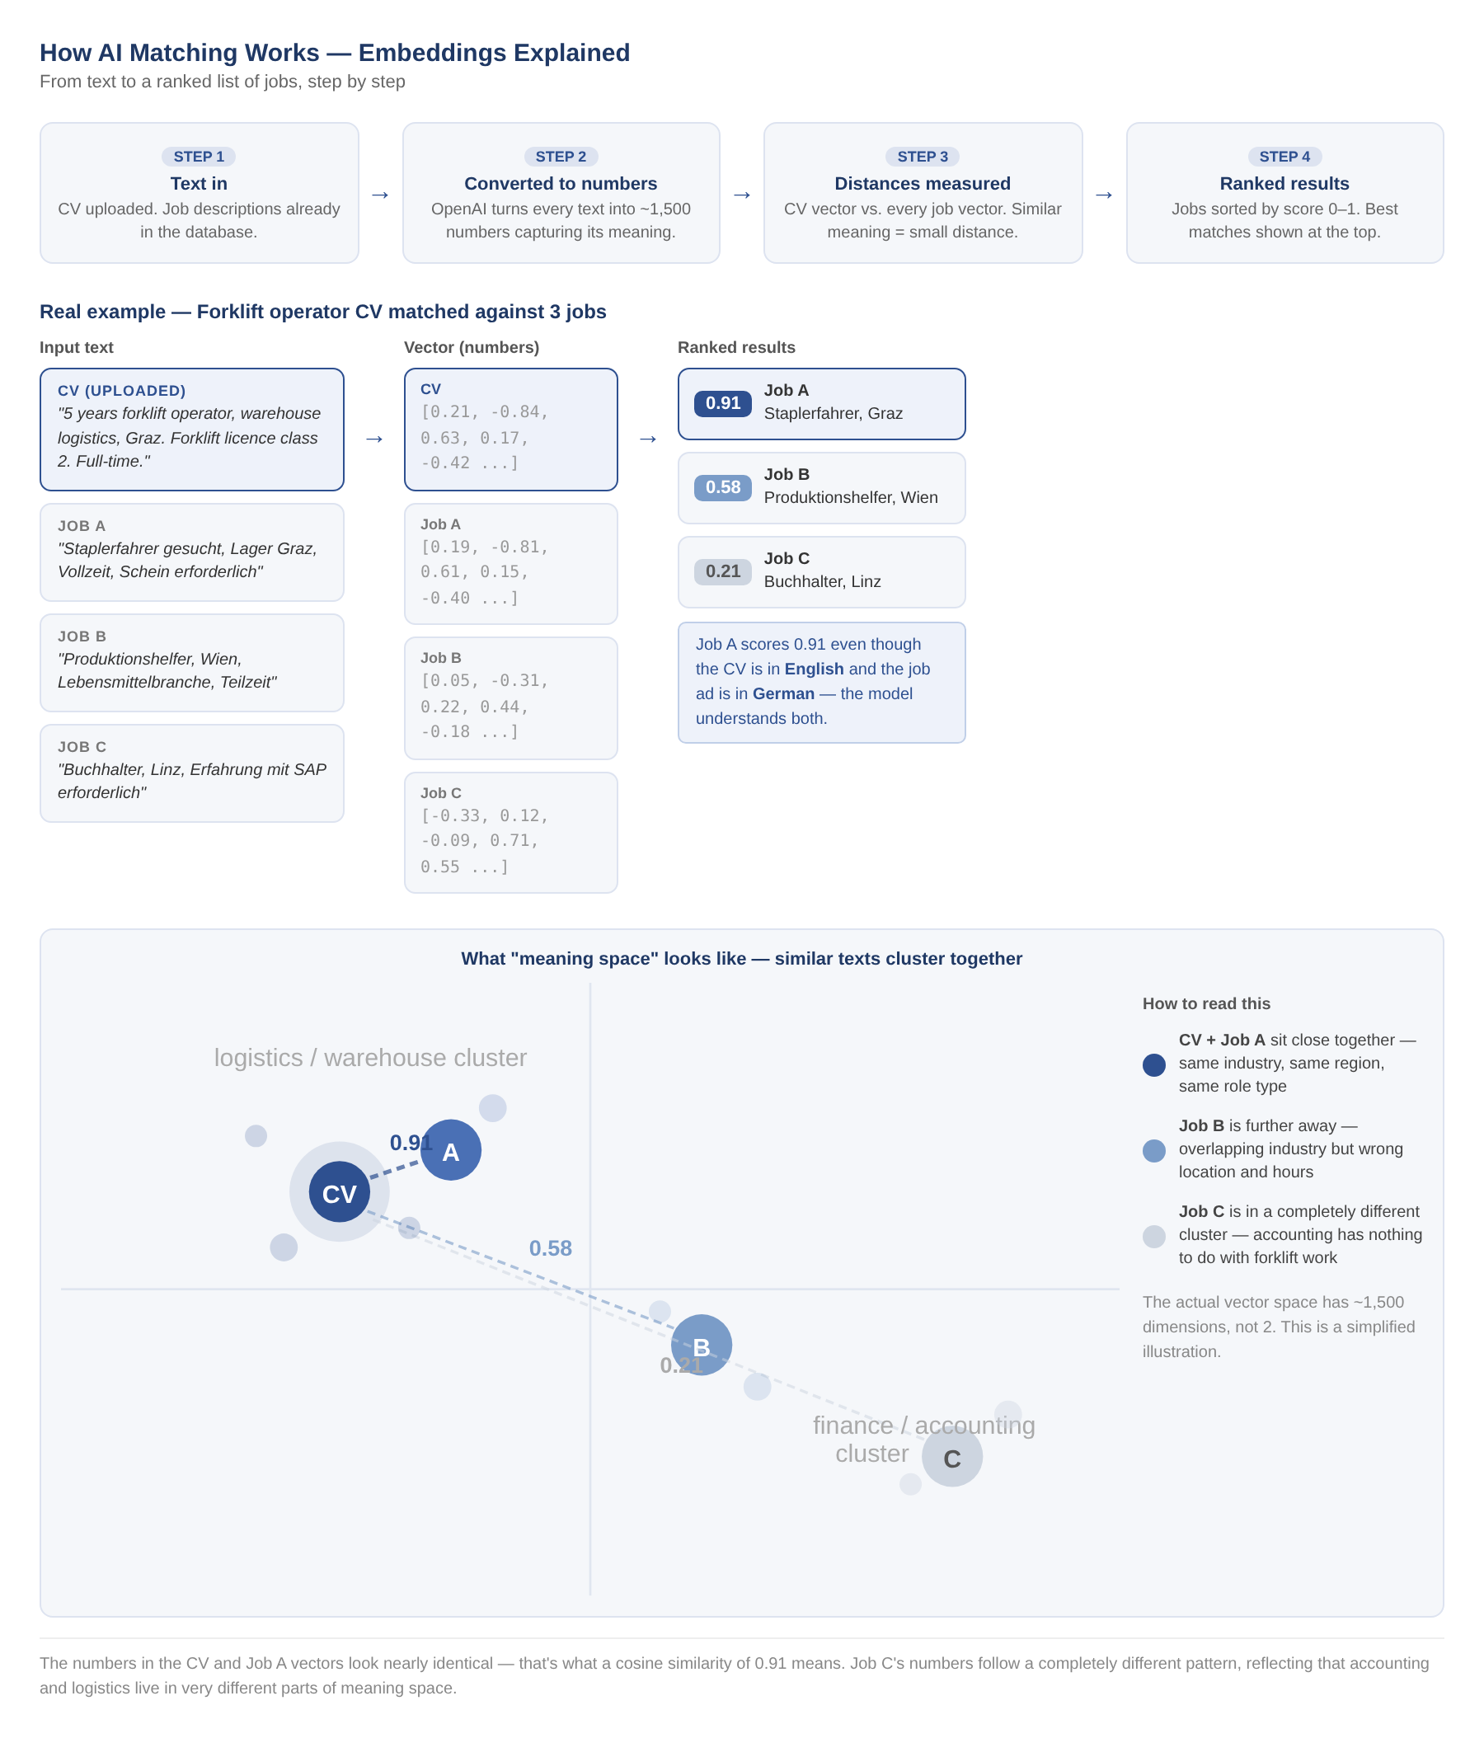

4.4 AI matching scoring logic

OpenAI Vector Store returns results ranked by cosine similarity - a standard measure of how close two vectors are in the embedding space. The score ranges from 0 to 1, where 1 means the vectors are identical and 0 means they share no directional relationship. In practice for CV-to-job matching:

- Score above 0.7 - strong semantic match - the job and CV describe very similar roles, skills, and context
- Score between 0.5 and 0.7 - moderate match - meaningful overlap but with gaps or differences in scope
- Score below 0.5 - weak match - included in results but likely not relevant; recruiter should review with caution

The AI score is displayed as the primary sort column in the results table. Structured filters (region, employment type, salary, work time, etc.) act as hard constraints applied before the vector search - they narrow the candidate pool but do not modify the score itself. All result columns are sortable so recruiters can re-sort by salary, date, or other attributes after the AI ranking is applied.

5. Feature Specifications

This section defines the detailed behaviour of each feature in the Jobs Intelligence AI Sales Tool. Each sub-section covers the intended user flow, key design decisions, and acceptance criteria. The specifications build directly on the architecture and data foundations established in Sections 3 and 4.

5.1 CV Upload & AI Matching
CV Upload & AI Matching is the core feature of the product. It accepts a candidate profile through one of three input modes, converts the text to an embedding vector, and returns a ranked list of matching jobs from the Jobs Intelligence Austria database. All three modes feed the same matching pipeline and produce equivalent results; the choice of mode depends on the recruiter’s workflow and the information available at the time of search.
Input modes
Mode 1 — CV Upload / Paste. The recruiter uploads a PDF CV or pastes raw CV text into a text area. The system extracts and normalises the text, strips formatting artefacts, and generates an embedding vector representing the candidate’s skills, experience, and profile. This is the primary mode for candidates who have an up-to-date CV available.
Mode 2 — Free-Text Profile Description. The recruiter types a natural-language summary of the candidate directly into a text field — for example, “Experienced forklift operator, Vienna, available from July, looking for full-time permanent work.” No CV is required. This mode is well-suited to telephone registrations, walk-in candidates, or situations where only verbal information is available.
Mode 3 — Guided Query. The tool asks the recruiter a short sequence of structured questions: target job title or role, key skills and qualifications, years of experience, preferred location, salary expectation, and employment type. Answers are assembled into a structured candidate profile, which is then vectorised and passed through the matching pipeline. This mode is recommended when no CV is available, when a consistent intake process is preferred across the team, or when the recruiter wants guidance building a search query.
Shared matching pipeline
Regardless of input mode, the candidate representation passes through the same pipeline:
- Text extraction and normalisation — CV text is extracted from PDF where applicable; all input is cleaned and standardised before processing.
- Embedding generation — the cleaned text is passed to OpenAI text-embedding-3-small, which returns a 1,536-dimension vector representing the candidate’s profile.
- Filter application — hard filters (region, employment type, salary range, contract type) narrow the job pool before the vector search runs. Filters constrain results but do not modify similarity scores.
- Cosine similarity search — the candidate vector is compared against pre-embedded job listings in the OpenAI Vector Store; each job receives a similarity score between 0 and 1.
- Ranking and display — results are sorted by similarity score and returned to the results table. Score thresholds are applied as defined in Section 4.4 (strong match > 0.7, moderate 0.5–0.7, weak < 0.5).
Language support
German and English are both supported natively. The text-embedding-3-small model is multilingual and handles both languages without translation or pre-processing. Recruiter input and job listings can be in either language, and cross-language matching — for example a German CV against English-language job descriptions, or vice versa — produces meaningful similarity scores. No additional configuration is required; this is a native capability of the embedding model.

5.2 Job Filter Panel
The filter panel provides hard constraints that narrow the job pool before the AI matching pipeline runs. Filters do not affect similarity scores — they reduce the candidate set the vector search operates on. They can also be used independently of AI matching to browse the database directly.
Filters are grouped into three categories:
Region — Bundesland, Bezirk, Ort, PLZ. Selections cascade hierarchically; multiple values can be selected at each level.
Job criteria — keyword search across job title, occupational group, and job description; ESCO skills (multi-select); salary range; earliest start date; work time (full-time / part-time); contract type (permanent / temporary / freelance); source portal.
Company — company name (text search); NACE industry code (multi-select); staffing agency toggle (include / exclude / only). The staffing agency flag is derived from NACE code 78xx or manual tagging and will be marked beta until fully populated.
All active filters apply as AND conditions. Filter state persists within a session.

5.3 Job Results Table
The results table displays the top N matching jobs returned by the AI pipeline, ranked by similarity score. N defaults to 20 and can be adjusted by the recruiter. All results within the top N are shown regardless of grade — if the search is strong, the set will be mostly A and B; for niche roles, C-rated results may appear within the top N.
Each result displays the following columns: AI match score (percentage and grade label), job title, company, location, occupational group, salary, work time, contract type, and a link to the original job posting. All columns are sortable.
Match grades map to the scoring thresholds defined in Section 4.4: A (strong match, above 70%), B (moderate match, 50–70%), C (weak match, below 50%).
The table includes an Export to Excel button. The export contains all visible results with an additional Status column (predefined values: To Review / Sent to Candidate / Interview Scheduled / Placed / Rejected) and a free-text Notes column for recruiter annotations.

5.4 Saved Jobs & Roundtrip Workflow
The export/import roundtrip allows recruiters to manage job results in Excel and bring their annotations back into the tool. After exporting results, the recruiter fills in the Status and Notes columns in Excel as they work through the list. The completed file can then be re-imported into the tool, repopulating the results table with their annotations alongside the job data.
The job ID field is the key used to match imported rows back to jobs in the database. Imported results reflect the state of the data at the time of original export — this is a known limitation with no special handling required.

6. UI / Prototype

6.1 Search tab — annotated wireframe
The wireframe below illustrates the layout of the Search tab. The application uses a three-tab structure (Search, Saved Jobs, Map). All key interactions on the Search tab — filtering, candidate input, and results — are contained on a single screen with no pagination between views.
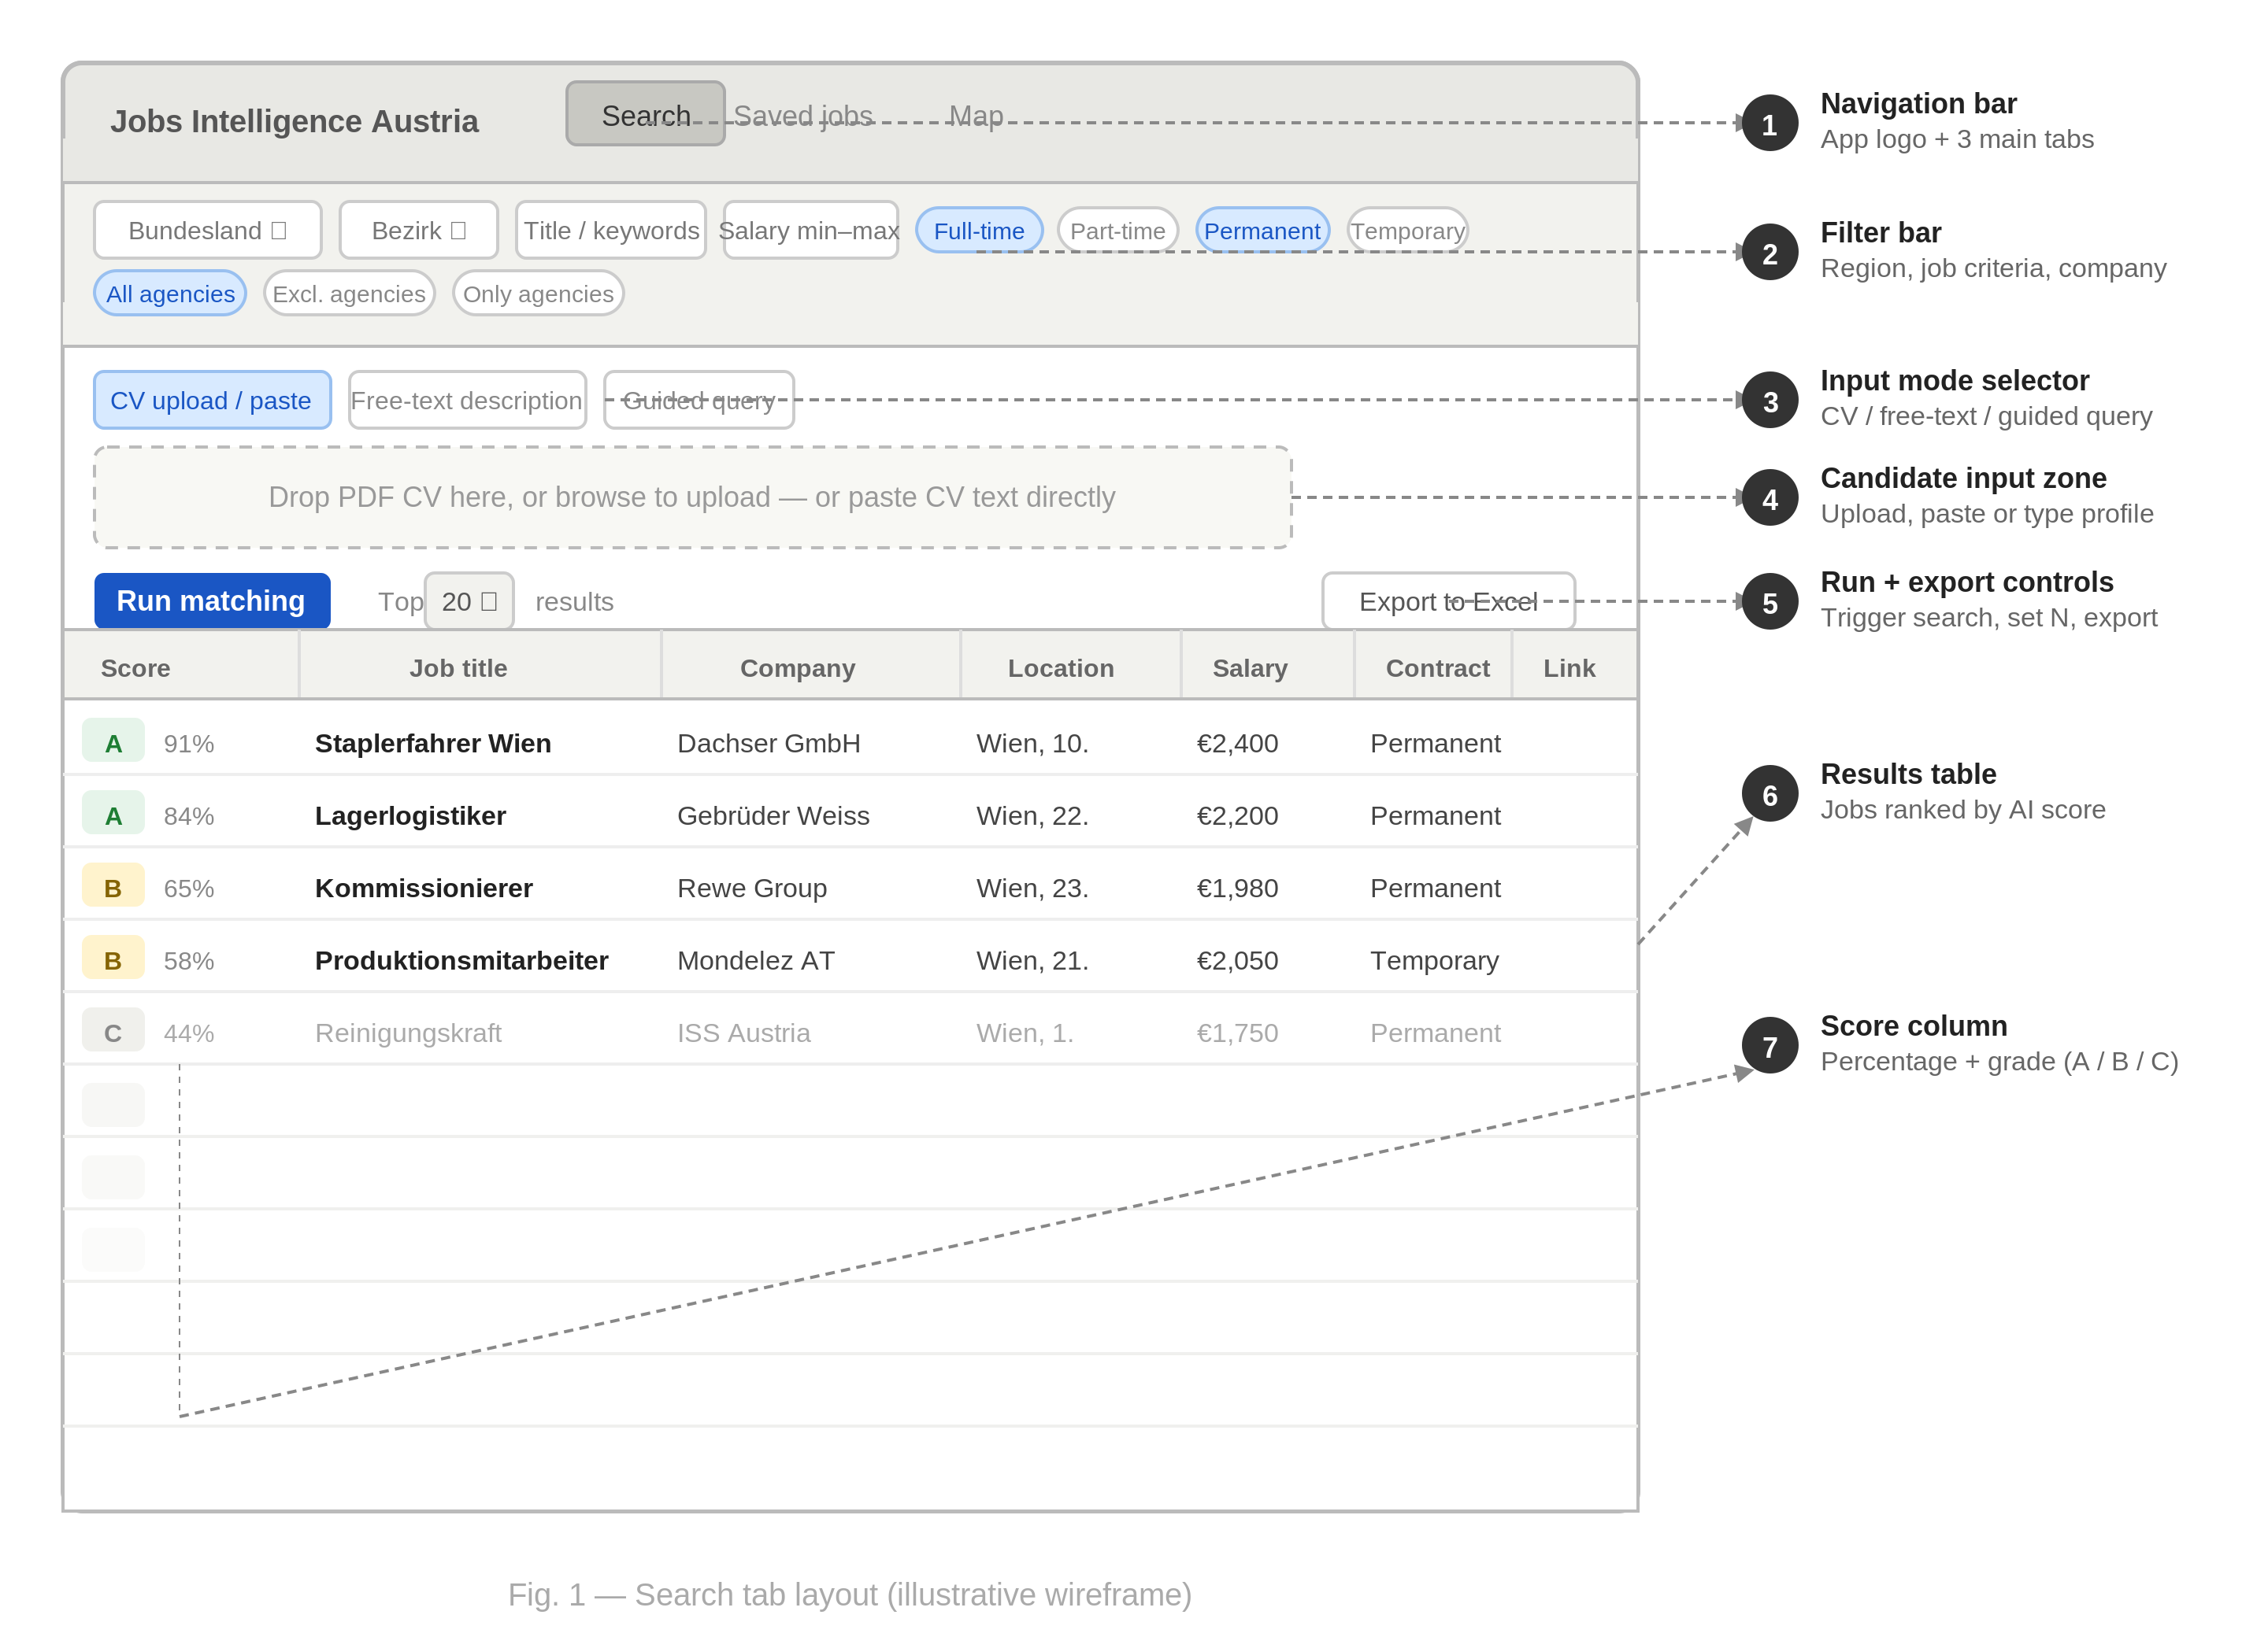
Fig. 1 — Search tab layout (illustrative wireframe)

