Timothy Jelinek

6/9/2024

Part2

2.) Data is not always normally distributed, because there will always be outliers such as children’s heights when comparing heights of everyone in the world.

3.) It is better to use the median instead of the mean for the measure of center when there is data from skewed distributions, because the median isn’t as impacted from extremely large or low numbers like the mean is.

4.) 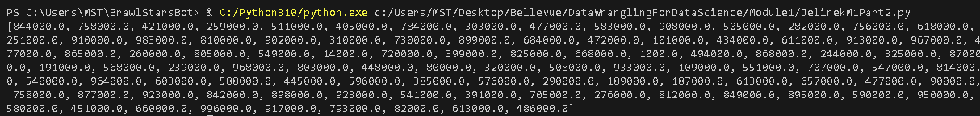

844000.0, 758000.0, 421000.0, 259000.0, 511000.0, 405000.0, 784000.0, 303000.0, 477000.0, 583000.0, 908000.0, 505000.0, 282000.0, 756000.0, 618000.0, 251000.0, 910000.0, 983000.0, 810000.0, 902000.0, 310000.0, 730000.0, 899000.0, 684000.0, 472000.0, 101000.0, 434000.0, 611000.0, 913000.0, 967000.0, 477000.0, 865000.0, 260000.0, 805000.0, 549000.0, 14000.0, 720000.0, 399000.0, 825000.0, 668000.0, 1000.0, 494000.0, 868000.0, 244000.0, 325000.0, 870000.0, 191000.0, 568000.0, 239000.0, 968000.0, 803000.0, 448000.0, 80000.0, 320000.0, 508000.0, 933000.0, 109000.0, 551000.0, 707000.0, 547000.0, 814000.0, 540000.0, 964000.0, 603000.0, 588000.0, 445000.0, 596000.0, 385000.0, 576000.0, 290000.0, 189000.0, 187000.0, 613000.0, 657000.0, 477000.0, 90000.0, 758000.0, 877000.0, 923000.0, 842000.0, 898000.0, 923000.0, 541000.0, 391000.0, 705000.0, 276000.0, 812000.0, 849000.0, 895000.0, 590000.0, 950000.0, 580000.0, 451000.0, 660000.0, 996000.0, 917000.0, 793000.0, 82000.0, 613000.0, 486000.0

5.)

6.)

7.)

8.)

Sources:

Pizur, T. (2022, April 2). Data isn’t usually normal - towards data science. *Medium*. https://towardsdatascience.com/your-data-isnt-normal-54fe98b1f322

Bhandari, P. (2023, June 21). *Central tendency | understanding the mean, median & mode*. Scribbr. https://www.scribbr.com/statistics/central-tendency/