**152-080 Databases**

**Unit 3: Introduction to Structure Query Language – Part 2**

This document describes 10 commands you need to create and execute on your local SQL Server in the **AdventureWorks** database. You will **JOIN** data from multiple tables. Please make sure to paste screen prints that show the command and the output and paste them into this word document.

Save your submission as ***U3_lastnamefirstname.docx*** and submit it in the unit *Apply* section of the course.

1. Display a Database Diagram with Person (Person), Employee (HumanResources), and BusinessEntity (Person). (You may need to change the owner of the database to “sa” )

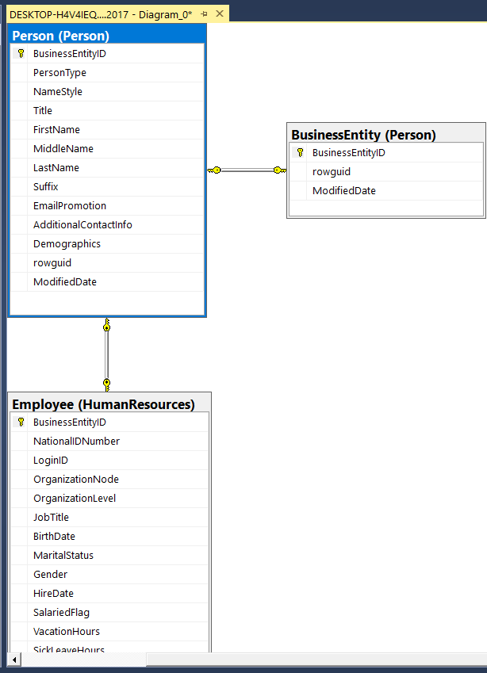

1. How many employees work for the company? (Hint: Check the schema **HumanResources** table **Employee**)

290

1. Display the **JobTitle** from the schema **HumanResources** table **Employee** table. Sort by **JobTitle**. (Do not allow duplicate job titles to display)

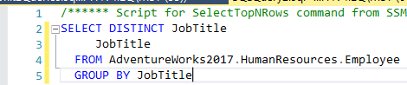

1. (Using **INNER JOIN**) Display **FirstName**, **LastName**, and **JobTitle** of every employee from the schema **HumanResources** table **Employee** table **Joined** with schema **Person** table **Person**. Sort by **LastName**. (Hint: Both tables use **BusinessEntityID**)

1. Modify the above query to only include employees with a **JobTitle** of **Buyer**.

1. Modify the above query to only include employees with a **JobTitle** of **Account.**  (Hint: You’ll need to use **LIKE** for comparison with a **wildcard**)

1. (Using **LEFT OUTER JOIN**) Modify the query you wrote in #4 to use a LEFT OUTER JOIN.

1. (Using **RIGHT OUTER JOIN**) Modify the query above to instead use a RIGHT OUTER JOIN.

