**152-080 Databases**

# **Unit 10: Table Constraints**

# Introduction

In the Lab in Unit 5 you created the database **Video** and the 5 tables for this database. In this lab you will **ALTER** the tables and add the table constraints that are defined in the tables below. For each of the tables add the required constraints as outlined below (mark in red).

Example: On the **Members** table add the default constraint to the ***JoinDate*** to use the system date.

Verify that all of the tables now are complete with the appropriate fields, types and lengths as well as any default values, keys and constraints.

The following diagram is a logical design of the entities and attributes for the **Video** database.

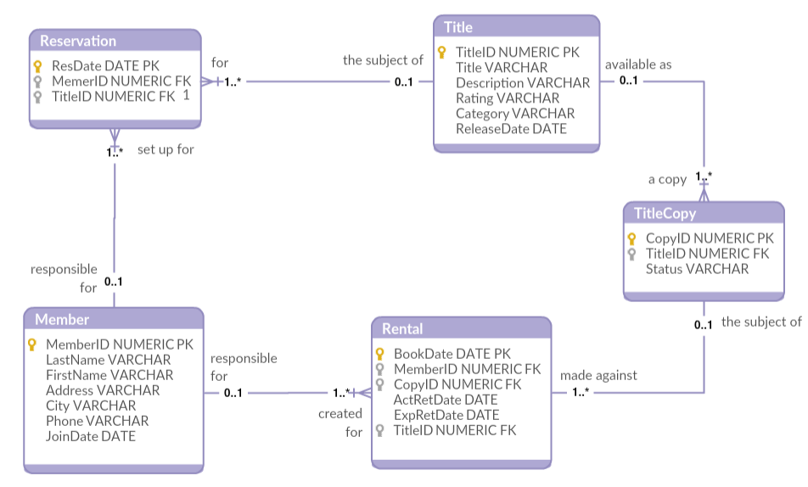

***Note****: This diagram is for reference only and it may not contain every object as described/required in the assignment. You're not required to know what the symbols mean or how they're generated. Also, disregard any text mentioned outside of the boxes. Focus on the "relationships".*

MAKE SURE document your work and your commands work before you past them into the document. Do not use the GUI interface to alter these actions.

Once completed, attach this completed word document to this assignment for grading.   Each question will be worth 5 points.

# Instructions

You are to complete the following actions in the database that you created named **Video** in the previous lab. The syntax must work. For each question below – paste in print screens of your query window showing the command and the functioning output.

Use the **ALTER** command to alter the tables and add the table constraints that are defined in the tables below.

1. Table Name: **Member**

**YOUR COMMAND WAS:**

|  |  |  |  |  |  |  |  |
| --- | --- | --- | --- | --- | --- | --- | --- |
| **Colum Name** | MemberID | LastName | FirstName | Address | City | Phone | JoinDate |
| **Key Type** | PK |  |  |  |  |  |  |
| **Null/Unique** | NN | NN |  |  |  |  | NN |
| **Check** |  |  |  |  |  |  |  |
| **Default Value** |  |  |  |  |  |  | **System Date** |
| **FK Ref Table** |  |  |  |  |  |  |  |
| **FK Ref Column** |  |  |  |  |  |  |  |
| **Data Type** | NUMERIC | VARCHAR | VARCHAR | VARCHAR | VARCHAR | VARCHAR | DATE |
| **Length** | 10 | 25 | 25 | 100 | 30 | 15 |  |

2. Table Name: **Title**

**YOUR COMMAND(S) WAS/WERE:**

|  |  |  |  |  |  |  |
| --- | --- | --- | --- | --- | --- | --- |
| **Colum Name** | TitleID | Title | Description | Rating | Category | ReleaseDate |
| **Key Type** | PK |  |  |  |  |  |
| **Null/Unique** | NN | NN | NN |  |  |  |
| **Check** |  |  |  | **G,**  **PG,**  **R,**  **NC17,**  **NR** | **Drama,**  **Comedy,**  **Action,**  **Child,**  **Scifi,**  **Documentary** |  |
| **Default Value** |  |  |  |  |  |  |
| **FK Ref Table** |  |  |  |  |  |  |
| **FK Ref Column** |  |  |  |  |  |  |
| **Data Type** | NUMERIC | VARCHAR | VARCHAR | VARCHAR | VARCHAR | DATE |
| **Length** | 10 | 60 | 400 | 4 | 20 |  |

3. Table Name: **TitleCopy**

**YOUR COMMANDS WERE:**

|  |  |  |  |
| --- | --- | --- | --- |
| **Colum Name** | CopyID | TitleID | Status |
| **Key Type** | PK | **FK** |  |
| **Null/Unique** | NN | NN, U | NN |
| **Check** |  |  | **Available,**  **Destroyed,**  **Rented,**  **Reserved** |
| **Default Value** |  |  |  |
| **FK Ref Table** |  | **Title** |  |
| **FK Ref Column** |  | **TitleID** |  |
| **Data Type** | NUMERIC | NUMERIC | VARCHAR |
| **Length** | 10 | 10 | 15 |

4. Table Name: **Rental**

**YOUR COMMANDS WERE:**

|  |  |  |  |  |  |  |
| --- | --- | --- | --- | --- | --- | --- |
| **Colum Name** | BookDate | MemberID | CopyID | ActRetDate | ExpRetDate | TitleID |
| **Key Type** | PK | **FK** | **FK** |  |  | **FK** |
| **Null/Unique** | NN | NN | NN |  |  | NN |
| **Check** |  |  |  |  |  |  |
| **Default Value** | **System**  **Date** |  |  |  | **System Date**  **+ 2 days** |  |
| **FK Ref Table** |  | **Member** | **TitleCopy** |  |  | **TitleCopy** |
| **FK Ref Column** |  | **MemberID** | **CopyID** |  |  | **TitleID** |
| **Data Type** | DATE | NUMERIC | NUMERIC | DATE | DATE | NUMERIC |
| **Length** |  | 10 | 10 |  |  | 10 |

5. Table Name: **Reservation**

**YOUR COMMANDS WERE:**

|  |  |  |  |
| --- | --- | --- | --- |
| **Colum Name** | ResDate | MemberID | TitleID |
| **Key Type** | PK | **FK** | **FK** |
| **Null/Unique** | NN | NN, U | NN |
| **Check** |  |  |  |
| **Default Value** |  |  |  |
| **FK Ref Table** |  | **Member** | **Title** |
| **FK Ref Column** |  | **MemberID** | **TitleID** |
| **Data Type** | DATE | NUMERIC | NUMERIC |
| **Length** |  | 10 | 10 |

6. Insert the following member into the Member table.

**YOUR COMMAND WAS:**

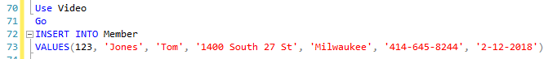

|  |  |  |  |  |  |  |
| --- | --- | --- | --- | --- | --- | --- |
| MemberID | LastName | FirstName | Address | City | Phone | JoinDate |
| 123 | Jones | Tom | 1400 South 27 St | Milwaukee | 414-645-8244 | 2/12/2018 |

Were there errors? If so, explain.

I did not have any errors.

7. Insert the following movie title into the Title table.

**YOUR COMMAND WAS:**



|  |  |  |  |  |  |  |
| --- | --- | --- | --- | --- | --- | --- |
| TitleID | Title | | Description | Rating | Category | ReleaseDate |
| 101 | Harry Potter | A series of fantasy novels that chronicle the life of a young wizard, Harry Potter, and his friends Hermione Granger and Ron Weasley. | | G | Scifi | 11/14/2001 |

Were there errors? If so, explain.

I did not have any errors.

8. Insert another movie title below into the Title table.

**YOUR COMMAND WAS:**

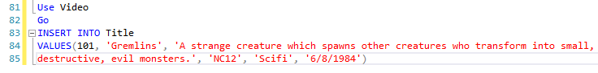

|  |  |  |  |  |  |
| --- | --- | --- | --- | --- | --- |
| TitleID | Title | Description | Rating | Category | ReleaseDate |
| 101 | Gremlins | A strange creature which spawns other creatures who transform into small, destructive, evil monsters. | NC12 | Scifi | 6/8/1984 |

Were there errors? If so, explain.

It didn’t work because the TitleID is a duplicate.

9. Insert the following rental data into the Rental table.

**YOUR COMMAND WAS:**

|  |  |  |  |  |  |
| --- | --- | --- | --- | --- | --- |
| BookDate | MemberID | CopyID | ActRetDate | ExpRetDate | TitleID |
| 2/10/2018 | 123 | 555 | 2/5/2018 | 2/22/2018 | 101 |

Were there errors? If so, explain.

It didn’t work because it conflicted with foreign key CopyID.

10. Insert the following data into the TitleCopy table.

**YOUR COMMAND WAS:**

|  |  |  |
| --- | --- | --- |
| CopyID | TitleID | Status |
| 555 | 101 | Available |

Were there errors? If so, explain.

No errors, it worked.

11. Repeat Step 9 above. Were there errors? If so, explain.

No, step 9 worked now.

The next 2 steps (#12 & #13) require that Step 9 above was successful. If it was not successful, make sure you go back and fix it before continued.

12. Delete the same data you had just inserted in Step 10 above.

**YOUR COMMAND WAS:**



Explain why it failed.

It didn’t work because there’s a foreign key constraint on CopyID.

13. Show the steps that must be taken in order to successfully delete the data in Step 12.

**YOUR COMMAND WAS:**

14. Verify that all of the tables were created correctly with the appropriate constraints and relationships. Create an ERD showing all tables and their relationships.

**

*Hint: Below is an example of an ERD showing relationships and constraints (FK) between tables.*

