Exercise 4 – No issues



Exercise 5 – No issues



Exercise 6 – No issues

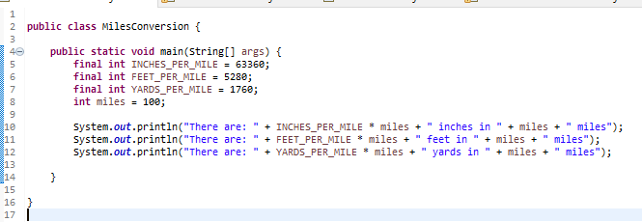



Exercise 7 – No issues

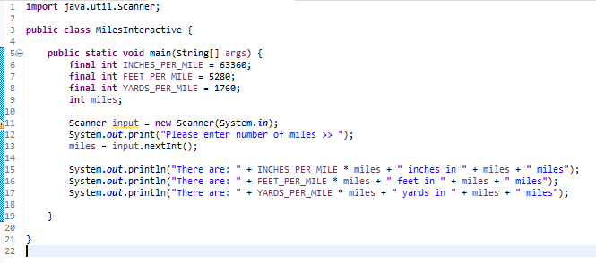

Exercise 8 – No issues



Exercise 9 – No issues



Exercise 10 – No issues



Exercise 11 – No issues

