Exercise 8 – No issues

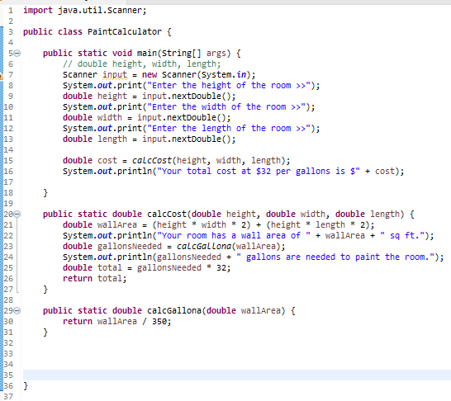

Exercise 11 – No issues



Exercise 12 – No issues

