Refer to the PowerPoint for a review of Functions. Including this slide here as a review of parameters/arguments:

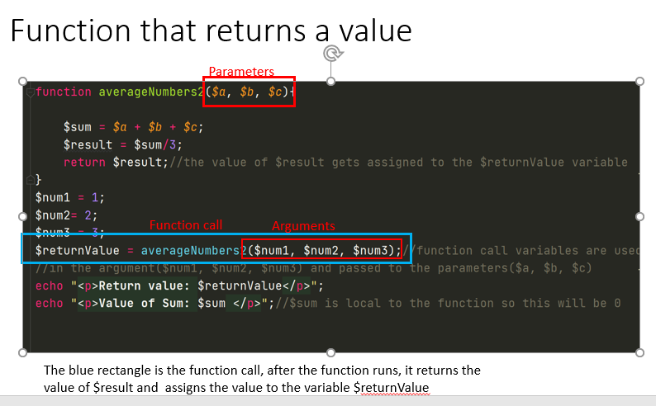

## Tips For Assignment 5:

**Declare 2 global variables near starting <?php to prevent errors when page loads:**

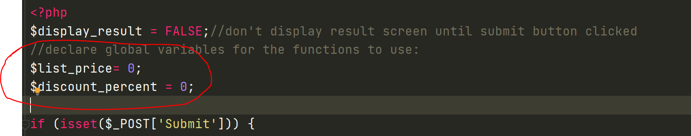

**For the function that returns a value:**

Make discount global:

**Global $discount;**//this gives PHP access to the variable outside the function

The other variable inside that function is returned by the function so PHP will already have access to it, therefore it does not need to be global.

**For the second function:**

When you read the code inside the function, remember the values on the right are getting assigned to the variables on the left. So the variables $list_price, $discount_percent, $discount, $discount_price need to get their value from somewhere, and they get them from the parameters in the function header. The parameters in the function header, receive their value from the function call arguments. Therefore the function call argument values have to be initialized somewhere first and should have a value.

The 4 variables $list_price_f, $discount_percent_f, $discount_f, $discount_price_f are being created and initialized inside the function. They need to be global so they can be accessed outside the function.