**Refresher exercise**

1. Write a function **’fill_list**’ that asks the user to enter 5 songs, store these songs in a list named playlist and return the list.

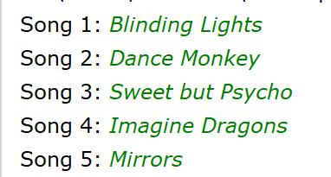

1. Write a function **‘menu’** that returns the selection. You may assume that the user only enters an ‘a’,’ b’, ‘c’ , ‘d’, ‘e’ or ‘s’.

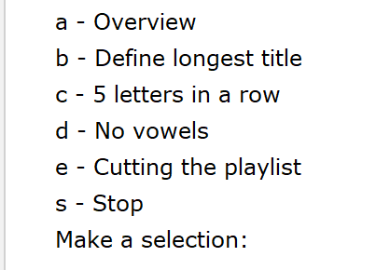

Place a tab before each item of the selection.

1. Write a **function ‘print_overview(playlist)’** that prints the list as shown below.

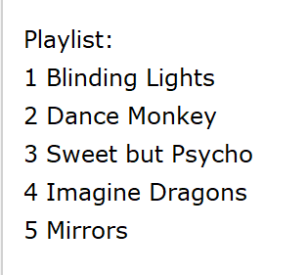

1. Now write the **main program.**

Firstly, you ask the user to enter 5 songs and you store them in the playlist. Use the function ‘fill_list’.

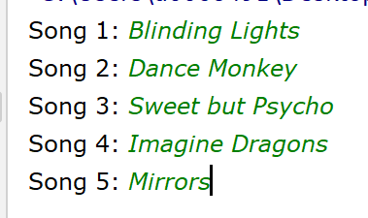

Afterwards the menu is offered, time after time until the user press ‘s’. In that case, stop the program immediately.

1. If the user selects ‘**a**’ in the menu, the playlist overview will be printed with the function print_overview() you wrote in part 3.
2. If the user selects **‘b’** in the menu, the length and the longest title are printed.

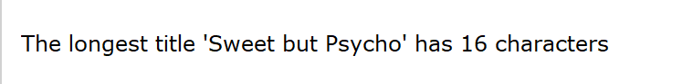

1. If the user chooses **‘c’** in the menu, you enter the number of a song and the title of that song will appear but the letters are shown 5 per 5. Only a valid number is accepted. Between 1 and the number of items within the list.

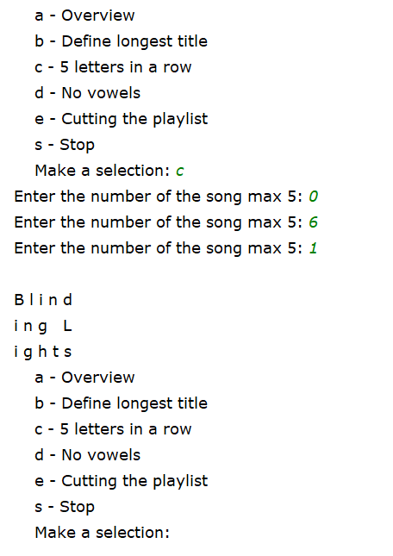

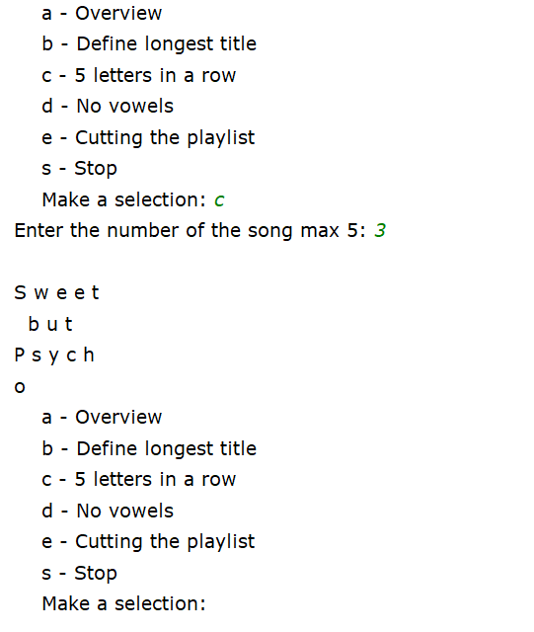

1. If the user chooses ‘d’ in the menu, then the vowels are removed from the song. Only a valid number is accepted. Between 1 and the number of items within the list.

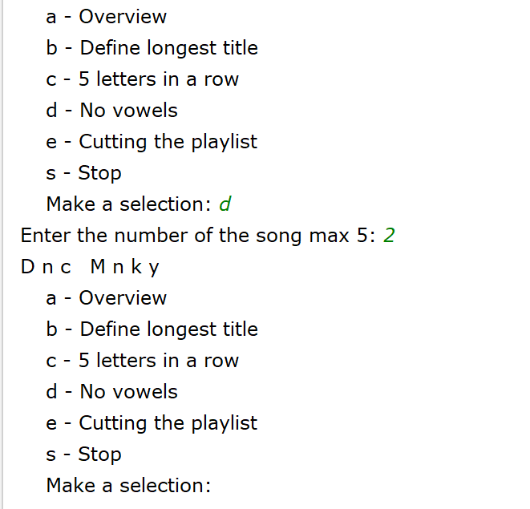

1. If the user chooses **‘e’ i**n the menu, the items starting from the entered number are stored in a new list ‘new_playlist’ and printed. Only a valid number is accepted. Between 1 and the number of items within the list.

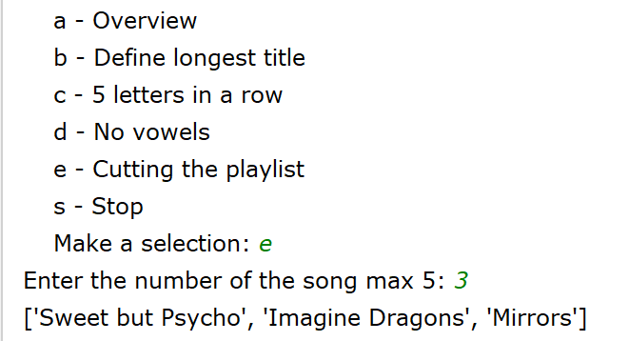

1. If the user chooses **‘s’** in the menu, the program is stopped.

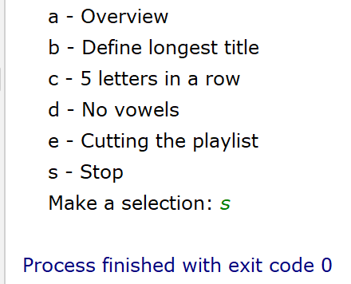

**Extra**: function with return named **valid_input(playlist)** to check the number of the song!