The Strak-machine / Architecture

1. Introduction
to be filled..

2. Use-cases

2.1 Strak-creation

Use-case-  Number | Description
2.1.1 | The user wants to create a set of matching strak-arfoils for a given root-airfoil.  He knows the Re-number / ReSqrt(cl) for the root-airfoil and also has calculated a list of Re or ReSqrt(cl)-numbers he wants to use for the strak-airfoils.

2.2 Planform-creation
Use-case-  Number | Description
2.2.1 | The user already has a set of airfoils that can be used to form a strak.  A wing-planform shall be created using the airfoils.  The position of the airfoil shall be automatically determined from the chord-lengths / Re-numbers.  A basic wing-shape will be given (eliptical / trapezoid etc.) and also some geometrical data of the wing (root-chord, half-spanwidth etc.)
2.2.2 | The user wants to import the generated wing-planform into XFLR5 / Flow5 to perform simulations of the plane.
2.2.3 | The user wants to use the generated wing-planform with DevWingMold to generate .stl-Data for milling /3d-printing molds for the wing.
2.2.4 | The aerodynamic data / polars of the strak-airfoils shall be taken into account when creating an optimized wing-planform.

2.3 Airfoil generation
Use-case-  Number | Description
2.3.1 | The user wants to analyse the generated airfoil(s) with an additional tool, e.g. XFLR5 /Flow 5. For this polars shall be automatically generated.
2.3.2
2.3.3
2.3.4

3. Further Requirements

3.1 Strak-creation

Requirement-  Number | Description
3.1.1 | The workspace for the creation of the strak-airfoils shall be automatically set-up, also batch-files shall be automatically generated that will perform the strak-generation-process.

4. Basic Architecure

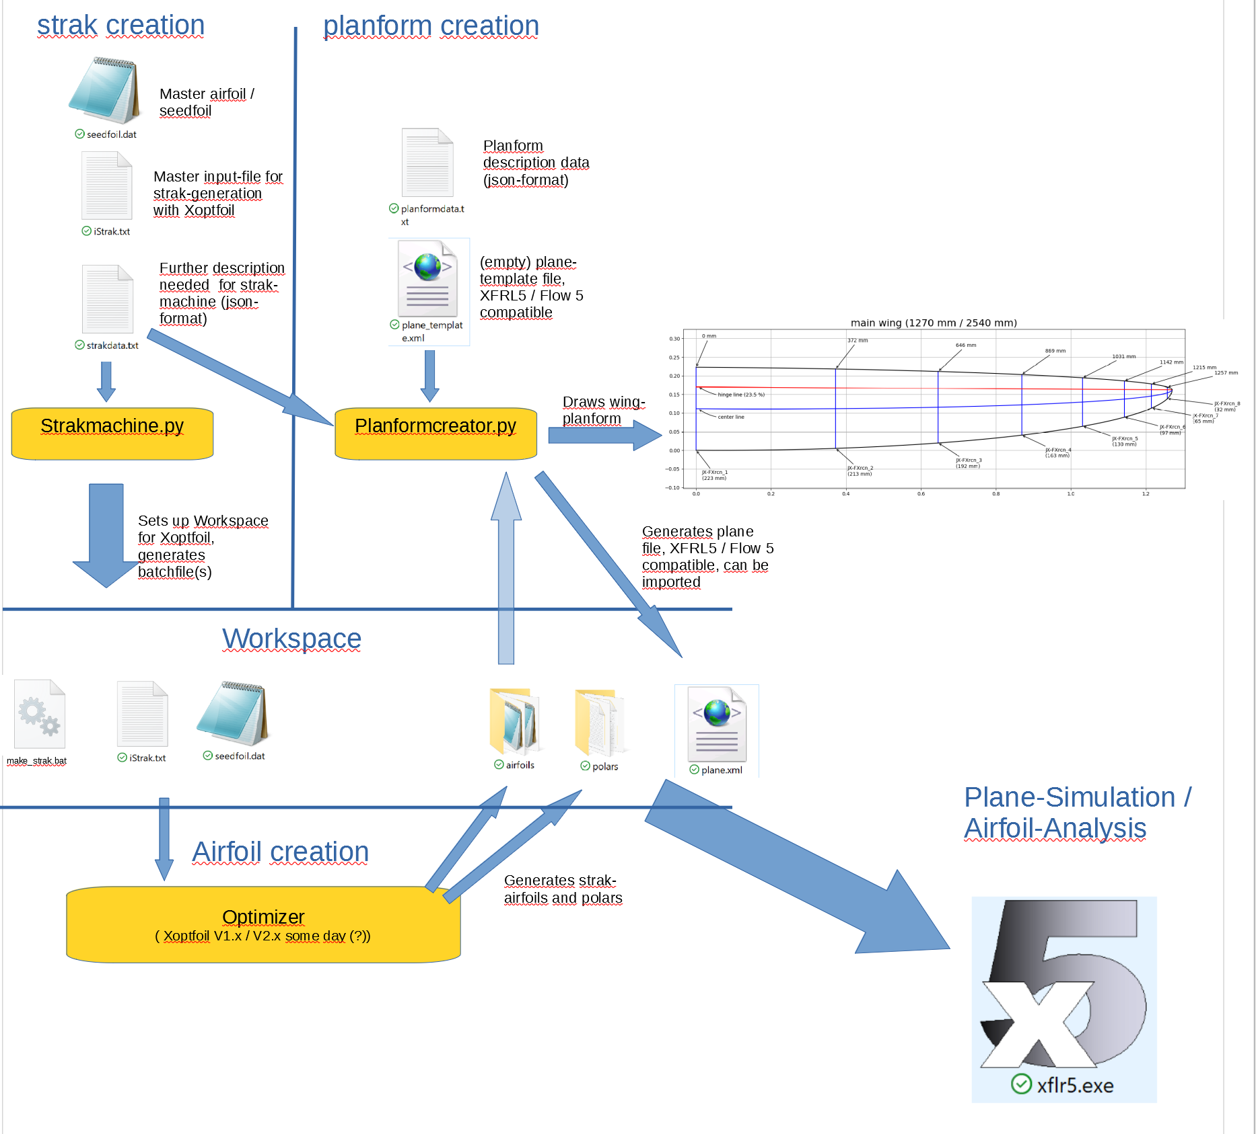
Three main modules are provided to adress all aspects of the use-cases that were described in the previous chapter.
The modules interact using a set of files that reside inside a common workspace in the filesystem.

The main functionality of these software-odules is:
1. Strak-creation
2. Planform-creation
3. Airfoil-creation / optimization (Xoptfoil-Jx)

3. Specification of Functions

3.1 Strak-creation

The creation of the strak-airfoils will be done using Xoptfoil-JX as an underlaid function.
For that purpose a working folder, an input-file and a so-called „seedfoil“ has to be provided for each strak-airfoil that shall be created.
Using separate working-folders for each airfoil gives us the advantage that it will be possible to run multiple instances of xoptfoil without influencing each other / destroying temporary build-files of another instance.
For each of the demanded airfoils, Xoptfoil-JX will be operated with the given working folder and set of files and will perform a single airfoil optimization.
Xoptfoil-JX does not directly know about the „dependency“ between the airfoils.

There are several possible strategies to create a set of strak-airfoils.
a) All airfoils can be created from one common root-airfoil
TODO: Bild
b) Each airfoil can be created from its predecessing strak-airfoil
TODO: Bild
c) There may already be an existing set of strak-airfoils, but for performance-reasons the strak shall be „refined“, so some intermediate airfoils shall be created.
TODO: Bild

Strategy a) and c) seemed to be most promising and will further be used inside this specification.

The following information has to specified by the user for setting up the workspace and defining the airfoil generation-process:
1. Project-Name
The name of the project, which is also the name of the workspace that will be created

2. Total number of airfoils
This defines the total number of airfoils including the root-airfoil and all strak airfoils, as well as predefined strak-airfoils.

3. List of Re-Numbers / ReSqrt(cl)-Numbers
For each of the airfoils a Re-number / ReSqrt(cl)- number has to be provided in this list, including the root airfoil.

4. List of airfoil-Names
For each of the airfoils an airfoil-name has to be specified in this list.

5. Master-input-File
The user has to provide a single Xoptfoil-input-file, that will be duplicated into each airfoil-working-folder.

6. input-folder-name
Name of the folder where to get the master-input-file, the root-airfoil and possibly predefined strak-airfoils

7. output-folder-name

4. Batchfile-Name
"inputFolder": "ressources",
"outputFolder": "build",
"XMLfileName": "plane.xml",
"planformType": "wing",
"ReSqrtCl": "150000",
"strategy" : "fromRootAirfoil",
"strakInputFileName": "iStrak.txt",
"tipInputFileName": "iTip.txt",
"numberOfTipAirfoils": 2,
"generateBatchfile": "true",
"batchfileName": "make_rocketeer_strak.bat"}

Workspace

