**Using The Strak Machine, first steps**

After you have succesfully installed Python and also the necessary additional packages, see **„HowToInstall.docx“,** you can now use the different parts of The Strak Machine.

These are mainly the two parts:

* Creating the wing- and tail- section of an aircraft
* Generating optimized airfoils using Xoptfoil-JX

**To get a quick overview, please execute the following steps:**

1. **Execute the batchfile „create_wing_planform.bat“, which can be found in the „Strackmachine“-folder, to create only the wing-section of the aircraft:**

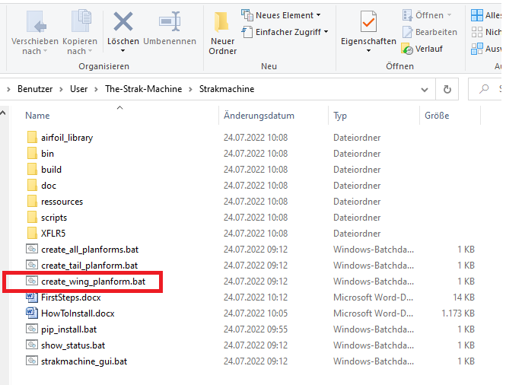

* The batchfile will pass the file „Strakmachine\ressources\planformdata_wing.txt“ to the python-script „Strakmachine\scripts\planform_creator.py“
* The python script „planform_creator.py“ will create a wing, using the parameters of the .txt-file (you can look inside the .txt.file using a standard editor like notepad or notepad++)

You should see the following output:

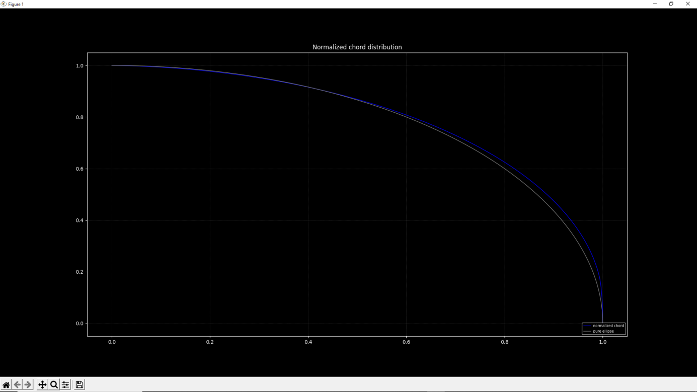

This is the „normalized“ distribution of the chord-lengths along the half wingspan.

You will see a comparison between a pure ellipse (gray) and the generated wing (blue), which is over-elliptic in this case.

Normalized means:

* on the x-axis, 1.0 equals the half wingspan
* on the y-axis, 1.0 equals the length oft he root-chord of the wing

1. Close the window to get the next output, that should look like this:

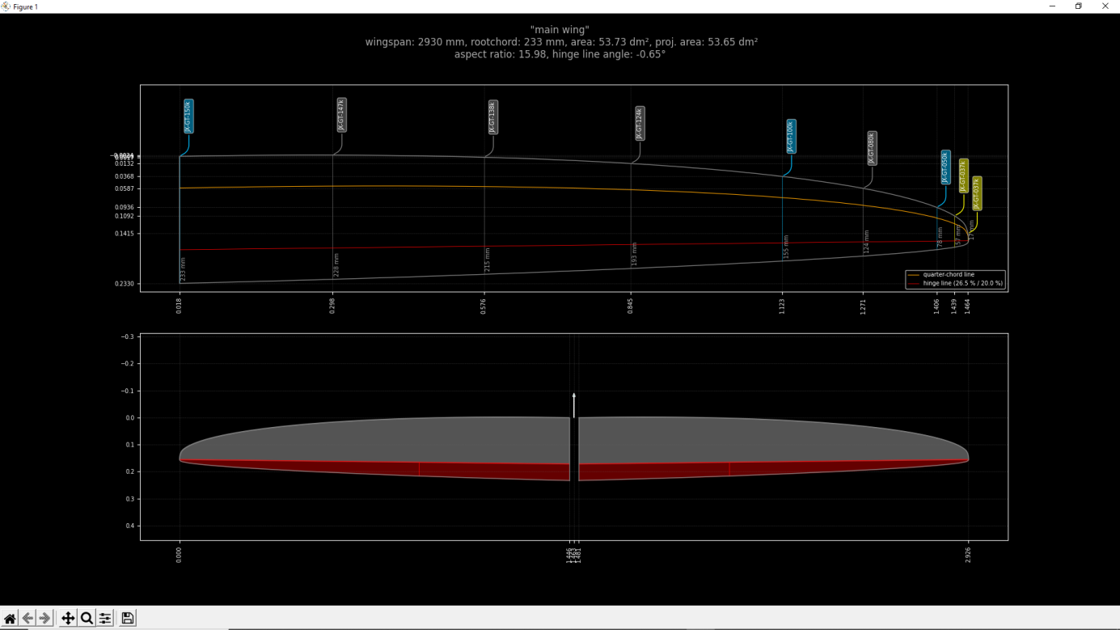

* You will see the wingplan with positions of the different airfoils, airfoilnames etc. in the upper part of the screen (plain view) and the **projected** view on top of the wing in the lower part.
* Projected view means, if the wing has a dihedral angle, which is normally the case, the wingplan and the projected view will differ in half wingspan.
* In this example, the wingplan shows half wingspan = 1464 mm and the projected view shows half wingspan = 2926/2 = 1463 mm, which is nearly the same, but at a dihedral angle of only 3°.
* When looking at a vtail with a much higher dihedral angle, this topic will become much more important.
* Please close the window again

1. **Execute the batchfile „create_tail_planform.bat“, which can be found in the „Strackmachine“-folder, to create only the tail-section of the aircraft:**

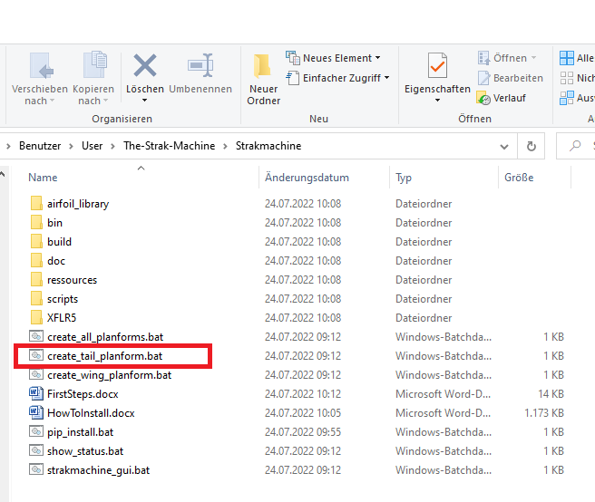

* The batchfile will pass the file „Strakmachine\ressources\planformdata_tail.txt“ to the python-script „Strakmachine\scripts\planform_creator.py“

You should see the following output:

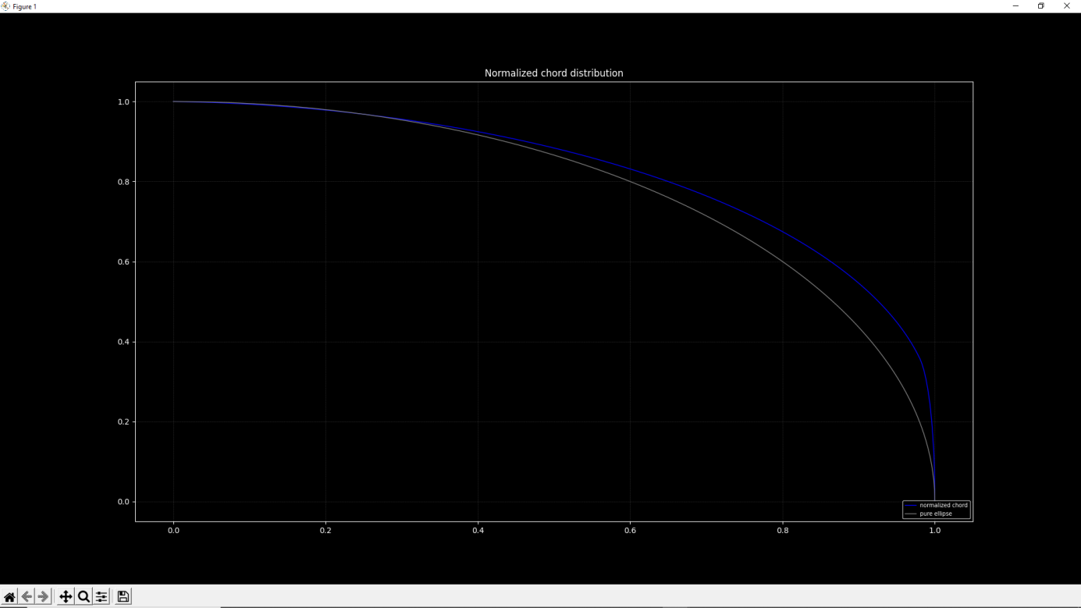

* This is the „normalized“ distribution of the chord-lengths for the V-tail.
* As you can see, looking at the comparison between the pure ellipse and the normalized chord of the „wing“ (V-tail), this planform is a lot more over-elliptic than the wing before.
* Close the window to get the next screen , that should look like this:

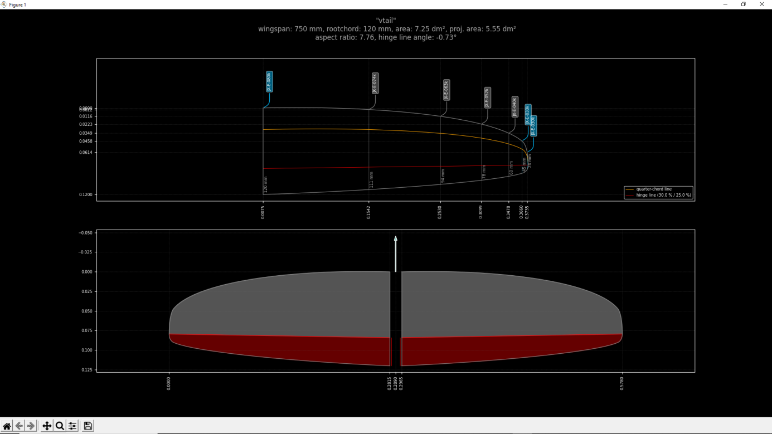

* You will see the wingplan oft he V-tail in the upper part of the screen (plain view) and the **projected** view of the V-Tail in the lower part.
* Please close the window again

1. **Execute the batchfile „create_all_planforms.bat“, which can be found in the „Strackmachine“-folder, to the wing- and also the tail-section of the aircraft:**

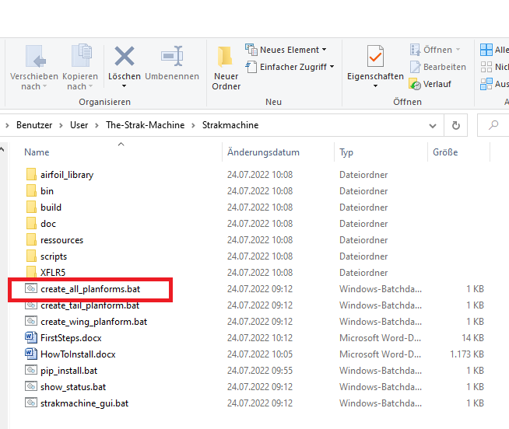

* The batchfile will execute the steps 1. and 2. And you will see the same four output-windows, when closing each window to proceed.

The output of the script „planform-creator.py“ can be found in the folder **„Strakmachine\build\02_planforms“:**

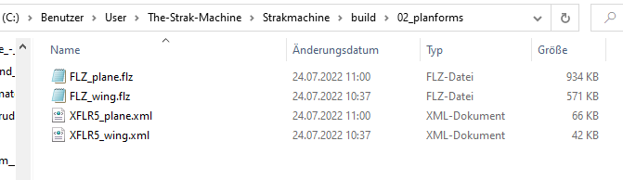

You will find here:

* FLZ-Vortex compatible file, containg the wing- and V-Tail-section (**FLZ_plane.flz**)
* FLZ-Vortex compatible file, containg only the wing-section (**FLZ_wing.flz**)
* XFLR5 compatible file, containg the wing- and V-Tail-section (**XFLR5_plane.xml**)
* XFLR5 compatible file, containg only the wing-section (**XFLR5_wing.xml**)

The .flz-files can be directly opened in FLZ-Vortex:

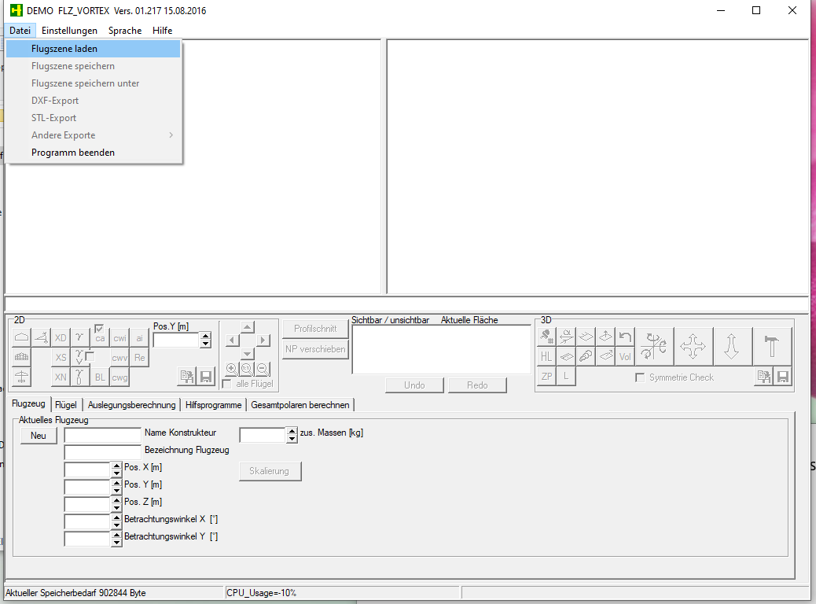

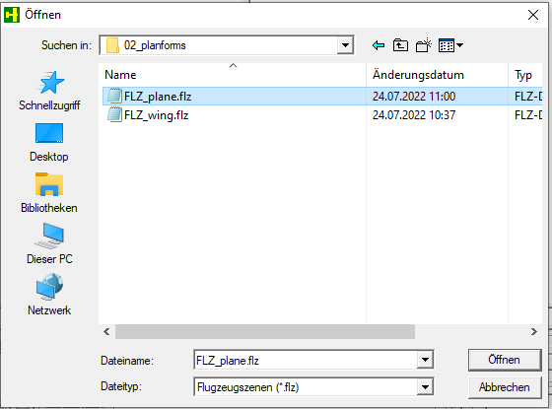

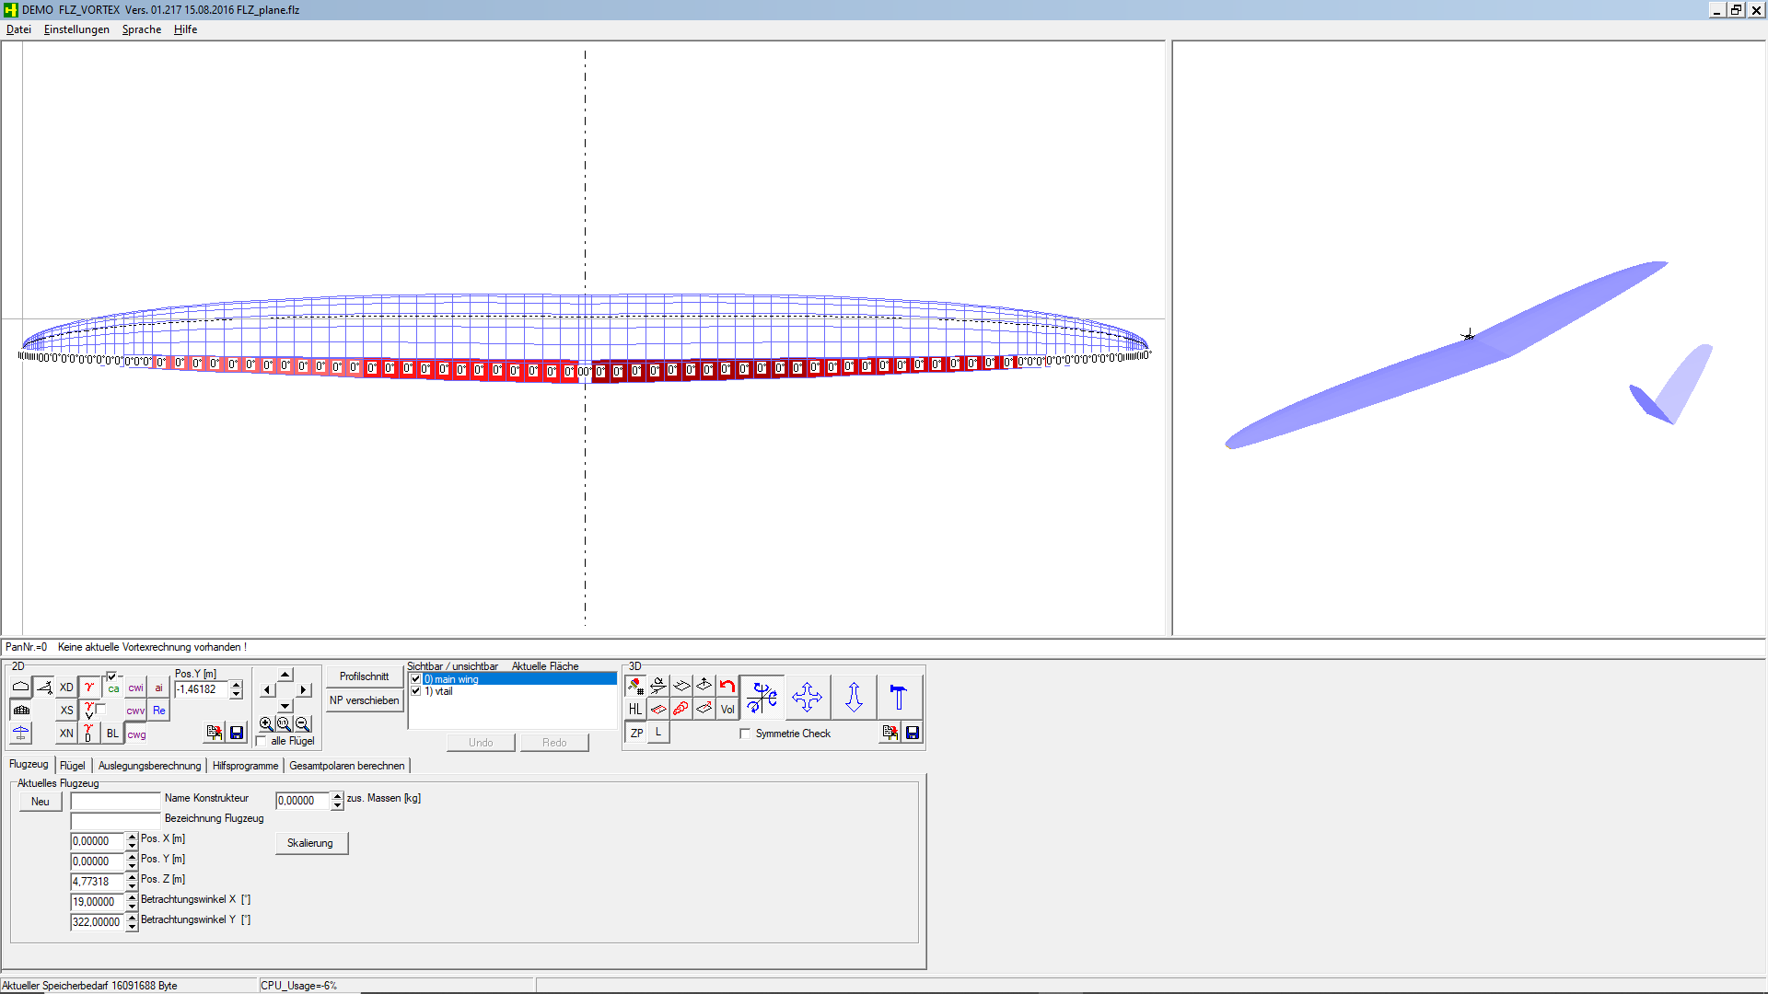

The .xml-files can be imported in XFLR5:

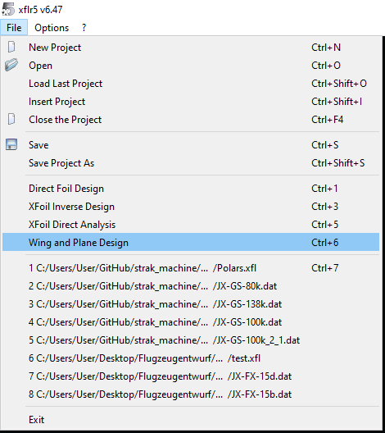

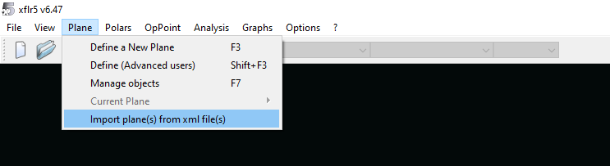

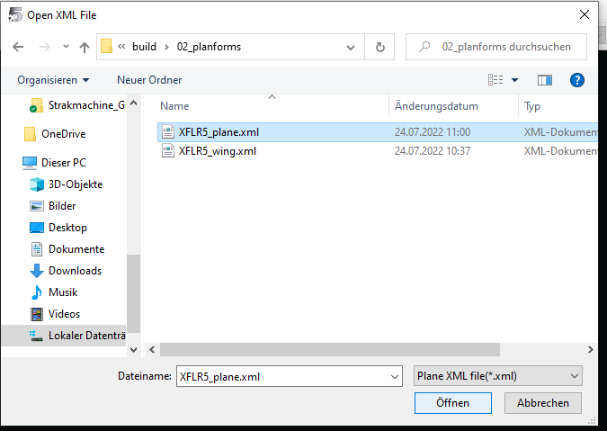

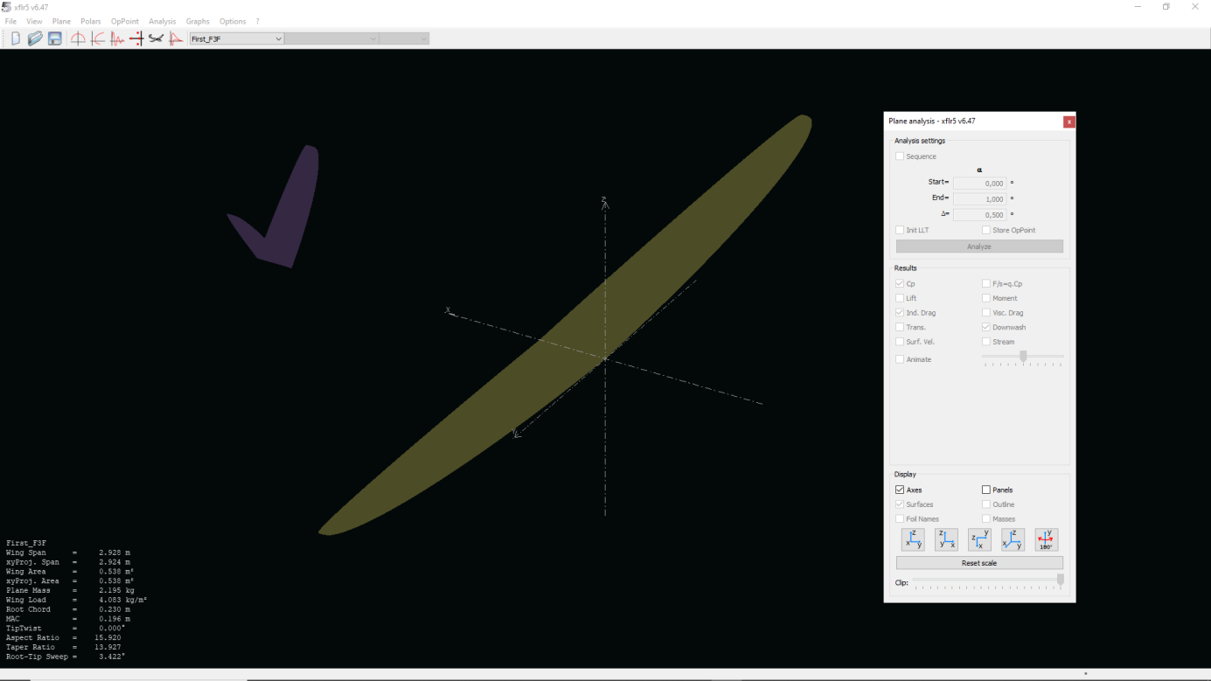

* In FLZ-Vortex, all airfoils will be already be included in the .flz-file
* In XFRL5 it is necessary to import the airfoils in the project:

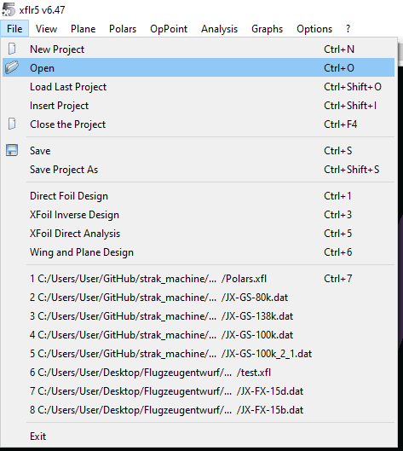

They can be found in the folder **„Strakmachine\build\01_airfoils“:**

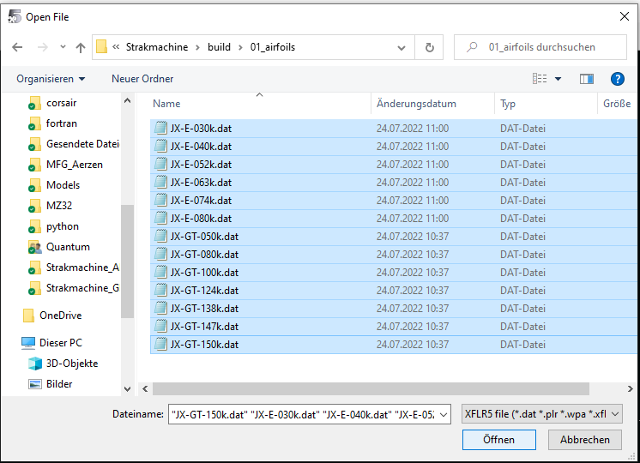

In this case, the airfoil „JX-GT-37k.dat“ is still missing, as we have to create it using the airfoil-optimizer Xoptfoil-JX“.

Back in the „wing and plane design“-view in XFLR5, you should now see that the wing is coloured in a brighter yellow, except the wing tips with the missing airfoil „JX-GT-37k“:

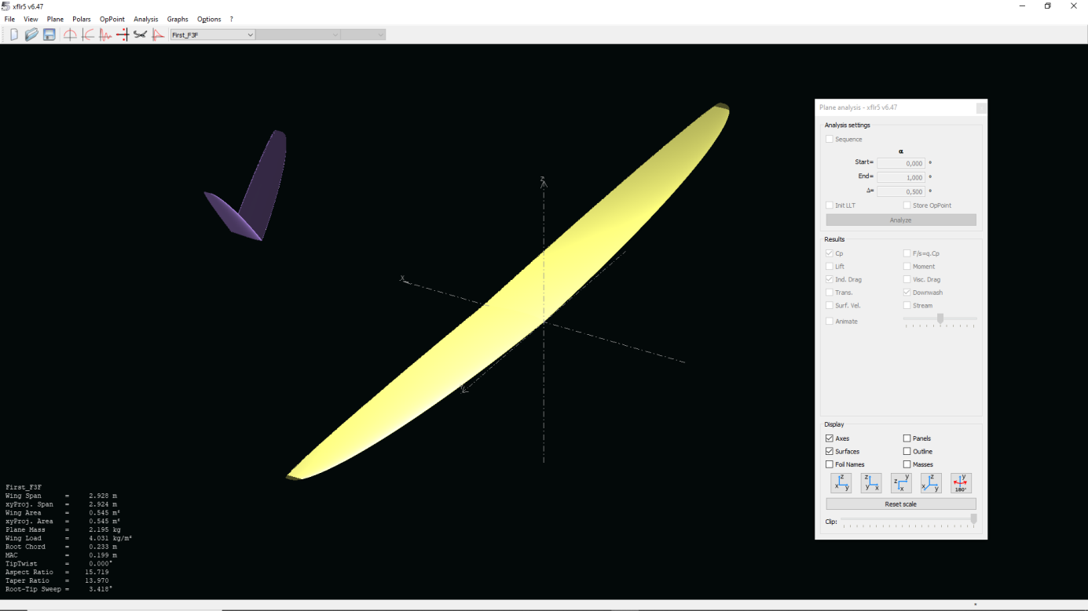

1. **Execute the batchfile „strakmachine_gui.bat to start the graphical editor for setting up the objectives for the optimizer**
2. You should first see a command line window like this:

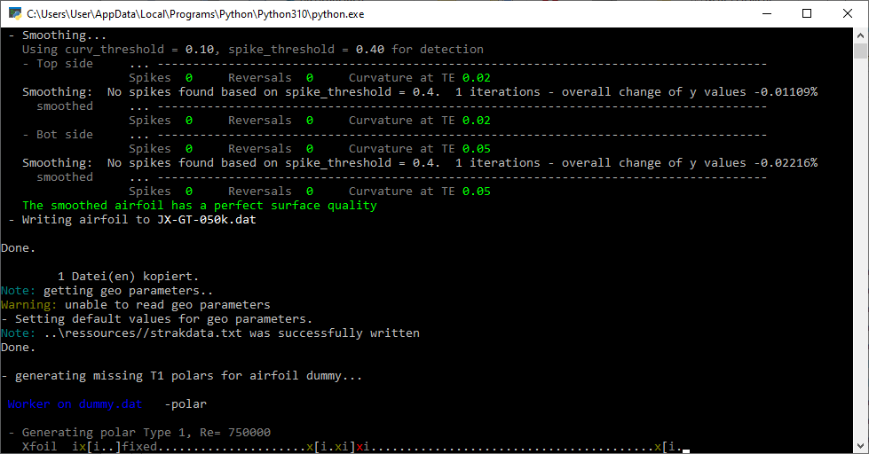

* The Strak machine will now perform some calculations using XFoil, like polars, generate seed-foils etc. when this has been finished, the following screen will appear:

